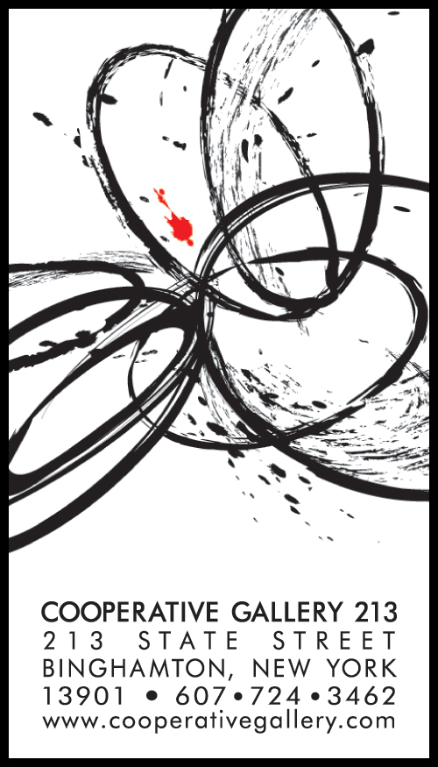

**“Many hands make light work” - Confucius**

**All work at Cooperative Gallery 213 is done by gallery members. By pooling our time and talents, we can accomplish far more than any of us could alone.**

Meetings are held the first Monday of each month at 7 p.m.

Dues for a solo membership are $400/year, paid quarterly.

Dues for a shared membership are $200/year, paid quarterly.

Commission on all work sold from the gallery is 20%

Sales tax at 8% is collected, reported, and paid to the state by the gallery.

**What you, as a member, can expect from the gallery:**

A solo or shared show once every “membership” year (16-19 months) in a spacious and well-lit gallery.

Open gallery hours on Fridays from 3-6 p.m., Saturdays from noon-4 p.m., and on First Fridays an additional 3 hours from 6-9 p.m.

Sales handled by the gallery.

Space on our website for your artist information and your own web gallery.

An opportunity to exhibit at least one work each month in the members’ gallery space.

The support of a group of dedicated professional artist.

**What the gallery expects from you as a member:**

Sharing the work of sitting at the gallery during business hours (about once every 4-5 weeks.)

Service on at least one committee set up for the maintenance and operation of the gallery.

Remaining a member for at least one gallery year to ensure the artistic and financial commitment for publicity and a reception.

Having read the preceding, I wish to apply for membership in Cooperative Gallery 213.

Name:____________________________________________ Phone:___________________

Address:___________________________________________Email:______________________

____________________________________________________

I am interested in **shared** **solo** (select one) membership.

With this application, I am submitting to the Membership Committee an **artist’s statement,** **resume and short biography,** **and 5 -10 images of my work in the form of CD, or 8” x 10” photos, or jpeg photos sent to** [cooperativegallery213@gmail.com](mailto:cooperativegallery213@gmail.com) **or a link to a photosharing site such as Google Photo or to my website that contains samples of my work.** I have included a SASE for return of my images. I understand that I will only be considered when an opening becomes available, and **if considered for membership, I will need to submit 4-6 original works for further review.**

_____________________________________________________ _____________

Signature or typed name Date

Artist’s statement, resume, application for membership and images of work or links to website may be e mailed with attachments to [cooperativegallery213@gmail.com](mailto:cooperativegallery213@gmail.com) with “Membership Application” in the subject line OR mailed to:

Cooperative Gallery 213

Membership Comm.

213 State Street

BInghamton NY 13901