**LAB 2 DATA VISUALIAZATION 225229142**

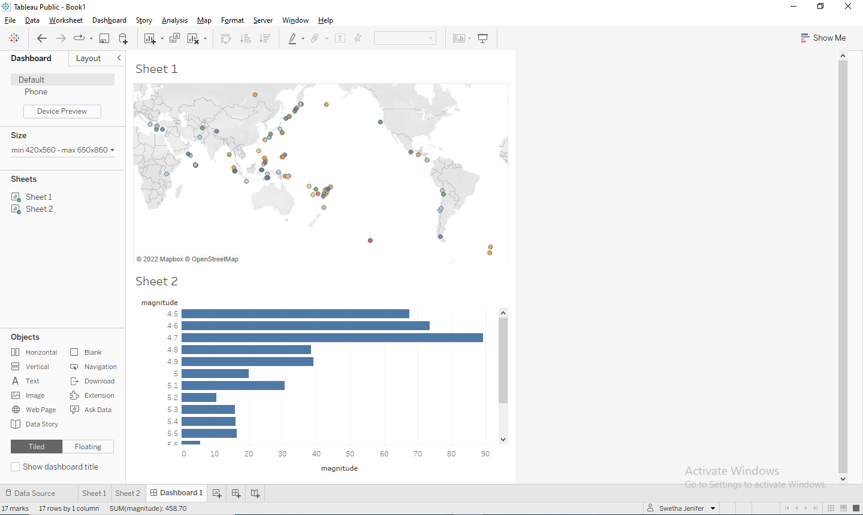

<https://public.tableau.com/views/lab342/Dashboard1?:language=en-US&publish=yes&:display_count=n&:origin=viz_share_link>