225229142-SWETHA JENIFER S

LAB 1: SET OPERATIONS

***SALES TABLE***

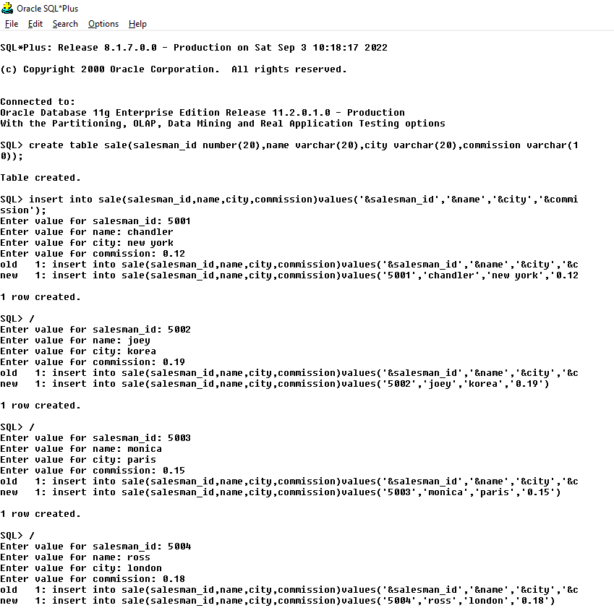

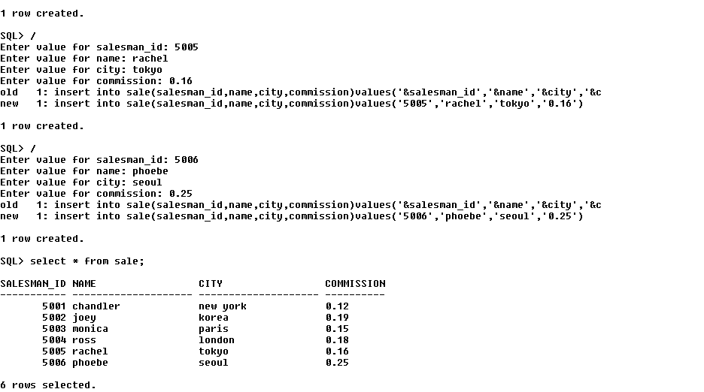

***CUSTOMER TABLE:***

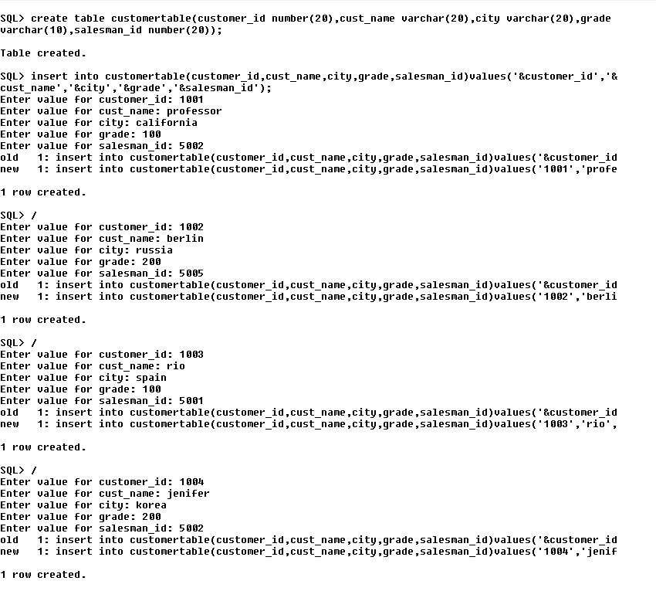

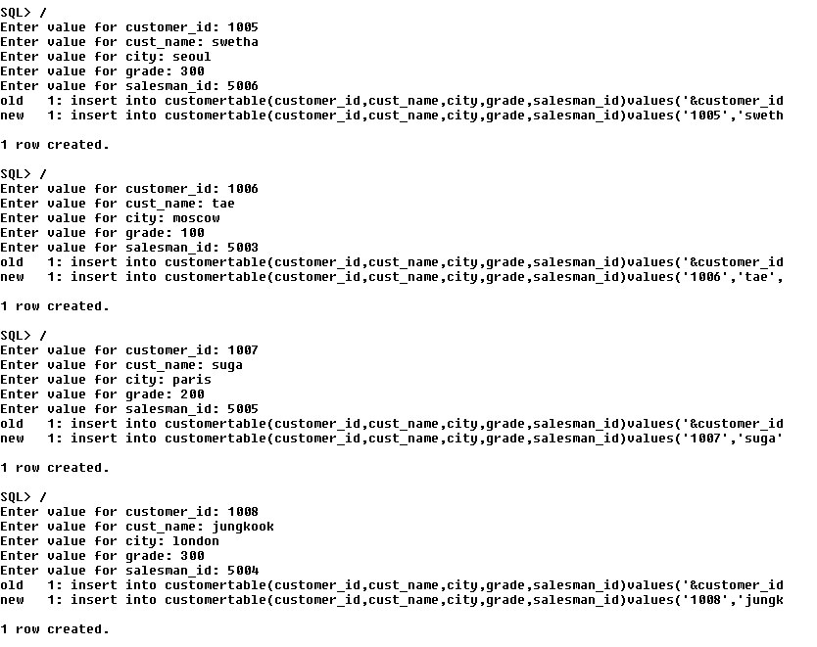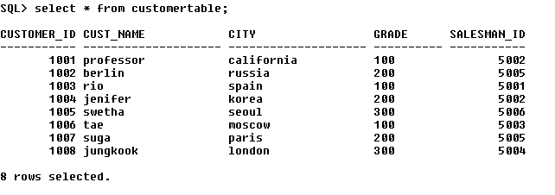

***ORDER TABLE***

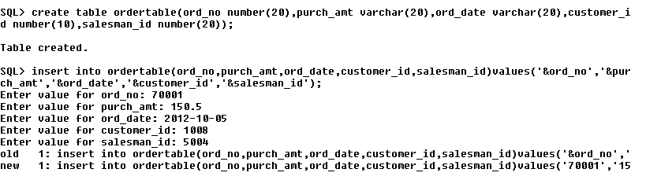

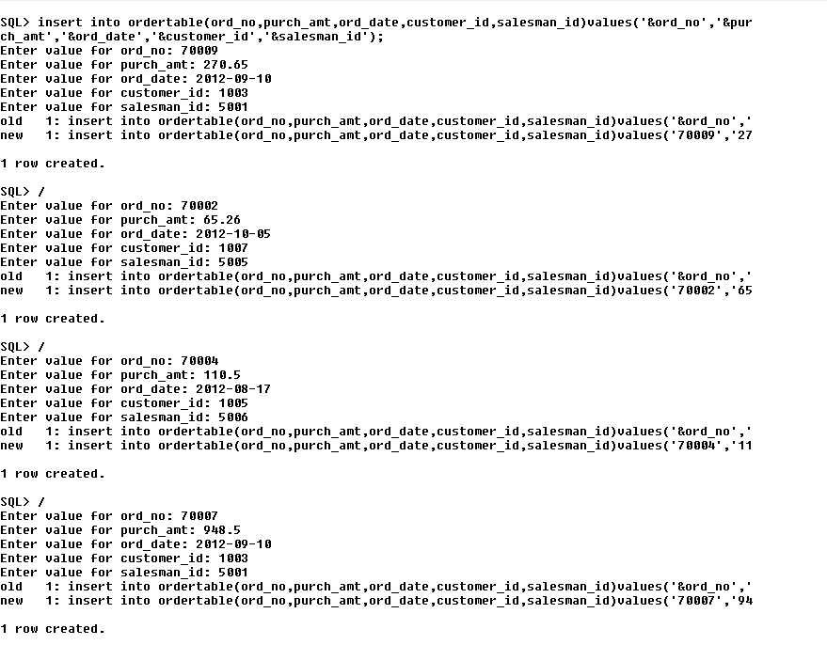

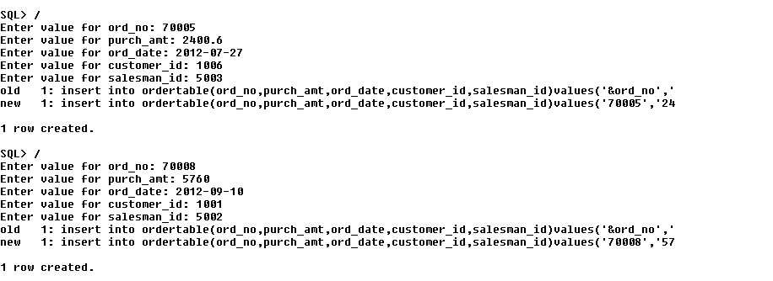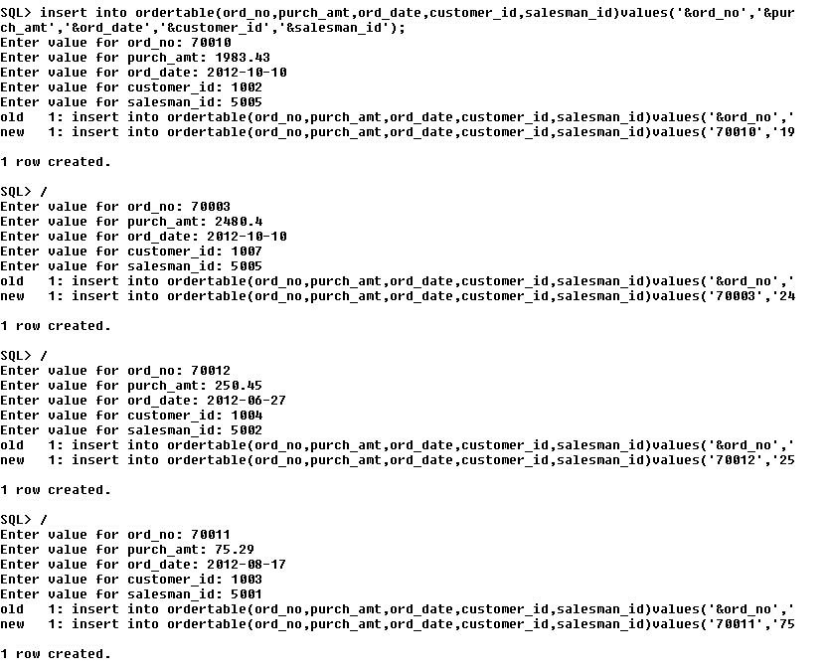

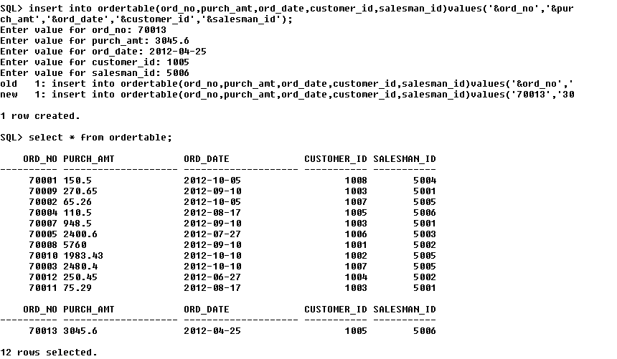

1. write a SQL query to find all salespeople and customers located in the

city of London.

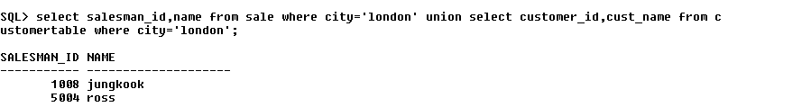

2. write a SQL query to find distinct salespeople and their cities. Return

salesperson ID and city

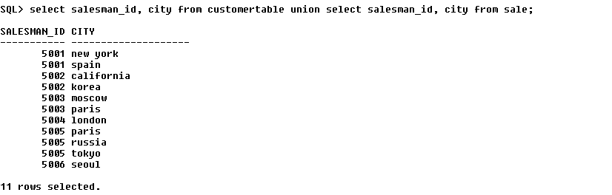

3. write a SQL query to find all those salespeople and customers who are

involved in the inventory management system. Return salesperson ID,

customer ID.

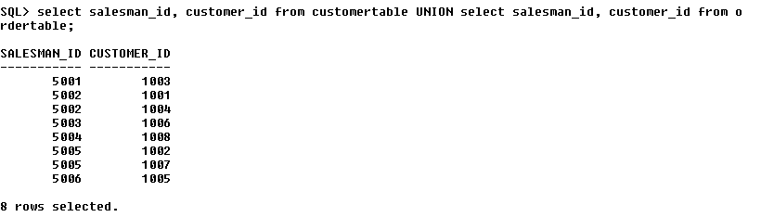

4. write a SQL query to find the salespersons who generated the largest

and smallest orders on each date. Return salesperson ID, name, order

no., highest on/lowest on, order date

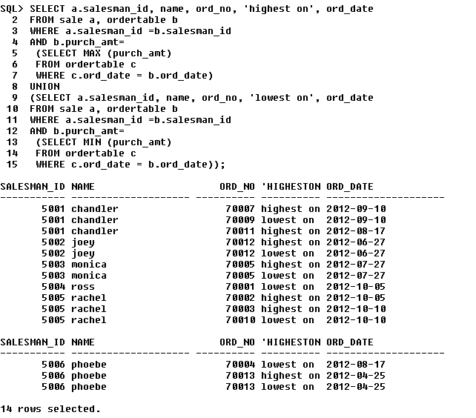

5.  write a SQL query to find the salespeople who generated the largest

and smallest orders on each date. Sort the result-set on third field.

Return salesperson ID, name, order no., highest on/lowest on, order

Date

