Does a Council of Small LLMs Forecast Better Than the Average of Its Members?
Nov 6, 2026 · @Sweksha
Sweksha Shaw. CS180 Individual Studies, San José State University, Fall 2026. Advisor: Prof. Bill Andreopoulos.

Abstract
LLM councils, in which several models answer and a chair model combines their answers, are increasingly used on the assumption that deliberation improves on any single model. We test that assumption on forecasting, where answers can be scored against real outcomes. Five open 7–14B models forecast 1,039 resolved Polymarket and Kalshi questions, alone and as councils, under a sample and comparisons fixed in advance, with five sources of data leakage removed. No council beat the simple average of its own members' probabilities: the Llama-chaired council matched it (+0.003 Brier, 95% CI −0.001 to +0.007) and the Qwen-chaired council was worse (+0.012, CI +0.007 to +0.016). Every setup trailed the market price by 0.08–0.13 Brier. Follow-up experiments show why: the chair behaves as an averager, over-weights its own model, gains nothing from a round of debate, and does no better when it is a 70B model. Re-scoring an earlier council study from this lab shows that its "council wins" result came from scoring errors. We release the questions as a leak-checked benchmark.

1 Introduction
A council asks several language models the same question, shows a chair model their answers, and takes the chair's response as final. The appeal is that models catch each other's mistakes. But a council costs an extra model call and an argument the chair may follow or ignore, and the obvious alternative, averaging the members' answers, costs nothing.
Forecasting is a clean place to test the difference. Each question resolves to Yes or No, forecasts can be scored with proper scoring rules, and prediction markets provide a strong reference price. An earlier council study in this lab compared councils with single models, but scored free-text answers by substring matching and with an LLM judge, and reached opposite conclusions on its two datasets.
This project asks: does a deliberating council of small LLMs forecast better than a simple average of its members' probabilities, and what explains the difference? Our contributions:
- A pre-registered, powered test of council against average on 1,039 resolved questions.
- Five follow-up experiments that locate where the council's answer comes from: a chair ablation, a fit of each chair's weights, one round of debate, repeated runs and a 70B chair.
- A re-scoring of the earlier study, with its scoring errors corrected.
- A benchmark of 1,185 leak-checked questions, a catalogue of the leaks found, and a public dashboard.

2 Related work
LLMs as forecasters. Early benchmarks found models well short of human forecasters (Zou et al., 2022), and GPT-4's binary forecasts in a 2023 Metaculus tournament were no better than saying 50% (Schoenegger & Park, 2023). Retrieval and aggregation narrowed the gap: a system that searches the news and aggregates several forecasts nears the crowd of competitive forecasters (Halawi et al., 2024), and a crowd of twelve LLMs was not statistically different from 925 human forecasters (Schoenegger et al., 2024). ForecastBench finds experts still ahead of the best LLM (Karger et al., 2025), and Paleka et al. (2025) show how retrospective evaluations leak the answer through training data, retrieval and question selection.
Combining forecasts. For human forecasts, averaging in log-odds and pushing the average toward 0 or 1 often beats a plain mean (Satopää et al., 2014; Baron et al., 2014); teaming also helped in the Good Judgment Project (Mellers et al., 2014). Our pooled baselines come from this literature.
Multi-agent LLMs. Multiagent debate improved reasoning and factual accuracy (Du et al., 2023), Mixture-of-Agents refines answers through layers of models (Wang et al., 2024), and the Language Model Council has models judge each other (Zhao et al., 2024). Our council is closest to a one-round Mixture-of-Agents with a chair. Unlike those tasks, forecasting lets the gain from deliberation be measured with a proper score against real outcomes.
Evaluation. We score with the Brier score, which is strictly proper (Brier, 1950; Gneiting & Raftery, 2007), its Murphy decomposition (Murphy, 1973), and the market price as a reference (Wolfers & Zitzewitz, 2004). LLM judges rate how good an answer looks and carry known biases (Zheng et al., 2023), so we report judge scores only to show how far they diverge from outcomes.

3 Background: the earlier council study
The earlier council study (Aye Nyein Kyaw, Spring/Summer 2026, llm-council-judge) compared councils with individual models and reached opposite conclusions on its two datasets. Re-scoring showed both were driven by scoring bugs.
 | As reported | After re-scoring
April dataset | Council won: Llama chair 55.1% vs Llama alone 23.2% | Accuracy was a substring match, so any answer containing "no" (including refusals such as "I cannot") counted as a correct No
July dataset (1,611 Yes/No questions) | Council lost: DeepSeek and Qwen alone (~48%) beat every council (41–44%) | Councils beat the single models but were no better than always answering No (67% of questions resolved No)
Judge scores | Councils 4.40–4.79 vs single models 3.46–3.71 | Failed judge reads were scored 1 only in single-model runs; without them single models score 4.30–4.75. The judge rated right and wrong answers alike (AUROC 0.44–0.66)
Market | Not recorded | Using Polymarket prices fetched for her questions, every council was 0.16–0.19 Brier worse than the market
Her results were imported read-only from a pinned commit, graded strictly (an explicit Yes is 1, an explicit No is 0, anything else abstains) and kept in their own dashboard tabs. Her repository was not modified. Earlier council runs by Aishwarya and Aswitha, documented in the team's Google Doc, were not imported.

4 Methods
Every model and council gives a probability that the event happens, and is scored against how the question actually resolved.
Part | What was used
Questions | 1,730 from Polymarket and Kalshi: 1,039 settled (pre-registered sample: 359 closing Jul–Oct 2026 plus 680 Polymarket questions from Jul 2025–Jun 2026), 146 older ones for a contamination check, 545 live
Models | Llama 3.1 8B, Mistral 7B, Qwen 3 8B, Gemma 2 9B, Phi-3 Medium (14B), run locally through Ollama on the university GPU server; DeepSeek R1 8B alone only; Llama 3.3 70B as a scale check
Councils | All five members answer, then a chair (Llama or Qwen in the main run) sees their answers and gives the final probability
Timing | Settled questions are asked "as of" a price date 7 days before the earlier of close and resolution, never today's date. 2,394 live forecasts were locked before their questions resolved
Baselines | The mean and log-odds average of the same members, the best single model, always No, the base rate, and the market price
Metrics | Brier and log score, accuracy, calibration (ECE) and sharpness, AUROC, balanced accuracy and MCC; paired differences with 95% bootstrap intervals stratified by source
The sample and every comparison were written into a decisions log before any settled results existed (Oct 16 and Oct 20). A power analysis set the smallest detectable difference against the average at about 0.013 Brier, so "no difference" is a real result.
Five leaks were found and fixed before scoring:
- Settled questions asked as of a date after the market closed (15 repriced or dropped).
- Prices anchored on resolution instead of the earlier of close and resolution (241 repriced).
- Markets outside the backtest window, because Polymarket filters by the event's dates (25 dropped).
- Live forecasts made after the market had already ended (49 questions, no longer scored).
- The earlier study's scoring bugs (re-graded as above).
Statistical analysis. Every comparison is a paired Brier difference on the questions both setups answered, with a 95% bootstrap interval that resamples questions within each source (Polymarket, Kalshi). Three checks were added after the results and are labelled as such in the decisions log: an equivalence test (TOST), which counts a council as matching the average only if its 90% interval lies inside ±0.013 Brier, the smallest difference the study could detect; a Holm–Bonferroni correction across the 11 council-versus-average comparisons; and AUROC with bootstrap intervals to check that the models forecast better than chance.
Prompts and decoding. Every single model receives the same system and user prompt (prompt version v2, full text in Appendix A): the "as of" date, the question, its closing date and the market's resolution rules (truncated at 1,500 characters), and a request for 2–4 sentences of reasoning followed by a probability, as JSON. Reasoning comes before the number because, with the number first, Llama 3.1 answered 0.55 on 12 of 15 test questions. The chair receives the same question block and every member's probability and reasoning, anonymised as Panelist A, B, C. All calls use temperature 0, seed 42, Ollama's structured-output mode with a JSON schema, and reasoning modes switched off. DeepSeek R1 ignores that switch and runs alone with a 1,024-token thinking budget. The repeated runs use temperature 0.7 with seeds 1, 2 and 3.
Parsing and failures. A probability is read from the JSON, or else from an explicit "probability: x" in the text; values such as 70 or "70%" are read as 0.70. A reply with no probability in [0, 1] is an abstention. Failed calls (server errors, timeouts) are retried on a later run and the retry replaces them; every raw response is kept, and live forecasts are locked with a timestamp and never edited.
Bootstrap. Intervals use 1,000 resamples (2,000 for the checks added afterwards), seed 0, drawing questions with replacement within each source so the Polymarket–Kalshi mix is fixed. A comparison on fewer than 30 shared questions reports its mean only.
Models and compute. Llama 3.1 8B Instruct, Mistral 7B Instruct v0.3, Qwen3 8B, Gemma 2 9B, Phi-3 Medium 14B, DeepSeek-R1 8B (distill) and Llama 3.3 70B Instruct, all through Ollama on one NVIDIA DGX Spark (20-core ARM CPU, 128 GB unified memory) at San José State. The main and follow-up runs used its GPU at about 6 seconds per 8B call and finished on Oct 21. The GPU driver then failed, so the 70B check ran on 10 of the 20 CPU cores: 718 forecasts in about 15 hours (Nov 2), roughly 80 seconds per call.

5 Results

5.1 Overall scores
The market was far ahead of every model, and no model beat a constant forecast at the base rate. Table 1 scores each setup on the 1,039 settled questions; lower Brier and log score are better.
Table 1. Scores on the pre-registered sample (n = 1,039; DeepSeek R1 answered 359).
Setup | Brier | Log score | Accuracy | ECE | AUROC
Market price | 0.169 | 0.512 | 73.8% | 0.071 | 0.840
Base rate (constant) | 0.246 | 0.685 | 56.5% | 0.000 | 0.500
Mean of members | 0.250 | 0.702 | 57.2% | 0.086 | 0.592
Council, Llama chair | 0.253 | 0.707 | 56.1% | 0.098 | 0.584
Phi-3 Medium (best single) | 0.254 | 0.727 | 57.8% | 0.098 | 0.597
Median of members | 0.257 | 0.723 | 57.2% | 0.110 | 0.583
Llama 3.1 8B | 0.257 | 0.739 | 54.5% | 0.120 | 0.570
Log-odds pool of members | 0.259 | 0.745 | 57.2% | 0.116 | 0.590
Gemma 2 9B | 0.261 | 0.742 | 57.7% | 0.124 | 0.592
Council, Qwen chair | 0.262 | 0.793 | 56.4% | 0.123 | 0.583
Mistral 7B | 0.277 | 0.851 | 55.6% | 0.144 | 0.560
DeepSeek R1 8B | 0.291 | 0.897 | 52.5% | 0.206 | 0.562
Qwen 3 8B | 0.295 | 1.021 | 55.4% | 0.219 | 0.570
Always No | 0.435 | 6.010 | 56.5% | 0.435 | 0.500
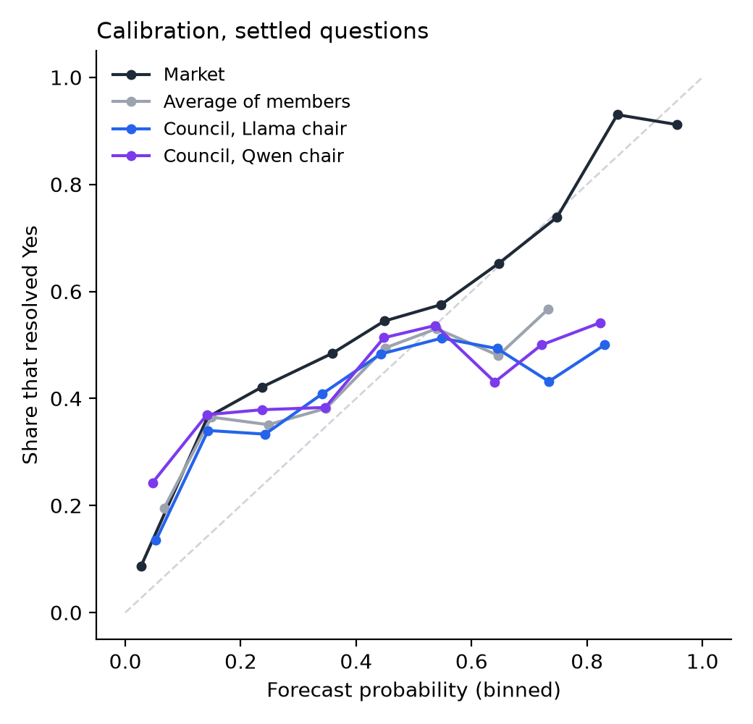
Figure 1. Calibration on the settled questions: forecasts grouped into bins against the share that resolved Yes; the dashed line is perfect calibration. The councils and the average lie almost on top of each other, and all stay flat above 0.5, while the market keeps rising.

5.2 Council against the members' average
No version of the council beat the plain average of its members, and most were significantly worse. Figure 2 shows every comparison against that average: the two main-run chairs, the other three members as chair, the chair ablations, debate and the 70B chair.
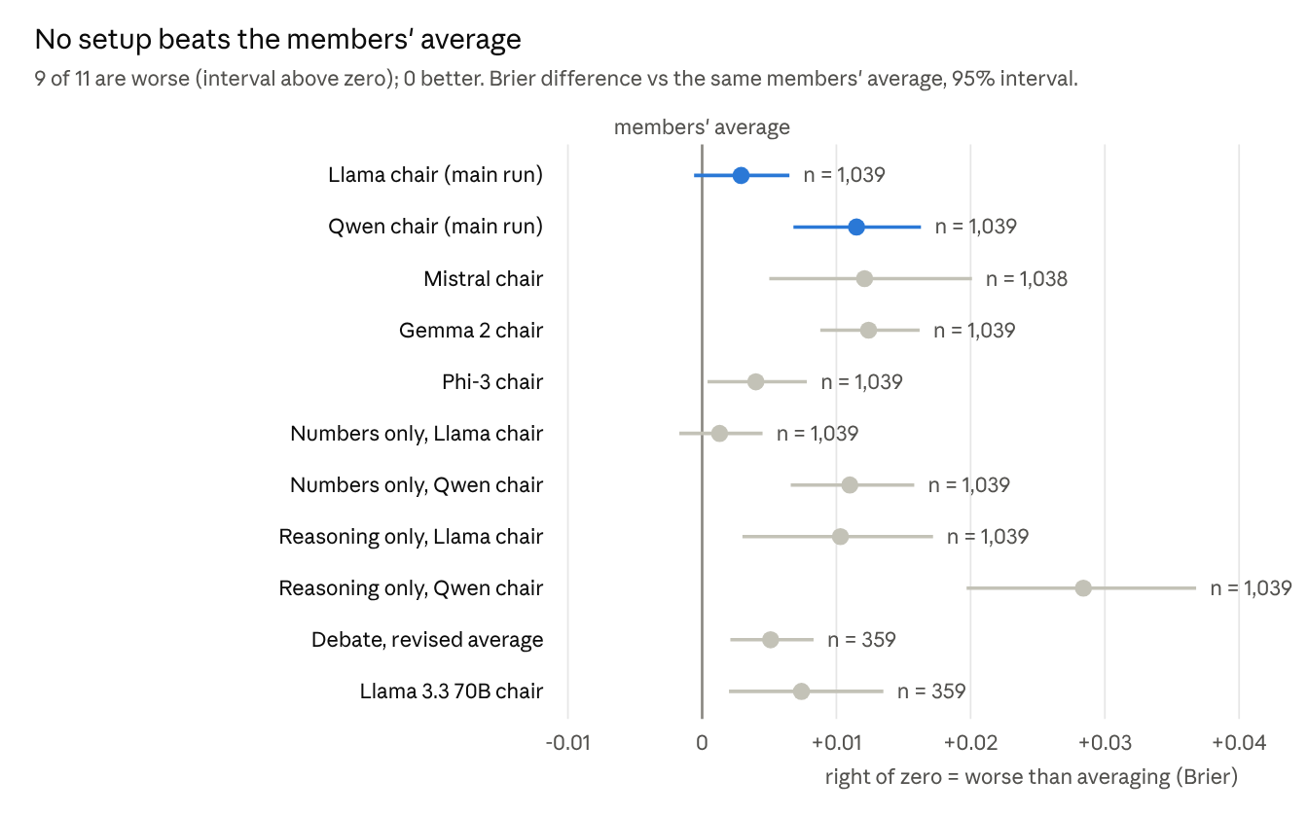
results/ablation, results/debate, results/scale in the repo · settled questions, Brier difference vs the mean of the same members
After a Holm–Bonferroni correction across these 11 comparisons, 8 remain significantly worse than the average and none is better; the Phi-3 chair moves to no clear difference (adjusted p = 0.11). The Llama-chaired council is formally equivalent to the average: its 90% interval (−0.0001 to +0.006) lies well inside the ±0.013 margin.
One pre-registered robustness cut points the other way. On the 494 questions where the market was uncertain (price between 20% and 80%), the Llama-chaired council beat its members' average by 0.0065 Brier (95% CI −0.011 to −0.002; Holm-adjusted p = 0.004 across the 6 certainty tests). It was worse on near-certain questions (+0.019), which cancels the gain overall. The Qwen-chaired council was worse in every group.

5.3 Follow-up experiments
- The chair just averages. A chair shown only the members' numbers matched the full council; one shown only their reasoning drifted from the average and did worse. The Llama and Qwen chairs stayed within 0.05 of the average on 72–88% of questions, against 33–39% when shown only reasoning.
- Chairs favour their own model. Fitting each chair's output as a weighted average of its members, 4 of 5 chairs over-weighted their own model (Qwen +0.17, Mistral +0.15, Gemma +0.10, Phi-3 +0.03); Llama's +0.03 was not significant.
- Debate makes models agree, not improve. After one round of revision, disagreement fell 18% but the revised average was worse than before debate (359 questions).
- Repeated runs agree. Across three runs at temperature 0.7 (199 questions), the market gap and the Qwen chair's deficit held every time, and the Llama chair stayed near the average.
- No sign of memorisation. On 146 older questions resolved before the models' training cutoffs, no model or council did relatively better than on later questions. The gap to the market before the cutoff minus the gap after ranged from −0.015 to +0.060 Brier; only Llama 3.1's interval excluded zero, and in the direction of doing worse on the older questions (Table B3).
- Bigger chair, same answer. Llama 3.3 70B chairing the same five members (run on the server's CPU, Nov 2) was worse than the average (+0.007) and no better than any 8B chair. The 70B model alone was no better than the best 8B member (+0.001, CI −0.020 to +0.022).
- Against the market, every setup trailed the market by 0.08–0.13 Brier (Table 1).
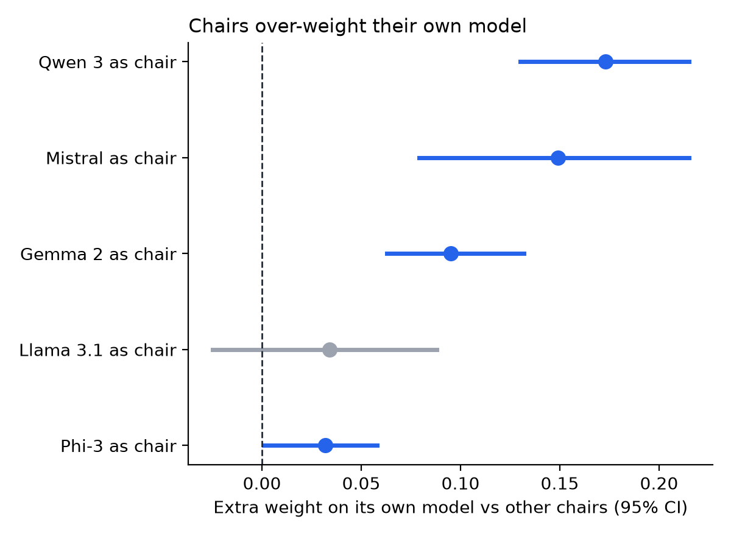
Figure 3. Self-preference: each chair's fitted weight on its own model minus the mean weight the other chairs put on that model, with 95% intervals (1,038 questions). Four of five chairs over-weight their own model.

5.4 By market and subgroup
The result holds in both markets. Against the members' average, the Llama-chaired council showed no clear difference on Kalshi (0.000, CI −0.008 to +0.009) or Polymarket (+0.004, CI −0.000 to +0.008); the Qwen-chaired council was worse on Polymarket (+0.012) and not clearly different on Kalshi (+0.010, CI −0.001 to +0.023). Both trailed the market in each (by 0.12–0.13 Brier on Kalshi, 0.08 on Polymarket). By topic, no council beat the average in any group; both were worse on culture questions (+0.033 to +0.034). By horizon, both were worse on questions resolving 8–30 days after the price date. Full tables are in Appendix B.

5.5 Live set (interim)
On the 260 live questions scored so far (forecasts locked before resolution; the set closes Nov 15, 2026), both councils were worse than their members' average: Llama chair +0.015 Brier (CI +0.008 to +0.022), Qwen chair +0.008 (CI +0.001 to +0.016). Both trailed the market by about 0.15. The final live results will replace these after the set closes.

6 Discussion
Why the council cannot beat averaging. Every member sees the same question with no outside information, so their disagreements are noise rather than different knowledge. Averaging already cancels noise; a chair has nothing further to resolve, and when it reads the members' arguments it drifts from the average and gets worse. This is consistent with the forecasting literature, where gains from combining come from independent information (Baron et al., 2014), and with work showing that LLM forecasters improve mainly when given retrieved news (Halawi et al., 2024).
Threat to validity: are the members too weak to combine? If the members carried no signal, "the council matches the average" would only mean that two ways of combining noise score alike. The members do carry signal, but little: every model ranks questions better than chance (AUROC 0.56–0.60, all 95% intervals above 0.5), yet none beats a constant base-rate forecast, and the mean of members sits 0.005 Brier above it (CI −0.006 to +0.015). The market, at AUROC 0.84, shows how much signal the questions hold. So the result is established for weak forecasters with shared information. It does not show that deliberation fails among stronger or better-informed models, and the uncertain-market result (Section 5.2) hints that a chair can add something where there is real doubt to resolve.
Where councils help. Combining models helps; deliberating adds nothing beyond combining. The plain average delivers each of these benefits as well or better, without the extra chair call.
- It lifts weak models. A council beat its chair's model answering alone when that model was weak (Qwen −0.033 Brier, Mistral −0.015) and matched the stronger ones.
- It matches the best model without knowing which one that is. Councils were no worse than Phi-3, the best single model (−0.001 and +0.008, both not significant), which can only be picked after seeing the results.
- It always answers. Councils gave a forecast on every question; in the earlier study, councils committed to a clear Yes or No on up to 58% of questions against 3–9% for most single models.
- Debate builds agreement. Disagreement fell 18% after one round, although accuracy did not improve.
Recalibrating forecasts toward 50% improved councils by 0.012–0.020 Brier, but it improved the average by about the same (0.010), so it does not change the ranking.

7 Limitations and future work
Limitations:
- Members are 7–14B open models; the 70B model was tested only as chair, and only on the 359 original settled questions.
- No retrieval and one round of debate. A second, differently worded chair prompt, and debate and the 70B chair on all 1,039 questions, were pre-registered on Nov 6 and are running.
- The extension questions are Polymarket only, because Kalshi's regular API no longer serves 2025–26 settled markets.
- The live set (545 questions) closes Nov 15, 2026; only 260 questions are scored so far. The equivalence test, the multiple-comparison correction and the discrimination check were added after the results.
Future work:
- Score the live set after Nov 15 as the out-of-sample check.
- Give members different information, such as time-stamped news retrieval, so the chair has real disagreements to resolve.
- Test stronger or more varied council members, not just a stronger chair, on a working GPU server.
- Add 2025–26 Kalshi questions through its historical API (the collector is ready).
- Write up the results for an arXiv submission next semester, with the benchmark given a DOI through Zenodo.
Any new comparison will be written into the decisions log before it is run, as before.

8 Conclusion
On 1,039 resolved prediction-market questions, a council of small open LLMs never forecast better than the simple average of its own members, and every setup fell well short of the market. The chair acts as an averager with a bias toward its own model; showing it the members' reasoning, adding a round of debate or making it ten times larger does not change that. The earlier study's apparent council advantage disappears once its scoring is corrected. For forecasting with similar models and shared information, averaging gives the benefit of a council at lower cost; whether deliberation helps once members bring different information is the next question.

Data and code availability
Everything is public and rebuilds from the committed data with one command.
Deliverable | Where
Code, data and results | GitHub repository, every change through a reviewed pull request with tests in CI
Leaderboard site and results dashboard | sweksha-cloud.github.io/llm-council-forecasting
Benchmark | benchmark-v1 release: 1,185 leak-checked resolved questions for reuse
Reproduction | make setup && make reproduce, and a Colab notebook that reruns the results in the browser
Decisions log | docs/decisions.md: every choice that could change a result, dated, including the pre-registration
Leakage write-up | docs/leakage.md: the five leaks, their size and the fix
Hand-off guide | docs/handoff.md, for whoever continues the project

References
- Baron, J., Mellers, B. A., Tetlock, P. E., Stone, E., & Ungar, L. H. (2014). Two reasons to make aggregated probability forecasts more extreme. Decision Analysis, 11(2), 133–145. https://doi.org/10.1287/deca.2014.0293
- Brier, G. W. (1950). Verification of forecasts expressed in terms of probability. Monthly Weather Review, 78(1), 1–3.
- Du, Y., Li, S., Torralba, A., Tenenbaum, J. B., & Mordatch, I. (2023). Improving factuality and reasoning in language models through multiagent debate. arXiv:2305.14325.
- Gneiting, T., & Raftery, A. E. (2007). Strictly proper scoring rules, prediction, and estimation. Journal of the American Statistical Association, 102(477), 359–378. https://doi.org/10.1198/016214506000001437
- Halawi, D., Zhang, F., Yueh-Han, C., & Steinhardt, J. (2024). Approaching human-level forecasting with language models. NeurIPS 2024. arXiv:2402.18563.
- Karger, E., Bastani, H., Yueh-Han, C., Jacobs, Z., Halawi, D., Zhang, F., & Tetlock, P. E. (2025). ForecastBench: A dynamic benchmark of AI forecasting capabilities. ICLR 2025. arXiv:2409.19839.
- Kyaw, A. N. (2026). LLM-as-Council: llm-council-judge [code and data]. https://github.com/JennicaANK/llm-council-judge
- Mellers, B., Ungar, L., Baron, J., et al. (2014). Psychological strategies for winning a geopolitical forecasting tournament. Psychological Science, 25(5), 1106–1115. https://doi.org/10.1177/0956797614524255
- Murphy, A. H. (1973). A new vector partition of the probability score. Journal of Applied Meteorology, 12(4), 595–600.
- Paleka, D., Goel, S., Geiping, J., & Tramèr, F. (2025). Pitfalls in evaluating language model forecasters. arXiv:2506.00723.
- Satopää, V. A., Baron, J., Foster, D. P., Mellers, B. A., Tetlock, P. E., & Ungar, L. H. (2014). Combining multiple probability predictions using a simple logit model. International Journal of Forecasting, 30(2), 344–356. https://doi.org/10.1016/j.ijforecast.2013.09.009
- Schoenegger, P., & Park, P. S. (2023). Large language model prediction capabilities: Evidence from a real-world forecasting tournament. arXiv:2310.13014.
- Schoenegger, P., Tuminauskaite, I., Park, P. S., Bastos, R. V. S., & Tetlock, P. E. (2024). Wisdom of the silicon crowd: LLM ensemble prediction capabilities rival human crowd accuracy. Science Advances, 10(45), eadp1528. https://doi.org/10.1126/sciadv.adp1528
- Wang, J., Wang, J., Athiwaratkun, B., Zhang, C., & Zou, J. (2024). Mixture-of-agents enhances large language model capabilities. arXiv:2406.04692.
- Wolfers, J., & Zitzewitz, E. (2004). Prediction markets. Journal of Economic Perspectives, 18(2), 107–126. https://doi.org/10.1257/0895330041371321
- Zhao, J., Plaza-del-Arco, F. M., Genchel, B., & Curry, A. C. (2024). Language Model Council: Democratically benchmarking foundation models on highly subjective tasks. arXiv:2406.08598.
- Zheng, L., Chiang, W.-L., Sheng, Y., et al. (2023). Judging LLM-as-a-judge with MT-Bench and Chatbot Arena. NeurIPS 2023 Datasets and Benchmarks. arXiv:2306.05685.
- Zou, A., Xiao, T., Jia, R., et al. (2022). Forecasting future world events with neural networks. NeurIPS 2022 Datasets and Benchmarks. arXiv:2206.15474.

Appendix A: Prompts
Single-model forecast (system):
You are a careful forecaster. You estimate the probability of future events using what you know, base rates, and reasoning. You cannot look anything up. Always give a probability, even when uncertain; never refuse.
Single-model forecast (user). {today} is the price date for settled questions, never the real date:
Today's date: {today}
Question: {question}
Closes: {close_date}
How it resolves: {criteria}
Estimate the probability that this question resolves YES.
Respond with JSON only, in exactly this format:
{"reasoning": "<2-4 sentences>", "probability": <number between 0 and 1>}
Chair (system):
You are the chair of a panel of forecasters. You read each panelist's independent forecast and reasoning, weigh their arguments, and give the panel's final probability. You cannot look anything up. Always give a probability; never refuse.
Chair (user):
{question_block}
The panelists answered independently:
Panelist A: probability 0.30. <reasoning>
Panelist B: probability 0.45. <reasoning>
...
Weigh their arguments and give the panel's final probability that this question resolves YES.
Respond with JSON only, in exactly this format:
{"reasoning": "<2-4 sentences>", "probability": <number between 0 and 1>}
The numbers-only chair sees only the probabilities; the reasoning-only chair sees only the reasoning, with probability-like numbers replaced by "[number withheld]". In debate, each member sees its own first answer and the others' answers and is asked to "reconsider your forecast in light of their arguments. Keep it if you still think it is right." Exact text of every prompt: forecast/prompts.py.

Appendix B: Additional tables
Table B1. Every council variant against the members' average, with the checks added after the results. Difference in Brier (negative = council better); equivalent = 90% interval inside ±0.013.
Setup | n | Difference | 95% CI | Holm p | Equivalent
Llama chair (main) | 1,039 | +0.0029 | −0.0008 to +0.0066 | 0.23 | yes
Qwen chair (main) | 1,039 | +0.0115 | +0.0069 to +0.0164 | <0.001 | no
Mistral chair | 1,038 | +0.0121 | +0.0049 to +0.0198 | 0.007 | no
Gemma 2 chair | 1,039 | +0.0124 | +0.0087 to +0.0162 | <0.001 | no
Phi-3 chair | 1,039 | +0.0040 | +0.0004 to +0.0078 | 0.11 | yes
Numbers only, Llama | 1,039 | +0.0013 | −0.0019 to +0.0045 | 0.42 | yes
Numbers only, Qwen | 1,039 | +0.0110 | +0.0066 to +0.0159 | <0.001 | no
Reasoning only, Llama | 1,039 | +0.0103 | +0.0034 to +0.0172 | 0.012 | no
Reasoning only, Qwen | 1,039 | +0.0284 | +0.0202 to +0.0369 | <0.001 | no
Debate, revised average | 359 | +0.0051 | +0.0020 to +0.0083 | 0.015 | yes
Llama 3.3 70B chair | 359 | +0.0074 | +0.0020 to +0.0140 | 0.036 | yes
Table B2. Council minus members' average by subgroup (Brier, 95% CI; groups under 30 questions omitted).
Group | n | Llama chair | Qwen chair
Kalshi | 200 | 0.000 (−0.008 to +0.009) | +0.010 (−0.001 to +0.023)
Polymarket | 839 | +0.004 (−0.000 to +0.008) | +0.012 (+0.007 to +0.018)
Market uncertain (20–80%) | 494 | −0.007 (−0.011 to −0.002) | +0.009 (+0.003 to +0.016)
Market leaning | 226 | 0.000 (−0.009 to +0.009) | +0.018 (+0.007 to +0.029)
Market near-certain | 319 | +0.019 (+0.013 to +0.026) | +0.011 (+0.003 to +0.021)
Resolves ≤7 days | 351 | −0.002 (−0.008 to +0.004) | +0.019 (+0.011 to +0.027)
Resolves 8–30 days | 668 | +0.006 (+0.002 to +0.010) | +0.008 (+0.002 to +0.013)
Sports | 420 | −0.002 (−0.006 to +0.002) | +0.006 (−0.001 to +0.013)
Politics | 210 | −0.002 (−0.012 to +0.009) | +0.018 (+0.007 to +0.032)
Culture | 103 | +0.034 (+0.022 to +0.046) | +0.033 (+0.014 to +0.052)
Other | 98 | +0.014 (+0.000 to +0.026) | +0.014 (+0.000 to +0.029)
Elections | 83 | +0.005 (−0.007 to +0.016) | +0.014 (−0.001 to +0.030)
Geopolitics | 82 | −0.005 (−0.017 to +0.007) | −0.008 (−0.019 to +0.003)
World | 43 | −0.010 (−0.026 to +0.007) | +0.003 (−0.012 to +0.019)
Table B3. Contamination check: questions resolved before each model's training cutoff (n = 61–146) against later ones. Excess gap = (Brier minus market Brier) before the cutoff, minus the same after; a negative value would suggest recall.
Setup | Cutoff used | Excess gap | 95% CI
Llama 3.1 8B | Dec 2023 (stated) | +0.060 | +0.011 to +0.110
Phi-3 Medium | Oct 2023 (stated) | +0.044 | −0.015 to +0.101
Mistral 7B | May 2024 (release) | +0.008 | −0.028 to +0.043
Gemma 2 9B | Jun 2024 (release) | −0.001 | −0.035 to +0.031
Qwen 3 8B | Apr 2025 (release) | −0.004 | −0.050 to +0.042
DeepSeek R1 8B | May 2025 (release) | −0.015 | −0.067 to +0.033
Council, Llama chair | Apr 2025 (latest member) | +0.021 | −0.013 to +0.054
Council, Qwen chair | Apr 2025 (latest member) | +0.013 | −0.025 to +0.048
Mean of members | Apr 2025 (latest member) | +0.011 | −0.017 to +0.039

Appendix C: Leakage catalogue
# | Leak | Size | Fix
1 | Settled questions asked as of a date after the market closed (Polymarket can resolve weeks after its scheduled close) | 15 settled questions | Price and "as of" date taken 7 days before the earlier of close and resolution; 13 repriced, 2 left unpriced
2 | Prices anchored on resolution rather than the earlier of close and resolution, leaking up to 7 days of the run-up | 127 of 360 settled, 122 of 153 contamination | 241 repriced (median change 0.005–0.007); 8 with no trade near the new date dropped
3 | Markets outside the backtest window, because Polymarket's API filters by the event's dates | 25 extension questions | Each market must close and resolve inside the window itself; the 25 dropped
4 | Live forecasts made after the market had already ended (Kalshi games and "by date" markets end early) | 49 of 342 live questions | Forecasts at or after the market's actual end are not scored
5 | Scoring bugs in the earlier council results: substring accuracy, and failed judge reads scored 1 for single models only | All 2,501 imported questions | Re-graded strictly; failed reads dropped everywhere
Full detail: docs/leakage.md.

