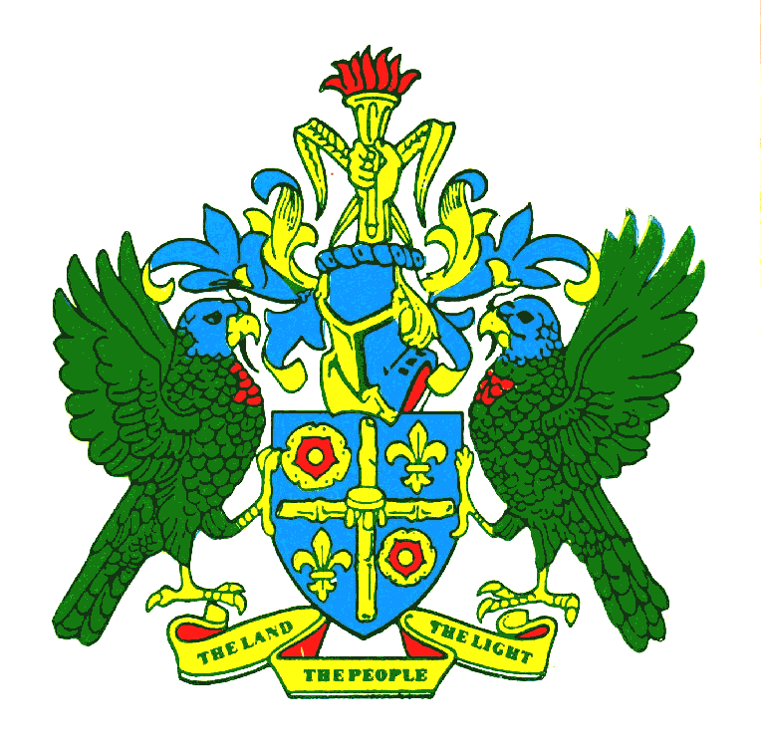
GOVERNMENT OF SAINT LUCIA
OFFICE OF THE PRIME MINISTER

PUBLIC NOTICE

The Office of the Prime Minister wishes to inform that its offices will be closed from Monday June 14, 2021, to Friday June 25, 2021, to facilitate urgent remedial works and deep cleaning. Normal operations will resume on Monday, June 28, 2021, from 8:00 a.m.

Kindly note that correspondence can be delivered to the Greaham Louisy Administrative Building, Waterfront at the Security Desk or sent via email at opmreception@govt.lc.

The Office can be contacted on Telephone Numbers;

Reception: 468-2111
Accounts: 468-2174
Prime Minister’s Secretary: 468-2233

The Office of the Prime Minister apologizes for any inconveniences caused due to this temporary closure.

Irene St. Croix (Mrs.)
Permanent Secretary

