**Consent Form**

You are being invited to participate in a research study about *Sonification.* This study is being conducted as part of a PhD research by Danyi Liu at Leiden University.

You were selected as a possible participant in this study. There are no known risks if you decide to participate in this research study. There are no costs to you for participating in the study. The information you provide will only be used in my research and thesis. The experiments will take about 25 - 30 minutes to complete.

The experiments are anonymous. No one will be able to identify you or your answers, and no one will know whether you participated in the study.

Your participation in this study is voluntary. By completing the experiments, you are voluntarily agreeing to participate. You are free to decline to answer any particular question you do not wish to answer for any reason.

If you have any questions about the study, please contact *Danyi Liu, +31626540328, d.liu.7@liacs.leidenuniv.nl*

Name _____________ Date ___________ Signature _________________

**Experiment Instructions**

Thank you for agreeing to participate in our sonification study. There are four speakers around you, which will play sounds during the experiment. You are free to change your head orientation, but please do not move the chair.

***Phase 1 Introduction (~ 3 minutes)***

**Element:** We designed four different sounds representing four chemical elements H, C, N, O. *We used pitch and density as two main features for the sound design in accordance with the weight differences of the four elements.*

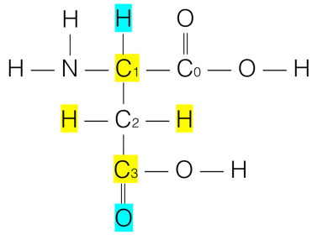

**Layer:** If you are standing on C2 (please see the figure right beside):

a) First layer: only sonifying the atoms directly connected to the current carbon position (marked as yellow ones).

b) Second layer: also sonifying atoms behind the directly connected atoms (marked as light blue ones).

Example: Now you are standing on C0 (see the figure below), you will hear three sounds adding one by one from your right. C1 is on the first layer, C2 is on the second layer and H is on the third layer. *On one hand, the distance determines the loudness and the sound of C1 is the loudest. On the other hand, C2 has slightly higher pitch and more resonance, which becomes less sharp and intensive. Reverb is employed to enhance the sensation of distance of atoms in the second layer.*

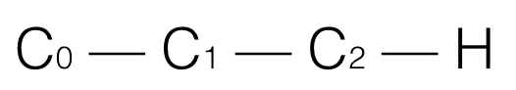

***Phase 2 Training (~8 minutes)***

You may have already found the differences among sounds. In this phase, you will hear several sound samples and be asked several questions as practice to get familiar with the sound design. Feedback will be provided on your answers.

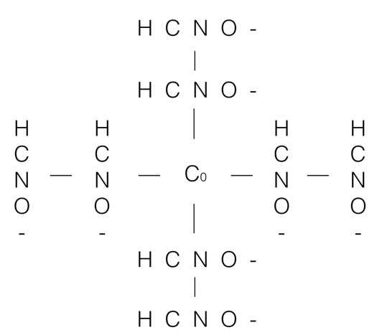***Phase 3 Test - Condition 1 (~ 7 minutes)***

Interface: You will hear three examples before the test, to get familiar with the interface.

You will hear 8 set of sounds. In each set there will be maximally 8 sound positioned around you. The first layer of sounds will be played first. After 10 seconds, the second layer of sounds will be played. Each layer will contain up to 4 sounds from four directions. Please use mouse (left click) to choose corresponding elements from each direction and layer as you hear. You can change your head orientation during the test. You can choose “-“ if there is no sound heard.

***Phase 4 Test - Condition 2 (~ 7 minutes)***

You will hear 8 sound samples, the duration of each sample will be 20 seconds. The sounds may come from four different directions (speakers) around you. Each direction will contain up to two layers of sound sources. You can use mouse (left click) to choose corresponding elements from each direction as you hear. You can change your head orientation during the test. You can choose “-“ if there is no sound heard.

**Experiment Instructions**

Thank you for agreeing to participate in our sonification study. There are four speakers around you, which will play sounds during the experiment. You are free to change your head orientation, but please do not move the chair.

***Phase 1 Introduction (~ 3 minutes)***

**Element:** We designed four different sounds representing four chemical elements H, C, N, O. *We used pitch and density as two main features for the sound design in accordance with the weight differences of the four elements.*



**Layer:** If you are standing on C2 (please see the figure right beside):

a) First layer: only sonifying the atoms directly connected to the current carbon position (marked as yellow ones).

b) Second layer: also sonifying atoms behind the directly connected atoms (marked as light blue ones).

Example: Now you are standing on C0 (see the figure below), you will hear three sounds adding one by one from your right. C1 is on the first layer, C2 is on the second layer and H is on the third layer. *On one hand, the distance determines the loudness and the sound of C1 is the loudest. On the other hand, C2 has slightly higher pitch and more resonance, which becomes less sharp and intensive. Reverb is employed to enhance the sensation of distance of atoms in the second layer.*



***Phase 2 Training (~8 minutes)***

You may have already found the differences among sounds. In this phase, you will hear several sound samples and be asked several questions as practice to get familiar with the sound design. Feedback will be provided on your answers.

***Phase 3 Test – Condition 1 (~ 7 minutes)***

You will hear 8 sound samples, the duration of each sample will be 20 seconds. The sounds may come from four different directions (speakers) around you. Each direction will contain up to two layers of sound sources. You can use mouse (left click) to choose corresponding elements from each direction as you hear. You can change your head orientation during the test. You can choose “-“ if there is no sound heard.

***Phase 4 Test – Condition 2 (~ 7 minutes)***

You will hear 8 set of sounds. In each set there will be maximally 8 sound positioned around you. The first layer of sounds will be played first. After 10 seconds, the second layer of sounds will be played. Each layer will contain up to 4 sounds from four directions. Please use mouse (left click) to choose corresponding elements from each direction and layer as you hear. You can change your head orientation during the test. You can choose “-“ if there is no sound heard.

No.___ Date__________

Training

1. There is a nitrogen atom on the second layer. Now a new sound is added, which layer is this sound object on?
2. There is an oxygen atom on the first layer. Now a new sound is added, which layer is this sound object on?
3. There is a hydrogen atom on the second layer. Now a new sound is added, which layer is this sound object on?
4. There is a carbon atom on the first layer. Now a new sound is added, which layer is this sound object on?

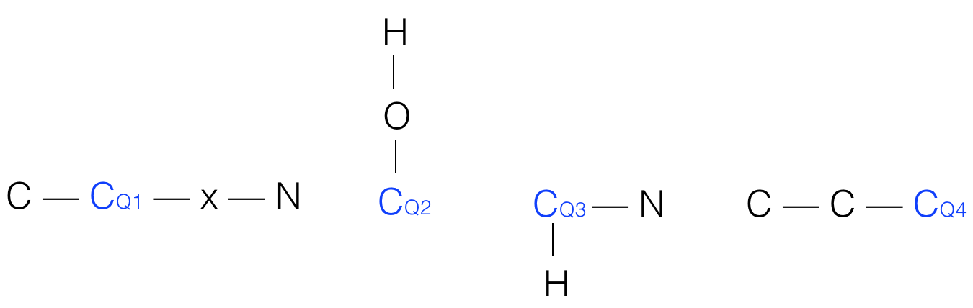

1. There are several sounds around you. How many nitrogen atoms are positioned on the first layer? Please point them out (direction).
2. There are several sounds around you. How many oxygen atoms are positioned on the first layer? Please point them out (direction).
3. There are several sounds around you. How many hydrogen atoms are positioned on the second layer? Please point them out (direction).
4. There are several sounds around you. How many carbon atoms are positioned on the second layer? Please point them out (direction).

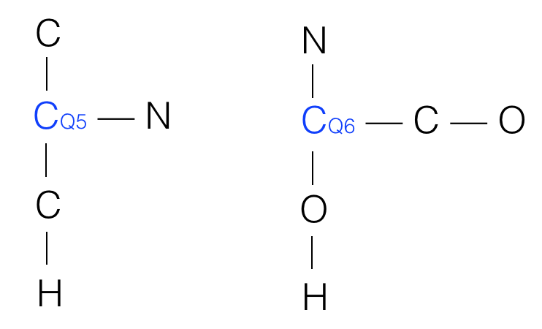 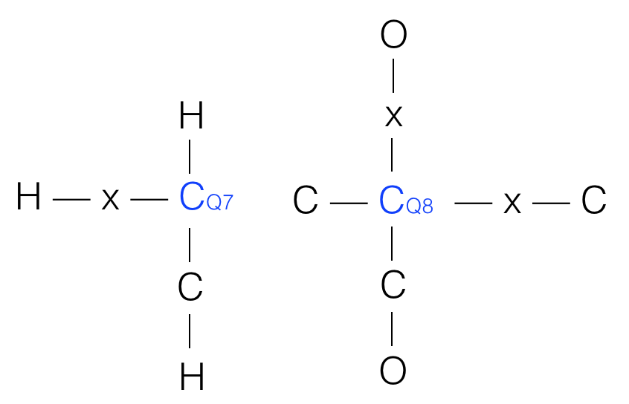

1. There is a carbon atom in front of you, four atoms will be added around you one by one? Please point out their directions, layers and element name.
2. There is a hydrogen atom from your left, four atoms will be added around you one by one? Please point out their directions, layers and element name.
3. There is an oxygen atom from your back, five atoms will be added around you one by one Please point out their directions, layers and element name.
4. There is a nitrogen atom from your right, six atoms will be added around you one by one? Please point out their directions, layers and element name.

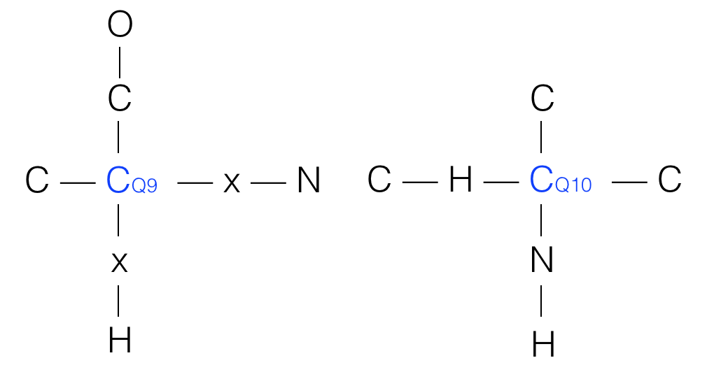 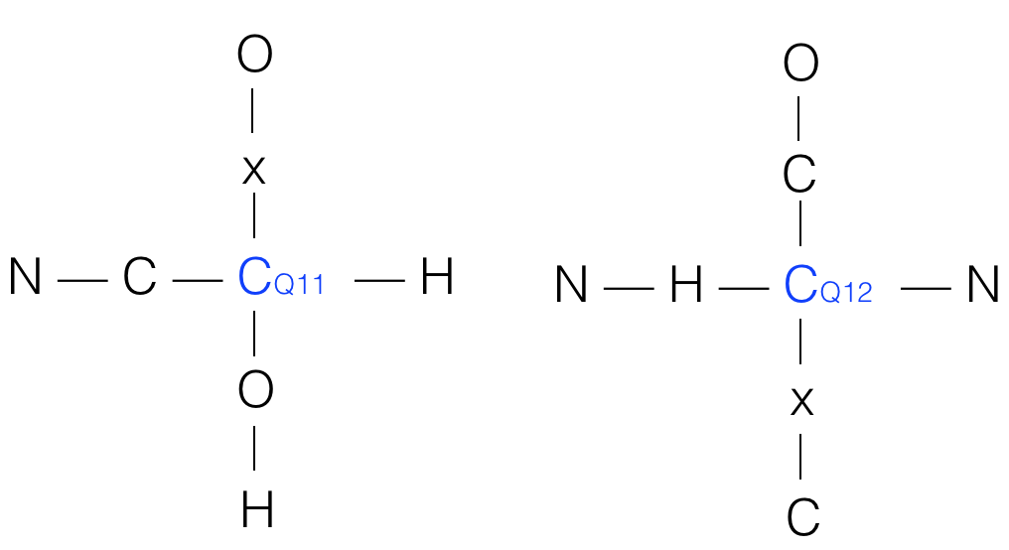

1. You will hear seven sound sources, please point out their directions, layers and name each atom.
2. You will hear six sound sources, please point out their directions, layers and name each atom.
3. You will hear seven sound sources, please point out their directions, layers and name each atom.
4. You will hear seven sound sources, please point out their directions, layers and name each atom.

