**TABLE 5.1 OPTOELECTRONIC PARAMETERS FOR CONFIGURATION 1**

|  |  |  |  |  |
| --- | --- | --- | --- | --- |
| Parameter |  | GaInP2 | GaAs | Ge |
|  |  |  |  |  |
| Bandgap (Eg) |  | 1.9 eV | 1.42 eV | 0.67 eV |
|  |  |  |  |  |
| **Wavelength (λ)** |  | 0.65428e-06 | 0.875e-06 m | 1.775e-06 |
|  |  | m |  | m |
|  |  |  |  |  |
| No of equivalent minima in the conduction |  |  |  |  |
| band (Mc) |  | 1 | 1 | 1 |
|  |  |
|  |  |  |  |  |
|  |  | |  |  |

|  |  |  |  |
| --- | --- | --- | --- |
| No of equivalent minima in the valence band |  |  |  |
| (Mv) | 3 | 1 | 1 |
|  |
|  |  |  |  |
| Electron Mobility (µe) | 0.4 (m2/Vs) | 0.2322 | 0.39 (m2/Vs) |
|  |  | (m2/Vs) |  |
|  |  |  |  |
| Hole mobility (µ h) | 0.02 (m2/Vs) | 0.02 (m2/Vs) | 0.19 (m2/Vs) |
|  |  |  |  |
| me*/me | 0.155 | 0.067 | 1.64 |
|  |  |  |  |
| mh*/mh | 0.460 | 0.473 | 0.28 |
|  |  |  |  |
| Shockley-Read-**Hall lifetime (Ƭ**SRH) | 10-5 (s) | 10-5 (s) | 10-5 (s) |
|  |  |  |  |
| Direct band-band recombination coefficient |  |  |  |
| (B) |  |  |  |
|  | 7.5e-16 | 7.5e-16 | 7.5e-16 |
|  | (s1m3) | (s1m3) | (s1m3) |
|  |  |  |  |
| Acceptor concentration (NA) | 1e23 (m-3) | 9e23 (m-3) | 1e23 (m-3) |
|  |  |  |  |
| Donor concentration (ND) | 2e24 (m-3) | 7.8e23 (m-3) | 2e24 (m-3) |
|  |  |  |  |
| Thickness of p- layer (Xp) | 100e-09 m | 100e-09 m | 100e-09 m |
|  |  |  |  |
| Thickness of n- layer (Xn) | 208e-09 m | 300e-09 m | 400e-09 m |
|  |  |  |  |
| Lattice constant | 5.660e-10 m | 5.659e-10 m | 5.646e-10 m |
|  |  |  |  |

**TABLE 5.2RESULTS FOR DIFFERENT LAYERS FOR CONFIGURATION 1**

|  |  |
| --- | --- |
| **Parameter** | **Values** |
|  |  |

**Top layer GaInP2 (Eg= 1.9 eV)**

Short circuit current density (Jsc1)

744.89 (A/m2)

|  |  |
| --- | --- |
| Open circuit voltage (Voc1) | 1.43 V |

**Middle layer GaAs (Eg=1.42 eV )**

Short circuit current density (Jsc2)

652.39 (A/m2)

Open circuit voltage (Voc2)

1.0415 V

**Bottom layer Ge (Eg= 0.67 eV )**

Short circuit current density (Jsc3)

163.9747 (A/m2)

Open circuit voltage (Voc3)

0.1216 V

**TABLE 5.3TOTAL CELL PARAMETERS FOR CONFIGURATION 1 FOR 1 SUN CONCENTRATION**

**Parameters**

**Value**

Current Density, Jsc

163.9747 (A/m2)

Total open circuit voltage, Voc

Maximum Voltage (Vm)

Maximum Current Density

Fill factor

**Efficiency, Ƞ**

2.5991 V

2.4802 V

162.2754 (A/m2)

0.9444

40.2 %

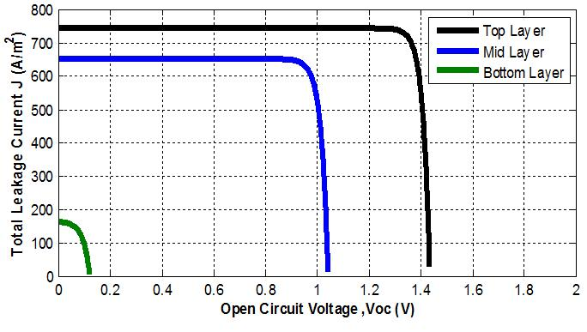

figure 5.4 : J-V characteristics curve for configuration 1 for 1 sun concentration

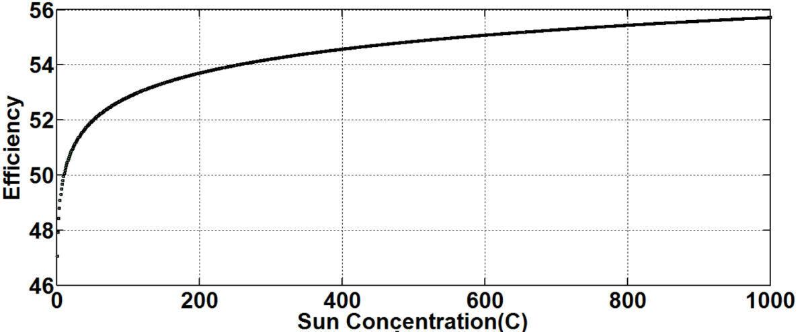

figure 5.5 : Efficiency Vs sun concentration for configuration 1

**TABLE 5.4 OPTOELECTRONIC PARAMETERS FOR CONFIGURATION 2**

|  |  |  |  |
| --- | --- | --- | --- |
| **Parameter** | **GaInP2** | **GaAs** | **GaAs0.91Bi0.085** |
|  |  |  |  |
| Bandgap (Eg) | 1.9 eV | 1.42 eV | 0.7 eV |
|  |  |  |  |
| **Wavelength (λ)** | 0.65428e-06 | 0.875e-06 m | 1.775e-06 m |
|  | m |  |  |
|  |  |  |  |
|  |  |  |  |

|  |  |  |  |
| --- | --- | --- | --- |
| No of equivalent minima in the conduction |  |  |  |
| band (Mc) | 1 | 1 | 1 |
|  |
|  |  |  |  |
| No of equivalent minima in the valence |  |  |  |
| band (Mv) | 3 | 1 | 1 |
|  |
|  |  |  |  |
| Electron Mobility (µe) | 0.4 (m2/Vs) | 0.2322 | 0.12 (m2/Vs) |
|  |  | (m2/Vs) |  |
|  |  |  |  |
| Hole mobility (µ h) | 0.02 (m2/Vs) | 0.02 (m2/Vs) | 0.0019 |
|  |  |  | (m2/Vs) |
|  |  |  |  |
| me*/me | 0.155 | 0.067 | 1.64 |
|  |  |  |  |
| mh*/mh | 0.460 | 0.473 | 0.044 |
|  |  |  |  |
| Shockley-Read-Hall lifetime **(Ƭ**SRH) | 10-5 (s) | 10-5 (s) | 10-5 (s) |
|  |  |  |  |
| Direct band-band recombination coefficient |  |  |  |
| (B) |  |  | 7.5e-16 (s1m3) |
|  | 7.5e-16 | 7.5e-16 |
|  | (s1m3) | (s1m3) |  |
|  |  |  |  |
| Acceptor concentration (NA) | 1e23 (m-3) | 9e23 (m-3) | 2e24(m-3) |
|  |  |  |  |
| Donor concentration (ND) | 2e24 (m-3) | 7.8e23 (m-3) | 4.4e25(m-3) |
|  |  |  |  |
| Thickness of p- layer (Xp) | 100e-09 m | 100e-09 m | 500e-09 m |
|  |  |  |  |
| Thickness of n- layer (Xn) | 208e-09 m | 300e-09 m | 100e-09 m |
|  |  |  |  |
| Lattice constant | 5.660e-10 m | 5.659e-10 m | 5.655e-10 m |
|  |  |  |  |

**TABLE 5.5RESULTS FOR DIFFERENT LAYERS FOR CONFIGURATION 2**

|  |  |
| --- | --- |
| **Parameter** | **Values** |
|  |  |
| **Top layer GaInP2 (Eg= 1.9 eV)** | |
|  |  |
| Short circuit current density (Jsc1) |  |
|  | 744.8989 (A/m2) |
|  |  |
| Open circuit voltage (Voc1) |  |
|  | 1.4360 V |
|  |  |
| **Middle layer GaAs (Eg=1.42 eV )** | |
|  |  |
| Short circuit current density (Jsc2) |  |
|  | 652.3479 (A/m2) |
|  |  |
| Open circuit voltage (Voc2) |  |
|  | 1.0415V |
|  |  |
| **Bottom layer GaAs0.91Bi0.085 (Eg= 0.7 eV )** | |
|  |  |
| Short circuit current density (Jsc3) |  |
|  | 163.9175 (A/m2) |
|  |  |
| Open circuit voltage (Voc3) |  |
|  | 0.2794V |
|  |  |

**TABLE 5.6 TOTAL CELL PARAMETER FOR CONFIGURATION 2 FOR SUN CONENTRATION 1**

|  |  |  |
| --- | --- | --- |
| **Parameters** |  | **Value** |
|  |  |  |
| Current Density, Jsc |  | 163.9747 (A/m2) |
|  |  |  |
| Total open circuit voltage, Voc |  | 2.7569 V |
|  |  |  |
| Maximum Voltage (Vm) |  | 2.6365 V |
|  |  |  |
| Maximum Current Density |  | 162.3761 (A/m2) |
|  |  |  |
| Fill factor |  | 0.9470 |
|  |  |  |
| **Efficiency, Ƞ** |  | 42.8 % |

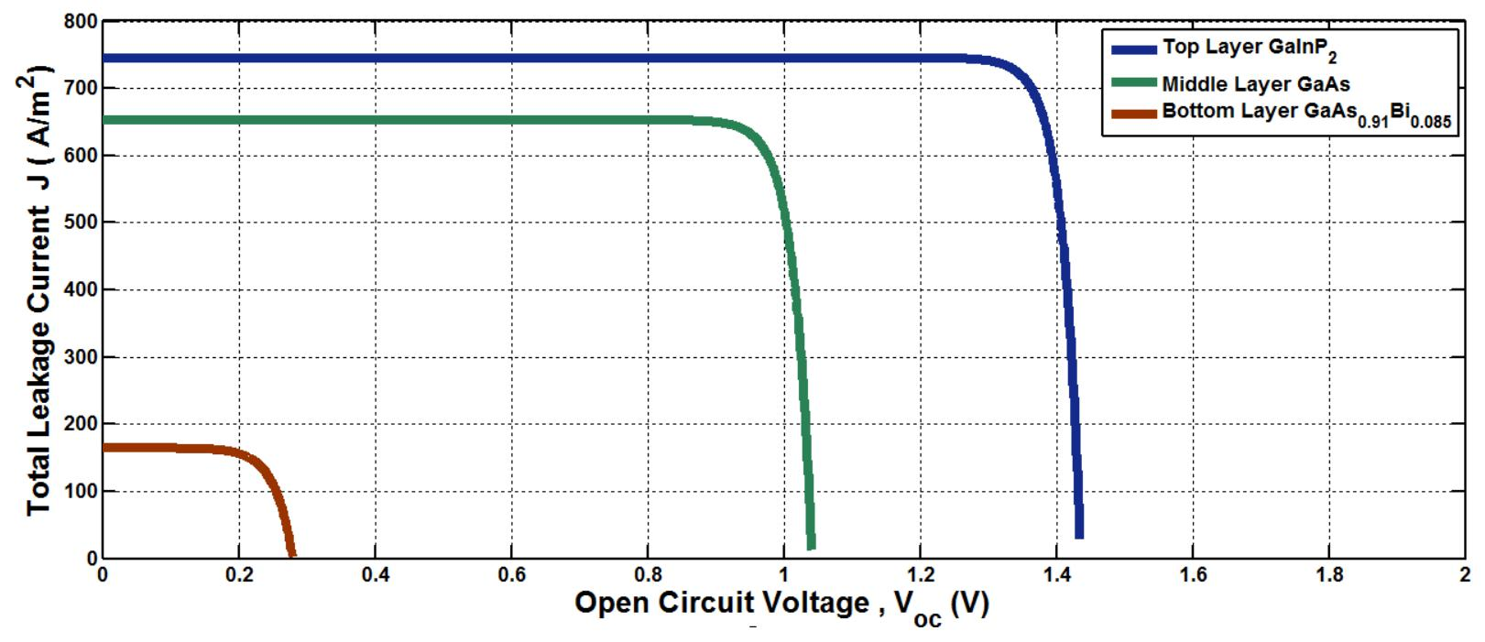

figure 5.7 : J-V characteristics curve for configuration 2 for 1sun concentration

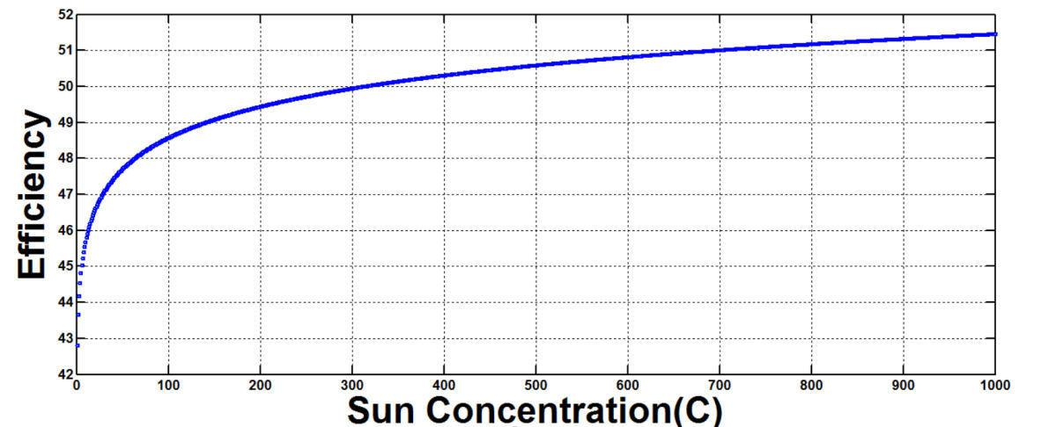

figure 5.8 : Efficiency Vs sun concentration curve for configuration 2

**TABLE 5.7** **OPTOELECTRONIC PARAMETERS FOR CONFIGURATION 3**

|  |  |  |  |
| --- | --- | --- | --- |
| **Parameter** | **AlAs** | **GaAs** | **GaAs0.91Bi0.085** |
|  |  |  |  |
| Bandgap (Eg) | 2.17 eV | 1.42 eV | 0.7 eV |
|  |  |  |  |
| **Wavelength (λ)** | 0.5730e-06 | 0.875e-06 | 1.775e-06 m |
|  | m | m |  |
|  |  |  |  |
| No of equivalent minima in the |  |  |  |
| conduction band (Mc) | 1 | 1 | 1 |
|  |
|  |  |  |  |
| No of equivalent minima in the |  |  |  |
| valence band (Mv) | 1 | 1 | 1 |
|  |
|  |  |  |  |
|  | 91 |  |  |

|  |  |  |  |  |  |
| --- | --- | --- | --- | --- | --- |
| Electron Mobility (µ e) | |  | 0.02 | 0.2322 | 0.12 (m2/Vs) |
|  |  |  | (m2/Vs) | (m2/Vs) |  |
|  | |  |  |  |  |
| Hole mobility (µ h) | |  | 0.01 | 0.02 | 0.0019 |
|  |  |  | (m2/Vs) | (m2/Vs) | (m2/Vs) |
|  |  |  |  |  |  |
| me*/me |  |  | 0.146 | 0.067 | 1.64 |
|  |  |  |  |  |  |
| mh*/mh |  |  | 0.760 | 0.473 | 0.044 |
|  | | |  |  |  |
| Shockley-Read-**Hall lifetime (Ƭ**SRH) | | | 10-5 (s) | 10-5 (s) | 10-5 (s) |
|  |  |  |  |  |  |
| Direct | band-band | recombination |  |  |  |
| coefficient (B) | |  | 7.5e-16 | 7.5e-16 | 7.5e-16 (s1m3) |
|  |  |  |
|  |  |  | (s1m3) | (s1m3) |  |
|  | | |  |  |  |
| Acceptor concentration (NA) | | | 1.7e24 (m-3) | 9e23 (m-3) | 2e24(m-3) |
|  | | |  |  |  |
| Donor concentration (ND) | | | 1.5e24 (m-3) | 7.8e23 (m-3) | 4.4e25(m-3) |
|  | | |  |  |  |
| Thickness of p- layer (Xp) | | | 100e-09 m | 100e-09 m | 500e-09 m |
|  | | |  |  |  |
| Thickness of n- layer (Xn) | | | 208e-09 m | 300e-09 m | 100e-09 m |
|  | |  |  |  |  |
| Lattice constant | |  | 5.633e-10 | 5.659e-10 m | 5.655e-10 m |
|  |  |  | m |  |  |
|  |  |  |  |  |  |

**TABLE 5.8 RESULTS FOR DIFFERENT LAYERS FOR CONFIGURATION 3**

|  |  |
| --- | --- |
| **Parameter** | **Values** |
|  |  |
| **Top layer AlAs(Eg= 2.17 eV)** | |
|  |  |
| Short circuit current density (Jsc1) |  |
|  | 700.5292 (A/m2) |
|  |  |
| Open circuit voltage (Voc1) |  |
|  | 1.6997V |
|  |  |
| **Middle layer GaAs (Eg=1.42 eV )** | |
|  |  |
| Short circuit current density (Jsc2) |  |
|  | 652.3479 (A/m2) |
|  |  |
| Open circuit voltage (Voc2) |  |
|  | 1.0415V |
|  |  |
| **Bottom layer GaAs0.91Bi0.085 (Eg= 0.7 eV )** | |
|  |  |
| Short circuit current density (Jsc3) |  |
|  | 163.9175 (A/m2) |
|  |  |
| Open circuit voltage (Voc3) |  |
|  | 0.2794V |
|  |  |