2.Discuss the progress you have made on your project so far. (400 words)

I’m going to promote a previous visualization and add three new ones. First of all, I made a whole construction to mix them up. Then I can focus on the details of my works.

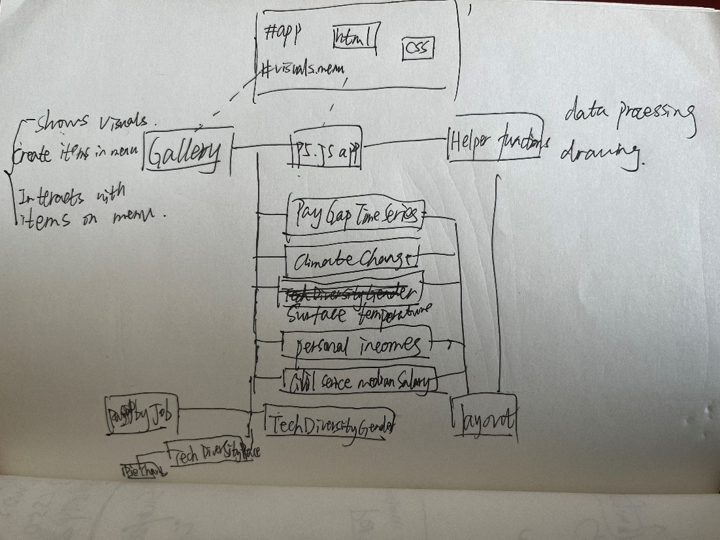

Graph 1-App construction

I hand-drawn the visualizations that will be tweaked in the future.

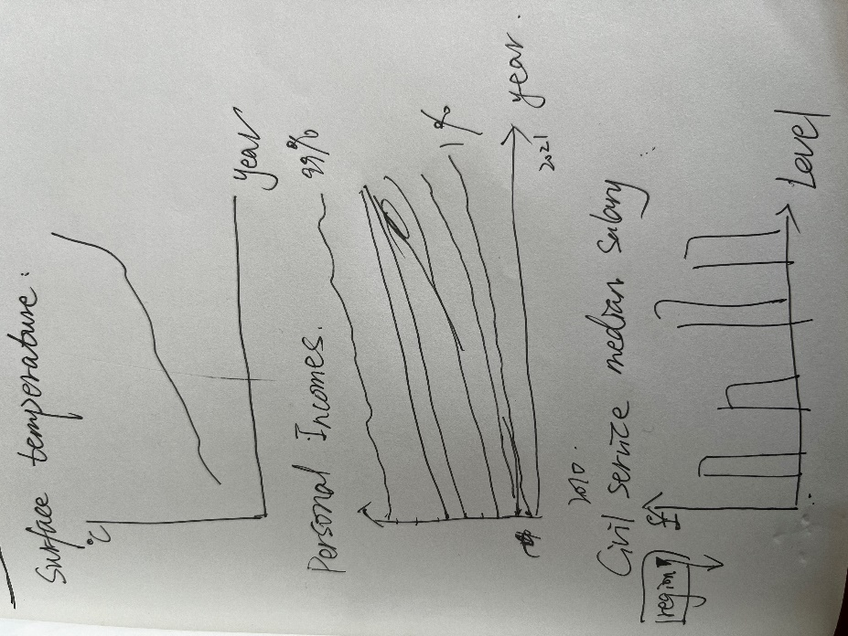

Graph 2-visuals1

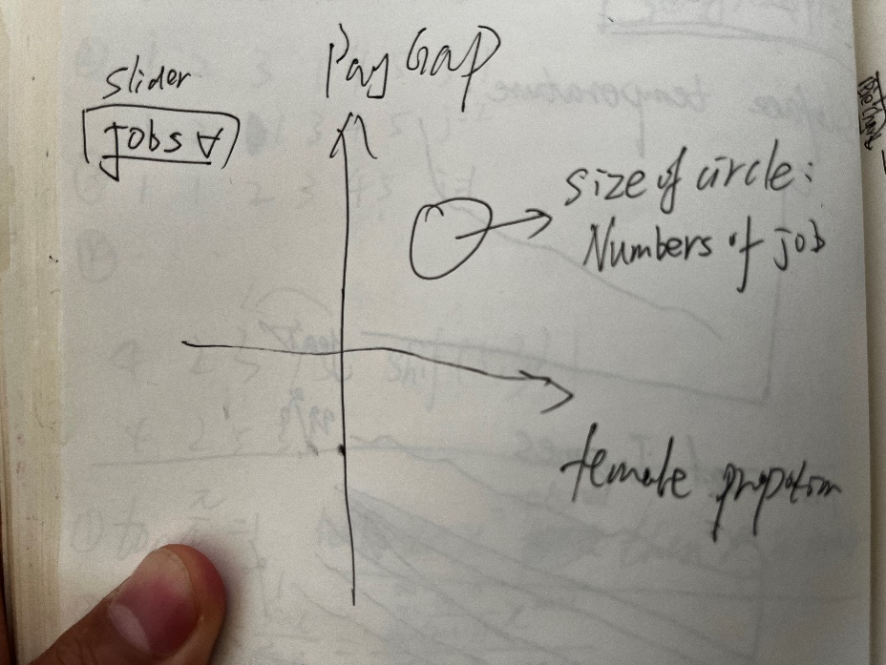

Graph 3-Visuals2

In terms of the progress, I have finished two new visualizations so far, which are ‘surface temperature’ and ‘personal incomes’. Part of the code and display is below.

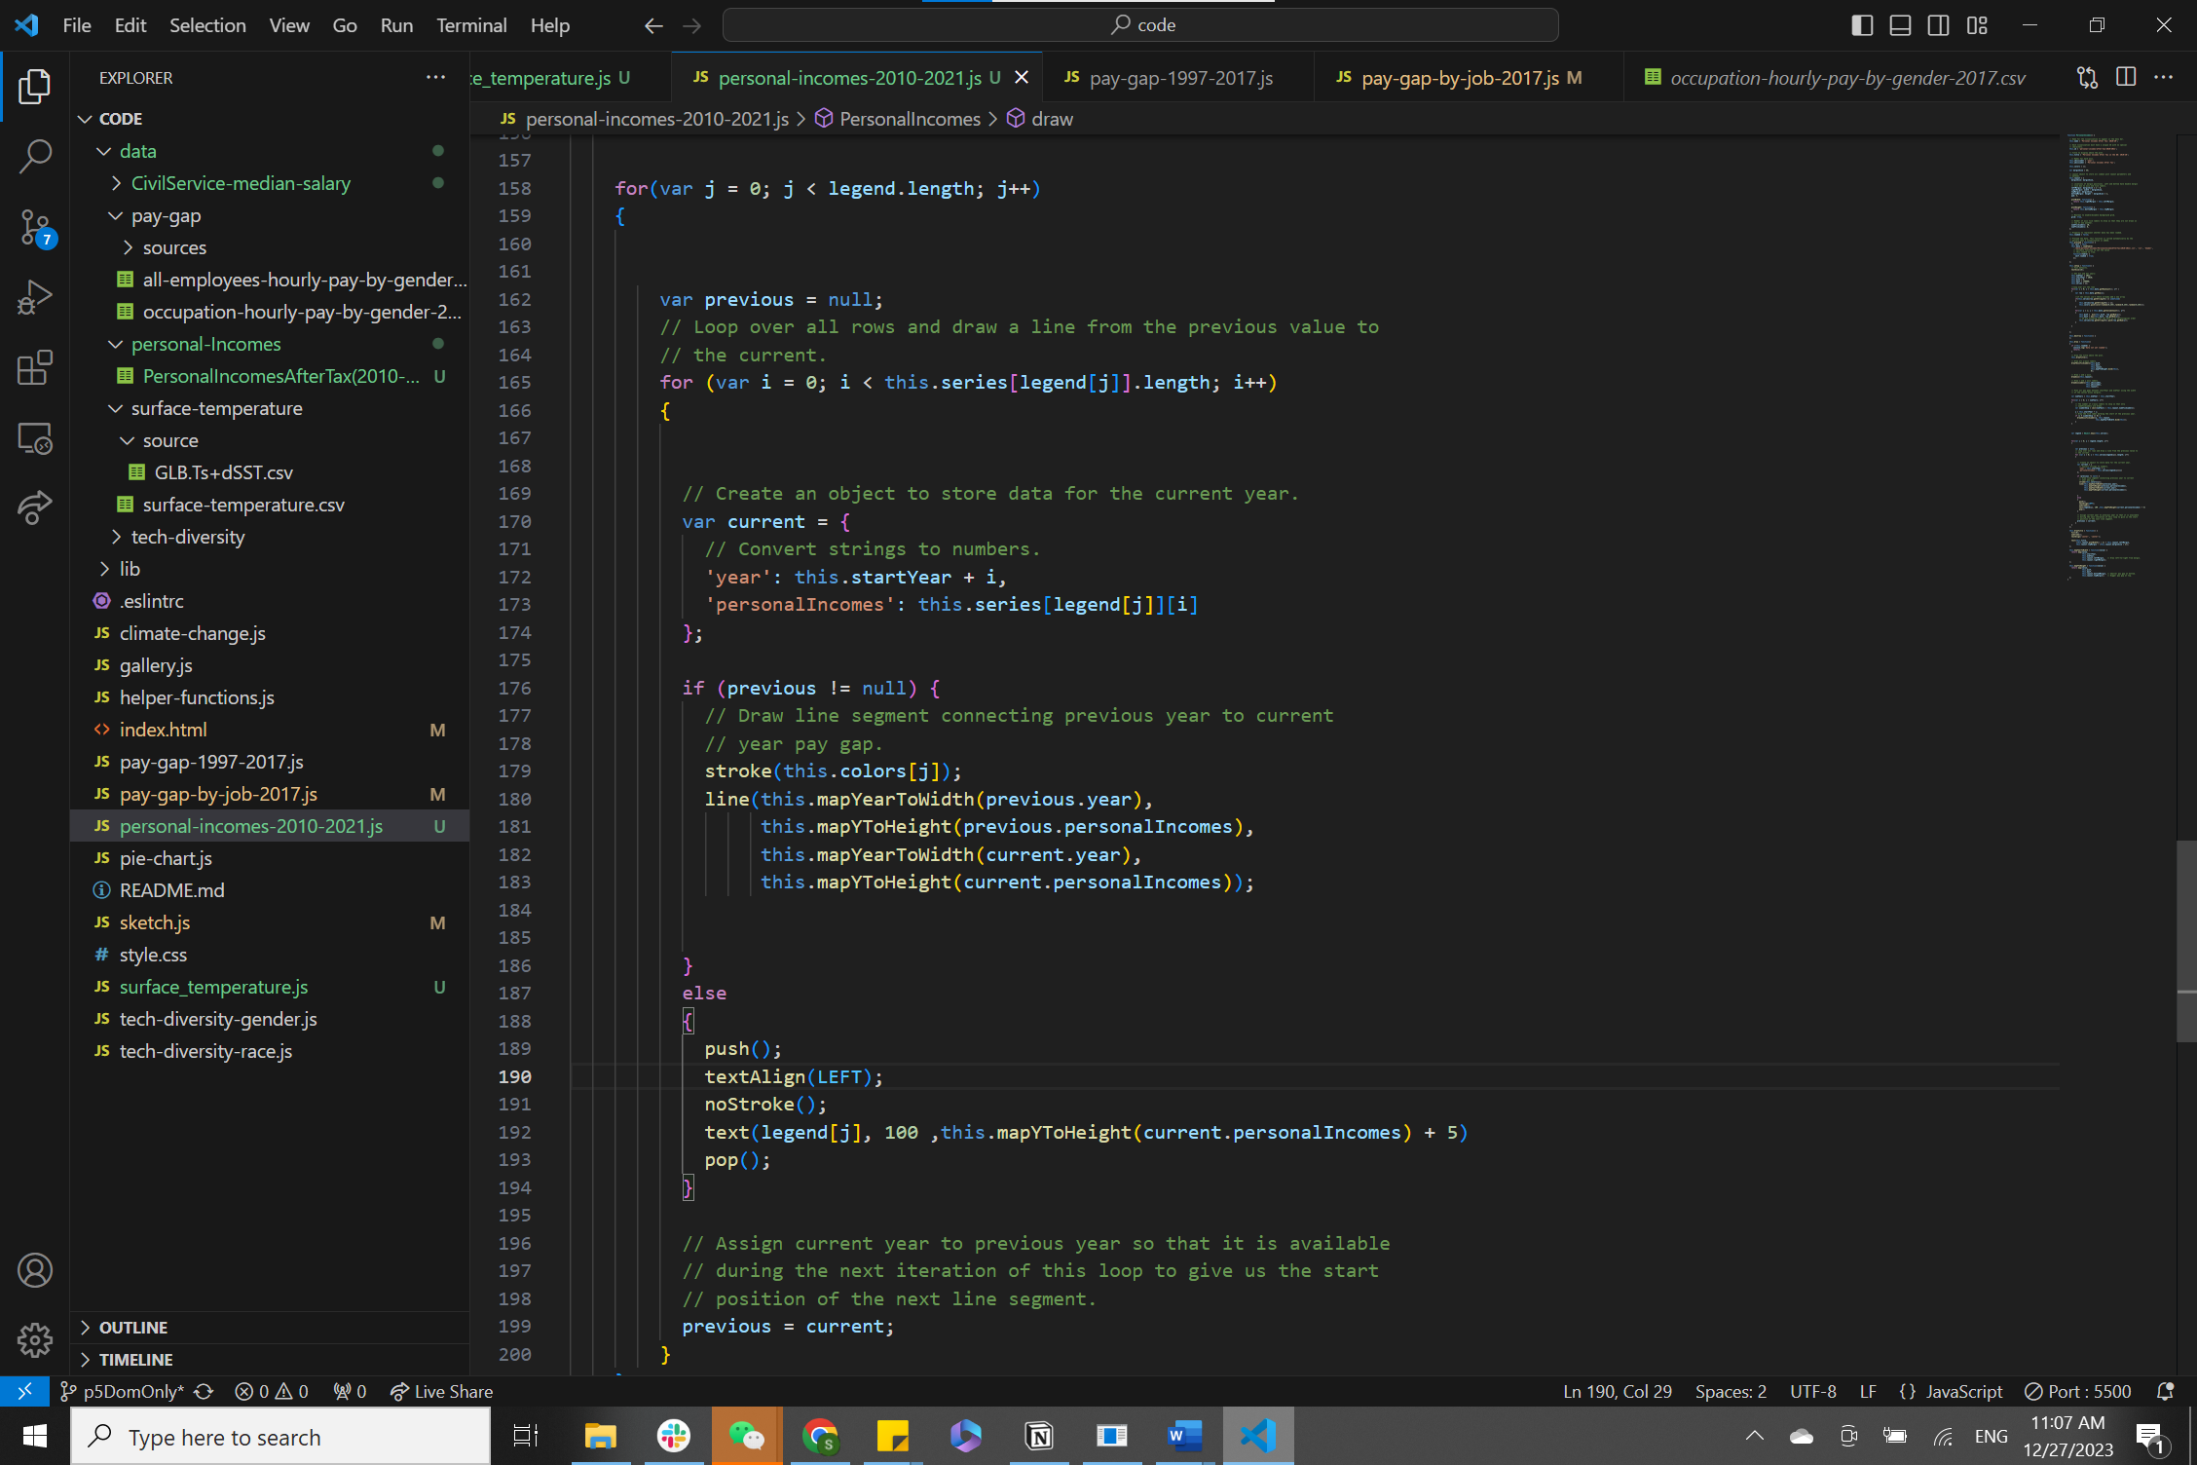

Graph 4- code screenshots1

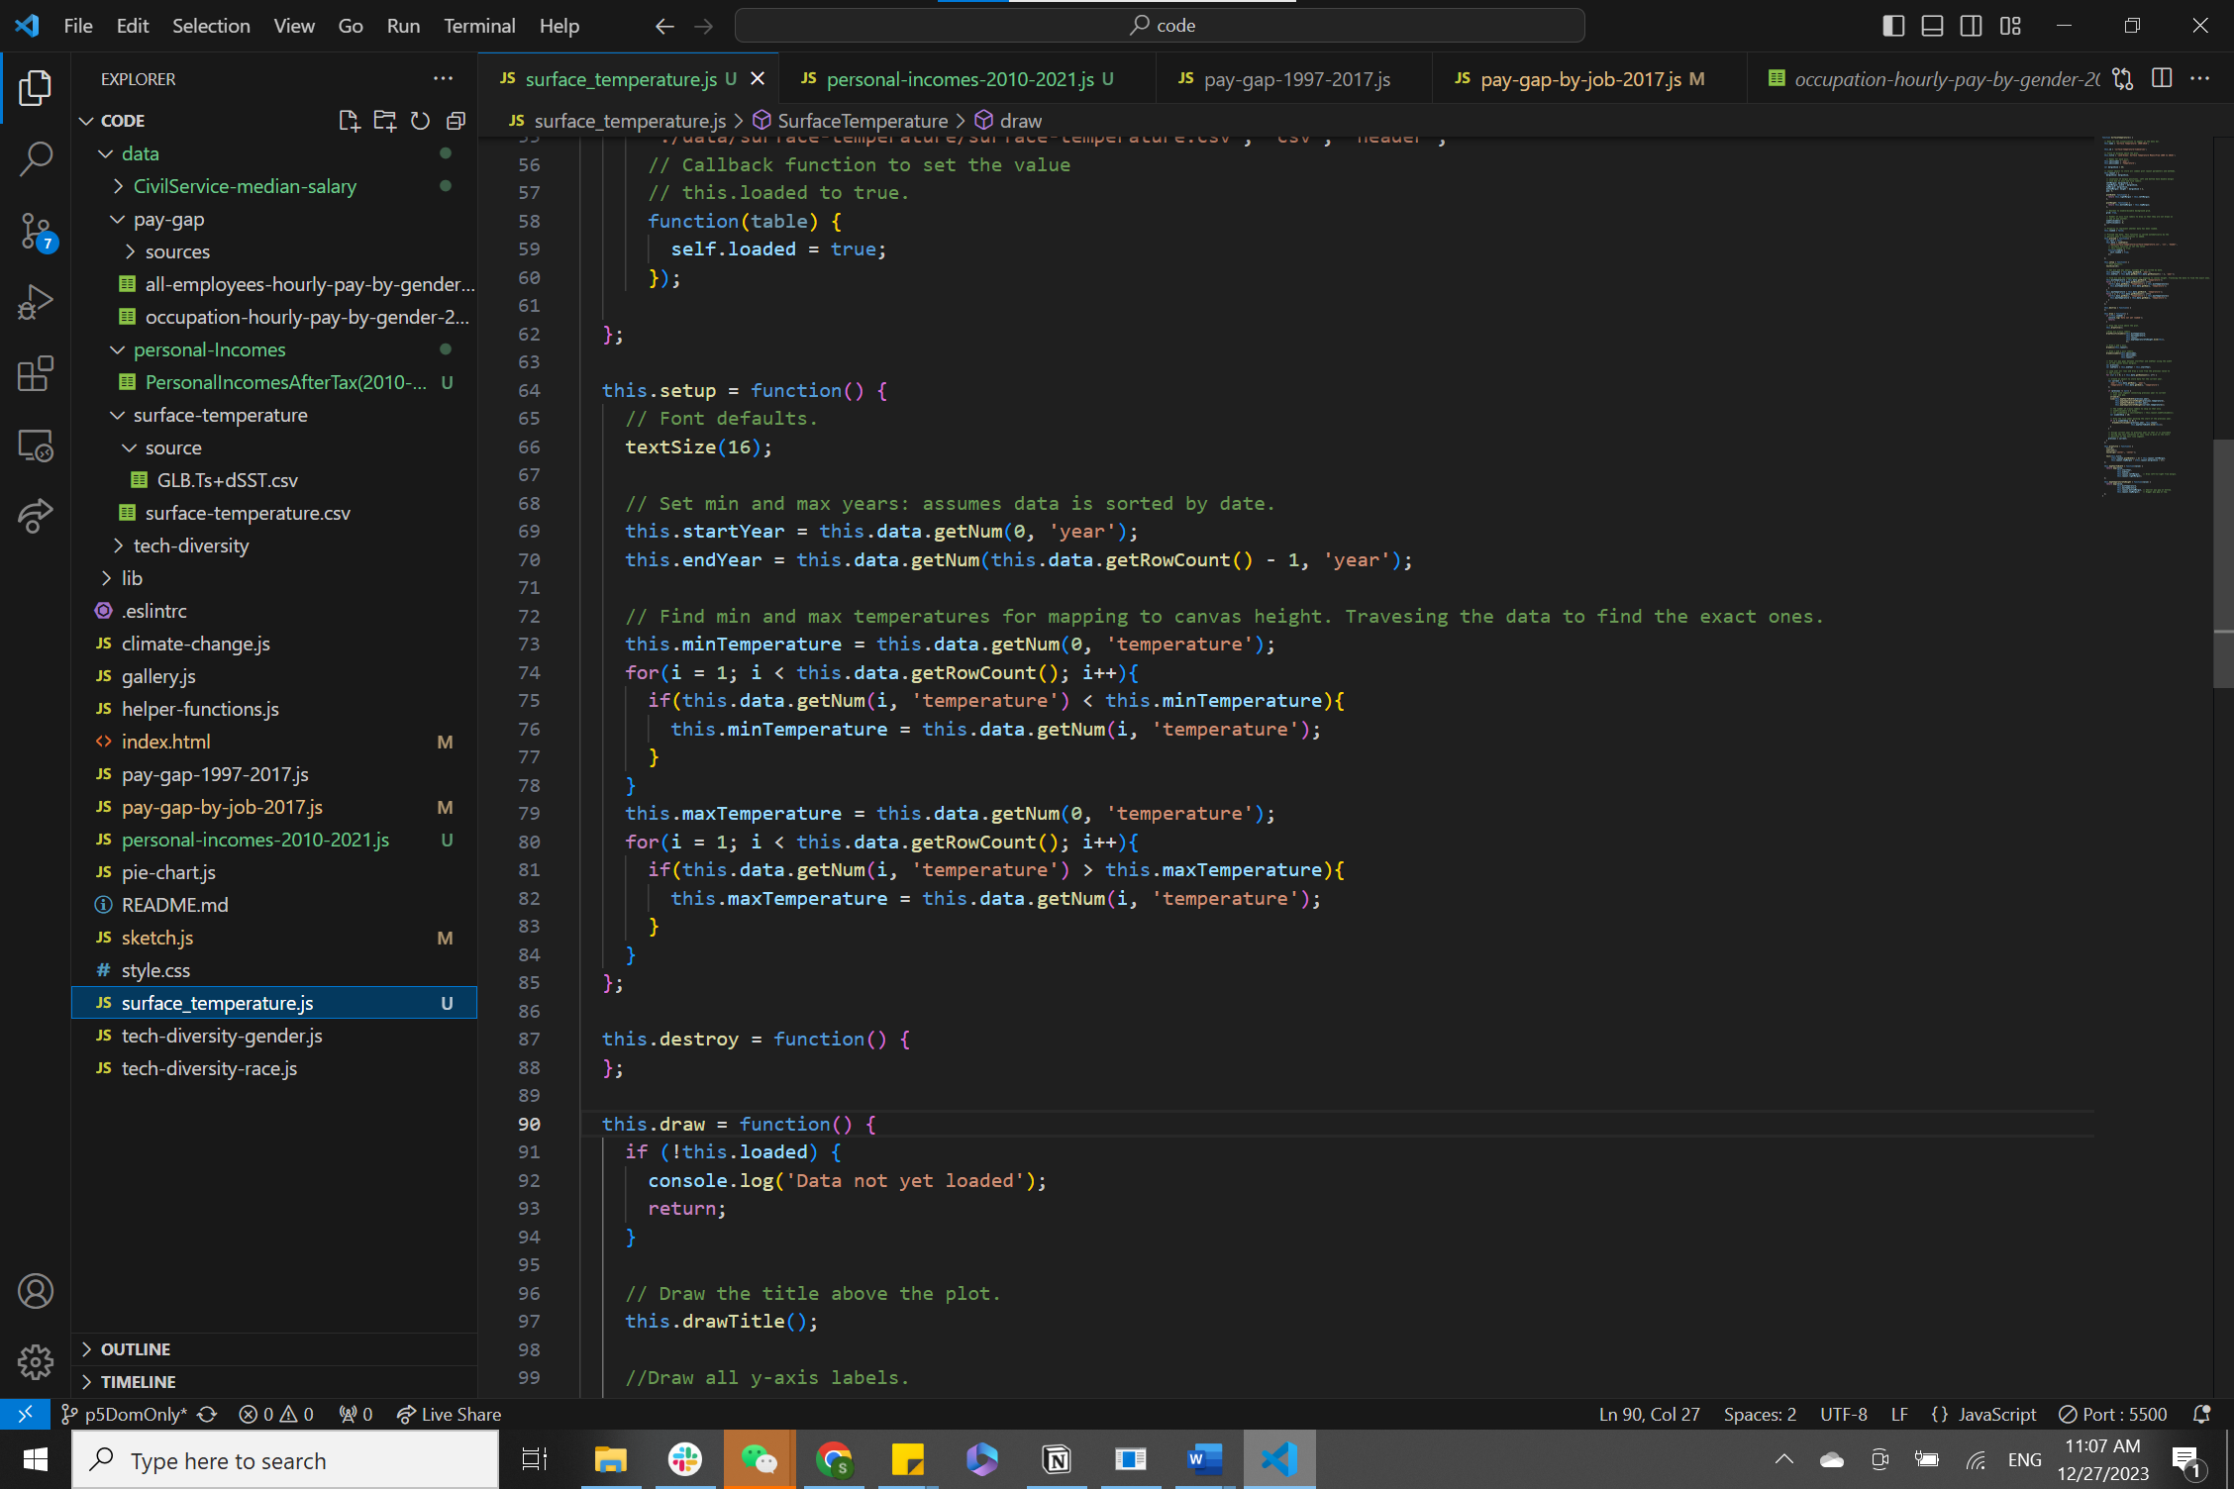

Graph 5 - code screenshots2

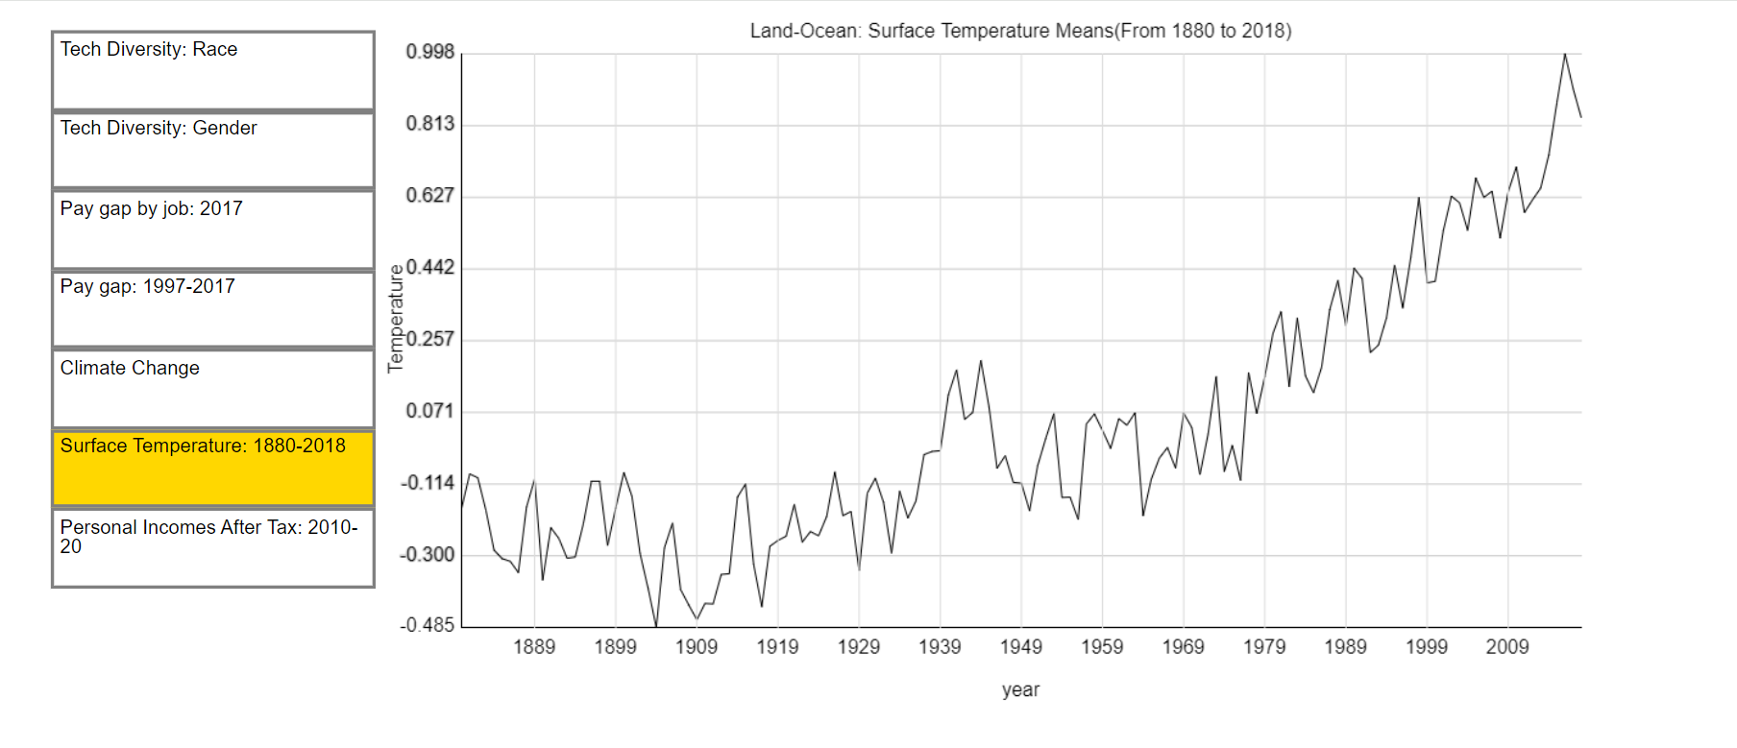

Graph 6 - App Appearance1

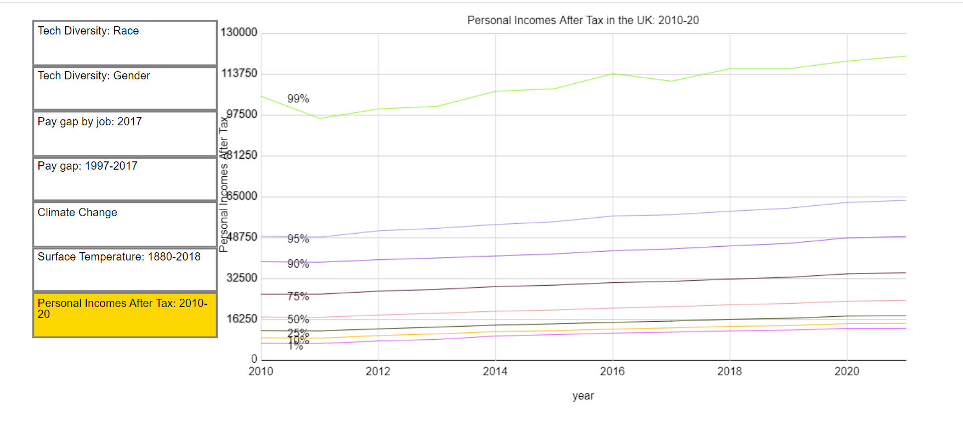

Graph 7 - App Appearance2

Next, I’m going to finished the ‘CivilServiceMedianSalary’ extension and do the promotion of ‘Pay gap by job:2017”. For the last extension, I hope to introduce a new element: a bar chart, and combine it with the slider and other knowledge learned before to show users a visual case that is readable and easy to understand.