Homework 4

# Question 1

We want to normalize

$$\frac{1}{2}\left|00\right\rangle -\frac{1}{2}\left|01\right\rangle$$

So, we get the new state

$$\frac{\left(\frac{1}{2}\left|00\right\rangle -\frac{1}{2}\left|01\right\rangle \right)}{\sqrt{{\left(\frac{1}{2}\right)}^{2}+{\left(-\frac{1}{2}\right)}^{2}}}=\frac{1}{\sqrt{2}}\left|00\right\rangle -\frac{1}{\sqrt{2}}\left|01\right\rangle$$

# Question 2

$$H^{⊗3}\left|101\right\rangle =\left(H\left|1\right\rangle \right)⊗\left(H\left|0\right\rangle \right)⊗\left(H\left|1\right\rangle \right)=\left(\frac{1}{\sqrt{2}}\left(\left|0\right\rangle -\left|1\right\rangle \right)\right)⊗\left(\frac{1}{\sqrt{2}}\left(\left|0\right\rangle +\left|1\right\rangle \right)\right)⊗\left(\frac{1}{\sqrt{2}}\left(\left|0\right\rangle -\left|1\right\rangle \right)\right)={\left(\frac{1}{\sqrt{2}}\right)}^{3}\left(\left|0\right\rangle -\left|1\right\rangle \right)⊗\left(\left|0\right\rangle +\left|1\right\rangle \right)⊗\left(\left|0\right\rangle -\left|1\right\rangle \right)={\left(\frac{1}{\sqrt{2}}\right)}^{3}\left(\left|000\right\rangle -\left|001\right\rangle +\left|010\right\rangle -\left|011\right\rangle -\left|100\right\rangle +\left|101\right\rangle -\left|110\right\rangle +\left|111\right\rangle \right)\text{=}\left(\frac{1}{\sqrt{8}}\right)\left(\left|000\right\rangle -\left|001\right\rangle +\left|010\right\rangle -\left|011\right\rangle -\left|100\right\rangle +\left|101\right\rangle -\left|110\right\rangle +\left|111\right\rangle \right)$$

The probability to get $\left|?11\right\rangle$ is then ${\left(\frac{1}{\sqrt{8}}\right)}^{2}\left({\left(-1\right)}^{2}+1^{2}\right)=\frac{1}{4}$

# Question 3

Three Hadamard together matrix:

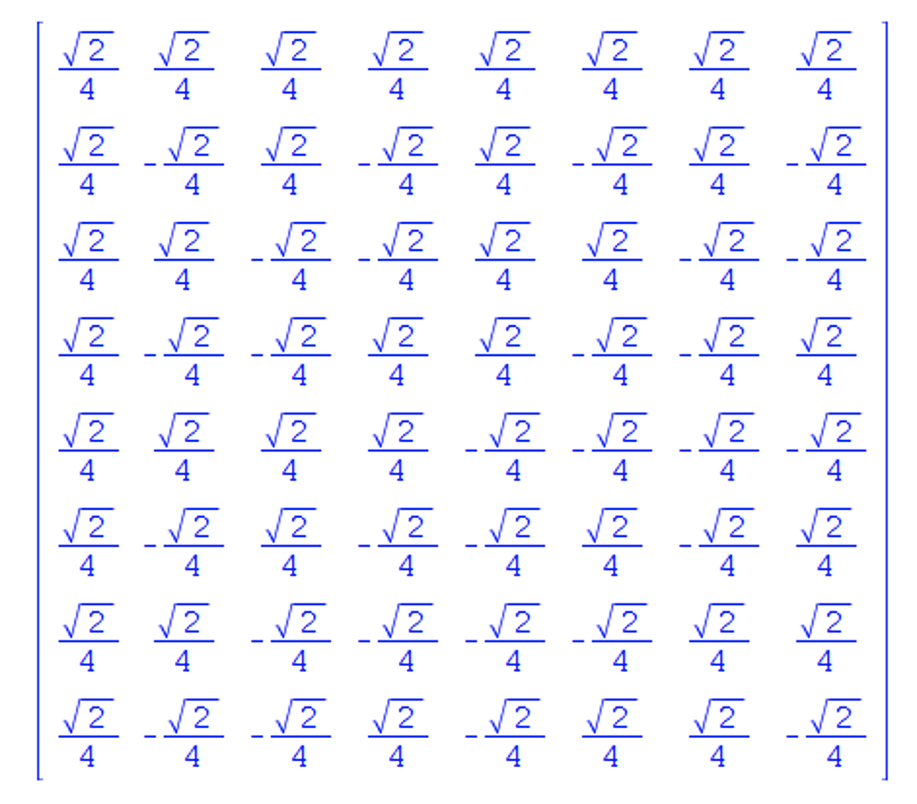

Control-Z on first two qubits:

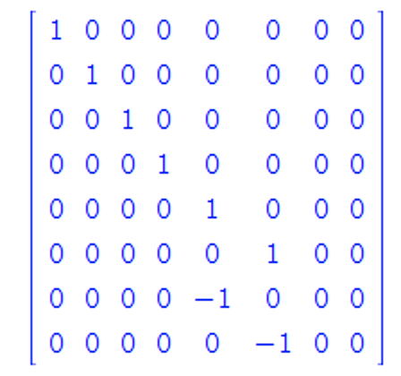

Control-Z on first and third qubits:

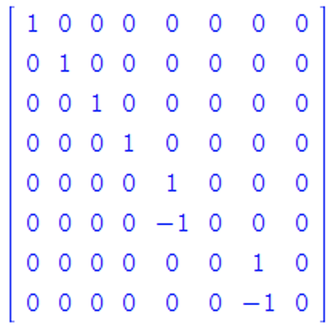

Hadamard on second and third qubits:

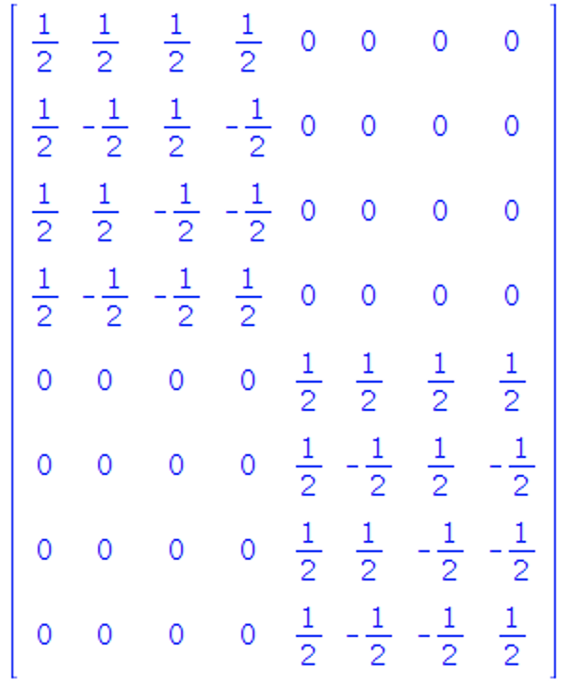

So, applying the circuit on $\left|000\right\rangle =\left(\begin{matrix}1 \\ 0 \\ 0 \\ 0 \\ 0 \\ 0 \\ 0 \\ 0\end{matrix}\right)$, we get $\left(\begin{matrix}\frac{\sqrt{2}}{2} \\ 0 \\ 0 \\ 0 \\ 0 \\ 0 \\ 0 \\ \frac{\sqrt{2}}{2}\end{matrix}\right)=\frac{\sqrt{2}}{2}\left|000\right\rangle +\frac{\sqrt{2}}{2}\left|111\right\rangle$

So, the probability of getting $\left|111\right\rangle$ is $\frac{1}{2}$.

# Question 4

Suppose we measure the qubit with index 0 in the standard basis. What is the probability

of getting 0, and if that happens, what is the state of the other qubit?

Probability is ${\left(-\frac{1}{2}\right)}^{2}=\frac{1}{4}$

The other states vanish. Meaning that we are now at just state $|10⟩$

Also, suppose we measure the qubit with index 1 in the standard basis. What is the probability of getting 1, and if that happens, what is the state of the other qubit?

Probability is ${\left(-\frac{1}{2}\right)}^{2}+{\left(\frac{1}{\sqrt{2}}\right)}^{2}=\frac{1}{4}+\frac{1}{2}=\frac{3}{4}$

The other states vanish. Now are at state $-\frac{1}{2}\left|10\right\rangle +\frac{1}{\sqrt{2}}\left|11\right\rangle \underset{→}{\text{normalize}}\left(\frac{2}{\sqrt{3}}\right)\left(-\frac{1}{2}\left|10\right\rangle +\frac{1}{\sqrt{2}}\left|11\right\rangle \right)$