ENGLISH VERSION
Business Case Study: Hotel Profitability & Corporate Segment Strategy
An 8-room corporate hotel in Bishkek
Amir Erjan; Data: owner interview, not audited
≈193k  owner profit a month  ≈2.2k USD · after rent, all costs and single tax | 24%  margin after single tax  reported 25%; bottom-up 24.1% | ≈69%  break-even occupancy after tax  on reported revenue; safety margin ≈25 points to today's 94% (≈64% at list ADR) | ≈4×  annual return on capital invested  ≈0.55M invested (200k refurbishment + 350k deposit); profit ≈2.3M a year; owner's labour unpaid, cash cushion not counted

On ≈0.55M som invested the hotel earns ≈2.3M a year, but all of that value rests on a lease that must be renewed in 3 years; at 94% occupancy the only free growth lever is price.
1.8×  Rent vs owner profit  Rent takes 4.2M a year, the owner keeps 2.3M. Each +1% of rent costs 3.5k a month. | ≈7.3k  1% of price ≈ 1 point of occupancy  Both are worth 7.3–7.6k of profit a month; at 94% there is no volume left to add, so price is the free lever. | −18%  Rent +10% hits profit  A +10% rent reset would cost 35k a month, 18% of owner profit (Section 5).

What to do. Protect the rent first (a reset of +5-10% would cost 0.6-1.3M over 3 years), then raise price on the 23% of nights outside contracts, sell Booking.com only on dates that corporate demand does not fill, and reprice contracts at each prolongation. The base programme adds ≈14.5k a month of operating profit; contract repricing adds ≈16k more. One-off cost is ≈180k som (estimate).

1. The business earns ≈4× its invested capital a year, but it rests on one lease
Rent of 350k som is 43.8% of revenue and 1.8 times the owner's profit.
The rent is fixed, with no indexation for the first 5 years, but the term is 3 years with renewal. The building's owner funded about 70M som and bears all CapEx (facade, roof, engineering systems). The tenant invested about 200k som in refurbishment, paid back within the first year, and placed a deposit of one month of rent (350k). The owner reported a 3-year term and no indexation for the first 5 years; how years 4-5 are protected was not clarified, so the end of the 3-year term is treated as the risk point.
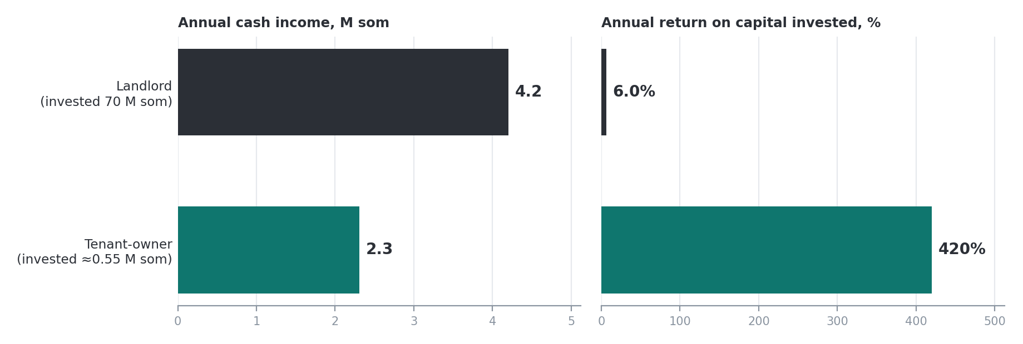
Landlord versus tenant-owner: annual cash income and annual return on capital invested.
 | Landlord | Tenant-owner
Capital invested | 70M som | ≈0.55M som (200k refurbishment + 350k deposit)
Annual cash income | 4.2M som (rent 350k × 12) | ≈2.3M som (192.5k × 12, after single tax; owner's labour unpaid)
Annual return on capital | 6.0% gross yield | ≈4.2× (420%)
Capital back from income | 16.7 years | ≈3 months
Main exposure | CapEx on the building | Renewal: each +1% of rent = −3.5k a month; +10% = −35.0k (18% of profit)

Note on the 4.2×: it excludes the owner's unpaid labour (with a manager at 60k som it would be ≈2.9×) and the one-month cash cushion of 350–600k som (counting the cushion gives ≈2.0–2.6×).
Lever 1: protect the rent. Negotiating a longer term and a cap on indexation costs no capital. If the alternative is a reset of +5-10%, protection is worth 17.5-35.0k a month, or 0.6-1.3M som over 3 years (assumption: the size of the reset). A +10% rent would cut the tenant's return from 4.2× to 3.4×: the business stays attractive, but the owner's profit falls by 18%.

2. Only 24 of every 100 som reach the owner; 76 are committed first
Rent, payroll and electricity are fixed and take 65% of revenue, so profit depends on holding occupancy and price.
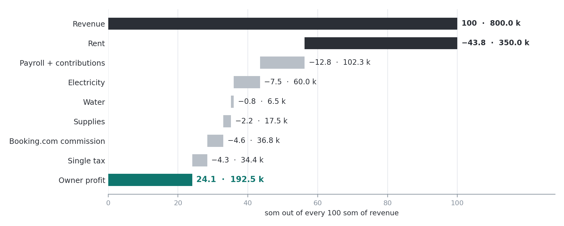
Where each 100 som of revenue goes, with monthly amounts in k som (average month).
Costs of 573.1k and the single tax of 34.4k leave 192.5k (24.1%); the reported 25% (≈200k) agrees within rounding, and before the single tax the margin is ≈29%. After the 5% FF&E reserve the owner keeps 152.5k. Supplies are the midpoint of 15-20k (assumption: monthly); the single tax is a blended 4.3% (assumption: 15% of receipts in cash; 6% on cash, 4% on non-cash). USD at 87.45 som (21 Oct 2026). Payroll and contributions are carried at 102.3k a month. The owner also reported a social-fund rate of 12.25% without saying whether the 100k payroll includes it; if it is added on top (≈12.3k), owner profit would be ≈182k (≈22.8%). The reported 25% margin is closer to the base case, so the base case is kept. Electricity is the reported monthly average of 60k; in heating months it reaches 100k (Section 5).
Channel | Share of nights | Terms
Corporate contracts | 77-80% | About 50 one-year contracts with prolongation; fixed prices, no discounts or commissions. Two mobile operators together are about 8% of occupancy.
Booking.com | ≈20% | Commission 23% = 36.8k a month.
Social media | ≈3% | No commission; direct bookings are almost none.

Unit economics
Line | Value | Unit
Per sold night, at reported ADR |  | som
Price (ADR) | 3,755 | som
Supplies | -77 | som
Booking.com commission, average | -173 | som
Contribution before single tax | 3,505 | som
Single tax (4.3%) | -161 | som
Contribution after single tax | 3,344 | som
Fixed costs per sold night | -2,268 | som
Profit per night at reported ADR | 1,076 | som
Reconciliation to reported revenue (×0.931) | -234 | som
Owner profit per sold night | 842 | som
Per room a month |  | k som
Revenue | 100.0 | k som
Costs | -71.6 | k som
Single tax | -4.3 | k som
Owner profit per room | 24.1 | k som

3. At 94% occupancy, price is the only free lever
One percent of price is worth almost exactly one point of occupancy, and only price can still move.
Unit of change | Formula (k som a month, after commission and single tax) | Profit
+1% price | 800 × 1% × (1 - 8.9%) | +7.3
+1 point of occupancy | 800 / 94 × (1 - 8.9%) - 17.5 / 94 | +7.6

Going from 94% to 100% would add only 6.4% volume, and practical headroom is 1-2 points (assumption). Prices are set by hand in a 3,500-4,000 corridor (14% spread) although weekends and city events already fill the hotel, and sustained occupancy above about 90% usually signals under-pricing. The average stay is 2 nights, while stays from 3 nights are more profitable.
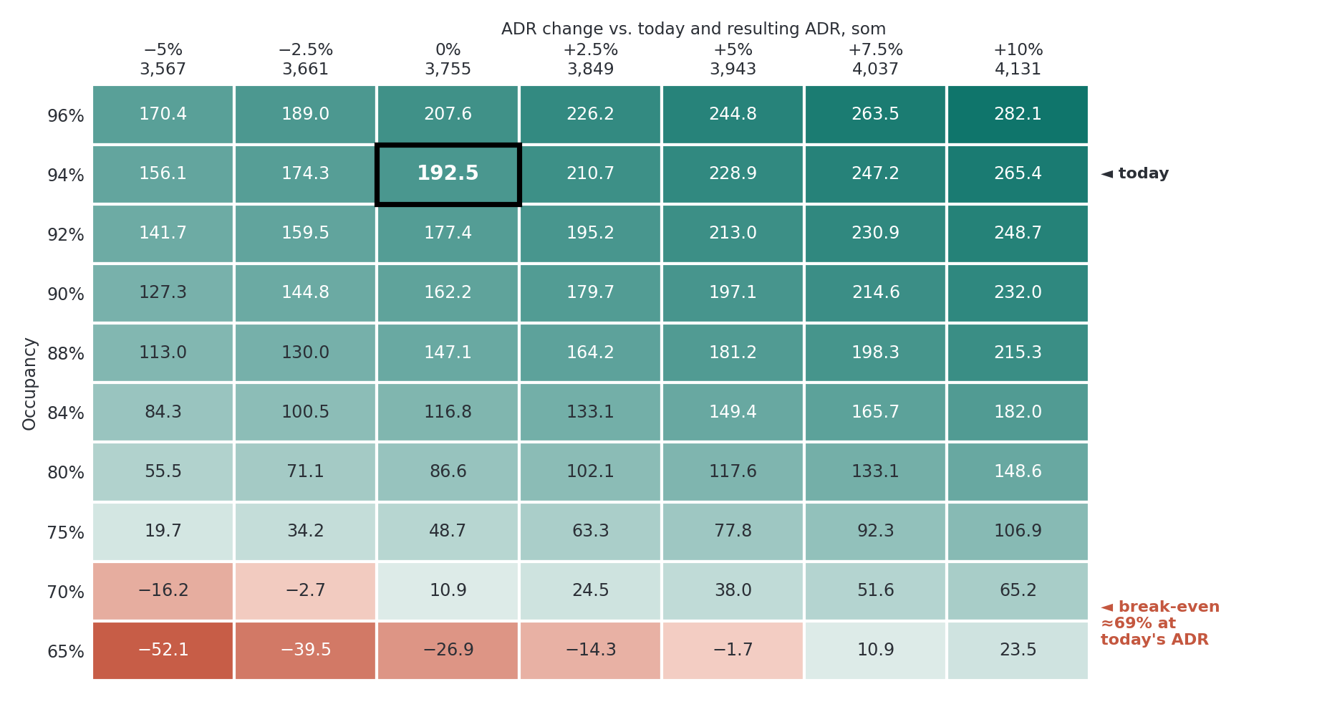
Owner profit after single tax, k som a month, by ADR change and occupancy; the outlined cell is today (192.5).
Revenue = occupancy × ADR × (1 + price change) × 243.3 room-nights × 0.931 (calibration factor, Section 4), which sets today's cell at exactly 800k revenue and 192.5k profit. Costs: fixed 518.8k; supplies scale with occupancy; commission 4.6% and single tax 4.3% scale with revenue. Break-even on the reported-revenue basis of the map is ≈69% after the single tax (safety margin ≈25 points); at list ADR 3,755 it would be 61% before and 64% after the single tax (≈30 points).

4. Occupancy, ADR and revenue differ by 7%; reported revenue is the anchor of the model
Occupancy × ADR × room-nights implies 858.9k som a month, while reported revenue is 800k.
Indicator | Value | Unit
Implied revenue (94% × 3,755 × 243.3) | 858.9 | k som a month
Reported revenue | 800.0 | k som a month
Gap | 58.9 | k som a month
Calibration factor (reported ÷ implied revenue) | 0.931 | ratio
Gap per year | 0.7 | M som
ADR implied by reported revenue and 94% occupancy | 3,498 | som
Occupancy implied by reported revenue and ADR 3,755 | 87.6% | %

The three figures reported by the owner (94% occupancy, ADR 3,755 som, revenue 800k a month) cannot all be exact at the same time, because ADR is revenue divided by nights sold. Matching them requires either an ADR of ≈3,498 som (about the lowest price of 3,500) or an occupancy of ≈87.6%. Possible reasons are different measurement periods, a different definition of occupancy or ADR, or rounding; they could not be checked because follow-up questions to the owner were no longer possible. The model therefore uses revenue of 800k, as reported from the owner's records, as its anchor, and the factor 0.931 only scales occupancy × ADR to it. Price, cost and margin results rest on revenue and do not depend on which figure is off; the break-even and the value of an occupancy point do, so they are stated on the reported-revenue basis. Next step for the owner: reconcile the three figures with booking and payment records, and repeat the check every month.

5. Profit survives any single shock, but a 15% fall in revenue cuts it by more than half
Fixed costs of 518.8k mean revenue shocks hit profit more than twice as hard as they hit revenue.
Shock | Revenue, k som | Owner profit, k som | Change, k som | Margin
Baseline | 800.0 | 192.5 | - | 24.1%
Revenue -10% | 720.0 | 121.4 | -71.1 (-37%) | 16.9%
Revenue -15% | 680.0 | 85.8 | -106.7 (-55%) | 12.6%
Two mobile operators lost (-8% of revenue) | 736.0 | 132.7 | -59.8 (-31%) | 18.0%
Rent +10% | 800.0 | 157.5 | -35.0 (-18%) | 19.7%
Electricity +20% | 800.0 | 180.5 | -12.0 (-6%) | 22.6%
Manager hired at 60k | 800.0 | 132.5 | -60.0 (-31%) | 16.6%

Supplies, Booking.com commission and the single tax move with revenue in the revenue shocks; losing the operators removes supplies and tax but not the commission.
The owner's labour is 31% of profit. With a manager at 60k som, owner profit would fall from 192.5k to 132.5k and margin from 24.1% to 16.6%. Winter electricity of 100k lowers a month's profit by 40k, and with 4 staff the loss of a trained employee is management's main risk.

6. One lever protects the rent; the others add ≈14.5k a month, plus ≈16k upside
Effects are on operating profit before the single tax, run-rate; one-off costs are estimates without quotes.
# | Lever | What the owner does | Assumption | Cost, k som | Effect, k som a month
1 | Rent protection | Negotiates a longer term and a cap on indexation before the 3-year term ends; no CapEx. | Avoids a reset of +5-10% (assumption); not in the base bridge | 0 | 17.5-35.0
2 | Prices on non-contract nights (23% of nights) | Corridor 3,500-4,400 with fences for peak dates and short booking windows; minimum stay of 2-3 nights on peaks; weekly RevPAR and ADR view. | +8% price, -2% volume on non-contract nights (assumption) | 20 | +8.7
3 | Channel mix | Sells Booking.com only on dates corporate demand does not fill and closes it on busy days; each Booking night costs ≈804 som of commission (23% of the realised price). | 4 points of nights move off Booking.com and refill at the same price (assumption); each point ≈1.9 | 0 | +7.8
4 | Prolongation calendar (upside) | ≈50 contracts, ≈4 renewals a month; +4% price review at each prolongation; break-even at 3.7% of contract volume lost. | +4% on 90% of contract revenue; 1% of volume lost (assumption: depends on renewal terms) | 0 | +16.2
5 | Energy | Key-card or occupancy switches, thermostat set-points, heating schedule, LED, draught sealing. | -10% electricity; standalone payback ≈20 months (assumption) | 120 | +6.0
 | Hygiene | Staff retention and SOPs (10k + 3k a month); a direct-booking line (30k + 5k a month). | Costs counted, benefit not counted | 40 | -8.0
 | Base case (levers 2, 3, 5 and hygiene) |  | Total one-off cost 180k | 180 | +14.5
 | Base + upside (lever 4) |  |  | 180 | +30.6

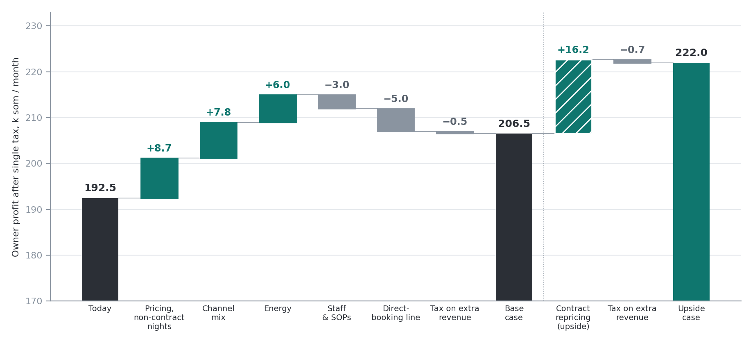
Bridge of owner profit after single tax, k som a month; base and upside are shown separately, and the vertical axis starts at 170.

Scenarios
Assumption / result | Conservative | Base | Upside
Price on non-contract nights | +4% | +8% | +8%
Volume lost on non-contract nights | 3% | 2% | 2%
Booking.com nights moved, points | 2 | 4 | 4
Electricity saving | 5% | 10% | 10%
Contract repricing (assumption: depends on renewal terms) | not applied | not applied | +4% on 90%; 1% lost
Payback of the 180k one-off cost, months | not reached | ≈13 | ≈6
Change in operating profit before tax, k som a month | ≈0 | +14.5 | +30.6
Change in owner profit after tax, k som a month | ≈0 | +14.0 | +29.5

Owner profit after single tax rises from 192.5k to 206.5k in the base case (+7%) and to 222.0k with the upside (+15%). The 36-month net effect is about 0.3–0.9M som, and the conservative case does not pay back.

30 / 60 / 90 days
Window | The owner | Expected effect | Control metric
Days 1–30 | Opens lease talks (longer term, indexation cap). Sets the 3,500–4,400 corridor with fences and a 2–3-night minimum stay on peaks. Closes Booking.com on days corporate demand fills. Starts a monthly reconciliation of occupancy, ADR and revenue. | Pricing and channel mix start: up to +16.5k a month at run-rate (assumption) | Occupancy ≥ 92%; monthly reconciliation done
Days 31–60 | Starts the prolongation calendar: ≈4 contracts a month, +4% at each. Orders the energy works. | ≈+1.3k a month of run-rate for each month of renewals (upside) | Contract attrition below 3.7%
Days 61–90 | Completes the energy works (120k, estimate). Compares the run-rate with the base case and closes the lease talks. | +6.0k a month from energy; base case ≈+14.5k | Owner profit ≈207k a month

7. Five actions, in this order
- Open the lease talks now and ask for a longer term and an indexation cap, because a reset of +5–10% would cost 0.6–1.3M som over 3 years, more than the base programme earns in the same period (≈0.5M).
- Raise prices on the 23% of non-contract nights, because each 1% of price is worth ≈7.3k a month, as much as a point of occupancy the hotel cannot add.
- Close Booking.com on the days corporate demand fills the hotel, because each Booking night costs ≈804 som of commission and moving 4 points of nights saves ≈7.8k a month.
- Reprice contracts at every prolongation (≈4 a month, +4%) and stop if attrition passes 3.7%, because this is the largest single upside, ≈16k a month.
- Reconcile occupancy, ADR and revenue every month, because the three reported figures differ by ≈7% (≈59k a month) and the break-even and the value of an occupancy point depend on which one is right.

Model limitations
- Implementation costs (20k, 120k, 30k and 10k som) are estimates without supplier quotes; payback and the 36-month effect are given as ranges.
- The one-month cash cushion is an assumption of 350–600k som, depending on its base, and is not used in any calculation.
- Contract repricing assumes that prices can be revised at prolongation; the upside depends on the renewal terms.
- Cost and margin figures are tied to reported revenue of 800k; the factor 0.931 only scales occupancy × ADR to that revenue (Section 4).
- All figures are as reported by the owner and were not audited; follow-up questions were no longer possible, so unclear points are treated as stated assumptions (payroll contributions, electricity in heating months, lease protection in years 4–5).
- The 4.2× return excludes the owner's unpaid labour and the one-month cash cushion (see the note in Section 1).

About this project
Source and data. The case is based on a written question-and-answer interview with the owner of an 8-room corporate hotel in Bishkek (32 questions on the business model, unit economics, costs, sales channels and risks) and a few follow-up figures. All figures are as reported by the owner and were not audited; where the data did not tie or was unclear, the case says so and states the assumption it used.
My work. I built the cost model, unit economics, price-and-occupancy map, shock tests and action plan from the owner's answers. I collected the answers through a structured 32-question Q&A interview with the hotel owner, building on the practical framework I previously used for the laptop and computer peripherals retail business case study at TSUM. I built the cost model, unit economics, and profit bridge using Excel and Python, with AI tools helping to structure and refine the analysis.
What I learned. It was striking how a business with 420% return on invested capital is entirely exposed to a single lease renewal. Next, I would ask the owner about the exact legal safeguards for years 4 and 5 of the lease. Doing this hands-on operational and financial modeling made corporate finance feel genuinely exciting rather than abstract.
Permission. The hotel and its corporate clients are not named.

РУССКАЯ ВЕРСИЯ
Бизнес-кейс: прибыльность отеля и стратегия корпоративного сегмента
Корпоративный отель на 8 номеров в Бишкеке · Эржан Амир · Данные: интервью с владельцем, не аудированы
≈193  тыс. сом — прибыль владельца в месяц  ≈2,2 тыс. USD · после аренды, всех затрат и единого налога | 24%  маржа после единого налога  заявлено 25%; расчёт снизу вверх 24,1% | ≈69%  безубыточная загрузка после налога  по фактической выручке, запас прочности ≈25 пунктов до текущих 94% (≈64% по прейскурантному ADR) | ≈4×  годовая доходность на вложенный капитал  вложено ≈0,55 млн (обновление 200 тыс. + депозит 350 тыс.); прибыль ≈2,3 млн в год; труд владельца не оплачивается, подушка не учтена

На ≈0,55 млн сом вложений отель приносит ≈2,3 млн в год, но вся эта ценность держится на договоре аренды, который нужно продлевать через 3 года; при загрузке 94% единственный свободный рычаг роста — цена.
1,8×  Аренда и прибыль владельца  Аренда забирает 4,2 млн в год, владельцу остаётся 2,3 млн. Каждый +1% аренды стоит 3,5 тыс. в месяц. | ≈7,3k  1% цены ≈ 1 пункт загрузки  Оба дают 7,3–7,6 тыс. прибыли в месяц; при 94% объёма для роста нет, поэтому свободный рычаг — цена. | −18%  Аренда +10% бьёт по прибыли  Пересмотр аренды на +10% стоил бы 35 тыс. в месяц — 18% прибыли владельца (раздел 5).

Что делать. Сначала защитить аренду (рост на 5–10% стоил бы 0,6–1,3 млн за 3 года), затем поднять цену на 23% ночей вне контрактов, продавать Booking.com только на даты, которые не заполняет корпоративный спрос, и пересматривать цены в контрактах при каждой пролонгации. Базовая программа добавляет ≈14,5 тыс. в месяц операционной прибыли, пересмотр цен в контрактах — ещё ≈16 тыс. Разовые затраты ≈180 тыс. сом (оценка).

1. Бизнес приносит ≈4× вложенного капитала в год, но держится на одном договоре аренды
Аренда 350 тыс. сом — это 43,8% выручки и в 1,8 раза больше прибыли владельца.
Аренда фиксирована, без индексации первые 5 лет, но срок договора — 3 года с продлением. Собственник здания вложил около 70 млн сом и несёт все капитальные расходы (фасад, крыша, инженерные системы). Арендатор вложил около 200 тыс. сом в обновление, окупил их в первый год и внёс депозит в размере месячной аренды (350 тыс.). Владелец назвал срок 3 года и отсутствие индексации первые 5 лет; чем защищены 4-й и 5-й годы, выяснить не удалось, поэтому точкой риска считается окончание 3-летнего срока.
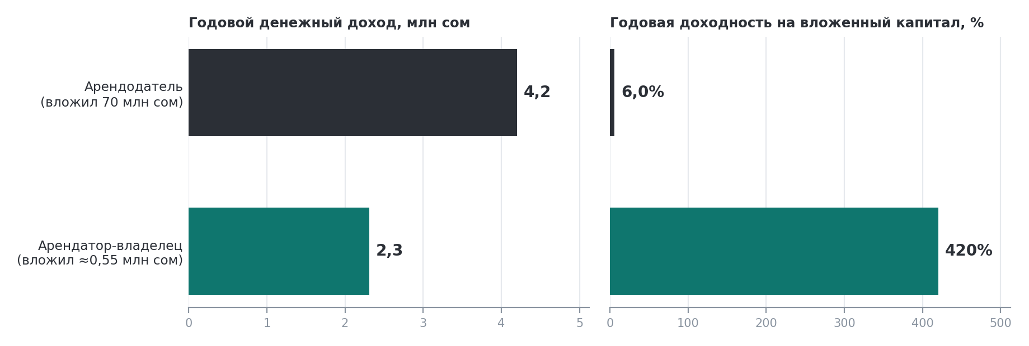
Арендодатель и арендатор-владелец: годовой денежный доход и годовая доходность на вложенный капитал.
 | Арендодатель | Арендатор-владелец
Вложенный капитал | 70 млн сом | ≈0,55 млн сом (обновление 200 тыс. + депозит 350 тыс.)
Годовой денежный доход | 4,2 млн сом (аренда 350 тыс. × 12) | ≈2,3 млн сом (192,5 тыс. × 12, после единого налога; труд владельца не оплачивается)
Годовая доходность на капитал | 6,0% валовая доходность | ≈4,2× (420%)
Возврат капитала из дохода | 16,7 года | ≈3 мес.
Основной риск | Капитальные расходы на здание | Продление: каждый +1% аренды = −3,5 тыс. в месяц; +10% = −35,0 тыс. (18% прибыли)

Примечание к 4,2×: показатель не учитывает неоплачиваемый труд владельца (с управляющим за 60 тыс. сом он был бы ≈2,9×) и подушку на один месяц 350–600 тыс. сом (с подушкой получается ≈2,0–2,6×).
Рычаг 1: защитить аренду. Договорённость о более длительном сроке и потолке индексации не требует капитала. Если альтернатива — пересмотр на +5–10%, защита стоит 17,5–35,0 тыс. в месяц, или 0,6–1,3 млн сом за 3 года (допущение: размер пересмотра). Аренда +10% снизила бы доходность арендатора с 4,2× до 3,4×: бизнес остаётся привлекательным, но прибыль владельца падает на 18%.

2. Владельцу доходят лишь 24 сома из каждых 100; 76 уходят раньше
Аренда, ФОТ и электричество фиксированы и занимают 65% выручки, поэтому прибыль зависит от удержания загрузки и цены.
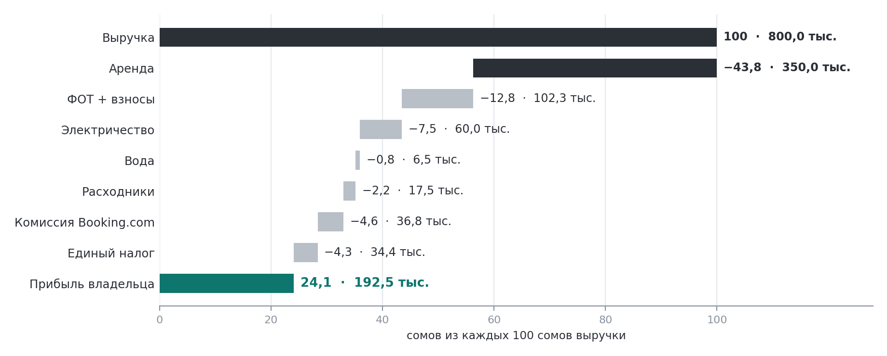
Куда уходит каждые 100 сом выручки, с суммами в тыс. сом в месяц (средний месяц).
Затраты 573,1 тыс. и единый налог 34,4 тыс. оставляют 192,5 тыс. (24,1%); заявленные 25% (≈200 тыс.) сходятся в пределах округления, а до единого налога маржа ≈29%. После резерва FF&E 5% владельцу остаётся 152,5 тыс. Расходники — середина 15–20 тыс. (допущение: в месяц); единый налог — в среднем 4,3% (допущение: 15% поступлений наличными; 6% с наличных, 4% с безналичных). USD по курсу 87,45 сом (21 октября 2026). ФОТ и взносы приняты в размере 102,3 тыс. в месяц. Владелец также назвал ставку взносов в Соцфонд 12,25%, но не уточнил, входит ли она в ФОТ 100 тыс.; если взносы добавляются сверху (≈12,3 тыс.), прибыль владельца составила бы ≈182 тыс. (≈22,8%). Заявленные 25% маржи ближе к базовому варианту, поэтому он сохранён. Электричество взято как заявленное среднее 60 тыс. в месяц; в месяцы отопления оно доходит до 100 тыс. (раздел 5).
Канал | Доля ночей | Условия
Корпоративные договоры | 77–80% | Около 50 годовых договоров с пролонгацией; цены фиксированные, скидок и комиссий нет. Два мобильных оператора вместе дают около 8% загрузки.
Booking.com | ≈20% | Комиссия 23% = 36,8 тыс. в месяц.
Соцсети | ≈3% | Без комиссии; прямых броней почти нет.

Юнит-экономика
Статья | Значение | Ед.
На проданную ночь, по заявленному ADR |  | сом
Цена (ADR) | 3 755 | сом
Расходники | −77 | сом
Комиссия Booking.com, в среднем | −173 | сом
Вклад до единого налога | 3 505 | сом
Единый налог (4,3%) | −161 | сом
Вклад после единого налога | 3 344 | сом
Постоянные затраты на проданную ночь | −2 268 | сом
Прибыль за ночь по заявленному ADR | 1 076 | сом
Сверка с фактической выручкой (×0,931) | −234 | сом
Прибыль владельца за проданную ночь | 842 | сом
На номер в месяц |  | тыс. сом
Выручка | 100,0 | тыс. сом
Затраты | −71,6 | тыс. сом
Единый налог | −4,3 | тыс. сом
Прибыль владельца на номер | 24,1 | тыс. сом

3. При загрузке 94% цена — единственный свободный рычаг
Один процент цены стоит почти ровно один пункт загрузки, и двигаться ещё может только цена.
Единица изменения | Формула (тыс. сом в месяц, после комиссии и единого налога) | Прибыль
+1% цены | 800 × 1% × (1 − 8,9%) | +7,3
+1 пункт загрузки | 800 ÷ 94 × (1 − 8,9%) − 17,5 ÷ 94 | +7,6

Рост с 94% до 100% добавил бы лишь 6,4% объёма, а практический запас — 1–2 пункта (допущение). Цены выставляются вручную в коридоре 3 500–4 000 (разброс 14%), хотя выходные и события в городе уже заполняют отель, а устойчивая загрузка выше примерно 90% обычно говорит о заниженных ценах. Средний срок проживания — 2 ночи, хотя проживание от 3 ночей выгоднее.
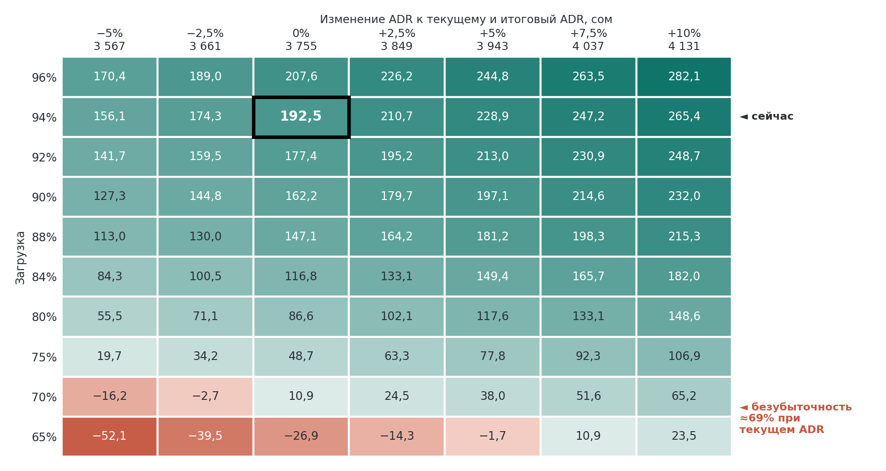
Прибыль владельца после единого налога, тыс. сом в месяц, по изменению ADR и загрузке; выделенная ячейка — текущее положение (192,5).
Выручка = загрузка × ADR × (1 + изменение цены) × 243,3 номеро-ночей × 0,931 (коэффициент приведения, раздел 4); так текущая ячейка равна ровно 800 тыс. выручки и 192,5 тыс. прибыли. Затраты: постоянные 518,8 тыс.; расходники растут с загрузкой; комиссия 4,6% и единый налог 4,3% растут с выручкой. Безубыточность по заявленной выручке, принятой на карте, — ≈69% после единого налога (запас прочности ≈25 пунктов); по прейскурантному ADR 3 755 она составила бы 61% до и 64% после единого налога (≈30 пунктов).

4. Загрузка, ADR и выручка расходятся на 7%; опорная точка модели — заявленная выручка
Загрузка × ADR × номеро-ночи дают 858,9 тыс. сом в месяц, а заявленная выручка составляет 800 тыс.
Показатель | Значение | Ед.
Расчётная выручка (94% × 3 755 × 243,3) | 858,9 | тыс. сом в месяц
Фактическая выручка | 800,0 | тыс. сом в месяц
Разрыв | 58,9 | тыс. сом в месяц
Коэффициент приведения (заявленная ÷ расчётная выручка) | 0,931 | коэф.
Разрыв в год | 0,7 | млн сом
ADR, следующий из выручки и загрузки 94% | 3 498 | сом
Загрузка, следующая из выручки и ADR 3 755 | 87,6% | %

Три цифры, названные владельцем (загрузка 94%, ADR 3 755 сом, выручка 800 тыс. в месяц), не могут быть точными одновременно: ADR - это выручка, делённая на число проданных ночей. Чтобы они сошлись, нужен либо ADR ≈3 498 сом (почти минимальная цена 3 500), либо загрузка ≈87,6%. Возможные причины - разные периоды измерения, разное определение загрузки или ADR, округление; проверить их не удалось, потому что уточняющие вопросы владельцу задать уже было нельзя. Поэтому опорной точкой модели взята выручка 800 тыс. по записям владельца, а коэффициент 0,931 лишь приводит загрузку × ADR к ней. Результаты по цене, затратам и марже опираются на выручку и не зависят от того, какая из цифр неточна; безубыточность и ценность пункта загрузки зависят, поэтому они указаны по заявленной выручке. Следующий шаг для владельца — сверить три показателя с записями бронирований и платежей и повторять проверку каждый месяц.

5. Прибыль переживает любой шок по отдельности, но падение выручки на 15% сокращает её более чем вдвое
Постоянные затраты 518,8 тыс. означают, что шоки выручки бьют по прибыли более чем вдвое сильнее, чем по выручке.
Шок | Выручка, тыс. сом | Прибыль владельца, тыс. сом | Изменение, тыс. сом | Маржа
База | 800,0 | 192,5 | – | 24,1%
Выручка −10% | 720,0 | 121,4 | −71,1 (−37%) | 16,9%
Выручка −15% | 680,0 | 85,8 | −106,7 (−55%) | 12,6%
Потеря двух мобильных операторов (−8% выручки) | 736,0 | 132,7 | −59,8 (−31%) | 18,0%
Аренда +10% | 800,0 | 157,5 | −35,0 (−18%) | 19,7%
Электричество +20% | 800,0 | 180,5 | −12,0 (−6%) | 22,6%
Управляющий за 60 тыс. | 800,0 | 132,5 | −60,0 (−31%) | 16,6%

При падении выручки расходники, комиссия Booking.com и единый налог снижаются пропорционально; при потере операторов уходят расходники и налог, но не комиссия.
Труд владельца — 31% прибыли. С управляющим за 60 тыс. сом прибыль владельца упала бы с 192,5 до 132,5 тыс., а маржа — с 24,1% до 16,6%. Зимнее электричество в 100 тыс. снижает прибыль месяца на 40 тыс., а при штате из 4 человек главный риск — потеря обученного сотрудника.

6. Один рычаг защищает аренду; остальные добавляют ≈14,5 тыс. в месяц, плюс ≈16 тыс. апсайда
Эффекты указаны для операционной прибыли до единого налога в месячном темпе; разовые затраты — оценки без котировок.
# | Рычаг | Что делает владелец | Допущение | Затраты, тыс. сом | Эффект, тыс. сом в месяц
1 | Защита аренды | Договаривается о более длительном сроке и потолке индексации до конца 3-летнего срока; без капзатрат. | Предотвращает пересмотр на +5–10% (допущение); не входит в базовый мост | 0 | 17,5–35,0
2 | Цены на неконтрактные ночи (23% ночей) | Коридор 3 500–4 400 с ограничениями на пики и короткие окна бронирования; минимальный срок 2–3 ночи на пики; еженедельный RevPAR и ADR. | +8% к цене, −2% объёма на неконтрактных ночах (допущение) | 20 | +8,7
3 | Микс каналов | Продаёт Booking.com только на даты, которые не заполняет корпоративный спрос, и закрывает его в загруженные дни; ночь через Booking стоит ≈804 сом комиссии (23% реализованной цены). | 4 пункта ночей уходят с Booking.com и заполняются по той же цене (допущение); каждый пункт ≈1,9 | 0 | +7,8
4 | Календарь пролонгаций (апсайд) | ≈50 договоров, ≈4 пролонгации в месяц; пересмотр цены на +4% при каждой пролонгации; точка безубыточности — потеря 3,7% контрактного объёма. | +4% на 90% контрактной выручки; потеря 1% объёма (допущение: зависит от условий продления контрактов) | 0 | +16,2
5 | Энергия | Выключатели по карте или присутствию, уставки термостатов, график отопления, LED, утепление. | −10% электроэнергии; самостоятельная окупаемость ≈20 месяцев (допущение) | 120 | +6,0
 | Гигиена | Удержание персонала и SOP (10 тыс. + 3 тыс. в месяц); линия прямых броней (30 тыс. + 5 тыс. в месяц). | Затраты учтены, выгода не считается | 40 | −8,0
 | Базовый сценарий (рычаги 2, 3, 5 и гигиена) |  | Итого разовые затраты 180 тыс. | 180 | +14,5
 | База + апсайд (рычаг 4) |  |  | 180 | +30,6

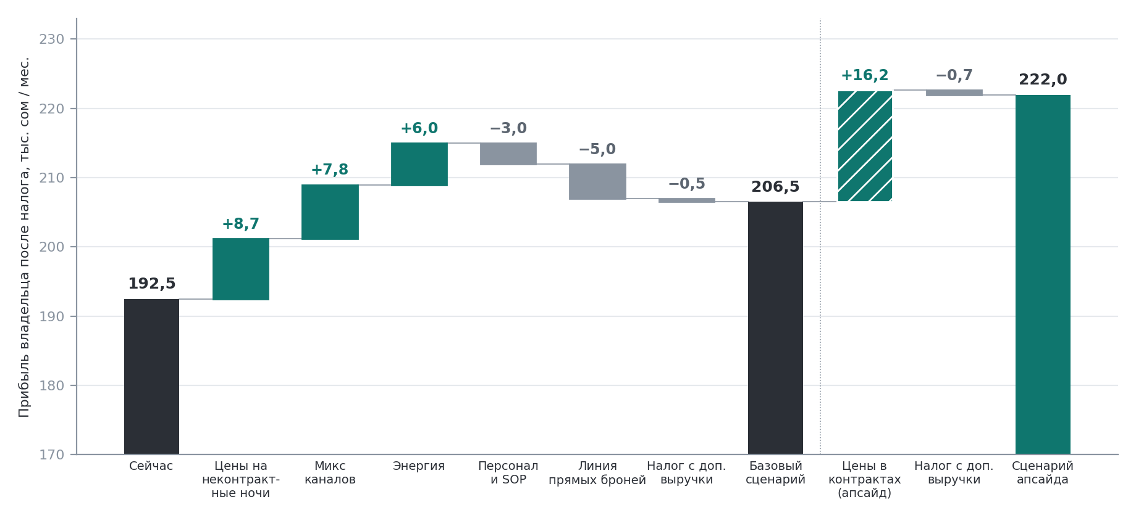
Мост прибыли владельца после единого налога, тыс. сом в месяц; база и апсайд показаны раздельно, вертикальная ось начинается со 170.

Сценарии
Допущение / результат | Консервативный | Базовый | Апсайд
Цена на неконтрактных ночах | +4% | +8% | +8%
Потеря объёма на неконтрактных ночах | 3% | 2% | 2%
Ночи, ушедшие с Booking.com, п.п. | 2 | 4 | 4
Экономия электричества | 5% | 10% | 10%
Пересмотр цен в контрактах (допущение: зависит от условий продления) | не применяется | не применяется | +4% на 90%; потеря 1%
Окупаемость разовых затрат 180 тыс., мес. | не достигается | ≈13 | ≈6
Изменение операционной прибыли до налога, тыс. сом в месяц | ≈0 | +14,5 | +30,6
Изменение прибыли владельца после налога, тыс. сом в месяц | ≈0 | +14,0 | +29,5

Прибыль владельца после единого налога растёт с 192,5 до 206,5 тыс. в базовом сценарии (+7%) и до 222,0 тыс. с апсайдом (+15%). Чистый эффект за 36 месяцев — около 0,3–0,9 млн сом; консервативный сценарий не окупается.

30 / 60 / 90 дней
Окно | Владелец | Ожидаемый эффект | Контрольная метрика
Дни 1–30 | Начинает переговоры по аренде (срок, потолок индексации). Вводит коридор 3 500–4 400 с ограничениями и минимальный срок 2–3 ночи на пики. Закрывает Booking.com в дни, когда спрос заполняют корпоративные клиенты. Запускает ежемесячную сверку загрузки, ADR и выручки. | Стартуют цены и микс каналов: до +16,5 тыс. в месяц в темпе (допущение) | Загрузка ≥ 92%; ежемесячная сверка выполнена
Дни 31–60 | Запускает календарь пролонгаций: ≈4 договора в месяц, +4% при каждой. Заказывает энергосберегающие работы. | ≈+1,3 тыс. в месяц в темпе за каждый месяц пролонгаций (апсайд) | Потеря контрактного объёма менее 3,7%
Дни 61–90 | Завершает энергосберегающие работы (120 тыс., оценка). Сверяет текущий темп с базовым сценарием и завершает переговоры по аренде. | +6,0 тыс. в месяц от энергии; базовый сценарий ≈+14,5 тыс. | Прибыль владельца ≈207 тыс. в месяц

7. Пять действий в таком порядке
- Начните переговоры по аренде сейчас и просите более длительный срок и потолок индексации, потому что пересмотр на +5–10% стоил бы 0,6–1,3 млн сом за 3 года, больше, чем базовая программа зарабатывает за тот же период (≈0,5 млн).
- Поднимите цены на 23% неконтрактных ночей, потому что каждый 1% цены стоит ≈7,3 тыс. в месяц, как пункт загрузки, которого у отеля нет.
- Закрывайте Booking.com в дни, когда отель заполняют корпоративные клиенты, потому что ночь через Booking стоит ≈804 сом комиссии, а перенос 4 пунктов ночей экономит ≈7,8 тыс. в месяц.
- Пересматривайте цены в контрактах при каждой пролонгации (≈4 в месяц, +4%) и останавливайтесь, если потеря объёма превысит 3,7%, потому что это крупнейший единичный апсайд, ≈16 тыс. в месяц.
- Ежемесячно сверяйте загрузку, ADR и выручку, потому что три заявленные цифры расходятся на ≈7% (≈59 тыс. в месяц), а точка безубыточности и ценность пункта загрузки зависят от того, какая из них верна.

Ограничения модели
- Затраты на внедрение (20, 120, 30 и 10 тыс. сом) — оценки без котировок поставщиков; окупаемость и эффект за 36 месяцев даны диапазонами.
- Подушка на один месяц — допущение 350–600 тыс. сом в зависимости от базы; она не используется ни в одном расчёте.
- Пересмотр цен в контрактах предполагает, что цены можно менять при пролонгации; апсайд зависит от условий продления контрактов.
- Затраты и маржа привязаны к заявленной выручке 800 тыс.; коэффициент 0,931 лишь приводит загрузку × ADR к этой выручке (раздел 4).
- Все данные приведены так, как их назвал владелец, и не аудированы; уточняющие вопросы задать было уже нельзя, поэтому неясные места оформлены как явные допущения (взносы с ФОТ, электричество в месяцы отопления, защита аренды на 4–5-м годах).
- Доходность 4,2× не учитывает неоплачиваемый труд владельца и подушку на один месяц (см. примечание в разделе 1).

О проекте
Источник и данные. Кейс основан на письменном интервью в формате «вопрос — ответ» с владельцем корпоративного отеля на 8 номеров в Бишкеке (32 вопроса о бизнес-модели, юнит-экономике, затратах, каналах продаж и рисках) и нескольких уточняющих цифрах. Все данные приведены так, как их назвал владелец, и не аудированы; где данные не сходились или были неясны, кейс прямо говорит об этом и указывает принятое допущение.
Моя работа. Я построил модель затрат, юнит-экономику, карту «цена × загрузка», стресс-тесты и план действий на основе ответов владельца. Я собрал данные через структурированное интервью из 32 вопросов с владельцем отеля, используя опыт построения бизнес-кейса по розничному бизнесу ноутбуков и компьютерных аксессуаров в ЦУМе. Для расчёта юнит-экономики, моста прибыли и стресс-тестов я использовал Excel и Python, а ИИ-инструменты помогали структурировать логику отчёта.
Чему я научился. Больше всего удивило, что бизнес с доходностью на капитал 420% полностью зависит от одного трёхлетнего договора аренды. В следующий раз я бы уточнил у владельца детали юридической защиты на 4–5 годы. Такой реальный финансовый анализ и работа с цифрами отеля показали, насколько увлекательной может быть сфера финансов.
Разрешение. Отель и его корпоративные клиенты не названы.

