AF 52
Smart Agriculture: Crop and Plant Health Monitoring and Air Quality Monitoring System using Arduino UNO
Submitted in partial fulfilment of the requirements
SE / Semester III
Computer Engineering
by
Name of Student [PID No.]
Name of Student [PID No.]
Name of Student [PID No.]
Name of Student [PID No.]
Under the Guidance of
Megha Godboley
Assistant Professor, Computer Department, SJCEM

DEPARTMENT OF COMPUTER ENGINEERING
ST. JOHN COLLEGE OF ENGINEERING & MANAGEMENT
UNIVERSITY OF MUMBAI
20____ - 20____


Certificate of Approval
This is to certify that _____________________, are bonafide students of SE/SEM-III in ________________- Computer Department, St. John College of Engineering and Management, Mumbai. They have satisfactorily completed the requirements of Project Report as prescribed by ST. JOHN COLLEGE OF ENGINEERING AND MANAGEMENT (An Autonomous College affiliated to University of Mumbai), while working on “Smart Agriculture: Crop and Plant Health Monitoring and Air Quality Monitoring System using Arduino UNO”.

Signature :--------------------------------  Name : Megha Godboley  Designation : Assistant Professor | Signature :--------------------------------  Name : Dr. Sunny Sall  Head of the Department, Computer Engineering

Signature :--------------------------------
Name : Dr. Kamal Shah
Principal,
St. John College of Engineering and Management.
Declaration
I/we declare that this written submission represents my/our ideas in my/our own words and where others ideas or words have been included, I/we have adequately cited and referenced the original sources. I/we also declare that I/we have adhered to all principles of academic honesty and integrity and have not misrepresented or fabricated or falsified any idea/data/fact/source in my/our submission. I/we understand that any violation of the above will be cause for disciplinary action by the Institute and can also evoke penal action from the sources which have thus not been properly cited or from whom proper permission has not been taken when needed.

(Signature)
. (Student Name )
Date: __________
Acknowledgement
We express our sincere gratitude to all those who have directly and indirectly contributed to the successful preparation of this project.
We are deeply grateful to Dr. Kamal Shah, Principal, St. John College of Engineering and Management, for providing an excellent academic environment and the necessary facilities to undertake this project.
We extend our heartfelt thanks to the Dr. Sunny Sall, Head of the Department, Computer Engineering for their constant encouragement, valuable suggestions, and continuous support throughout the preparation of this project.
We would like to express our sincere appreciation to our project guide, Mrs. Megha Godboley, for their invaluable guidance, constructive suggestions, technical expertise, and continuous motivation. Their encouragement and insightful feedback have been instrumental in shaping this project synopsis.
We also acknowledge all the faculty members and laboratory staff of the Department of Computer Engineering for their timely assistance, cooperation, and technical support.
Finally, we express our heartfelt gratitude to our parents, family members, friends, and classmates for their constant encouragement, moral support, and cooperation throughout this work.
Group Members
1. __________________________
2. __________________________
3. __________________________
4. __________________________
ABSTRACT
Crop and plant health depends on a few conditions that change from hour to hour: how much water is present in the soil, the temperature and humidity of the surrounding air, and the quality of that air. In small farms, nurseries and kitchen gardens these conditions are still mostly judged by eye or by touch, which is slow and often inaccurate.
This project presents a low-cost, portable monitoring system built around an Arduino UNO. A DHT11 sensor measures air temperature and humidity, an MQ135 gas sensor gives an indication of air quality, and a soil moisture sensor shows whether the soil is dry or wet. The Arduino reads all three sensors and displays the values on a 16x2 LCD, whose contrast is adjusted with a 10k preset. The circuit is mounted in an enclosure with openings for airflow and is powered by a 9 V battery supported by a 3.7 V rechargeable cell, so it can be used in the field.
The prototype was tested by placing the soil moisture probe in dry soil and in water, by observing the air-quality reading with the enclosure open and closed, and by placing the unit near plants to read temperature and humidity. The readings changed clearly with each condition. The system works as a standalone unit without internet connectivity. Data logging, remote alerts and automatic irrigation are identified as future extensions.
C O N T E N T S
Sr. No. | Topic | Page No.
1 | Project Problem Statement  • Existing Problem  • Need for the Project | 7
2 | Project Objectives  • Main Objective  • Specific Objectives | 8
3 | Project Methodology  • Proposed Approach  • Working Principle  • System / Process Flow | 9
4 | Components / Technologies Used  • Hardware Components  • Software / Technologies | 12
5 | Advantages and Disadvantages  • Key Advantages  • Practical Benefits  • Limitations | 14
6 | Applications and Future Scope  • Practical Applications  • Potential Use Cases  • Future Improvements  • Future Enhancements | 15
7 | Conclusion  • Summary  • Overall Outcome | 16
8 | References  • Research Papers  • Websites & Online Sources  • Technical Documentation  • Books / Journals | 17

1. Project Problem Statement

1.1 Existing Problem
Plants respond quickly to changes in their surroundings. Too little water in the soil stresses the crop, while too much water harms the roots. High temperature and low humidity increase water loss from leaves, and poor air quality in closed or crowded spaces such as nurseries, small greenhouses and indoor plant areas can affect plant growth as well.
On many small farms and gardens these conditions are checked manually, by pressing the soil with a finger or by judging the weather. This depends entirely on the person’s experience, gives no numerical value, and is easy to get wrong. Commercial sensing and monitoring equipment does exist, but it is usually expensive and is designed for large installations, which makes it hard for small growers, students and hobby gardeners to use.

1.2 Need for the Project
There is a need for a simple and affordable device that can be placed in the field or near a plant and can show the important readings immediately, without a computer or a smartphone. Such a device should be easy to build from commonly available components, run on batteries, and be compact enough to be carried from one place to another.
Problem statement: To design and build a low-cost, battery-powered monitoring system based on Arduino UNO that measures soil moisture, air temperature, humidity and air quality around crops and plants, and displays the readings on an LCD so that the user can judge plant conditions on the spot.

2. Project Objectives

2.1 Main Objective
To develop a working prototype of a smart agriculture monitoring system that continuously measures the soil and air conditions important for crop and plant health and presents them on a local display.

2.2 Specific Objectives
- To measure soil moisture and identify whether the soil is dry or wet using a soil moisture sensor.
- To measure air temperature and relative humidity around the plants using the DHT11 sensor.
- To monitor the quality of the surrounding air using the MQ135 gas sensor.
- To read all sensor outputs with an Arduino UNO and show them together on a 16x2 LCD.
- To make the unit portable by powering it from batteries and housing the circuit in an enclosure with openings for airflow.
- To test the prototype under different conditions (dry soil, wet soil, open and closed enclosure, placement near plants) and verify that the readings respond correctly.
- To keep the total cost low by using commonly available components.

3. Project Methodology

3.1 Proposed Approach
The system is divided into four simple parts: sensing, processing, display and power. Three sensors collect the readings, the Arduino UNO acts as the processing unit, the LCD shows the output, and a battery supply makes the unit portable. The project was carried out in the following steps.
- Selection of components. Sensors were chosen for the three quantities to be observed (soil moisture, temperature and humidity, air quality) together with an Arduino UNO and a 16x2 LCD.
- Preparing the display. Wires were soldered to the LCD module and a 10k preset was connected to it so that the display contrast can be adjusted.
- Mounting and wiring. The Arduino, sensors and LCD were fixed inside a box and connected using male-to-female and female-to-female jumper wires. The soil moisture probe is taken out of the box through a wire so that it can be placed in the soil.
- Power arrangement. A 9 V battery is connected through a power jack and switch. Because this alone did not supply the circuit properly, a 3.7 V rechargeable cell was connected in series with it to improve the supply.
- Programming. A program was written and uploaded to the Arduino UNO to read the sensors and print the values on the LCD.
- Testing. The completed unit was tested with the soil probe in dry conditions and in water, with the enclosure open and closed, and near actual plants.

3.2 Working Principle
When the unit is switched on, the Arduino UNO initialises the LCD and the sensors and then keeps reading them one after another. Each sensor works on a different principle.
- DHT11 (temperature and humidity). The sensor contains a humidity-sensing element and a temperature-sensing element and sends the measured values to the Arduino as a digital signal on a single data line. In this project the data pin is connected to digital pin 7 of the Arduino.
- MQ135 (air quality). The MQ135 is a gas sensor whose internal resistance changes with the concentration of gases such as ammonia, smoke and other pollutants in the air. This change is given as an analog voltage, which the Arduino reads. A higher or lower reading than usual therefore shows that the air composition has changed. The sensor needs some time after power-on to stabilise, and air must be able to reach it, which is why openings were made in the enclosure.
- Soil moisture sensor. The probe is inserted into the soil, and its output voltage changes with the amount of water present. The reading is clearly different for dry soil and for wet soil (the sensor was tested in dry soil and in water).
- Arduino UNO. The analog outputs of the MQ135 and the soil moisture sensor are converted to digital numbers by the Arduino’s built-in 10-bit analog-to-digital converter (values from 0 to 1023). The Arduino then sends the values to the LCD.
- 16x2 LCD. The display shows the readings in two lines of 16 characters. The preset connected to the contrast pin is turned until the text is clearly visible.

3.3 System / Process Flow
Figure 1 shows how the components are connected in the system, and Figure 2 shows the sequence of operations followed by the program.
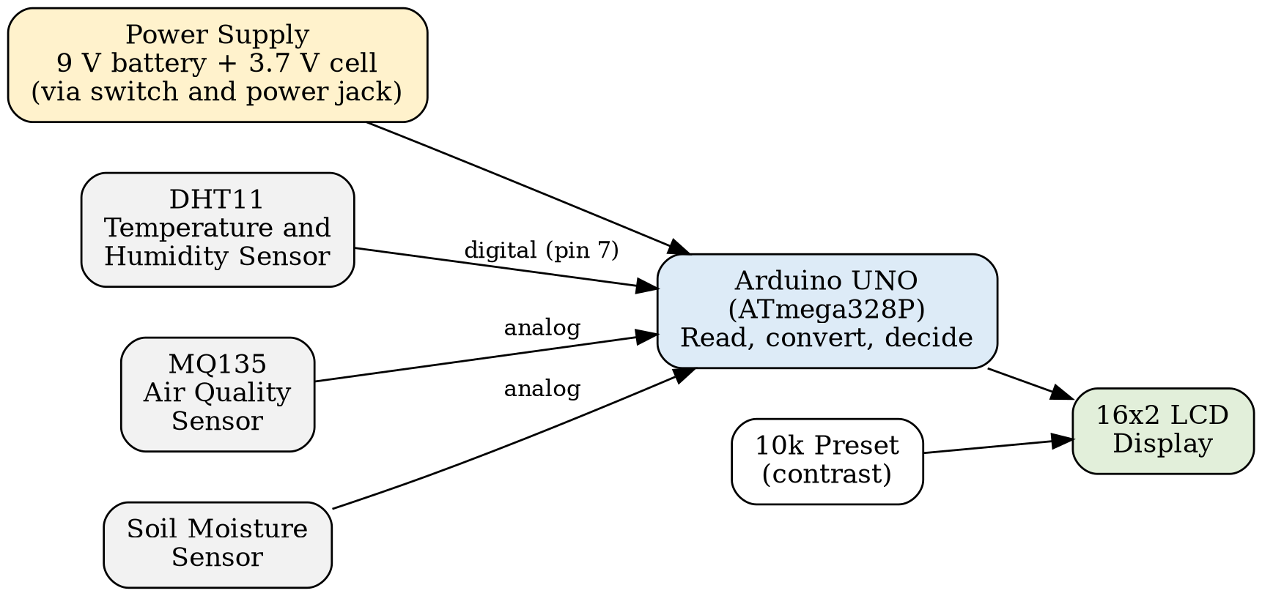
Figure 1: Block diagram of the Smart Agriculture Monitoring System
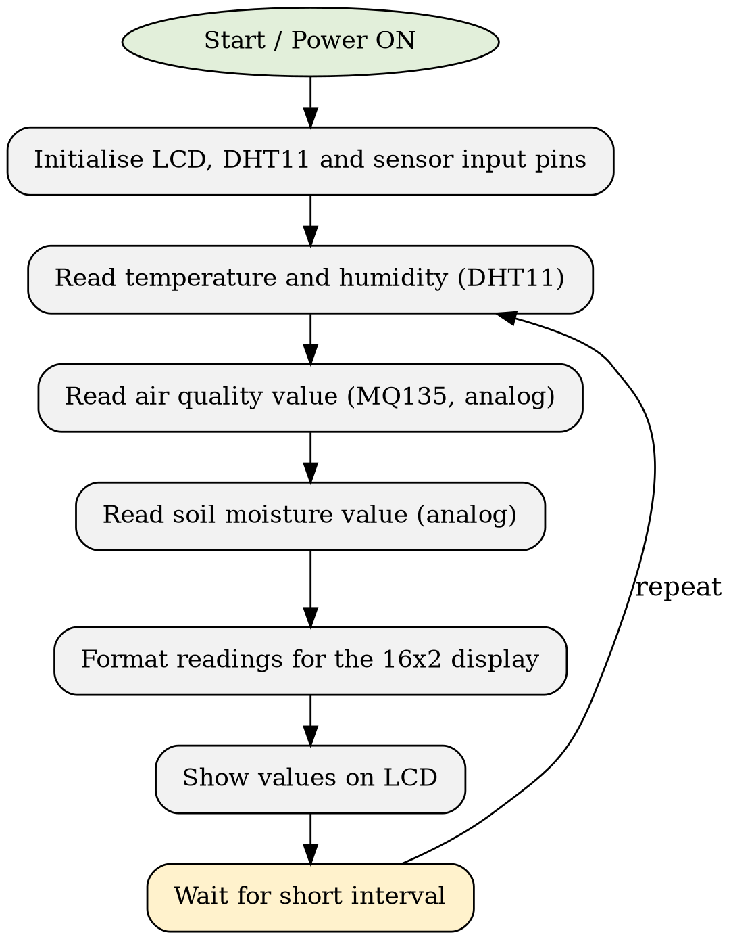
Figure 2: Flowchart of the sensing and display process
The process repeats continuously as long as the power is on, so the displayed values are updated as conditions around the unit change.

4. Components / Technologies Used

4.1 Hardware Components
Table 1 lists the hardware used in the prototype. The system is a standalone embedded unit; it has no wireless module and does not use a cloud service.
Table 1: Hardware components used
Sr. No. | Component | Purpose in the project
1 | Arduino UNO | Main controller; reads the sensors and drives the LCD
2 | 16x2 LCD display | Displays soil moisture, temperature, humidity and air quality readings
3 | MQ135 gas sensor | Detects changes in air quality
4 | DHT11 sensor | Measures air temperature and relative humidity
5 | Soil moisture sensor | Detects whether the soil is dry or wet
6 | 10k preset (potentiometer) | Adjusts the contrast of the LCD
7 | Male-to-female jumper wires | Connections between the Arduino and modules
8 | Female-to-female jumper wires | Connections between the LCD, sensors and Arduino
9 | Power jack | Connects the battery supply to the Arduino
10 | 9 V battery with battery cap | Main power source
11 | Switch | Turns the unit on and off
12 | 3.7 V rechargeable battery | Connected in series with the 9 V battery to improve the supply
13 | Wire (about one metre) | Extends the soil moisture probe outside the box
14 | Enclosure box | Holds the circuit; openings allow air to reach the sensors

(Insert photograph here)
Figure 3: Assembled prototype with sensors, Arduino UNO and LCD inside the enclosure

4.2 Software / Technologies
The Arduino UNO is programmed in the Arduino programming language (based on C/C++) using the Arduino IDE. The program reads the sensors and prints their values on the LCD. Table 2 summarises the technology used in the project.
Table 2: Technology stack of the project
Aspect | Technology used
Microcontroller | Arduino UNO
Sensors | DHT11, MQ135, soil moisture sensor
Output device | 16x2 LCD (contrast set with 10k preset)
Programming language / IDE | Arduino language (C/C++) / Arduino IDE
Libraries | DHT sensor library and LiquidCrystal library
Power supply | 9 V battery with 3.7 V rechargeable cell in series
Connectivity / cloud | None (standalone unit)
Data storage | None (values are shown live on the LCD)
Machine learning | Not used

5. Advantages and Disadvantages

5.1 Key Advantages
- Low cost, since it uses common, easily available components.
- Measures four useful quantities (soil moisture, temperature, humidity and air quality) in a single unit.
- Readings are displayed instantly on the LCD, so no computer, phone or internet connection is needed.
- Battery powered and housed in a box, so it can be carried and placed close to the plants.
- Simple circuit, easy to understand, build and repair.

5.2 Practical Benefits
- Helps the user decide when a plant or field needs water instead of guessing.
- Warns indirectly about unusual air conditions in closed spaces such as nurseries or small greenhouses.
- Suitable for small farms, home gardens and school or college demonstrations of smart agriculture.
- The design can be extended easily by adding more sensors or modules.

5.3 Limitations
- The system only displays values; it does not store them, so no history or trend can be seen.
- There is no alert (buzzer, SMS or app notification) when a reading crosses a safe limit.
- The DHT11 has limited accuracy (typically about ±2 °C and ±5 % relative humidity) and a limited range.
- The MQ135 gives a relative indication of air quality; it is not calibrated to give exact gas concentrations unless calibrated separately.
- Probe-type soil moisture sensors can degrade with long use in wet soil.
- One sensing point covers only the small area where the probe and unit are placed.
- The battery arrangement should be checked against the Arduino UNO’s recommended input voltage range (7–12 V), since two cells are connected in series.

6. Applications and Future Scope

6.1 Practical Applications
- Monitoring soil moisture in small fields, farms and kitchen gardens.
- Checking temperature, humidity and air quality inside nurseries and small greenhouses.
- Indoor plant care in homes and offices.

6.2 Potential Use Cases
- Educational and demonstration kit for students learning sensors and embedded systems.
- A low-cost tool for farmers to decide when irrigation is required.
- Environmental monitoring of a room or storage area where air quality matters.

6.3 Future Improvements
- Use of more accurate sensors (for example DHT22 for temperature and humidity and a capacitive soil moisture sensor, which resists corrosion better).
- Calibration of the MQ135 against a reference to obtain meaningful air-quality values.
- Replacing the battery arrangement with a regulated supply or a solar-charged battery for longer field operation.
- A weatherproof enclosure to protect the electronics from rain and dust.

6.4 Future Enhancements
- Connecting an ESP32 or NodeMCU to send readings to a cloud dashboard or mobile application.
- Adding data logging (SD card or cloud) to study how conditions change over days and seasons.
- Adding alerts through a buzzer, GSM SMS or app notification when limits are crossed.
- Adding a relay and water pump for automatic irrigation based on soil moisture.
- Adding more sensors such as light intensity, rain and soil pH, and later using the collected data for plant disease or growth prediction.

7. Conclusion

7.1 Summary
This project presented a Smart Agriculture system for monitoring crop and plant health and air quality. Using an Arduino UNO, a DHT11 sensor, an MQ135 gas sensor and a soil moisture sensor, the system measures soil moisture, temperature, humidity and air quality and shows them on a 16x2 LCD. The circuit was assembled in an enclosure and powered by batteries so that it can be used near the plants.

7.2 Overall Outcome
The prototype worked as a standalone monitoring unit. During testing, the soil moisture reading changed clearly when the probe was moved from dry soil into water, the air-quality reading responded to the condition of the enclosure (open or closed), and temperature and humidity were displayed when the unit was placed near the plants. Table 3 summarises these observations.
Table 3: Observations recorded during testing
Sr. No. | Test condition | Observation on LCD | Remark
1 | Soil moisture probe in dry soil | Low-moisture (dry) reading displayed | Sensor responded correctly
2 | Soil moisture probe placed in water | Reading changed clearly to the wet value | Sensor responded correctly
3 | Air quality with enclosure open / closed | Air-quality value changed with the condition of the enclosure | Sensor responded correctly
4 | Unit placed near plants in the open | Temperature about 36 °C, humidity about 50 % | Sensor responded correctly
Overall, the project shows that a useful field monitoring device can be built at low cost with basic components. With the addition of connectivity, data logging and automatic irrigation, it can be developed into a more complete smart agriculture system.
(Insert photograph here)
Figure 4: LCD output showing sensor readings during testing

8. References

Research Papers
[1] M. Giacobbe, S. Timpanaro, A. Puliafito and G. Forte, “Smart Agriculture: Continuous Plant Health Monitoring and Pathogen Detection with IoT and AI,” conference paper, University of Messina (iCities 2024). Available: https://icities24.unime.it/papers/34.pdf
[2] “Plant Monitoring System using KNN Algorithm,” EasyChair Preprint no. 9698, 14 Feb. 2023. Available: https://easychair.org/publications/preprint/9lLB

Websites & Online Sources
[3] VMK Technical Power, “Smart Agriculture Project, Crop & Plants Health Monitoring System, Air Quality Monitoring,” YouTube, 9 Sept. 2022. Available: https://www.youtube.com/watch?v=RKP4zovgIyE
[4] Adafruit Industries, “DHT sensor library,” GitHub repository. Available: https://github.com/adafruit/DHT-sensor-library

Technical Documentation
[5] Arduino, “Arduino UNO Rev3,” Arduino Documentation. Available: https://docs.arduino.cc/hardware/uno-rev3
[6] Arduino, “LiquidCrystal library,” Arduino Reference. Available: https://www.arduino.cc/reference/en/libraries/liquidcrystal/
[7] Hanwei Electronics Co., Ltd., “MQ135 Gas Sensor Technical Data Sheet.”

Books / Journals
[8] S. Monk, Programming Arduino: Getting Started with Sketches, 2nd ed. New York, NY, USA: McGraw-Hill Education, 2016.

