Week 3: Statistical Analysis and Predictive Modeling
Titanic Passenger Dataset — Survival Prediction

1. Dataset Rationale
Dataset: Titanic passenger dataset (continued from Week 1 and Week 2), sourced from the public Kaggle/Data Science Dojo Titanic dataset.
The Titanic dataset was chosen because it has a clear binary outcome (Survived), a mix of categorical variables (Sex, Pclass, Embarked) and numeric variables (Age, Fare), and it continues directly from the data cleaning and visualization work completed in Week 1 and Week 2.

2. Exploratory Statistical Analysis / Hypothesis Testing

2.1 Survival vs Passenger Class (Chi-square test)
H0: Survival is independent of passenger class. H1: Survival is not independent of passenger class.
chisq_class <- chisq.test(table(titanic$Pclass, titanic$Survived))
print(chisq_class)
Result: X-squared = 100.98, df = 2, p-value < 2.2e-16. Since p is far below 0.05, we reject the null hypothesis — survival is significantly associated with passenger class, consistent with the class-based fare and survival patterns seen elsewhere in this analysis.

2.2 Survival vs Sex (Chi-square test)
chisq_sex <- chisq.test(table(titanic$Sex, titanic$Survived))
print(chisq_sex)
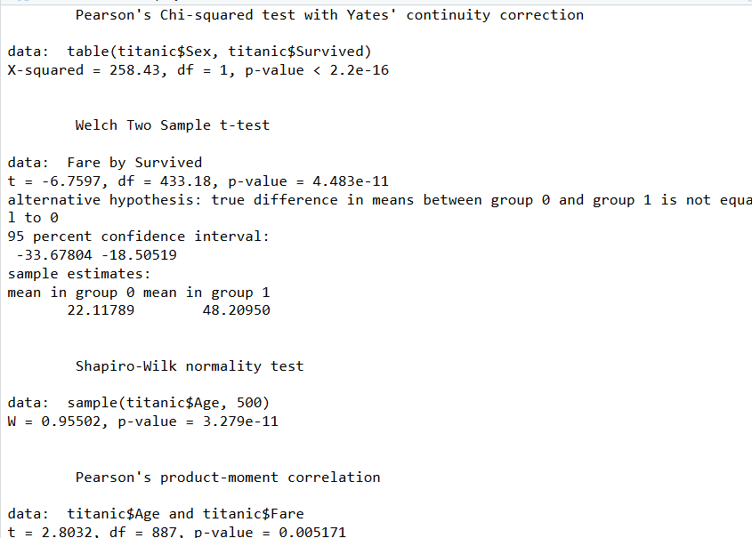
Result: X-squared = 258.43, df = 1, p-value < 2.2e-16. This is well below 0.05, so we reject the null hypothesis — survival is strongly associated with sex.

2.3 Fare Comparison: Survivors vs Non-survivors (t-test)
t_fare <- t.test(Fare ~ Survived, data = titanic)
print(t_fare)
Result: mean fare for non-survivors was 22.12 vs 48.21 for survivors, t = -6.76, p = 4.48e-11. The difference is highly significant — survivors paid substantially higher fares on average, consistent with wealthier/higher-class passengers having better survival odds.

2.4 Normality Check on Age (Shapiro-Wilk test)
shapiro_sample <- shapiro.test(sample(titanic$Age, 500))
print(shapiro_sample)
Result: W = 0.955, p = 3.28e-11. Since p < 0.05, Age is not normally distributed, so parametric tests/models that assume normality should be interpreted with some caution for this variable.

2.5 Correlation: Age and Fare
cor_test <- cor.test(titanic$Age, titanic$Fare, method = "pearson")
print(cor_test)
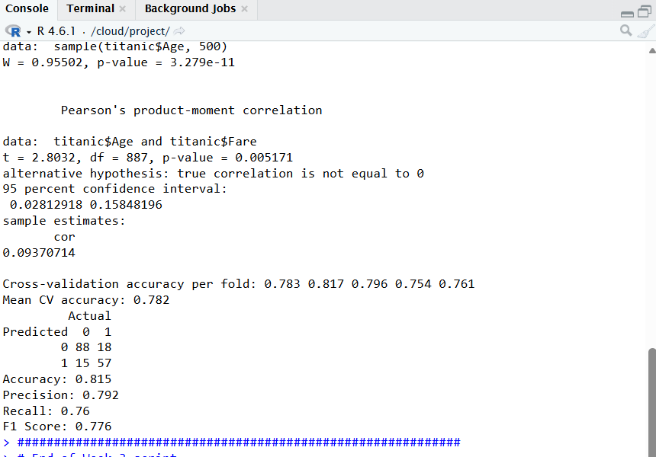
Result: r = 0.094, p = 0.0052. This is a very weak but statistically significant positive correlation — older passengers paid only slightly higher fares on average.

3. Model Building
Model type: Logistic Regression (binary classification: Survived = 0/1).
Logistic regression was chosen because the outcome variable (Survived) is binary, and logistic regression directly models the probability of a binary outcome rather than predicting a continuous value.

3.1 Train/Test Split and Model Fit
set.seed(123)
n <- nrow(titanic)
train_index <- sample(1:n, size = 0.8 * n)
train_data <- titanic[train_index, ]
test_data <- titanic[-train_index, ]

model <- glm(Survived ~ Pclass + Sex + Age + Fare + SibSp + Parch,
data = train_data, family = "binomial")
summary(model)
Sex and Pclass were the strongest, most statistically significant predictors (p < 0.001), followed by Age and SibSp. Being male and being in a lower class (2nd or 3rd) both sharply reduced the odds of survival. Fare and Parch were not statistically significant once Sex, Class, and Age were accounted for.

3.2 Cross-Validation
k <- 5
folds <- sample(rep(1:k, length.out = nrow(train_data)))
cv_accuracy <- numeric(k)

for (i in 1:k) {
cv_train <- train_data[folds != i, ]
cv_test <- train_data[folds == i, ]
cv_model <- glm(Survived ~ Pclass + Sex + Age + Fare + SibSp + Parch,
data = cv_train, family = "binomial")
cv_pred_prob <- predict(cv_model, newdata = cv_test, type = "response")
cv_pred <- ifelse(cv_pred_prob > 0.5, 1, 0)
cv_accuracy[i] <- mean(cv_pred == cv_test$Survived)
}
cat("Mean CV accuracy:", round(mean(cv_accuracy), 3), "\n")
Mean CV accuracy across 5 folds was 0.782 (range 0.754–0.817), showing the model performs consistently across different subsets of the data rather than overfitting to one split.

4. Diagnostic Analysis & Model Evaluation

4.1 Confusion Matrix and Performance Metrics
pred_prob <- predict(model, newdata = test_data, type = "response")
pred_class <- ifelse(pred_prob > 0.5, 1, 0)
conf_matrix <- table(Predicted = pred_class, Actual = test_data$Survived)
print(conf_matrix)
Accuracy = 0.815, Precision = 0.792, Recall = 0.76, F1 = 0.776. The recall of 0.76 means the model missed about a quarter of actual survivors (false negatives), while precision of 0.79 shows most predicted survivors were correctly classified.

4.2 Residual Plot
plot(model$fitted.values, residuals(model, type = "deviance"),
main = "Residuals vs Fitted (Logistic Model)",
xlab = "Fitted probabilities", ylab = "Deviance residuals",
pch = 20, col = "steelblue")
abline(h = 0, col = "red", lty = 2)
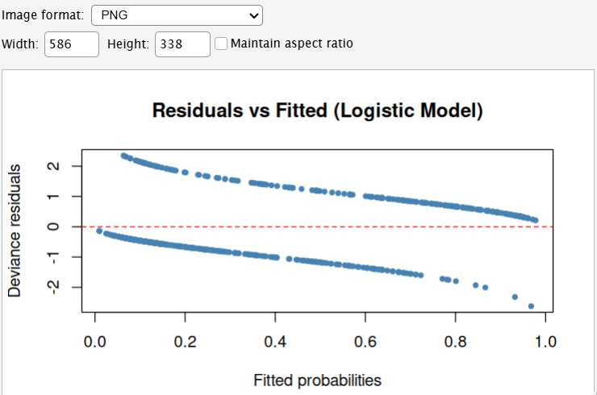
The residual plot shows two distinct curved bands rather than a random scatter — this is expected for logistic regression, since residuals naturally separate by the two outcome classes (survived vs not survived). There is no extreme funnel shape or outlier cluster, suggesting the model fit is reasonable without major violations.

4.3 Predicted Probability by Actual Outcome
boxplot(pred_prob ~ test_data$Survived,
main = "Predicted Probability by Actual Survival",
xlab = "Actual Survived (0/1)", ylab = "Predicted Probability",
col = c("tomato", "seagreen"))
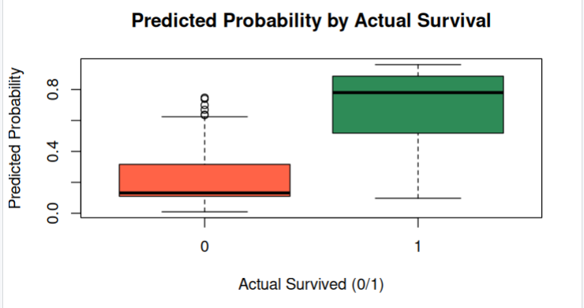
The boxplot shows clear separation between the two groups — passengers who did not survive (0) have a median predicted probability around 0.2, while passengers who survived (1) have a median predicted probability around 0.75, with minimal overlap between the boxes. This indicates the model distinguishes well between the two outcome classes.

5. Model Strengths, Limitations & Potential Improvements
The model performs well overall, with 81.5% test accuracy and consistent 5-fold cross-validation performance (~78%), and it correctly identifies sex and class as the dominant survival factors, matching well-documented historical evacuation patterns. Its main limitation is that logistic regression assumes a linear relationship between predictors and the log-odds of survival, which may miss more complex interactions (for example, between age and class, or family size and survival). The model also relies on median-imputed Age values and does not use potentially informative fields such as Cabin or passenger Title extracted from Name. Potential improvements include engineering new features (e.g., Title extracted from Name, family size from SibSp+Parch), trying non-linear models such as Random Forest or Gradient Boosting for comparison, and tuning the classification threshold instead of using a fixed 0.5 cutoff to better balance precision and recall.

6. Conclusion
The hypothesis tests confirmed that survival on the Titanic was significantly associated with passenger class, sex, and fare paid, while age was found to be non-normally distributed and only weakly correlated with fare. The logistic regression model built on these variables achieved 81.5% accuracy and an F1 score of 0.776 on the test set, with consistent cross-validation performance, confirming that sex and class are the strongest predictors of survival. These findings, along with the cleaned dataset and visualizations from Weeks 1 and 2, set up a solid foundation for Week 4's comprehensive integration report.

