Week 1: Data Cleaning and Preliminary Analysis Using R
Dataset: Titanic Passenger Dataset (Kaggle / public domain)
Prepared by: Sweta

1. Introduction & Dataset Overview
This report documents the data cleaning, preprocessing, and preliminary exploratory analysis of the Titanic passenger dataset, a widely used public dataset for learning data analysis techniques. The dataset contains demographic and travel information for 891 passengers aboard the RMS Titanic, along with whether each passenger survived.
The dataset was chosen because it naturally contains the complexities required for this task: missing values (in the Age, Cabin, and Embarked columns), a mix of numerical variables (Age, Fare, SibSp, Parch) and categorical variables (Sex, Pclass, Embarked, Survived), and realistic outliers (particularly in the Fare column).

1.1 Dataset Structure
Column | Type | Description
PassengerId | Numeric | Unique identifier for each passenger
Survived | Categorical | 0 = Did not survive, 1 = Survived
Pclass | Categorical | Ticket class (1st, 2nd, 3rd)
Name, Sex, Age | Mixed | Passenger demographic details
SibSp, Parch | Numeric | Number of siblings/spouses, parents/children aboard
Fare | Numeric | Ticket fare paid
Cabin | Categorical | Cabin number (mostly missing)
Embarked | Categorical | Port of embarkation (C, Q, S)

The dataset was loaded into R using the following code:
titanic <- read.csv("titanic.csv", stringsAsFactors = FALSE)
str(titanic)
dim(titanic)
Initial inspection using dim() confirmed the dataset has 891 rows and 12 columns.

2. Data Cleaning Process

2.1 Identifying Missing Values
The colSums(is.na()) function was used to count missing values in numeric columns, and an additional check for empty strings was performed for character columns (since R does not always read blanks as NA when importing CSV files).
colSums(is.na(titanic))
colSums(titanic == "")
Age: 177 missing values (19.9%)
Cabin: 687 missing values (77.1%)
Embarked: 2 missing values (0.2%)
This confirmed three columns required cleaning: Age (numeric, moderate missingness), Cabin (categorical, very high missingness), and Embarked (categorical, minimal missingness).

2.2 Handling Missing Values
- Age: Imputed missing values with the median age, since Age is numeric and slightly skewed — median is more robust to outliers than the mean.
- Embarked: Imputed the 2 missing values with the mode (most frequent port, 'S'), as this is standard practice for categorical variables with very few missing entries.
- Cabin: Since over 77% of values were missing, imputing would introduce unreliable data. Instead, the column was converted into a binary flag (Cabin_Known: 1 if cabin was recorded, 0 otherwise) and the original column was dropped.
titanic$Age[is.na(titanic$Age)] <- median(titanic$Age, na.rm = TRUE)
mode_embarked <- names(sort(table(titanic$Embarked[titanic$Embarked != ""]),
decreasing = TRUE))[1]
titanic$Embarked[titanic$Embarked == ""] <- mode_embarked
titanic$Cabin_Known <- ifelse(titanic$Cabin == "", 0, 1)
titanic$Cabin <- NULL

2.3 Outlier Detection
Outliers were detected using the Interquartile Range (IQR) method, where any value beyond 1.5 × IQR from the first or third quartile is flagged as an outlier. This method was applied to the Fare and Age columns.
detect_outliers <- function(x) {
Q1 <- quantile(x, 0.25); Q3 <- quantile(x, 0.75)
IQR_val <- Q3 - Q1
lower <- Q1 - 1.5 * IQR_val
upper <- Q3 + 1.5 * IQR_val
sum(x < lower | x > upper)
}
detect_outliers(titanic$Fare)
detect_outliers(titanic$Age)
Outliers in Fare: 116
Outliers in Age: 11
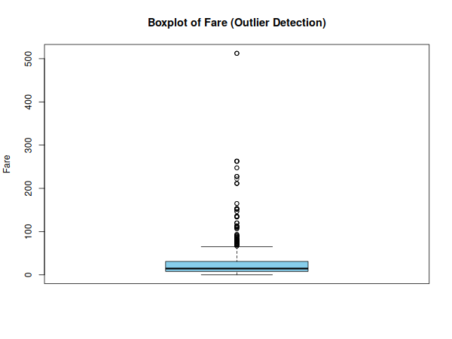
Figure 1: Boxplot of Fare showing a large number of high-value outliers
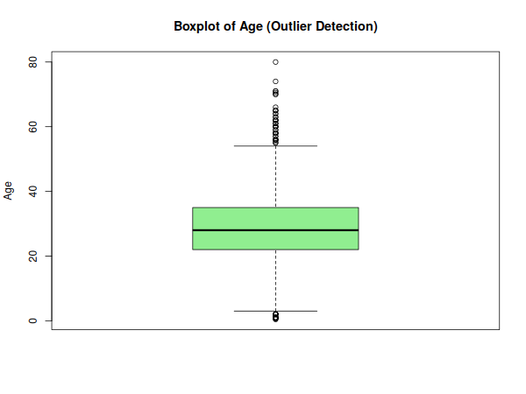
Figure 2: Boxplot of Age showing a smaller number of outliers
Fare had a substantially higher number of outliers (116) compared to Age (11), reflecting the wide gap between economy and first-class ticket prices. Rather than removing these records (which would discard real, meaningful information about wealthy passengers), extreme Fare values were capped at the 99th percentile — a technique called winsorization — to reduce their influence on later statistical analysis without losing the records entirely.
cap_val <- quantile(titanic$Fare, 0.99)
titanic$Fare_capped <- ifelse(titanic$Fare > cap_val, cap_val, titanic$Fare)

2.4 Normalization
Min-Max normalization was applied to Age and the capped Fare column, scaling both to a range of 0 to 1. Normalization is important so that variables measured on very different scales (Age in years vs Fare in currency) can later be compared or used together in a model without one variable dominating due to scale alone.
normalize <- function(x) (x - min(x)) / (max(x) - min(x))
titanic$Age_norm <- normalize(titanic$Age)
titanic$Fare_norm <- normalize(titanic$Fare_capped)

2.5 Encoding Categorical Variables
Two encoding strategies were used depending on the nature of the categorical variable:
- Label Encoding: Sex was converted to a binary numeric column (Sex_encoded: 1 = male, 0 = female), since it has only two categories.
- One-Hot Encoding: Embarked (3 categories: C, Q, S) was expanded into three separate binary columns, since it has no natural order and more than two categories.
- Factor Conversion: Pclass and Survived were converted into R factors with descriptive labels, which is appropriate for ordinal/categorical variables used in summaries and visualizations.
titanic$Sex_encoded <- ifelse(titanic$Sex == "male", 1, 0)
titanic$Embarked_C <- ifelse(titanic$Embarked == "C", 1, 0)
titanic$Embarked_Q <- ifelse(titanic$Embarked == "Q", 1, 0)
titanic$Embarked_S <- ifelse(titanic$Embarked == "S", 1, 0)
titanic$Pclass <- factor(titanic$Pclass, levels = c(1,2,3),
labels = c("1st","2nd","3rd"))
titanic$Survived <- factor(titanic$Survived, levels = c(0,1),
labels = c("No","Yes"))

3. Exploratory Data Analysis

3.1 Structure and Summary After Cleaning
str(titanic)
summary(titanic)
'data.frame': 891 obs. of 20 variables:
$ Survived : Factor w/ 2 levels "No","Yes"
$ Pclass : Factor w/ 3 levels "1st","2nd","3rd"
$ Sex : chr "male" "female" "female" "female" ...
$ Age : num 22 38 26 35 35 28 54 2 27 14 ...
$ Fare : num 7.25 71.28 7.92 53.1 8.05 ...
$ Embarked : chr "S" "C" "S" "S" ...
$ Cabin_Known : num 0 1 0 1 0 0 1 0 0 0 ...
...(additional engineered columns: Fare_capped, Age_norm, Fare_norm,
Sex_encoded, Embarked_C/Q/S)
The dataset now contains no missing values in the key analysis columns, and all categorical variables are properly typed for statistical summaries and visualization.

3.2 Descriptive Statistics & Survival Breakdown
table(titanic$Survived)
prop.table(table(titanic$Survived))
table(titanic$Sex, titanic$Survived)
table(titanic$Pclass, titanic$Survived)
Survived: No = 549 (61.6%) Yes = 342 (38.4%)
Sex vs Survived:
No Yes
female 81 233
male 468 109
Pclass vs Survived:
No Yes
1st 80 136
2nd 97 87
3rd 372 119
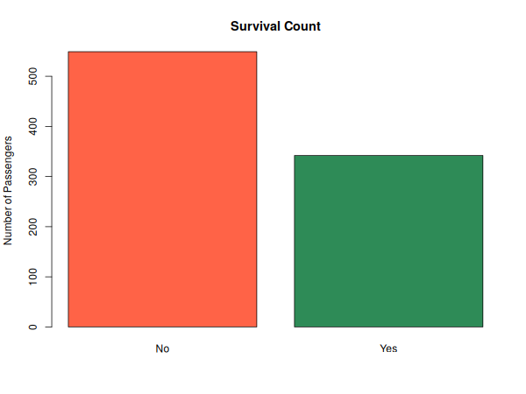
Figure 3: Overall survival counts
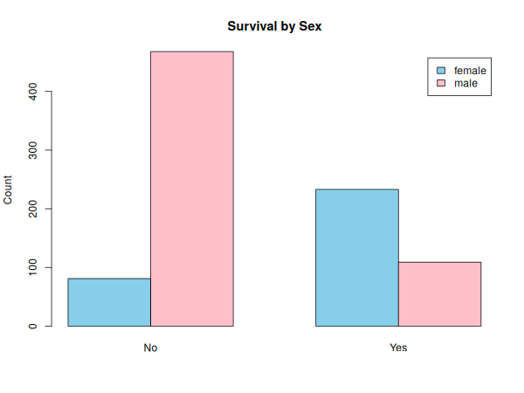
Figure 4: Survival counts split by sex
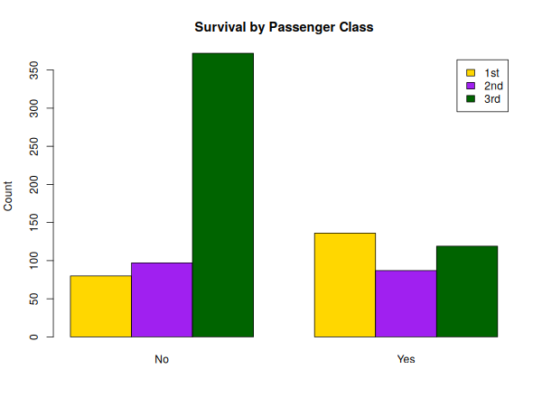
Figure 5: Survival counts split by passenger class
Key insight: Survival rate was strongly associated with both sex and class. Female passengers survived at a much higher rate than male passengers (74% vs 19%), and 1st class passengers survived at a much higher rate (63%) than 3rd class passengers (24%). This is consistent with the historical 'women and children first' evacuation policy and the location of higher-class cabins closer to lifeboats.

3.3 Distribution of Age
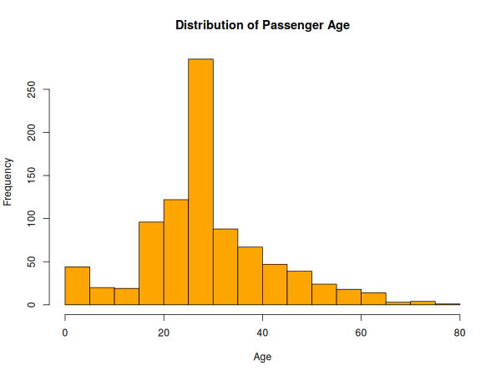
Figure 6: Histogram of passenger age after median imputation
The Age distribution is right-skewed with a concentration of passengers between 20 and 40 years old. A small spike around the imputed median value is visible, which is an expected side effect of median imputation and is noted here for transparency.

3.4 Relationship Between Age and Fare
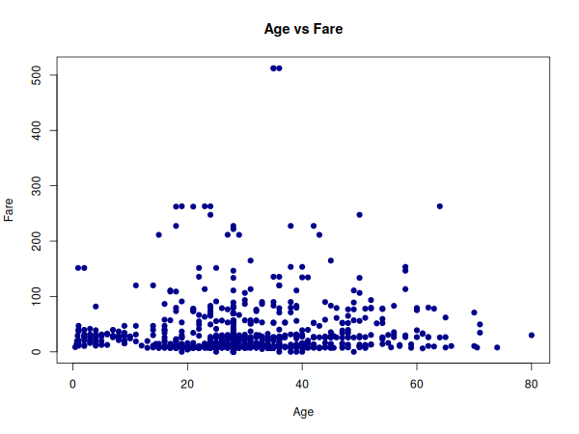
Figure 7: Scatter plot of Age vs Fare
The scatter plot shows no strong linear relationship between Age and Fare — passengers of all ages paid a wide range of fares, though the highest fares (associated with 1st class) were paid across a broad age range rather than concentrated in a specific age group.

3.5 Correlation Analysis
num_vars <- titanic[, c("Age","Fare","SibSp","Parch","Sex_encoded")]
cor(num_vars, use = "complete.obs")
Age Fare SibSp Parch Sex_encoded
Age 1.00 0.10 -0.23 -0.17 0.08
Fare 0.10 1.00 0.16 0.22 -0.18
SibSp -0.23 0.16 1.00 0.41 -0.11
Parch -0.17 0.22 0.41 1.00 -0.25
Sex_encoded 0.08 -0.18 -0.11 -0.25 1.00
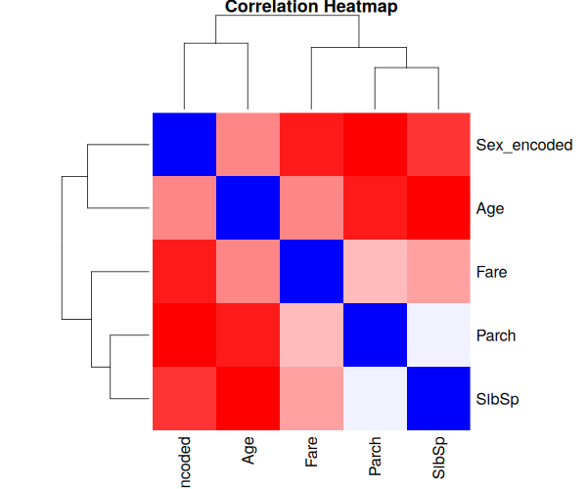
Figure 8: Correlation heatmap of numeric variables
Notable correlations: SibSp (siblings/spouses aboard) and Parch (parents/children aboard) have a moderate positive correlation (0.41), which makes sense since both relate to family group size. Sex_encoded (male = 1) has a mild negative correlation with Fare (-0.18) and Parch (-0.25), suggesting men were slightly more likely to travel alone and in lower fare classes than women, who often travelled with family.

4. Key Insights Summary
- The dataset required three distinct missing-value strategies: median imputation (Age), mode imputation (Embarked), and feature engineering into a binary flag (Cabin), chosen based on the type and severity of missingness in each column.
- Fare contained significantly more outliers than Age (116 vs 11), handled through winsorization at the 99th percentile rather than deletion, to preserve sample size.
- Survival was strongly related to Sex and Pclass — female and 1st-class passengers had far higher survival rates.
- Family-related variables (SibSp, Parch) were moderately correlated, while Age and Fare showed little linear relationship.
- After cleaning, normalization, and encoding, the dataset is fully prepared for further statistical modelling (to be built upon in Week 3's predictive modelling task).

5. Conclusion
This task involved end-to-end data cleaning and exploratory analysis of the Titanic dataset using R. Missing values were handled using context-appropriate strategies, outliers were detected and treated using the IQR method and winsorization, numeric variables were normalized, and categorical variables were encoded using both label and one-hot encoding. The exploratory analysis using summary(), str(), tables, and multiple visualizations revealed clear patterns in survival related to sex and passenger class, providing a strong, clean foundation for the visualization and predictive modelling tasks in subsequent weeks.

