Week 4: Comprehensive Data Analysis Reporting and Presentation
Titanic Passenger Dataset — End-to-End Analysis
Prepared by: Sweta
GitHub Repository: github.com/sweta-y/titanic-week1-analysis
Integrating the Week 1 (Data Cleaning), Week 2 (Visualization), and Week 3 (Statistical Modelling) tasks into a single, cohesive final report.

Table of Contents
1. Introduction
2. Data Preparation (Week 1 Recap)
3. Data Visualization (Week 2 Recap)
4. Statistical Analysis & Predictive Modelling (Week 3 Recap)
5. Discussion: Integrated Insights & Business Implications
6. Conclusion: Lessons Learned, Challenges & Future Directions

1. Introduction
This report brings together four weeks of work analysing the Titanic passenger dataset, a widely used public dataset (891 passengers, 12 original columns) that combines demographic, travel, and survival information. Across the internship, the dataset was progressively cleaned, visualised, and modelled to answer one central question: which factors most strongly influenced a passenger's chance of survival?
The Titanic dataset was originally selected because it contains the complexities this internship required: missing values across multiple columns (Age, Cabin, Embarked), a mix of numerical and categorical variables, and realistic outliers in ticket fares. This made it well suited to demonstrate the full data analysis lifecycle — cleaning, exploration, visual communication, and predictive modelling — in a single connected narrative rather than four disconnected exercises.
Sections 2 through 4 summarise the methodology and results from each of the three preceding weeks. Section 5 draws these threads together into an integrated discussion, and Section 6 reflects on lessons learned and directions for further analysis.

2. Data Preparation (Week 1 Recap)
The first phase of the project focused entirely on getting the raw dataset into a clean, analysis-ready state using R.

2.1 Missing Value Treatment
Three columns required attention, each treated according to the type and severity of its missingness:
- Age (19.9% missing, numeric): imputed with the median, since Age is slightly right-skewed and the median is more robust to outliers than the mean.
- Embarked (0.2% missing, categorical): imputed with the mode ('S', the most frequent port), standard practice for a categorical column with very few gaps.
- Cabin (77.1% missing, categorical): too sparse to impute reliably, so it was converted into a binary flag (Cabin_Known) and the raw column dropped.
titanic$Age[is.na(titanic$Age)] <- median(titanic$Age, na.rm = TRUE)
mode_embarked <- names(sort(table(titanic$Embarked[titanic$Embarked != ""]),
decreasing = TRUE))[1]
titanic$Embarked[titanic$Embarked == ""] <- mode_embarked
titanic$Cabin_Known <- ifelse(titanic$Cabin == "", 0, 1)
titanic$Cabin <- NULL

2.2 Outlier Detection & Treatment
The IQR method (values beyond 1.5x IQR from Q1/Q3) flagged 116 outliers in Fare and 11 in Age. Rather than deleting the Fare outliers — which would discard genuine information about wealthy passengers — extreme values were winsorized (capped) at the 99th percentile.
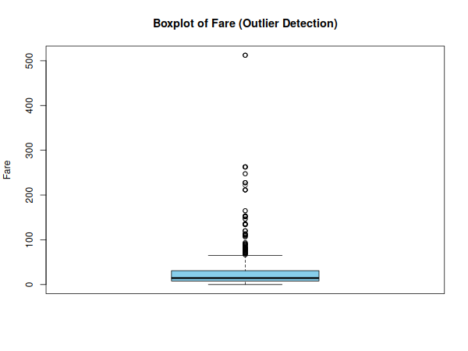
Figure 1: Boxplot of Fare showing a large number of high-value outliers.

2.3 Normalization & Encoding
Min-Max normalization scaled Age and capped Fare to a 0–1 range so the two variables could later be compared on equal footing. Categorical variables were encoded with the method appropriate to their structure: Sex via label encoding (binary), Embarked via one-hot encoding (3 unordered categories), and Pclass/Survived as R factors with descriptive labels.

2.4 Initial Exploratory Findings
After cleaning, the dataset contained no missing values in any analysis column. Descriptive breakdowns immediately surfaced the dataset's central pattern: 38.4% of passengers survived overall, but survival was heavily skewed by sex (74% of women survived vs 19% of men) and by class (63% of 1st class passengers survived vs 24% of 3rd class).
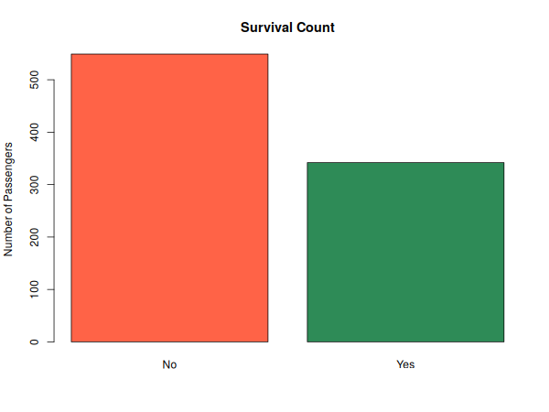
Figure 2: Overall survival counts (No = 549, Yes = 342).
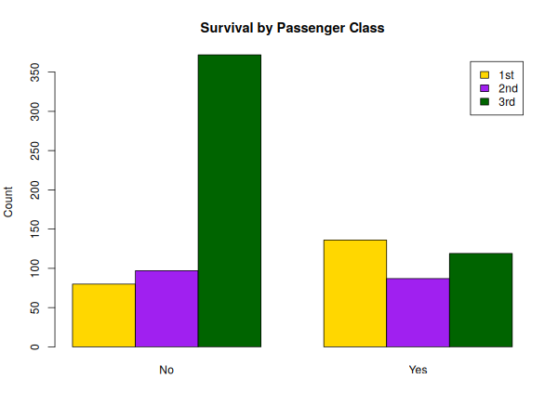
Figure 3: Survival counts split by passenger class.
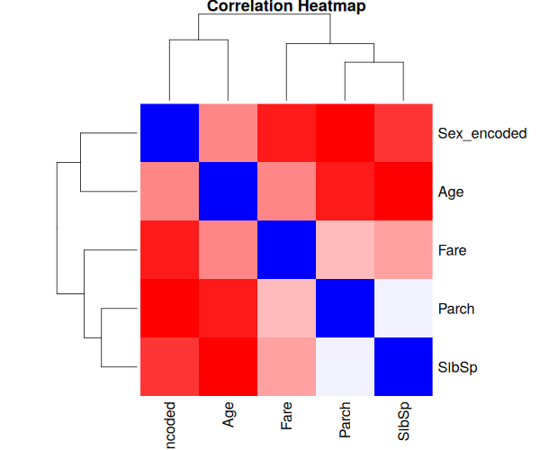
Figure 4: Correlation heatmap of numeric variables — SibSp and Parch show the strongest relationship (r = 0.41).
These early patterns — the strength of Sex and Pclass as survival predictors — turned out to anchor every subsequent phase of the project.

3. Data Visualization (Week 2 Recap)
The second week built on the cleaned dataset from Week 1 to produce eight visualizations in R, each chosen to communicate a different type of pattern — categorical comparison, proportion, distribution shape, spread, correlation, trend, part-to-whole composition, and a two-way categorical relationship.

3.1 Categorical Comparisons
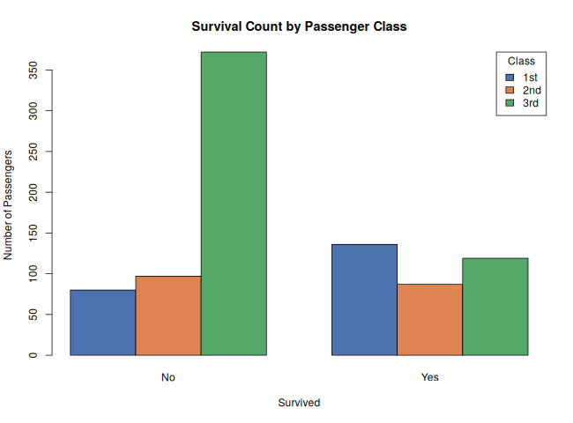
Figure 5: Grouped bar chart — survival counts by passenger class. 1st class passengers were the only group where survivors outnumbered non-survivors.
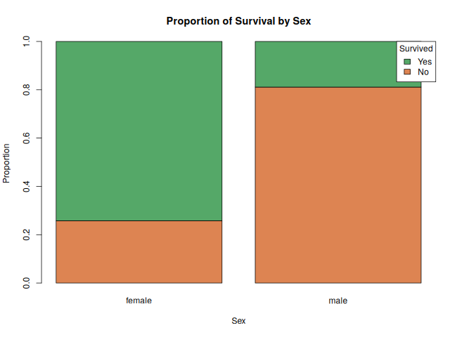
Figure 6: Stacked proportion bar chart — survival rate by sex, making the ~74% vs ~19% survival gap immediately visible.

3.2 Distribution & Spread
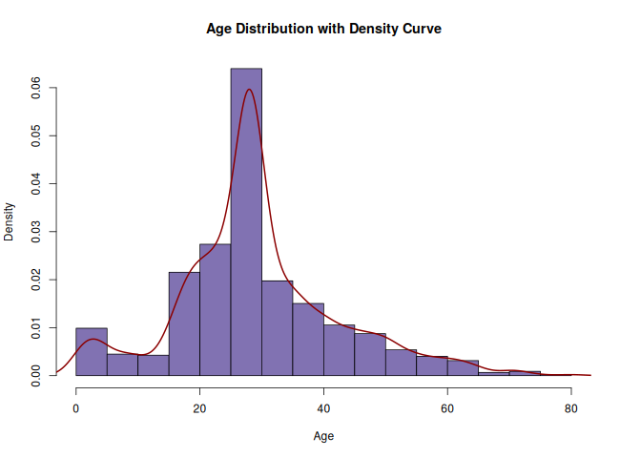
Figure 7: Histogram with density overlay — Age is right-skewed, concentrated between 20 and 40 years, with a small spike at the imputed median.
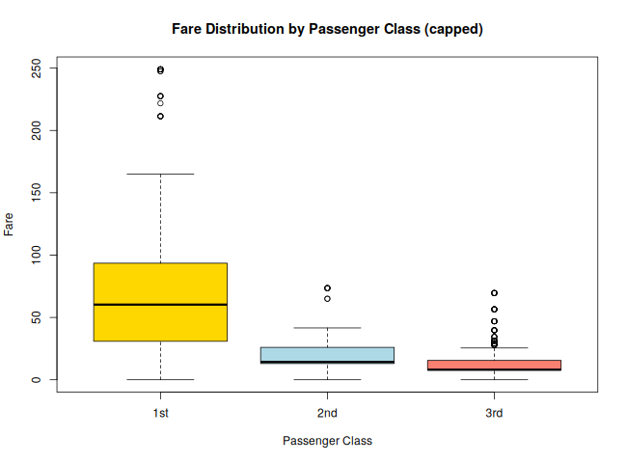
Figure 8: Boxplot of capped Fare by class, showing 1st class fares are both higher and far more variable than 2nd or 3rd class.

3.3 Relationships & Trends
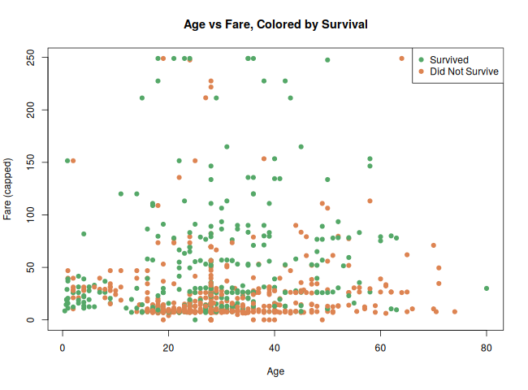
Figure 9: Age vs Fare scatter plot coloured by survival — survivors (green) cluster at higher fares across all ages, but no clear age effect on its own.
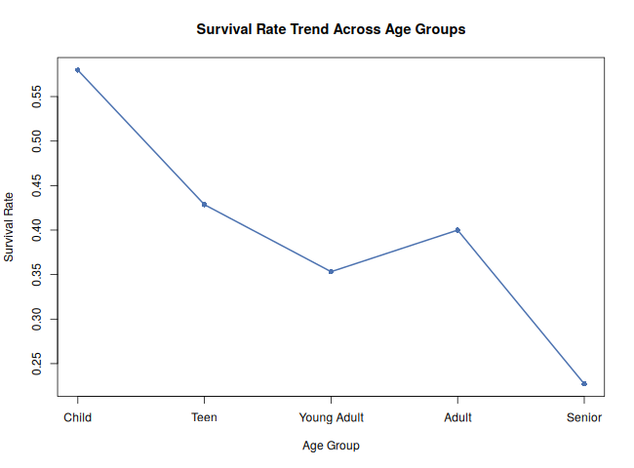
Figure 10: Survival rate trend across age groups (Child → Senior) — children had a noticeably higher survival rate than adults.

3.4 Composition & Two-Way Categorical View
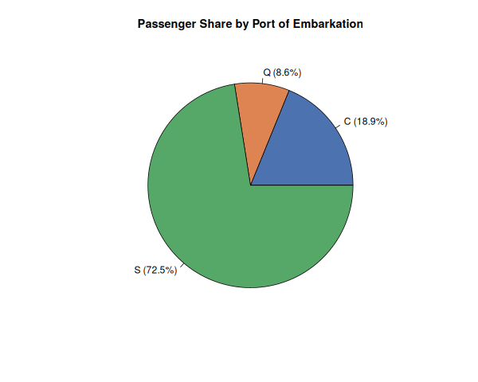
Figure 11: Passenger share by port of embarkation — the majority boarded at Southampton (S).
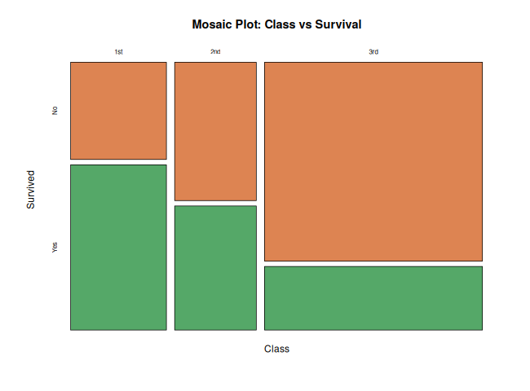
Figure 12: Mosaic plot of class vs survival — box widths represent class size and heights represent survival split, visually reinforcing the class gradient seen in Figure 5.
Taken together, the eight visualizations reinforced and sharpened the findings from Week 1: survival was driven primarily by sex and class, with age acting as a secondary factor (children faring better than adults) and fare acting largely as a proxy for class rather than an independent effect.

4. Statistical Analysis & Predictive Modelling (Week 3 Recap)

4.1 Hypothesis Testing
Formal hypothesis tests confirmed what the visualizations suggested:
Test | Comparison | Result | Conclusion
Chi-square | Survival vs Pclass | X² = 100.98, df = 2, p < 2.2e-16 | Significant association
Chi-square | Survival vs Sex | X² = 258.43, df = 1, p < 2.2e-16 | Significant association
t-test | Fare: survivors vs non-survivors | t = -6.76, p = 4.48e-11 | Survivors paid significantly more
Shapiro-Wilk | Normality of Age | W = 0.955, p = 3.28e-11 | Age is not normally distributed
Pearson correlation | Age vs Fare | r = 0.094, p = 0.0052 | Very weak, but significant, positive correlation
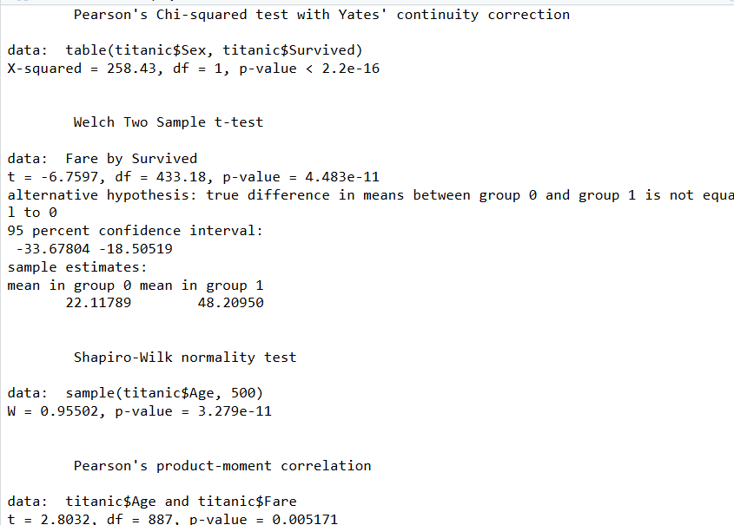
Figure 13: R console output verifying the Sex vs Survival chi-square test and the Fare t-test reported above.

4.2 Logistic Regression Model
A logistic regression model was fitted to predict Survived from Pclass, Sex, Age, Fare, SibSp, and Parch, using an 80/20 train-test split (seed = 123). Sex and Pclass emerged as the strongest, most statistically significant predictors (p < 0.001), followed by Age and SibSp; Fare and Parch lost significance once Sex, Class, and Age were accounted for — confirming that Fare's earlier apparent effect was largely explained by class.
model <- glm(Survived ~ Pclass + Sex + Age + Fare + SibSp + Parch,
data = train_data, family = "binomial")

4.3 Cross-Validation & Test Performance
5-fold cross-validation produced a mean accuracy of 0.782 (range 0.754–0.817), indicating the model generalises consistently rather than overfitting one split. On the held-out test set, the model achieved:
Metric | Value
Accuracy | 0.815
Precision | 0.792
Recall | 0.760
F1 Score | 0.776
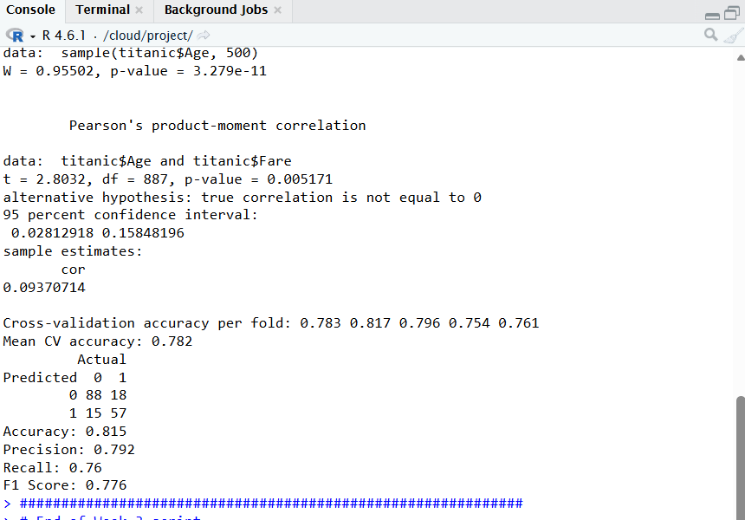
Figure 14: R console output showing the Shapiro-Wilk test, Age-Fare correlation, per-fold cross-validation accuracy, and the confusion matrix underlying the metrics below.
The underlying confusion matrix on the test set (n = 178) was:
 | Actual: No | Actual: Yes
Predicted: No | 88 | 18
Predicted: Yes | 15 | 57

4.4 Diagnostics
The deviance residual plot showed two distinct curved bands rather than random scatter — expected behaviour for logistic regression, since residuals separate by outcome class — with no extreme funnel shape or outlier cluster.
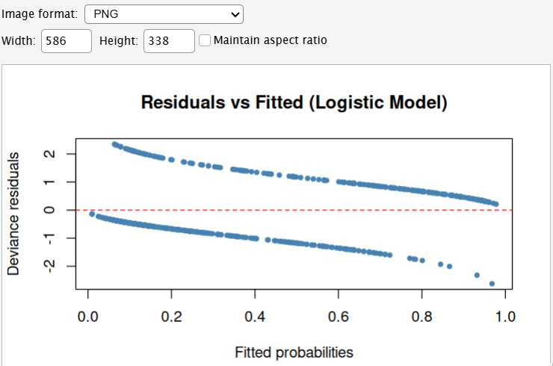
Figure 15: Residuals vs fitted values for the logistic regression model.
Predicted probabilities also separated cleanly by actual outcome: non-survivors clustered around a median predicted probability of ~0.2, survivors around ~0.75, with minimal overlap — evidence the model discriminates well between the two classes.
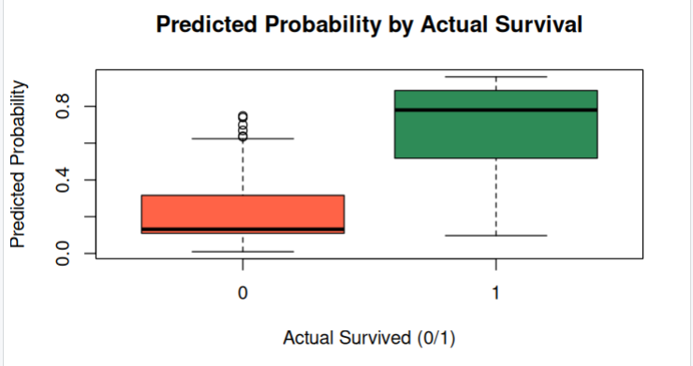
Figure 16: Predicted probability distribution by actual survival outcome.

5. Discussion: Integrated Insights & Business Implications
Viewed as a whole, all three analytical phases converge on the same conclusion through different methods: sex and passenger class were the dominant determinants of survival on the Titanic, consistent with the historical 'women and children first' evacuation policy and the physical proximity of higher-class cabins to lifeboats.
- Data cleaning (Week 1) surfaced the pattern descriptively — 74% vs 19% survival by sex, 63% vs 24% by class.
- Visualization (Week 2) made the pattern immediately legible to a non-technical audience through bar, stacked-bar, and mosaic charts, and added a secondary insight: children survived at higher rates than adults.
- Statistical modelling (Week 3) confirmed the pattern was not due to chance (p < 2.2e-16 for both Sex and Pclass) and quantified it in a predictive model with 81.5% test accuracy.
In a real-world (non-historical) setting, this kind of layered analysis — descriptive, visual, then confirmatory/predictive — mirrors how a business analytics team would validate a hypothesis before acting on it: first spot a pattern in the data, then communicate it visually to stakeholders, then confirm it statistically and build a model that can generalise to new cases. The consistency across all three methods is itself a finding — it means the survival-by-sex-and-class pattern is robust and not an artifact of any single technique or visualization choice.
The weak Age-Fare correlation and the loss of Fare's significance once class was included in the regression are also practically useful: they show that Fare was largely a proxy for class rather than an independent driver of outcomes, a distinction that matters when deciding which variables are worth engineering further versus which are redundant.

6. Conclusion: Lessons Learned, Challenges & Future Directions

6.1 Lessons Learned
- Choosing the right missing-value strategy depends on both the variable's type and the severity of missingness — a single blanket approach (e.g. always impute, or always drop) would have either discarded useful passengers (Cabin) or introduced bias (Age with mean instead of median).
- Visual and statistical evidence reinforce each other: a chart makes a pattern visible, but a hypothesis test is what confirms it is not due to random chance.
- Simpler models (logistic regression) can perform strongly and remain interpretable, which matters when the goal includes explaining *why* a prediction was made, not only how accurate it is.

6.2 Challenges
- Balancing outlier treatment: deciding to winsorize Fare rather than delete or leave outliers required weighing information loss against distortion of later statistical tests.
- Median imputation of Age introduced a visible artificial spike in its distribution (Figure 7), a limitation that had to be acknowledged rather than hidden.
- Logistic regression's linearity assumption meant potential interaction effects (e.g. Age x Class) were not directly captured.

6.3 Future Directions
- Engineer new features such as passenger Title (extracted from Name) and family size (SibSp + Parch), which are known in the wider literature to improve Titanic survival models.
- Compare logistic regression against non-linear models such as Random Forest or Gradient Boosting to test whether interaction effects meaningfully improve accuracy.
- Tune the classification threshold (currently a fixed 0.5 cutoff) to better balance precision and recall depending on which type of error is more costly in context.
Overall, this four-week project demonstrated a complete, defensible data analysis workflow in R — from raw, messy data to a validated predictive model — with each week's output directly informing the next, culminating in this integrated report.

