**CANN**

Although a CANN is able to track a moving input, its reaction time is always delayed with respect to the instant position of the input, due to that neurons responding to external input and neuronal interaction via recurrent synapses consume time.

Continuous attractor neural networks (CANNs) are widely used as a canonic model to describe the encoding of continuous features, such as head-direction, moving direction, orientation or spatial location of an object, in the brain.

**----------------------------------------------------------------------------------------------------**

**#Nodes = 100**

**Aw (strength constant or scale factor) = 100**

**C is Inhibition constant.**

**Slope parameter of Sigmoidal gain function = 0.1**

**The initial values of average states are -10.**

**X-axis = time at which the average state ‘u’ of ith node is changing** (taking smaller steps where the average state changes rapidly and larger steps where it’s relatively constant).

**Y-axis =** the rate of change in average state ‘u’ of ith node with time shown by a sigmoidal gain function.

Time of active external input is from (0th to 10th) and active length of the external input is from node 45th to node 55th (central nodes in the n/w) and value initialized to these indices is 10.

Equilibrate states are from node 10th to node 100th.

**-------------------------------------Time evolution of node activity in the network------------------------------------**

**Tau (time constant) = 1 and Firing Threshold =0**

If inhibition constant (C=0.1) is less then the suppression of the other node activity in the network is through a short range and vice versa. And as the suppression range is increasing, the persistence of the activity packet even after the external input removed is being lost.

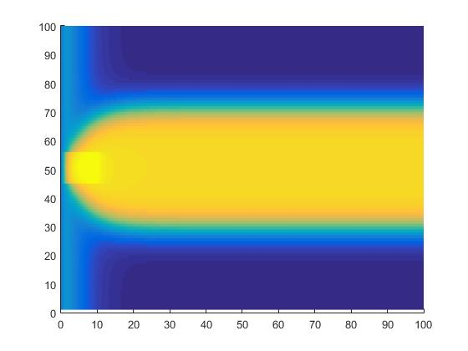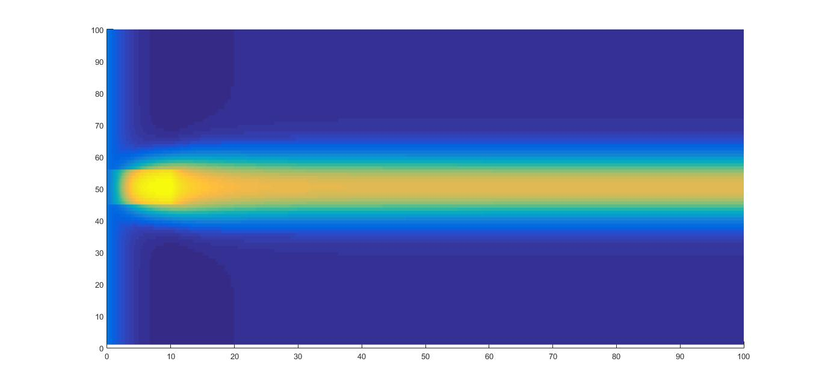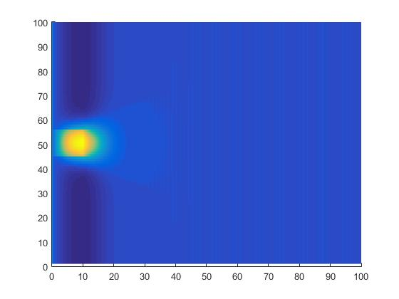

**C = 0.1 C = 0.2 C = 0.3**

**--------------------------------------------------------------------------------------------------------------------------------------**

**Firing Threshold =0, C = 0.2**

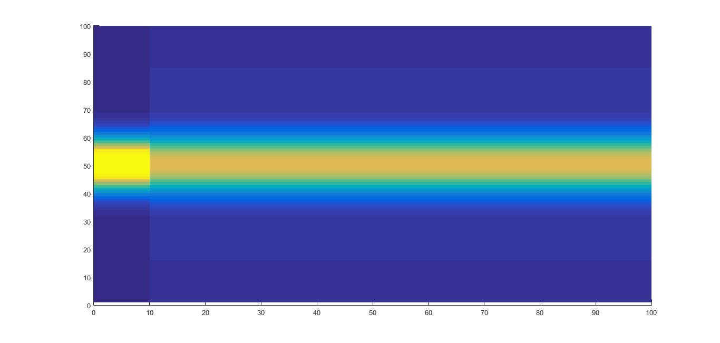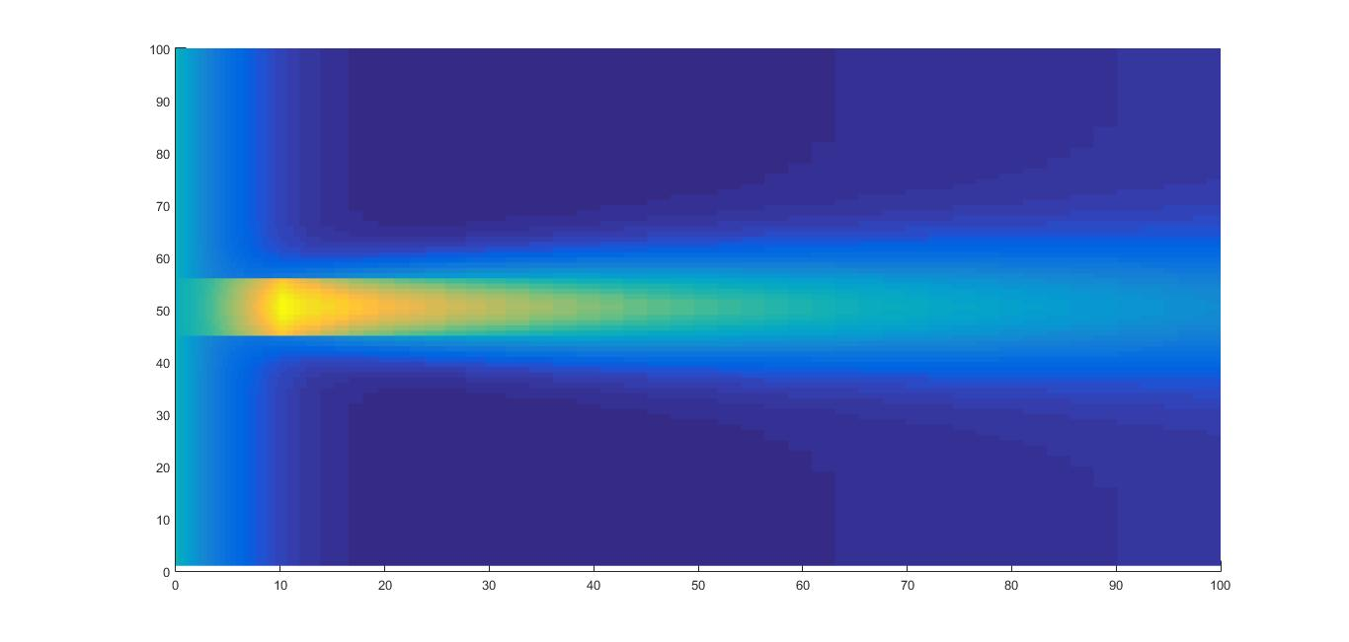

**Tau = 0.001 Tau = 10**

Activity starts much early and persists through a long range as much as the tau value is less.

-------------------------------------------------------------------------------------------------------------------------------

**Tau = 50, C = 0.2**

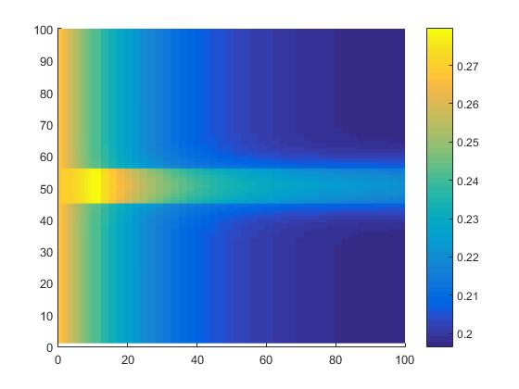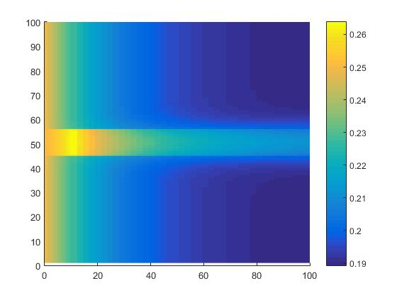

**Firing Threshold = 0 Firing Threshold = 1**

The strength of the node activity is high if the firing threshold is low.

-----------------------------------------------------------------------------------------------------------------------------------------

100 nodes

From 0 to 10, external input is given with I_ext values listed in the table. The experiment was done with time value 1000.

|  |  |  |  |  |  |
| --- | --- | --- | --- | --- | --- |
| **C** | **Aw** | **I_ext** | **Tau** | **Firing Threshold (Th)** | **Attractor State** |
| 0.2 | 100 | 2.8832 | 1 | 0 | Remains |
| 0.2 | 100 | 2.955 | 1 | 0.1 | Remains |
| 0.2 | 100 | 3.03075 | 1 | 0.2 | Remains |
| 0.21 | 100 | 3.03075 | 1 | 0.2 | Lost(inhibited) |
| 0.2 | 99.99998 | 3.03075 | 1 | 0.2 | Remains |
| 0.2 | 99.99998 | 3.03075 | 1.00001 | 0.2 | Remains |

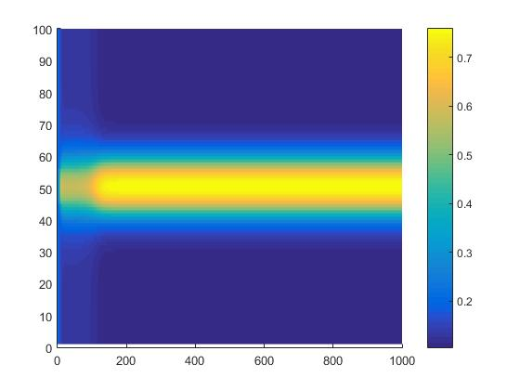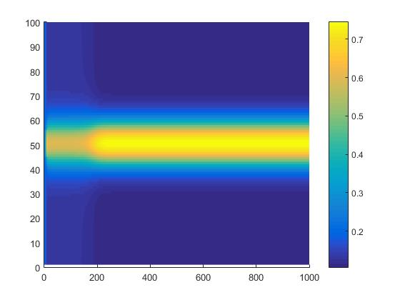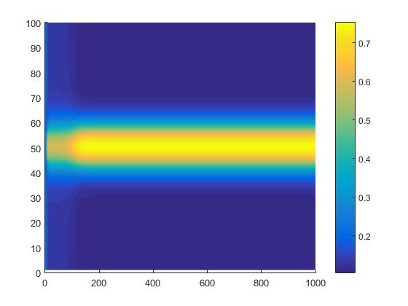

**I_ext = 2.8832 I_ext = 2.955 I_ext = 3.03075**

**Th = 0 Th = 0.1 Th = 0.2**

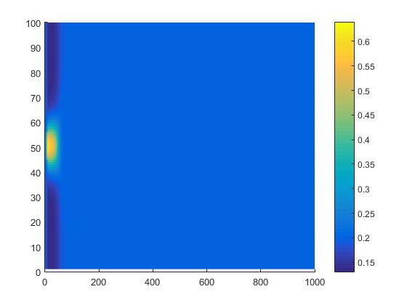

**I_ext = 3.03075, Th = 0.2, C= 0.21**

**Stabilization of the activity packet**

**--------------------------------------------------------------------------------------------------------------------------------------**

**#nodes = 1000**

**Aw (strength constant or scale factor) = 200**

**C is Inhibition constant.**

**Slope parameter of Sigmoidal gain function = 0.1,**

