**Computational Neuroscience Assignment-4**

**Convolutional Neural Network**

**BT6270**

**Sweta Kumari**

**BT17D019**

**1. Three figures (mona, ball, cat) are given in .txt format. Each figure is a 90x100 matrix.**

**a. Visualize the images and make sure that the black pixels are represented by -1 and white pixels are represented by +1.**

**Ans.**

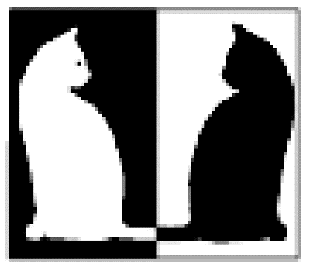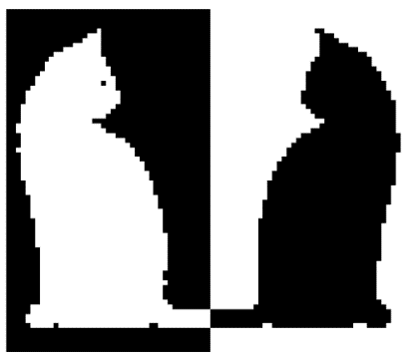

Other two were already in binary form (-1 or 1).

**b. Develop a code for Hopfield network with N=9000 neurons which are fully connected**

**Ans.** We are given three images ball, cat, and mona, each of which is 90 x 100 dimension. To develop a code for **Discrete Hopfield network** with (90 * 100) 9000 neurons, each of which is connected to all other neurons excepting itself with a particular connection weight between them.

This code contains the step:

1. Load the three images and save it as 3*9000 matrix by reshaping those (from 90 x100 to 9000) and appending those in that matrix.
2. Checked all three images are in binary format.
3. Kept those images for training the network.
4. Prepared trigger images by changing some patches of those images.

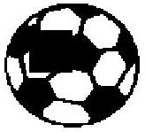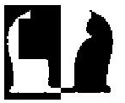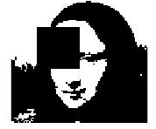

1. Calculated weight matrix from training images.
2. Updated each node using till 50 iterations:



1. Finally got the retrieved images from trigger images.

The code is attached in ‘hopf_1_2_3.m’ file.

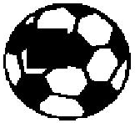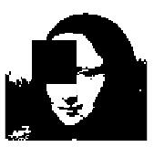

**Trigger Image**

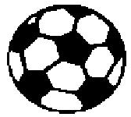 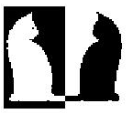 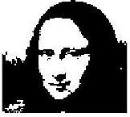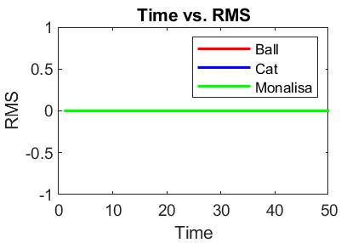

**Retrieved**

Wrote the code Hopfield Network and run the code for the above trigger images (covered some part of the image with black patch to put the noise in the trigger images) and the retrieved images are also shown in just bellow of the trigger image.

**2. Save the image of ball in the network**

**a. Initialize a zero matrix of the same size as that of the input image and replace a small patch with a portion of the input image as shown in figure 1. Use this (figure 1.B) as the cue for retrieving the image**

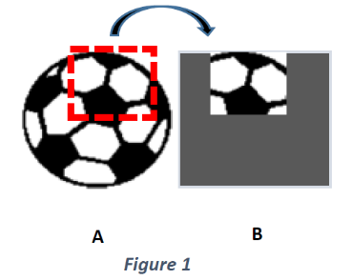

**b. Plot the patch which is given as the input trigger**

**Ans.** These are the patches of size (11 x 11) which are given as input trigger for all three images

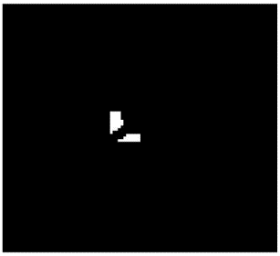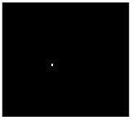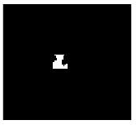

**Mona**

**Cat**

**Ball**

**c. Plot the Root Mean Squared (RMS) error with time**

**Ans.** This plot is shown for the above patches as trigger images with no noise in weights



**3. Save all three images (mona, ball and cat) in the network**

**a. Give small patches of each image to retrieve the corresponding saved image.**

**Ans.** These are the patches of size (11 x 11) which are given as input trigger for all three images



**Mona**

**Cat**

**Ball**

**b. Plot the RMS error with time and the final retrieved image for all three inputs.**

**Ans.** This plot is shown for the above patches as trigger images with no noise in weights



**Trigger Image**

  

**Retrieved**



**c. Make X% of weights to be zero and repeat questions 3.a and 3.b for X=25%, X=50% and X=80%**

**(i). Plot the RMS error with time for each case**

**Ans.** Weight matrix is symmetric

**X=25%**



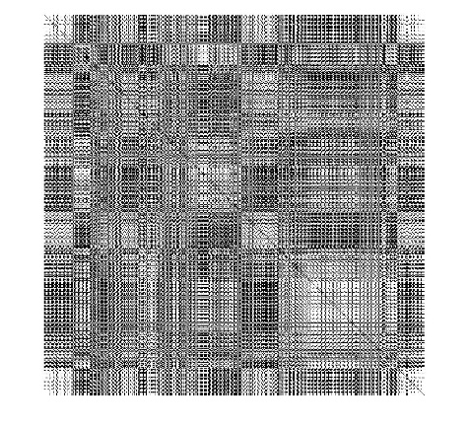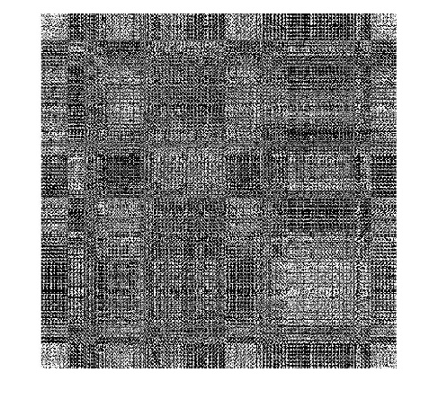

**Weights Before**

**Weights After**

**X=50%**



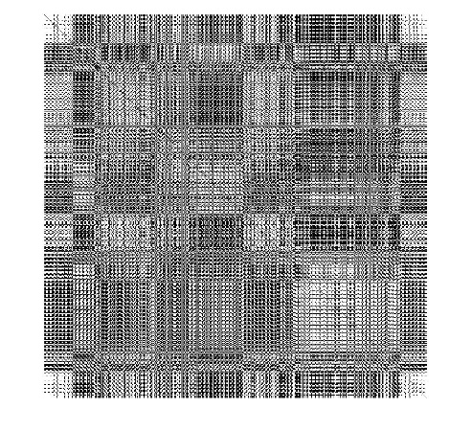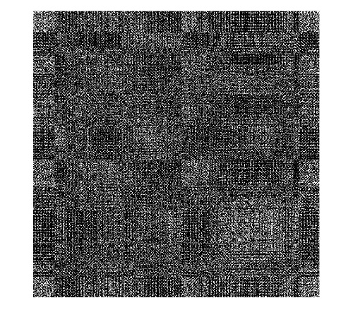

**Weights After**

**Weights Before**

**X=80%**



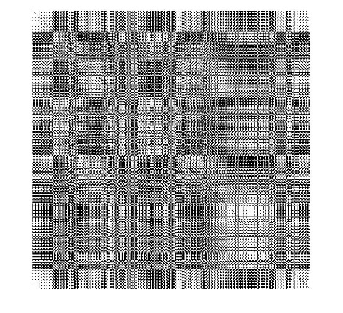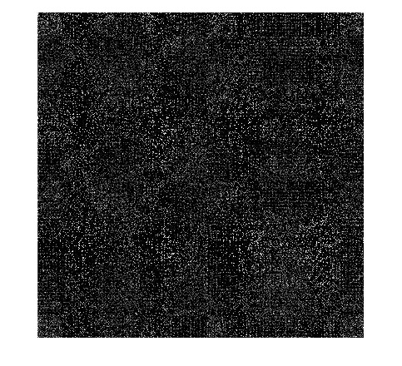

**Weights After**

**Weights Before**

**ii. Plot the final retrieved image for each case**

**Ans.**

**X=25%**

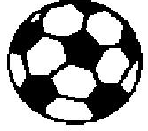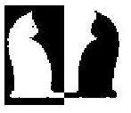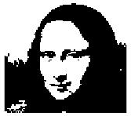

**Retrieved**

**X=50%**

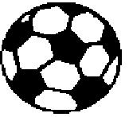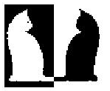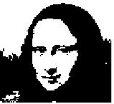

**Retrieved**

**X=80%**



**Retrieved**