**BT6270-COMPUTATIONAL NEUROSCIENCE**

**ASSIGNMENT-1**

**Sweta Kumari (BT17D019)**

**Introduction of Hodgkin-Huxley Model**

Hodgkin-Huxley is a mathematical model to describe the initiation and propagation of action potential in neurons. It defines a set of nonlinear differential equations which approximates the electrical characteristics of the excitable neurons. This model was described by Alan Lloyd Hodgkin and Andrew Fielding Huxley in 1952. They explained the ionic mechanism underlying the initiation and propagation of action potentials in the squid giant axon. They also received the Nobel Prize in Physiology and Medicine for this work in 1963.

**Observation of Action Potential**

The given task in this assignment is to find the values of the external current for various numbers of spikes of the neuron can be observed. We were given the basic MATLAB code, which takes input of external current from the user and gives the characteristic neuron firing plot. Only Na and K channels are considered for this model.

**Following modifications were made to obtain the mentioned graphs and subsequently the values of I1, I2 and I3 from the modified code.**

* The external current ranging is from 0 to 0.8 to study the firing rates
* Number of iterations = 1,00,000 (increased from 10,000)
* Minimum value for considering a wave as AP = 12
* I1: Number of peaks for an increment of 0.0001 uA/mm^2 is greater than 0
* I2: Number of peaks for an increment of 0.0001 uA/mm^2 is increased by 5
* I3: Number of peaks for an increment of 0.0001 uA/mm^2 is decreased by 5

**Table 1 contains the threshold values for I1, I2 and I3**.

* I1 represents external current at which the first AP was observed.
* I2 represents the external current at the junction between finite number of APs and when continuous firing starts.
* I3 represents the external current at which distortion in continuous firing is observed, resulting in no more APs.

|  |  |  |
| --- | --- | --- |
| **External Current (I_ext)** | **# Action Potentials** | **Value (****)** |
| **I1** | Single AP | 0.0224 |
| **I2** | Continuous AP | 0. 0625 |
| **I3** | No AP | 0.4578 |

*Table 1: Threshold value for I1, I2 and I3*

**Graphs**

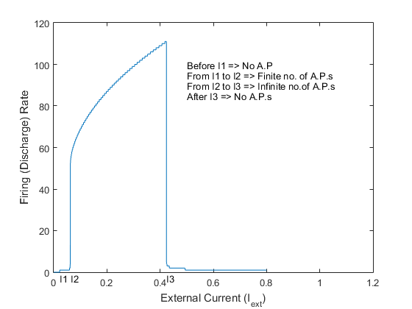 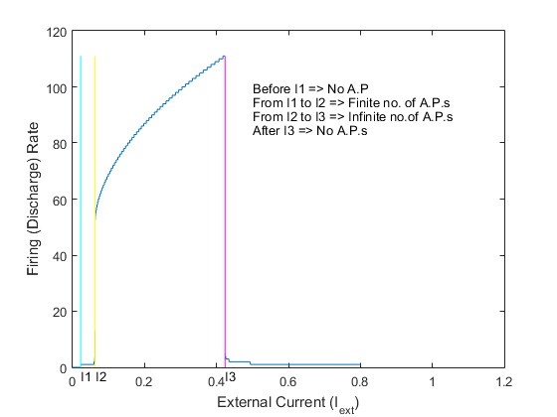

***Figure 1:*** *the graph for firing rate vs external applied current* ***Figure 2:*** *shows the points I1, I2 and I3.*

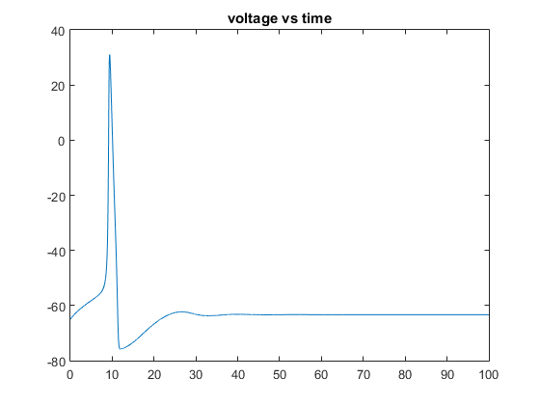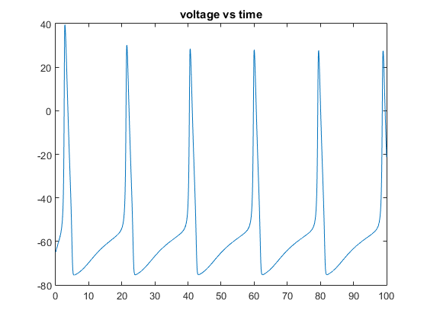

***Figure 3:*** *the voltage vs time graph for I_ext = 0.0224* ***Figure 4:*** *the voltage vs time graph for I_ext = 0.0625*

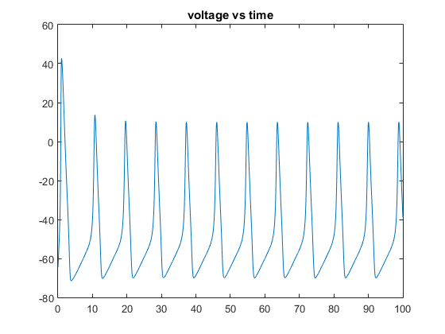

***Figure 5:*** *the voltage vs time graph for I_ext = 0.4578*