Dated 04.06.14

**THIEVES ARRESTED**

With the arrest of three thieves namely 1. Charanjeet Singh @ Rinku, 2. Karan Sharma @ Mannu, 3. Abdul Wahid, Police Team of Police Station Namkum, Ranchi worked out three cases of theft and recovered two Generator sets one of 125 K.V and another set of 62 K.V and one Mahindra Jeep DDA-294.

**PROFILE OF ACCUSED**

(1) Charanjeet singh @ Rinku Age 25 yrs. studied up to 6th class and dropout. He was running small business to provide light in marriage processions. He was not earning sufficient money in this business, hence to earn more money in short period he started committing thefts to expand his business.

(2) Karan Sharma @ Mannu aged 22 years is dropout and was also running business of providing light in marriage procession with Charanjeet Singh @ Rinku. Both were running same business at the Godown in Guru Nanak Vihar, Namkum,Ranchi.

(3) Md. Abdul Wahid aged 29 years is 8th class pass from Kithore district Meerut UP and presently running a small business of sale- purchase of Generator sets in sector 20 Dhurwa,Ranchi. He came in contact of Charanjeet and Karan Sharma because both charanjeet and Karan Sharma were running a business of providing lights in Marriage processions. Abdul Wahid also provided generator sets in marriage pandals. Abdul Wahid Paramjeet @ Rinku and Karan Sharma know each others. To earn more money in short period he purchased stolen generator from Charanjeet Singh and Karan Sharma.

**PREVIOUS INVOLVEMENTS :**

(I) FIR No. 309/14 U/S 379 IPC PS Lalpur,Ranchi.

(II) FIR No. 343/14 U/S 379 IPC PS Bariyatu,Ranchi.

(III) FIR No. 360/14 U/S 379/411/34 IPC PS Namkum,Ranchi.

**RECOVERY**

1. One Generator set 125 K.V,

2. One Generator set 62 K.V

3. One Mahindra Jeep DDA-294.

**CASES WORKED OUT**

(I) FIR No. 309/14 U/S 379 IPC dated 14.03. 2014 PS Lalpur,Ranchi

(II) FIR No. 343/14 U/S 379 IPC dated 01.06.2014 PS Bariyatu,Ranchi

(III) FIR No. 360/14 U/S 379/411/34 IPC dated 24.05.2014 PS Namkum,Ranchi

**INCIDENT AND OPERATION**

In order to curb the incident of theft, special patrolling teams were constituted in the area of Police Station Namkum,Ranchi. ASI Hawa Singh ,HC Ishwar Singh No. 145/W, Ct. M.R. Parsad no. 1673/W, Ct. Mahender No. 1136/W under the overall supervision of Inspr. B.R. Sankhla , SHO-Namkum, while they were on patrolling near Veer Bazar Road, Chander Vihar ,Ranchi. They spotted one Charanjeet Singh @ Rinku & Karan Singh @ Mannu carrying one Generator set towing with Jeep. On being suspicious, both were asked to produce relevant documents of Jeep and Generator Set. On questioning, they tried to escape but with the help of other staff both were overpowered. They could not produce relevant documents and being suspected to be stolen Jeep and Generator set, both were arrested U/S 41.1 D CrPC vide DD No. 8A date 04.06.14 Police Station Namkum.

**INTERROGATION:**

On their sustained interrogation, they confessed that they had stolen one Generator Set from the area of PS Namkum and sold to one Abdul Wahid R/o HATIYA. Abdul Wahid. Then raids to apprehend him were conducted. On dated 04.06.14 Abdul Wahid has been apprehended near Sahid chpowk,Ranchi and Generator Set was recovered from his possession. All the three accused have been arrested vide case FIR No. 360/14 U/S 379/411/34 IPC police station Namkum.

On sustained interrogation both disclosed that they had stolen Mahendra Jeep (DDA 294) from the area of Police Station Rajouri Garden and Generator Set from the area of Police Station Bariyatu. They also disclosed that they had also stolen one green colour 62 KV Generator set on 23.05.14 from Mahavir Vihar, Chander Vihar and sold the same to one Md. Abdul Wahid R/o G 153 Sec. 20 DHURWA of at the cost of Rs 70,000/-.

The staff involved in the good work is being rewarded.

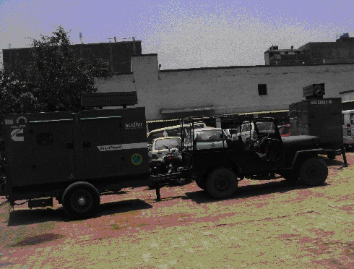

**Shri Prabhat Kumar (IPS)**

**City Supretendent Police, Ranchi**