WEEK 4 PROJECT REPORT
Predictive Modeling and Optimization in Logistics Systems
Python • Machine Learning • Transit-Time Forecasting
Project area: Logistics Data Analytics
Target variable: Transit_Time_days
Dataset: 320 simulated shipment records
Tools: Python, pandas, scikit-learn, Matplotlib

1. Executive Summary
This project forecasts shipment transit time in days from shipment and operating-condition features. A hypothetical dataset of 320 shipments was simulated. Linear Regression and Random Forest were compared; Random Forest hyperparameters were tuned using GridSearchCV and five-fold cross-validation. MAE, RMSE and R-squared were calculated on a held-out test set. The model insights are translated into recommendations for dispatch planning, route and mode selection, capacity allocation, exception management and cost control.
All records are simulated for learning. Results are not a guarantee of performance on real carrier data.

2. Problem Definition
Logistics teams need a useful estimate of delivery duration before a shipment arrives. Underestimation can cause missed delivery promises and poor inventory planning; overestimation can create excessive buffers. This is a supervised regression task: predict Transit_Time_days from information available at dispatch.
- Business question: Given shipment and route conditions, what is the expected transit time in days?
- Prediction unit: one shipment. Intended users include dispatch planners, operations analysts and customer-service teams.
- Potential use: identify delay risk, communicate realistic ETAs and prioritize limited operational resources.

3. Dataset and Features
The dataset contains 320 records. Weather and carrier-experience fields include a small amount of intentionally introduced missing data so the pipeline can demonstrate imputation.
Feature | Type | Meaning
Distance_km | Numeric | Shipment distance in kilometres
Transport_Mode | Categorical | Road, Rail, Air or Sea
Destination_Type | Categorical | Metro, Urban, Rural or Remote
Shipment_Volume_units | Numeric | Shipment size proxy
Weather | Categorical | Clear, Rain or Storm
Traffic_Level | Categorical | Low, Medium or High
Month | Numeric | Month number
Carrier_Experience_years | Numeric | Carrier experience proxy
Weekend_Delivery | Categorical | Weekend or weekday delivery
Transport_Cost_INR | Numeric | Simulated cost in INR
Transit_Time_days | Target | Transit duration in days
Simulation assumptions: distance increases travel time; mode and destination affect average speed and last-mile complexity; weather, traffic, season and weekend operations can add delay; carrier experience may reduce delay. Random noise represents unobserved factors. In real work, only use predictors known when the forecast is requested. Exclude cost if it is calculated after route selection or depends on future information.

4. Data Preparation and Workflow
- Load the CSV and separate predictors from the target.
- Split data into 80% training and 20% testing with a fixed random seed.
- Impute numeric missing values with the median and categorical missing values with the most frequent category.
- Scale numeric variables and one-hot encode categories.
- Keep transformations in an sklearn Pipeline so each training fold learns preprocessing only from its training data.
- Compare baseline models, tune Random Forest on training data, then evaluate on the held-out test set.

5. Model Selection

5.1 Linear Regression
A fast and interpretable baseline that estimates linear relationships. It is useful for comparison but may miss nonlinear patterns and interactions.

5.2 Random Forest Regressor
An ensemble of decision trees that can capture nonlinear effects and interactions. It works well with mixed data after encoding, but is less directly interpretable and needs ongoing monitoring.

5.3 Hyperparameter tuning
GridSearchCV tested 100 or 200 trees, unlimited or 10-level maximum depth, and minimum leaf sizes of 1 or 2. Five-fold shuffled KFold cross-validation was used and negative MAE was the selection score. The test set was held out for final evaluation.

6. Python Implementation
The ZIP includes the full runnable script. The excerpts below demonstrate preprocessing and model training.

6.1 Preprocessing pipeline
numeric_pipe = Pipeline([
("imputer", SimpleImputer(strategy="median")),
("scale", StandardScaler())
])
categorical_pipe = Pipeline([
("imputer", SimpleImputer(strategy="most_frequent")),
("onehot", OneHotEncoder(handle_unknown="ignore"))
])
preprocessor = ColumnTransformer([
("num", numeric_pipe, numeric_features),
("cat", categorical_pipe, categorical_features)
])

6.2 Training and evaluation
search = GridSearchCV(
Pipeline([("prep", preprocessor),
("model", RandomForestRegressor(random_state=42))]),
{"model__n_estimators": [100, 200],
"model__max_depth": [None, 10],
"model__min_samples_leaf": [1, 2]},
scoring="neg_mean_absolute_error", cv=5
)
search.fit(X_train, y_train)
pred = search.best_estimator_.predict(X_test)
mae = mean_absolute_error(y_test, pred)
rmse = np.sqrt(mean_squared_error(y_test, pred))
r2 = r2_score(y_test, pred)

7. Evaluation Metrics
- MAE: average absolute prediction error in days; easy to explain operationally.
- RMSE: error in days that penalizes large misses more strongly.
- R-squared: proportion of test-set variation explained relative to a mean-only baseline; it can be negative.
- Cross-validation MAE: average error across training folds; review both mean and standard deviation.

8. Results
Metrics below were calculated on a held-out test set from the synthetic dataset. Lower MAE/RMSE are better; R-squared closer to 1 indicates a stronger fit.
Model | MAE (days) | RMSE (days) | R²
Linear Regression | 0.348 | 0.412 | 0.891
Random Forest (baseline) | 0.455 | 0.553 | 0.803
Tuned Random Forest | 0.449 | 0.547 | 0.808
Best parameters: {'model__max_depth': 10, 'model__min_samples_leaf': 1, 'model__n_estimators': 200}. Five-fold training CV MAE: 0.500 days (standard deviation 0.058). If the tuned model does not improve meaningfully on the simpler baseline, consider the simpler model for ease of explanation.

8.1 Actual vs predicted
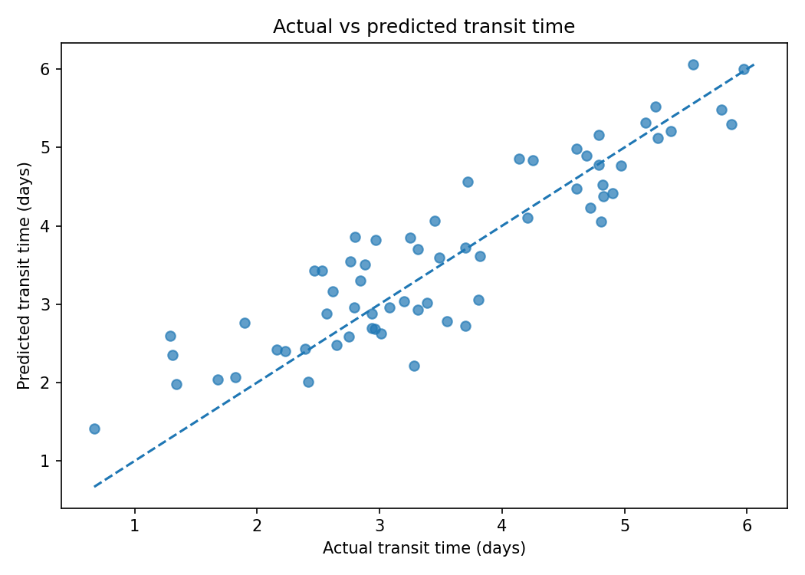
Points near the diagonal indicate more accurate predictions. Review large errors by transport mode, distance, weather and destination.

8.2 Predictor importance
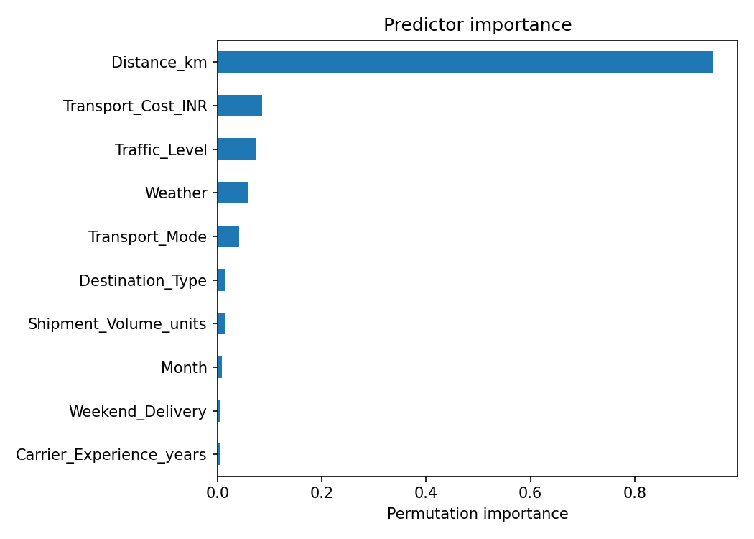
Permutation importance measures how much model score worsens when a feature is shuffled. It is predictive evidence, not proof of causation; correlated features can share importance.

9. Optimization Strategies

9.1 Exception-based dispatch planning
- Flag shipments predicted to exceed the delivery promise; use a tiered alert queue for urgent and high-risk orders.
- Refresh estimates when new traffic or weather information becomes available, where reliable data feeds exist.

9.2 Route and mode planning
- Compare feasible routes and modes using predicted time, transport cost, capacity, emissions and service constraints.
- Use predictions as inputs to a route optimizer, not as a substitute for one. The optimizer must enforce capacity, delivery windows, driver hours and road restrictions.

9.3 Carrier and capacity allocation
- Reserve experienced carriers or contingency capacity for route/time combinations with repeated delay risk.
- Consolidate compatible low-urgency shipments only when delivery commitments remain satisfied.

9.4 Weather and traffic contingency
- Prepare approved alternate routes, departure windows and early customer notifications for storm or high-congestion periods.

9.5 Cost/service balance
- Evaluate plans using a combined objective: transport cost + delay penalty + service-failure penalty, subject to operational constraints.
- Monitor on-time delivery, average delay, cost per shipment, vehicle utilization and complaints before and after an intervention.

10. Illustrative Scenario
If long-distance shipments to remote destinations coincide with storms and high traffic, planners can compare alternate departure times and approved routes, reserve contingency capacity, prioritize time-critical orders and notify customers early. Compare expected benefits with incremental cost and constraints; record actual outcomes to verify whether the intervention worked. This is a proposed workflow, not a claim of a specific percentage saving.

11. Limitations and Future Improvements
- Synthetic data cannot capture all real-world exceptions and changing operating conditions.
- For production, use time-based validation to mimic future prediction rather than relying only on random splits.
- The model does not automatically produce reliable prediction intervals; quantile models or calibrated uncertainty methods could help plan buffers.
- Check for leakage and confirm every predictor is available at prediction time.
- Monitor performance by mode, route, destination and season; retrain only after documented validation.
- Add permitted historical GPS, scan-event, promised-delivery, warehouse-workload and holiday data; protect sensitive customer information.

12. Conclusion and Recommendations
This project demonstrates the complete regression workflow: data simulation, preprocessing, baseline comparison, hyperparameter tuning, cross-validation, test-set evaluation, feature importance and visualization. The recommended next step is a controlled pilot on historical shipment data with time-based validation and explicit business tolerances. Predictions should support human planning and a constraint-aware optimizer, and measured outcomes should confirm whether operational changes improve reliability and cost.

Appendix A. How to Run
- Install Python 3.10 or newer.
- Extract the ZIP and open the extracted week4_logistics_predictive_modeling folder in VS Code.
- Run: python -m pip install -r requirements.txt
- Run: python predict_logistics.py
- Review the outputs folder for metrics, predictions, validation summary, feature importance and charts.
Random seeds are fixed for reproducibility. This educational project uses simulated data; validate on real, time-ordered data before operational deployment.

