**Optimal EVC Implementation on CWU Ellensburg Campus**



ADMG 501.001- ITAM Bootcamp

Information Technology and Administrative Management, Central Washington University

College of Education and Professional Studies, Central Washington University

Dr. Elizabeth Fountain

November 28, 2023

**Table of Contents**

Problem Statement 3

Problem and Data Analysis 3

Stakeholders 3

Jeff Bousson 4

Joel Klucking & James Wohlpart 4

Faculty and Staff 4

Students and Ellensburg Community 4

Constraints 5

Funding 5

Timing and Buy-In 5

Future Funding 5

Opportunities 6

Alternatives 6

Alternative 1 6

Alternative 2 7

Alternative 3 8

Key Decision Criteria 9

Key Decision Criteria #1: Resources Usage 25% 9

Table 1 10

Key Decision Criteria #2: Equity & Ethics 35% 11

The Price of EVs 11

Table 2 12

Cheapest 15 Electric Vehicles in 2023 12

Economies of Scale 12

New Clean Vehicle Credit 12

EV Battery Price Trends 13

Scoring 13

Table 4 13

Key Decision Criteria #3: ROI 40% 14

Pricing 14

Costs 14

Electrical Services 14

Table 6 15

Table 7 16

Alternatives Evaluation and Analysis 16

Alternative 1: EVC roll out of 6 dual-head chargers will occur between 1 to 2 years at the Student Union & Recreation Center. 17

Resource Usage (25%) 17

Equity & Ethics (35%) 17

ROI (40%) 17

Alternative 2: EVC roll out of 3 dual-head chargers will occur over 2 to 3 years in 2 locations. 17

Resource Usage (25%) 17

Equity & Ethics (35%) 17

ROI (40%) 18

Alternative 3: EVC roll out of 6 dual-head chargers will occur in 3 or more years in 3 locations spread 2 in each location. 18

Resource Usage (25%) 18

Equity & Ethics (35%) 18

ROI (40%) 18

Results 19

Table 8 19

Alternative Criteria Rating 19

Scoring Alternative 1 19

Scoring Alternative 2 20

Scoring Alternative 3 20

Overall Scores 20

Recommendation 21

Action and Implementation Plan 21

Year 1 21

Year 2 22

Year 3 22

Year 4 22

References 23

**Executive Summary**

The purpose of this research is to respond to the state of Washington’s Motor Vehicle Emission Standards-Zero Emission Vehicles law. The goal is to reduce carbon emissions by 45% by 2023, with plans to install level 2 dual-heads electric vehicle chargers on the Central Washington University Campus.

The stakeholders involved in this project include Jeff Bouson, Joel Klucking, Jim Wohlpart, CWU Faculty and Staff, students, and the Ellensburg community. Each of these members plays an important role by providing resources, information, evaluation, and future recommendations.

Research suggests two potential opportunities that can further help Central Washington University’s campus reduce carbon emissions and enhance long-term sustainability. The first opportunity is transitioning to an electric fleet, and the second is promoting the use of electric vehicles through the installation of electric vehicle charging stations.

Based on the information the team has collected for this project, there is a prediction that the demand for electric vehicles (EVs) will increase over time. However, given the current situation of electric vehicle charging stations already on campus, it is important to maximize the benefits in terms of cost and usage. Therefore, installing them at the right time and location will be essential.

To produce a feasible recommendation, three alternatives were generated based on information the team conducted and researched. The results were scored according to three criteria: resource usage (25%), equity and ethics (35%), and ROI (40%).

In terms of the scores, alternative 1 has a total score of 17.21%, alternative 2 has 18.71%, and alternative 3 has 23.07%. The result indicates that implementing alternative 3 will yield the highest benefits in terms of ROI, equity and ethics, and resource usage compared to the other options.

# **Problem Statement**

To meet its climate action goals and be eligible for upcoming grant funding, CWU needs a plan for installing more electric vehicle chargers (EVCs) at its Ellensburg campus.

# **Problem and Data Analysis**

The state of Washington passed the Motor Vehicle Emission Standards-Zero Emission Vehicles law in 2020 to replace fossil fuel vehicles with clean-energy automobiles (Zero-Emission Vehicles, 2023, para 1-2). This is part of a larger effort to curve carbon emissions by 45% by 2030 under the Climate Commitment Act (The Climate Commitment Act, 2022, para 4). CWU, as a Washington State Institution, is a participant in this sustainability effort. Since it is a global issue, action must be taken on a state and regional level to create a bigger impact. the local level, the CWU community and the Ellensburg community are experiencing the effects of global warming. “Washington’s climate is changing. Over the past century, most of the state has warmed one to two degrees (F). Glaciers are retreating, the snowpack is melting earlier in the year, and the flow of meltwater into streams during summer is declining” (EPA, pg. 1, 2016). Therefore, CWU needs to install dual-head EVCs to be on track with this initiative. To accomplish this, CWU will require to seek funds, through sustainability grants that encourage the installation of EVCs. To successfully secure funding, CWU needs to establish parameters for creating the infrastructure, including determining locations and setting a timeline for implementation.

## **Stakeholders**

The stakeholders are active contributors to the success of this project by providing useful resources, crucial information, evaluations, and future recommendations. There are a total of six possible direct and indirect stakeholders involved in this project:

## **Jeff Bousson**

Jeff is the Sustainability Officer at Central Washington University. Sustainability Officer is a new position within CWU. This position was created to help the organization reach their climate goals and stay on track to achieve the State of Washington’s climate action goals. Jeff joined CWU in December 2022 and has been actively working on creating CWU’s Climate Action Plan. During this process there have been many grant opportunities for funding projects related to sustainability. This case seeks to answer the questions Jeff has about the best path forward as we get funding to purchase new EV chargers on campus.

## **Joel Klucking & James Wohlpart**

Joel Klucking is CWU’s Senior Vice-President of Finance and Administration. James Wohlpart serves as the President of Central Washington University. Joel focuses on the overall cost and risk to the university, providing insights directly to President Wohlpart.

## **Faculty and Staff**

Faculty and staff at the university are key stakeholders and could be involved in various aspects of the project. Their expertise and perspectives may contribute significantly to different facets of the project's planning, implementation, and experiences afterward.

## **Students and Ellensburg Community**

Students and the Ellensburg community would be considered indirect stakeholders in this case, meaning the decisions made by the key stakeholders will impact them.

Gathering their perspectives on this matter will be essential before moving forward with any given recommendation.

## **Constraints**

### ***Funding***

Given the current state of student enrollment, it will be important to secure funding outside of the university. Electric vehicle chargers are not cheap to install or maintain over time. The cost analysis will provide details on the expected cost of installation and maintenance. We can take this information when applying for grants to help reduce the cost directly to CWU.

### ***Timing and Buy-In***

We are in a significant place with electric vehicle chargers and the mass adoption of electric vehicles. “Electric cars’ share of the overall car market has risen from around 4% in 2020 to 14% in 2022 and is set to increase further to 18% this year, based on the latest IEA projections” (Iea, 2023, para 2). We are certainly heading in the direction of mass buy-in of electric vehicles within the United States of America. At what point will electric vehicles be the primary transportation method for CWU’s students? As of today, EVs are expensive and that barrier to entry means that there are relatively few students who own electric vehicles in CWU’s student population. If we do not time the purchase of EV chargers properly, there is the risk of charging stations not being used enough to justify the cost. This would also have the secondary effect of not having the latest charging technology by the time those chargers would be used. Another secondary effect would be students seeing empty charging stations causing them to question the university’s decision to waste money on under-utilized infrastructures. Students' requirements and satisfaction should be our key focus since they are our primary customers.

### ***Future Funding***

Future funding could be jeopardized by failing to install adequate EV charging capacity and reduce CWU’s Carbon footprint within Washington State’s climate policies and timelines.

### ***Opportunities***

The opportunity of installing EV charging stations is to promote the use of electric vehicles to produce lower emissions compared to traditional gasoline-powered vehicles. This aligns with the campus's sustainability goals and helps reduce the overall carbon footprint and could lead to boosting the institution's appeal.

# **Alternatives**

Between 2020 and 2021 there was a 6.6 million increase in electric vehicles (EVs) in the United States (Progressive, 2023). If this trend continues, there will be a greater demand for EVs and thus EVCs. There will be 30 million chargers in the United States by 2030, 1.2 million of which will be public chargers (Kampshoff et al, 2022). As the demand of EVs will increase over time, the following alternatives use time of installation as the varying factor. For the purposes of this study, the following information operates under the assumption that CWU will implement a total of 6 dual-head, L2 chargers at the current average economy price of $6000/charger (Energy5, 2023). Location of EVCs will depend on the priorities of the university.

**Alternative 1**

Our first alternative is to consider the installation of six dual-head chargers within one or two years at the Student Union & Recreation Center. “The Student Union and Recreation Center is the largest building on the Central Washington University campus, spanning 228,261 square feet across three stories. It is centrally located with easy access to parking lots, malls, primary city streets, academic buildings, and residence halls” (Explore Student Union, Para. 2).

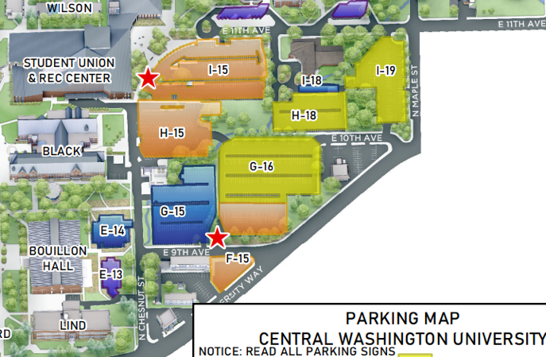The Student Union & Recreation Center also houses the largest number of parking spaces and lots on campus. Based on the map, there are a total of 10 parking lots within walking distance (I-19, I-18, H-18, G-16, G-15, H-15, I-15, F-15, E-14, E-13).

*(CWU Parking Map 7.13.2023)*

Notably, Lot I-15 is the closest parking lot, situated right outside and facing the Wildcat Statue and the Student Union & Recreation Center.

After in-depth research, the demand for electric vehicles is on the rise. Considering the critical role played by the Student Union & Recreation Center at the heart of Central Washington University, it will be important and beneficial to point out that the Student Union & Recreation Center provides accessibility, ample parking space, and sufficient capacity in the area. Installing electric vehicle charging (EVC) stations not only addresses the diverse needs of students, faculty, families, and visitors but also holds enormous potential in preparing the university to meet its climate action goals.

Considering all the information we have gathered, our objective is to align with the state of Washington’s Motor Vehicle Emission Standards-Zero Emission Vehicles law, which aims to reduce carbon emissions by 45%. Installing six level two dual-head Electric Vehicle Chargers (EVC) in parking lot I-15 will provide EV charging for a total of 12 vehicles simultaneously. This initiative not only sets an example of using EVC to embrace long-term sustainability and reduce carbon emissions but also caters to the needs of individuals requiring EV charging.

**Alternative 2**

Our second alternative is to install six dual-head chargers in two different locations within a timeline of two-three years. One of the locations that we have considered for this option is the Student Union and Recreation Center, where we would implement three of the dual-headed chargers. The SURC is not only the largest building on campus but also one of the busiest, and targets anyone that visits the university. This could include potential new students visiting with their families, current students, and faculty, and even alumni coming back to visit the campus. Since this alternative has two different locations the roll out process is likely to take more time compared to the first alternative.

Our second location for this alternative, where we would implement the other three dual-headed chargers, is in the N-19 parking lot in front of the music building. This location will target the parents and students that attend many events and concerts in this building. The parking lot has a lot of space to be able to add charging stations in and it is also in a location that is often busy.

**Alternative *3***

Our third alternative is to install six dual-head chargers with two chargers in three different locations. We considered SURC parking lot, CWU lot S-10 parking lot in front of psychology building, and parking lot by the Houge music building. Considering Student Union and Recreation Center as the most visited and used building, installing two dual-head chargers will be able to provide charging facilities to the CWU family, visitors, and the public.

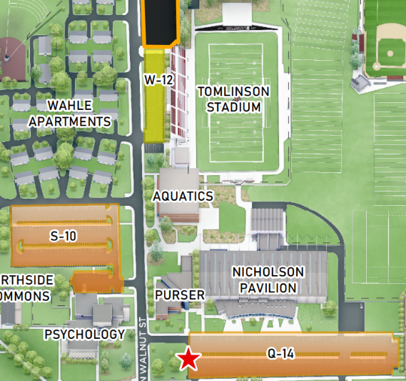Similarly, CWU parking lot S-10 being close to Tomilson Stadium, CWU Recreation Sports Complex and Student housing Whale complex, it can be considered as a second location for alternative 3. EV chargers in CWU parking lot S-10 will be accessible to the visitors of Tomilson stadium during athletic events and CWU Recreation Sports and residents of Whale complex.

*(CWU Parking Map 7.13.2023)*

The third location for alternative 3 is considered as the parking lot space in the Music Building as it would be a great spot targeting families and community going to concerts in the farthest area from the rest of the EV charging station location, this location will be able to provide an EV charging facility to the visitors of Music building and residents of Student Village apartments.

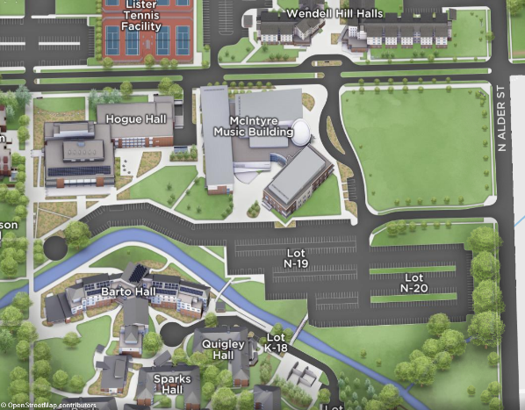*(CWU Parking Map 7.13.2023)*

# **Key Decision Criteria**

There are many elements that make up the infrastructure for installing EVCs. This case study has chosen to group these elements into three measurable categories: resource usage, equity and ethics, and return on investment (ROI). While these classifications are interconnected, each is made of distinct variables that pertain to the overall criteria. This section of the case study will explore each category thoroughly to formulate the calculations needed to determine the most feasible alternative. Based on the response from the primary stakeholder, Jeff Bousson, the categories are weighted as: resource usage (25%), equity and ethics (35%), and ROI (40%).

## **Key Decision Criteria #1: Resources Usage 25%**

Elements to consider when evaluating the alternatives listed above include resources to install the six dual-head at corresponding location in the specified timelines. The resources analyzed in this criterion are physical space and energy involved in implementation.

Land must be designated for the installation of these chargers with Washington State regulations and accessibility measures in mind. This state under law requires 1 in 25 spaces to be ADA accessible at 8’x8’ access aisle for cars and 11’x5’ access aisle for van (NWA Center, para 14, 2023). Due to this ratio, one ADA accessible spot should be considered at each location. However, this may vary depending on the existing ADA accessible spots at selected locations. Because of this, the areas of installation will be listed as a range. Standard parking spaces in Washington are 8’x 5’ (Northwest ADA Center, para 13, 2023). If each dual-head charger takes up 2 standard parking spot and, in some cases, one ADA accessible van spot, the area of installation for each alternative is as follows:

* Alternative 1- 480 sq ft to 535 sq ft.
* Alternative 2- 240 sq ft to 295 sq ft in each location.
* Alternative 3- 160 sq ft to 215 sq ft in each location.

The parking space available in each of the locations listed in the alternative varies. According to the CWU interactive campus map (2023) the SURC which has approx. 341 standard and 6 ADA spots (13,970 sq ft). McIntyre Music Building has approx. 294 standard and 12 ADA spots (12,420 sq ft). The Psychology Building has a total of 204 spots (8,160 sq ft). Based on these areas and the current low demand for electric vehicles within the CWU community, the percentage of EVC spaces in campus lots are scored:

### **Table 1**

*Scoring of resource usage based on percentage of space per sq ft.*

|  |  |
| --- | --- |
| **Score** | **Percentage** |
| 1 | 3% or Higher |
| 2 | 2% - 3% |
| 3 | 1% - 2% |

The other element to consider in this criterion is energy. For the purposes of this case study, all dual-head chargers will be L2. L2 EVCs 208V electrical service in commercial spaces (U.S. Department of Transportation, para. 3, 2023). Therefore, electricity diverted to installation sites for each of the alternatives is as follows:

* + Alternative 1- 1,248V to one location
  + Alternative 2- 624V to 2 locations
  + Alternative 3- 416V to 3 locations

Given the city’s power grid structure, diverting power to different locations is not significantly different than diverting power to one location (Nicole Baker, Sustainability Coordinator City of Ellensburg, 2023). Therefore, energy levels in each alternative will be assumed to be a total value of 1,248V.

## **Key Decision Criteria #2: Equity & Ethics 35%**

The ethical dimension involves a commitment to environmental responsibility and ensuring that the university's actions align with broader sustainability objectives. By embracing EV technology, CWU can contribute to reducing carbon emissions and demonstrate a commitment to ethical stewardship of the environment. Simultaneously, the decision must be equitable, acknowledging the potential impact on diverse demographic groups. Installing EVCs can pave the way for increased accessibility to electric vehicles, particularly for individuals in the lower economic strata, thereby addressing transportation-related disparities.

### ***The Price of EVs***

As of July 2023, the average price of a new EV was $53,469 and a new Combustion Engine Vehicle was $48,334. As the price of EVs continue to drop, they will eventually drop below the cost of the Combustion Engine Vehicle. This equilibrium point will cause the adoption rate of EVs to greatly increase. As the adoption rate increases the secondary market will grow, allowing for more EVs to be purchased by those of lower income brackets. We will score each alternative by the forecasted average cost of the 15 lowest EVs during that period. Taking the lowest 15 in terms of cost best matches the budget of the student demographic.

### **Table 2**

### *Cheapest 15 Electric Vehicles in 2023*

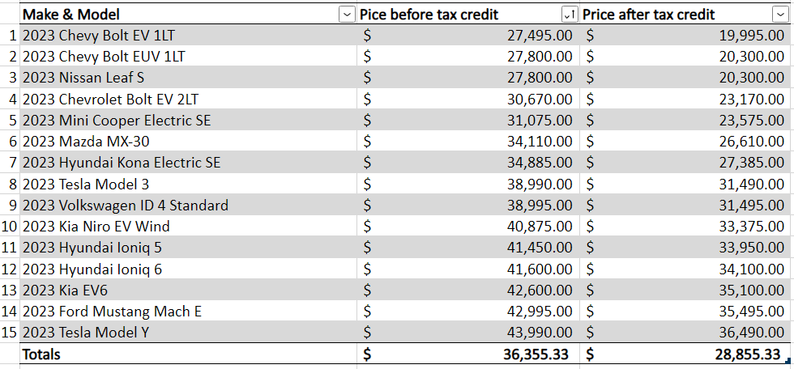

### ***Economies of Scale***

Economies of scale-wise, based on previous research, the demand for EVs is expected to increase over time as more people purchase EVs. More EV companies will start to produce EVs and EVC on a larger scale to meet the growing demand. As technology advances and more electric cars are manufactured, the cost, parts, and raw materials decrease, making these cars more affordable compared to regular ones with gas engines (Heakal, 2021).

### ***New Clean Vehicle Credit***

Starting in January 2024 the US Department of the Treasury has stated that EV buyers will be able to transfer the $7,500.00 new clean vehicle credit directly to the car dealership (US Dept. Treasury, 2023). This will reduce the price of the EV at the point of sale. Previously the credit would be applied to the individual’s tax bill due the following April. This will make it much easier for consumers to utilize this benefit.

### ***EV Battery Price Trends***

The price of EV batteries greatly influences the price of EVs. EV batteries are expected to continue to decrease to ~ $80 USD per kWh by 2025. Currently these are priced around $160 USD per kWh. (Market and Markets, 2023 para. 2). With a project completion date of 2025, the average EV cost is projected to match the overall market average cost of buying a new vehicle.

### ***Scoring***

The scoring of each alternative will be based on the forecasted average cost of an EV in the coming years. The percent change in the overall cost will be calculated and applied to the total price of the cheapest 15 EVs.

**Table 3**

*Forecasted Average cost for Cheapest 15 EVs*

*Note.* To calculate the percent change in the forecasted average cost of EVs we used data trends and excluded outliers.

### **Table 4**

*Price of new EV within 15 cheapest sample groups. Prices calculated from Figure___.*

|  |  |  |
| --- | --- | --- |
| **Score** |  | **Price of a New EV** |
| 1 |  | $30,000 + |
| 2 |  | $25,000 - $30,000 |
| 3 |  | $20,000 - $25,000 |

## **Key Decision Criteria #3: ROI 40%**

To make a recommendation, the economic implications and impacts of bringing Electric Vehicle Charging Stations to Central Washington University must be considered. Location, electrical services, number of stations, labor, grant opportunities and taxes all play an important role in the total cost estimate. Therefore, the third decision criteria will be quantified as ROI.

### ***Pricing***

The price of electric vehicle charging stations can vary depending on brand and type. On average, the upfront cost to purchase a dual-head public level two electric vehicle charging station is around $6,000-$8,000 (Bourlaug et al., 2020) with installation costs being around $2000-$10,000 per charging station (Nyserda, n.d.). This cost would then be multiplied by the total number of units proposed in each alternative.

### ***Costs***

The remaining costs that will be included in the ROI are the maintenance and electrical costs. For example, the price of concrete, landscaping, electricity, and software is all included in the total cost estimate. According to Home Advisor, the cost to deconstruct two parking spots is $1 to $2 per square foot and “new parking lot construction costs on average between $4 and $7 per square foot for both materials and labor” (2022). If parking spots are not deconstructed, the cost to resurface a concrete lot is between $3-$5 (Home Advisor, 2022). Additionally, Future Energy states the software costs to host user “information in the cloud is around $28 per month for each port” (2021).

### ***Electrical Services***

Lastly, the price of electricity will be the greatest and most significant cost in the total cost estimate. In an article from Future Energy, the complete cost to upgrade a 480-voltage power circuit is $12,000-$15,000 (2021). The dedicated branch circuits to each charging station must also be considered. To support each level 2 electric vehicle charging station, the dedicated branch circuits range from $870-$960 (Waters, 2019). If there are multiple locations of electric vehicle parking spots, there will be multiple main power circuits. If all electric vehicles are in one location, there will only be one main power circuit, and therefore a decrease in total cost. The number of main power circuits will be the largest factor that alters the criterion scoring.

Below is a table including all projected average costs that will be used to calculate the total costs of each alternative.

**Table 5**

*Projected Average Costs*

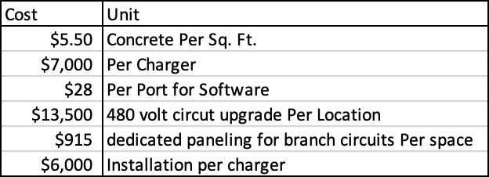

*Note.* These are national averages without consultation from a contractor. Costs may change based on location, time of year, demand, and availability.

### **Table 6**

Based on the information above and the current proposed alternatives, the criterion will be scored by the following cost estimates:

|  |  |
| --- | --- |
| **Score** | **Cost Estimates** |
| 1 | $120,000 – $130,000 |
| 2 | $110,000 – $120,000 |
| 3 | $100,000 – $110,000 |

*Note.* These are cost estimates based on the current research found by the ITAM cohort. Complete cost estimates will need extensive additional research that is outside the scope of this study.

The total cost estimates will not include concrete per square foot due to unknown factors. Considering the current electric vehicles at the Ellensburg campus, soft costs will not be included in our cost estimate. For example, soft costs such as parking blocks, custom stripping, signage, and protective bollards will not be included. These additional objects do not appear to have been added to the current electric vehicle charging stations. If more electric vehicle charging stations are implemented, it is not predicted these physical objects will be placed.

### **Table 7**

*Estimated total upfront cost calculated as ROI:*

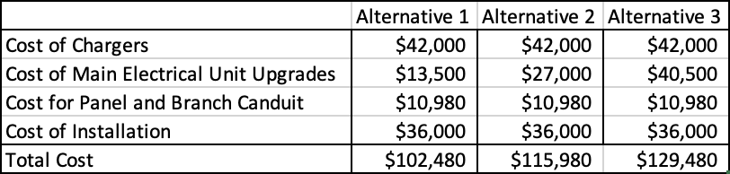

*Note.* These are cost estimates based on the current research found by the ITAM cohort. Complete cost estimates will need extensive additional research that is outside the scope of this study.

# **Alternatives Evaluation and Analysis**

*The decision criteria listed above have established that the feasibility of each alternative will be determined on a 1 to 3 scale based on the three criteria. That scale is defined as:*

|  |  |  |
| --- | --- | --- |
| **Score** |  |  |
| 1 | 2 | 3 |
| Unacceptable | Acceptable | Ideal |

## **Alternative 1: EVC roll out of 6 dual-head chargers will occur between 1 to 2 years at the Student Union & Recreation Center.**

The first alternative is to install six dual-head chargers within one or two years by the Student Union & Recreation Center. To choose the best alternative that can be used to maximize benefits in terms of cost and usage among the three options: in this section, each alternative will be scored according to three criteria: resource usage (25%), equity and ethics (35%), and ROI (40%).

### ***Resource Usage*** ***(25%)***

In the first alternative a maximum of 535 sq ft out of 13,970 sq ft, equaling 3.8%. This alternative scored 1 point.

### ***Equity & Ethics (35%)***

In 2025 the average price of the cheapest 15 EVs based on our forecasted date would be $34,608.10 without any tax credits and $27,468.55 if the $7,500 tax credit is still in effect. If the prediction of the tax credit being still in effect holds true. This would give this alternative a score of 2 points.

### ***ROI*** ***(40%)***

The estimated upfront cost of installing 6 dual-head charges in one location in 1-2 years is $102,480. This scored 3 points.

## **Alternative 2: EVC roll out of 3 dual-head chargers will occur over 2 to 3 years in 2 locations.**

### ***Resource Usage (25%)***

In the second alternative a maximum of 295 sq ft in two locations out of a total of 26,390 sq ft, equaling 2.2%. This alternative scored 2 points.

### ***Equity & Ethics (35%)***

In 2026 the average price of the cheapest 15 EVs based on our forecasted date would be $32,944.83 without any tax credits and $26,148.41 if the $7,500 tax credit is still in effect. If the prediction of the tax credit being still in effect holds true. This would give this alternative a score of 2 points.

### ***ROI (40%)***

The estimated upfront cost of installing three dual-head charges in two locations in two-three years is $115,980. This scored 2 points.

## **Alternative 3: EVC roll out of 6 dual-head chargers will occur in 3 or more years in 3 locations spread 2 in each location.**

Having location spread out in three locations alternative 3 will be more equitable providing charging facilities to the broader demographics including students, faculties, visitors and parents. Similarly, alternative 3 suggests installation of EV chargers in three or more years, with that CWU will be able to meet the increasing demand of charging stations gradually based on the usage.

### ***Resource Usage (25%)***

In the third alternative a maximum of 215 sq ft in three locations out of a total of 34,550 sq ft, equaling 1.9%. This alternative scored 3 points.

### ***Equity & Ethics (35%)***

In 2027 the average price of the cheapest 15 EVs based on our forecasted date would be $31,361.50 without any tax credits and $24,891.72 if the $7,500 tax credit is still in effect. If the prediction of the tax credit being still in effect holds true. This would give this alternative a score of 3 points.

### ***ROI*** ***(40%)***

The estimated upfront cost of installing two dual-head charges in three locations in three or more years is $129,480. This scored 1 point.

## **Results**

The alternative scores above were recorded in Table 8. The totals shown in this matrix are the basis for the following formulas that determine the overall score for each alternative using the scale of 1 = Unacceptable, 2 = Acceptable, and 3 = Ideal. The calculation of the overall score for an alternative included multiplying the initial score of each decision criteria by the weight: resource usage (25%), equity & ethics (35%), and ROI (40%).

|  |  |  |  |
| --- | --- | --- | --- |
| **Table 8***Alternative Criteria Rating* | | | |
|  | **Resource Usage** | **Equity & Ethics** | **ROI** |
|  | 25% | 35% | 40% |
| **Alternative 1** | 1 | 2 | 3 |
| **Alternative 2** | 2 | 2 | 2 |
| **Alternative 3** | 3 | 3 | 1 |
| *Note ratings are based on 1 = Unacceptable, 2 = Acceptable, 3 = Ideal* | | | |

### ***Scoring Alternative 1***

Alternative 1 states that six dual-head EVCs will be installed in the SURC parking lot I-15 within one-two years. This alternative was assessed using three matrixes of resource usage (25%), equity and ethics (35%), and ROI (40%) as calculated above.

The resource usage for this alternative was measured as an area range of 535 sq ft out of 13,970 sq ft, equaling 3.8% (1pt). Equity and ethics were calculated based on the average cost of new EV and found to be $34,608.10 without any tax credits and $27,468.55 if the $7,500 tax credit is still in effect. (2pts). The ROI projected in this alternative was $102,480 (3pts).

Alternative 1 = (1/25) +(2/35) +(3/40) = 17.21%

### ***Scoring Alternative 2***

Alternative 2 proposes that three dual-head EVCs will be installed in the SURC parking lot I-15 and Music N-19 parking lot within two-three years. The resource usage for this alternative was measured as an area range of 295 sq ft in two locations out of a total of 26,390 sq ft, equaling 2.2% (2pts). Equity and ethics were calculated based on the average cost of a new EV and found to be $32,944.83 without any tax credits and $26,148.41 with tax (2pts). The ROI projected in this alternative was $115,980 (2 pts).

Alternative 2 = (2/25) +(2/35) +(2/40) = 18.71%

### ***Scoring Alternative 3***

Alternative 3 suggests that two dual-head EVCs will be installed in the SURC parking lot I-15, Music N-19 parking lot, and Psychology S-10 parking lot in three or more years. The resource usage for this alternative was measured as an area range of 215 sq ft in three locations out of a total of 34,550 sq ft, equaling 1.9% (3pts). Equity and ethics were calculated based on the average cost of new electric vehicles and found to be $31,361.50 without any tax credits and $24,891.72 with tax (3pts). The ROI projected in this alternative was $129,480 (3pts).

Alternative 3 = (3/25) +(3/35) +(1/40) = 23.07%

### ***Overall Scores***

Based on these operations above, Alternative 1 weighted score was 17.21%, Alternative 2 was 18.71%, and Alternative 3 was 23.07% as shown in Figure 1.1. This indicates that Alternative 3 scored the highest in this study.

# **Recommendation**

Based on the scores discussed above, Alternative 3 should be implemented. This means the EVC rollout of 6 dual-head chargers will be installed in the SURC parking lot I-15, Music N-19 parking lot, and Psychology S-10 parking lot in 3 or more years.

# **Action and Implementation Plan**

|  |  |  |  |  |
| --- | --- | --- | --- | --- |
| Timeline: | Year 1 | Year 2 | Year 3 - 4 | Year 4+ |
| Implementation | Planning | Further Data Collection and Analysis | Implementation | Results Analysis |

## **Year 1**

The first year will be mainly focused on planning. This project can be integrated into the resources for the Climate Action Plan, taking advantage of numerous grant opportunities for funding projects related to sustainability. This case aims to provide information and establish a clear path for the CWU sustainability office in determining the optimal approach to secure funding for the purchase of new EV chargers on campus.

## **Year 2**

In year 2, the recommended approach will be to further collect and analyze data from our current EVCs regarding their usage, cost, and return on investment. As technology continues to evolve each year, our early research suggests that as the prices of EVs and EV batteries continue to decrease, they will eventually fall below the cost of Combustion Engine Vehicles. This insight will help determine the optimal time to apply for the grant and initiate implementation, while maximizing its impact on embracing long-term sustainability and reducing carbon emissions. Most importantly, it will satisfy the needs of individuals requiring EV charging on the CWU campus.

## **Year 3**

In year 3, this phase will involve the actual implementation. Once sufficient information is gathered, grants are approved by the State, and implementation is confirmed and supported by data indicating an optimal moment for action. At this stage, potential changes may occur as technology continues to thrive. Currently, level two dual-headed chargers seem to yield the best outcome, but it is possible equipment upgrades will be considered based on future advancements. Information related to ethics, resources, costs, ADA compliance, and space from this research will remain relevant throughout the implementation process.

## **Year 4**

In year 4 and beyond, this phase will follow the installation of the EVCs, involving the analysis of results to determine whether additional infrastructure is required at each location or if promotion and marketing strategies are needed to spread awareness to students, faculty, family, and public.

In summary, to ensure effective and impactful implementation, timing is essential. Rolling out at a measured pace, while staying attuned to upcoming changes in the EV market, trends, and related funding, while making informed executive decisions at the right time will be the key to success in implementation.

# **References**

Borlaug. B, Salisbury. S, Gerdes. M, Muratori. M. (June 22, 2020). *Levelized Cost of Charging Electric Vehicles in the United States*

<https://www.sciencedirect.com/science/article/pii/S2542435120302312>

Central Washington University. (n.d.) *Student Union & Recreation Center*

<https://www.cwu.edu/student-life/surc/visit-surc/index.php>

Central Washington University. (n.d.) *Explore Student Union*

<https://www.cwu.edu/student-life/surc/>

Central Washington University. (July 13, 2023) Parking Map

<https://www.cwu.edu/admissions-aid/visit/parking/_documents/7.13.2023-parking-map-004.pdf>

Department of Ecology, State of Washington. (n.d.) Z*ero-emission vehicles (ZEV).*

<https://ecology.wa.gov/air-climate/reducing-greenhouse-gas-emissions/zev>

DiNello. S. (July 1, 2021). *How Much Do EV Charging Stations Cost?*

<https://futureenergy.com/ev-charging/how-much-do-ev-charging-stations-cost/>

Energy5yourway. (Aug 27, 2023). *The Future of Electric Vehicle Charging Station Installation Cost Predictions and Projections*

<https://energy5.com/the-future-of-electric-vehicle-charging-station-installation-cost-predictions-and-projections>

EPA. (August, 2016). *What Climate Change Means for Washington.* <https://19january2017snapshot.epa.gov/sites/production/files/2016-09/documents/climate-change-wa.pdf>

Heakal. R. (June 27, 2021). *What Are Economies of Scale?*

<https://www.investopedia.com/insights/what-are-economies-of-scale/#:~:text=Economies%20of%20scale%20occurs%20when,development%20such%20as%20improved%20infrastructure>.

HomeAdvisor. (August 6, 2022). *How Much Does It Cost To Build A Parking Lot?*

[*https://www.homeadvisor.com/cost/outdoor-living/pave-a-parking-lot/*](https://www.homeadvisor.com/cost/outdoor-living/pave-a-parking-lot/)

HomeAdvisor. (December 8, 2022). *How Much Does A Heated Driveway Cost?*

[*https://www.homeadvisor.com/cost/garages/heated-driveway/*](https://www.homeadvisor.com/cost/garages/heated-driveway/)

IEA. (April 26, 2023). *Demand for electric cars is booming, with sales expected to leap 35% this year after a record-breaking 2022*.

<https://www.iea.org/news/demand-for-electric-cars-is-booming-with-sales-expected-to-leap-35-this-year-after-a-record-breaking-2022>

Kampshoff, P. Kumar, A. Peloquin S. Sahdev, S. (April, 2022). *Building the electric-vehicle charging infrastructure America needs*. McKinsey & Company

MARKETSandMARKETS. (2023). *Electric Vehicle Market*

<https://www.marketsandmarkets.com/Market-Reports/electric-vehicle-market-209371461.html>

Northwest ada Center. (2023). *Parking for People with Disabilities in Washington State*

<https://nwadacenter.org/factsheet/parking-people-disabilities-washington-state>

NYSERDA. (2023). *Installing a Charging Station*

<https://www.nyserda.ny.gov/All-Programs/ChargeNY/Charge-Electric/Charging-Station-Programs/Charge-Ready-NY/Installing-a-Charging-Station>

Progressive (n.d.) *What is the future of electric cars?*

<https://www.progressive.com/lifelanes/on-the-road/future-of-electric-cars/#:~:text=By%202030%2C%20electric%20vehicle%20sales,nearly%20all%20new%20car%20sales>

U.S. Department of Transportation. (June 22, 2023). *Charger Types and Speeds*

[*https://www.transportation.gov/rural/ev/toolkit/ev-basics/charging-speeds*](https://www.transportation.gov/rural/ev/toolkit/ev-basics/charging-speeds)

U.S. DEPARTMENT OF THE TREASURY. (October 6, 2023). *U.S. Department of the Treasury, IRS Release Guidance to Expand Access to Clean Vehicle Tax Credits, Help Car Dealers Grow Businesses*

<https://home.treasury.gov/news/press-releases/jy1783>

Valdes. R (July 10, 2023). *How Much Are Electric Cars?*

<https://www.kbb.com/car-advice/how-much-electric-car-cost/#:~:text=According%20to%20data%20from%20Cox,year%20as%20it%20cut%20prices>.

Washington State Legislature (n.d.) *WAC 51-50-1101*

<https://app.leg.wa.gov/wac/default.aspx?cite=51-50-1101>

Waters. D (November 15, 2019). *EV Charging Infrastructure: Nonresidential Building Standards*

<https://ww2.arb.ca.gov/sites/default/files/2020-08/CARB_Technical_Analysis_EV_Charging_Nonresidential_CALGreen_2019_2020_Intervening_Code.pdf>

White. C (Feb 18, 2022) *The Climate Commitment Act: Washington’s path to carbon-neutrality by 2050.*

<https://ecology.wa.gov/blog/february-2022/the-climate-commitment-act-washington-s-path-to-ca>