**The Big merger**

**PROJECT MANAGEMENT PLAN**

**Chester marketing company**

**321 helena ave**

**ellensburg, wa 98926**

**May 29, 2024**

Table of Contents

Executive Summary 4

Project Purpose/Justification 4

Business Need/Case 4

Business Objectives 4

Project Description 4

Project Objectives and Success Criteria 4

Requirements 4

Constraints 4

Assumptions 5

Preliminary Scope Statement 5

Risks 5

Project Deliverables 6

Summary Milestone Schedule 6

Summary Budget 7

Project Approval Requirements 10

Project Manager 10

Introduction 14

Schedule Management Approach 14

Schedule Control 16

Schedule Changes and Thresholds 17

Scope Change 17

Introduction 21

Quality Management Approach 21

Quality Requirements / Standards 22

Quality Assurance 23

Quality Control 25

Quality Control Measurements 26

Introduction 27

Communications Management Approach 27

Communications Management Constraints 27

Stakeholder Communication Requirements 28

Roles 28

Project Team Directory 30

Communication Methods and Technologies 31

Communications Matrix 31

Communication Flowchart 33

Guidelines for Meetings 33

Communication Standards 34

Communication Escalation Process 35

Glossary of Communication Terminology 36

Procurement Definition 41

Type of Contract to be Used 42

Procurement Risks 42

Procurement Risk Management 43

Cost Determination 44

Standardized Procurement Documentation 44

Procurement Constraints 45

Contract Approval Process 45

Decision Criteria 46

Vendor Management 46

Performance Metrics for Procurement Activities 47

**Project Charter**

# Executive Summary

Two formerly competing companies, Able Marketing Company, and Baker Marketing Company have merged to become our current company, the Chester Marketing Company. However, with the merger comes the issue of having to find a new office for all 300 of our employees, along with moving our current equipment. In addition to finding a new office space, we also will have to merge these two different company cultures together and create a new company logo/design, along with also going through a new work orientation to foster a welcoming environment for everyone.

# Project Purpose/Justification

## Business Need/Case

The Big Merger project has been created to increase office space for the newly merged company. The new office space will also include additional workspaces that will benefit employees' morale and artistic freedom. The costs associated with the successful design and implementation of the new office space will be covered by a larger, merged company with anticipated organizational growth.

## Business Objectives

The business objectives for this project are in direct support of our corporate strategic plan to purchase a new office space that supports organizational growth and employee morale.

* Locate and purchase a new office space in Ellensburg, WA in the next 90 days.
* Check and approve all office infrastructure is ready for operations in the next 90 days.
* Move prior office equipment in the next 30 days.
* Purchase new office equipment in the next 30 days.
* Deliver necessary information and materials to all employees in the next 60 days.

# Project Description

The Big Merger Project involves the integration of Able Marketing Company and Baker Marketing Company into Chester Marketing Company due to shifts in the economy. This merger necessitates securing an office space within 10 miles of CWU Ellensburg campus to accommodate the combined 300 employees, each requiring desks, chairs, and computers. Additional requirements include space for computer servers, conference rooms, a breakroom, kitchen, mail room, bathrooms, artwork, video recording, email addresses, employee ID badges, label, access keys, website and a reception area. The project aims to ensure all aspects are operational upon employee relocation, utilizing project management tools for efficient execution.

## Project Objectives and Success Criteria

The objectives which mutually support the milestones and deliverables for this project have been identified. To achieve success on the Big Merger project, the following objectives must be met within the designated time and budget allocations:

* Find and purchase a new office space that is within 10 miles of the CWU Ellensburg campus in the next 25 days.
* Clean new office space and perform mandated checks on all infrastructure including plumbing, electrical, HVAC, fire alarms, and emergency exits within the next 60 days.
* Hire a moving company and transfer all previous office equipment from the two companies to the new office building within the next 30 days.
* Begin setting up office equipment and determine what new office equipment needs to be purchased and prepared in the next 45 days.
* Complete office set-up in the next 30 days.
* Complete all IT changes to employee accounts and the company website within the next 60 days.
* Deliver necessary materials to employees and provide an employee orientation welcome party to the new office space in the next 90 days.

## Requirements

This project must meet the following list of requirements to achieve success.

* The office space must be large enough to accommodate for over 300 employees.
* The office space must be located within 10 miles of the CWU Ellensburg campus.

Additional requirements may be added as necessary, with project sponsor approval, as the project moves forward.

## Constraints

The Following are the constraints outlined for The Big Merger Project

* Office space must include a dedicated area for the main computer servers, meeting size and environmental requirements.
* Office must accommodate 6 conference rooms, break/lunchroom, kitchen, mail room, and 10 bathrooms while ensuring workspace adequacy.
* Office layout must incorporate at least 260 sq ft for artwork display, considering overall aesthetic coherence.
* Allocate minimum 200 sq ft for soundproof video recording space, considering proximity and accessibility.
* Designate accessible space for receptionists to greet customers, including reception desk and visitor seating.

## Assumptions

Upon the mutual agreement and signing of this document, all involved parties acknowledge the validity and accuracy of the following assumptions:

* The project is being fully supported by project sponsors, stakeholders, and all departments.
* The project's objective will be disseminated across the company before implementation.
* The Project sponsors will allocate extra resources if needed.
* The project manager will be in communication with the IT department.

## Preliminary Scope Statement

The Big Merger Project will encompass a broad overview of its components of Chester Marketing Company including office space, orientation, building infrastructure and IT infrastructures with ongoing business operation during the moving time. The project is not changing building infrastructures, doubling staff shifts or hiring new employees. All project work will be independent from daily marketing operations. All project funding will be managed by Bill Smith who is the project manager for the Big Merger project. Any additional funding will need to be approved by Bob Chester, the CEO and sponsor of the project. This project will conclude when the offices of both companies are moved into the new building after orientation within a timeline of 12months – 2 years of start date.

# Risks

The risks identified include:

* Decrease in revenue due to the merge occurring.
* Operations halting
* Being unable to secure an office within 10 miles of the CWU Ellensburg campus.
* Equipment being lost during the merge.
* Technology implementation difficulties
* Finding an office big enough to have all the rooms, as well as being able to fit all the equipment.
* Not making deadlines with the move

# Project Deliverables

These are the following deliverables:

1. The office spaces.

* Dividers/cubicles
* Desk, chair, and computer (and other equipment)
* 6 conference rooms
* Space for art, along with the breakroom, kitchen, mail room and 10 bathrooms
* New company website, along with new employee login information
* New company design/logo/color scheme
* Work orientation.

# Summary Milestone Schedule

The project Summary Milestone Schedule is presented below. As requirements are more clearly defined this schedule may be modified. Any changes will be communicated through project status meetings by the project manager.

|  |  |
| --- | --- |
| **Summary Milestone Schedule – List key project milestones relative to project start.** | |
| **Project Milestone** | **Target Date** |
| 1. Project Merger Start | 3/29/2024 |
| 1. Acquire Office Move Company Sponsorship | 4/5/2024 |
| 1. Deploy Moving Trucks @ Previous Facility | 4/8/2024 |
| 1. Empty Facilities and Personal Belongings | 4/9/2024 |
| 1. Haul Over Materials and Belongings to new Location | 4/10/2024 |
| 1. Complete Office Move | 4/27/2024 |
| 1. Acquire and Install New IT Hardware | 5/17/2024 |
| 1. IT Technicians enable Ethernet and install PCs in Cubicles | 5/22/2024 |
| 1. Installation of Conference Room TVs | 5/26/2024 |
| 1. IT Lab and PC installs Complete | 5/26/2024 |
| 1. Setup Badges and IDs/ Email Handle | 5/31/2024 |
| 1. Orientation Event | 6/7/2024 |
| 1. Project Complete | 6/15/2024 |

# Summary Budget

The following table contains a summary budget based on the planned cost components and estimated costs required for successful completion of the project.

|  |  |
| --- | --- |
| **Summary Budget – List component project costs** | |
| **Project Component** | **Component Cost** |
| **Hardware**   * PC * Laptop * Printers * Scanners * Display TV * Ethernet/HDMI/Power Cords * Wi-Fi/Network Cards * Bluetooth Receivers * Phone/Phone Lines | **$500,000** |
| **Labor**   * Movers $25/hr. * Trucks * Dollys * Ladders * Tools * IT Technicians /$35hr | **$255,000** |
| **Software and Licensing**   * VPN * Adobe Creative Cloud * Microsoft Office * Monday.com * Corporate Facebook * Business Instagram * Website Domain Purchase * Microsoft Outlook License * ID Cards | **$175,000** |
| * **Office** * Dividers/Cubicles * Desks * Counters * Microwaves * Coffee Machine * Mini Fridge | **$355,000** |
| **Orientation**   * $15k/per employee * Swag $5k. * Food $5k * Merger Merchandise $5k | **$30,000** |
| **IT Lab Preparation**   * Inventory Auditing * Restoring Supplies * Check Locks | **$105,000** |
| **TOTAL =** | **$1,420,000** |

# Project Approval Requirements

Success for the merger will be determined once we have secured a big enough office with enough space for all 300 employees. In addition, the office must be within 10 miles of the CWU Ellensburg campus. Furthermore, operations must be working and complete, along with all the deadlines for the project being met. Lastly, a new company website and logo design should be created.

# Project Manager

Bill Smith is named Project Manager for the duration of the Big Merger Project. Mr. Smith’s responsibility is to manage all project tasks, scheduling, and communication amongst employees and vendors regarding the Big Merger Project. Mr. Smith’s team consists of five business analysts, ten project specialists, 5 inventory control analysts, two IT specialists, and two HR specialists. Mr. Smith will coordinate all resource requirements with the HR department manager, Sally Anderson. Mr. Smith is authorized to approve all budget expenditures up to, and including, the allocated budget amounts. Any additional funding must be requested through the Project Sponsor, Bob Chester. Mr. Smith will provide weekly updates to the project sponsor, and any additional information requested.

**Team Contract**

**Project Name: The Big Merger**

**Project Team Members Names and Sign-off:**

|  |  |
| --- | --- |
| **Name** | **Sign-off on Team Contract** |
| **Jillian L.** | **Jillian L.** |
| **Sweta K.** | **Sweta K.** |
| **Fernando TZ.** | **Fernando TZ.** |
| **Solomon K.** | **Solomon K.** |

**Code of Conduct:** As a project team, we will:

* Openly discuss disagreements and ideas before the final submission of documents.
* Share all ideas and provide feedback: supportive and constructive.
* Prioritize team member opinions and project work.

**Participation:** We will:

* Delegate even amounts of project work amongst all team members.
* Actively attend team meetings in person or on Microsoft Teams
* Attend class lectures every Wednesday.

**Communication:** We will:

* Communicate in team project group chats, attending any team meetings or phone calls.
* Attend any planned team meetings through Microsoft Teams.
* Notify team members about planned absences from team meetings or lectures.

**Problem Solving:** We will:

* Brainstorm ideas together to deliver quality work.
* Communicate with other team members of any inconveniences.
* Acquire additional help and resources from outside leaders.

**Meeting Guidelines:** We will:

* Ensure all team members are aware of team meeting times and agenda.
* Explain all changes made to project work amongst team members who miss meetings.
* Prioritize project and class work over other discussions during meetings.

**Team SWOT Analysis**

|  |  |
| --- | --- |
| **Strengths - a good or beneficial quality or attribute of a person or thing.**   * Fernando: Productive * Fernando: Strong leadership skills * Fernando: Team Player * Sweta: Creative * Sweta: Punctual * Sweta: Organized * Solomon: Expressive * Solomon: Adaptable * Solomon: Strong communication skills * Jillian: Critical Thinker * Jillian: Detail oriented * Jillian: Good listener | **Weaknesses - a quality or feature regarded as a disadvantage or fault.**     * Fernando: Time management * Fernando: Easily distracted. * Fernando: Lacks attention to detail * Sweta: Passive * Sweta: Lack of experience in management * Sweta: Impatient * Solomon: Procrastinator * Solomon: Indecisive * Solomon: Lack of motivation * Jillian: People Pleaser * Jillian: Makes impulsive decisions. * Jillian: High anxiety/overthinker |
| **Opportunities – a set of circumstances that make it possible to do something.**     * Fernando: Can help the project get ahead of meet schedule timeline. * Fernando: Can use strong leadership skills to help motivate the team and make deadlines. * Fernando: Increase team morale. * Sweta: Can provide creative or new ideas for the project. * Sweta: Can help the project meet deadlines through strong punctuality. * Sweta: Reliable source for knowledge on merger. * Solomon: Can handle team conflicts. * Solomon: Can present information at the orientation and welcome both organizations. * Solomon: Reassure other employees that the change was necessary and good. * Jillian: Use critical thinking skills to brainstorm project weaknesses/drawbacks. * Jillian: Can help find minor mistakes to project documents. * Jillian: Can provide good feedback through active listening skills. | **Threats – the possibility of trouble, danger, or ruin.**     * Fernando: Missing a task deadline. * Fernando: Low quality of work due to lack of detail. * Fernando: Distract others/ Bad influence. * Sweta: Afraid to share opinions which could build resentment: Angry team member. * Sweta: Slow productivity * Sweta: Getting annoyed with other team members due to impatience. * Solomon: Delayed project decisions could create a higher budget. * Solomon: Delayed stakeholder updates and conversations: Upset stakeholders. * Solomon: Lack of motivation could lead to lack of quality work or decrease other employees' morale. * Jillian: No project input/ideas due to being a people pleaser. * Jillian: Impulsive decisions could lead to a higher budget or longer timeline. * Jillian: Overstress could lead to voluntary removal from the project. |

**Scope Statement**

|  |
| --- |
| **Project Title: The Big Merger**  **Date: 4/17/24** **Prepared by:** Jillian L, Sweta K, Fernando T.Z, Solomon K |
| **Project Justification:**  This project is to provide more space for the employees of Chester Marketing Company, as this company was created through the merging of two previously existing companies and now, they’re 300 employees. |
| **Product Characteristics and Requirements:**  The office must be within 10 miles of CWU Ellensburg campus.  The office must hold over 300 employees.  The office must contain a kitchen and soundproof room.  The project must be within the deadline/time constraint. |
| **Summary of Project Deliverables**  **Project management-related deliverables:** business case, charter, team contract, scope statement, WBS, schedule, cost baseline, status reports, final project presentation, final project report, lessons-learned report, and any other documents required to manage the project.  **Product-related deliverables:** research reports, design documents, software code, hardware, etc.  The office building.  Soundproof room  Dividers/cubicles   1. 6 conference rooms 2. New company website and new employee login info 3. Work orientation. 4. Desks, chairs, computers, and other equipment 5. Space for art 6. breakroom kitchen/meal room 7. 10 bathrooms |
| **Project Success Criteria:**  We know the project will be successful when we:   1. Find and purchase a new office space that is within 10 miles of the CWU Ellensburg campus in the next 25 days (about 3 and a half weeks). 2. Clean new office space and perform mandated checks on all infrastructure including plumbing, electrical, HVAC, fire alarms, and emergency exits within the next 60 days. 3. Hire a moving company and transfer all previous office equipment from the two companies to the new office building within the next 30 days. 4. Begin setting up office equipment and determine what new office equipment needs to be purchased and prepared in the next 45 days. 5. Complete office set-up in the next 30 days. 6. Complete all IT changes to employee accounts and the company website within the next 60 days (about 2 months). 7. Deliver necessary materials to employees and provide an employee orientation welcome party to the new office space in the next 90 days. |

**Schedule Management Plan**

# Introduction

The project schedule functions as a blueprint outlining the execution path of the project. It holds significance as it offers the project team, sponsor, and stakeholders an overview of the project's progress. The schedule management plan helps to establish the methodology the project team will employ in crafting the project schedule. Also, this plan provides procedures for monitoring the project schedule and changes after the baseline schedule's approval. This encompasses the identification, examination, documentation, prioritization, approval or dismissal, and dissemination of all alterations related to the schedule.

# Schedule Management Approach

The approach that will take effect immediately will include an enterprise version of Miro. Within the software, the Gantt chart will be developed to visualize key milestones. Keeping track of the milestones will provide a chance for the PM and stakeholders to check in on the project's progress. Some key events will be the start of the project, office move, technical installations, ID setup, and the final Orientation event. The approach will take an estimated 3 months from project start to end.

**Roles and responsibilities for schedule development are as follows:**

Roles have been declared within the project start meeting held in late March. The Big Bob X Chester Foundation has ensured to hire top-level project coordinators to oversee progress. All team members were trained in task management within programs like Miro in preparation for the merger. Each member has been assigned the appropriate workload to keep operations moving swiftly across the activity-packed month of April. Within each phase (move, install, implementation, and welcoming phase), work will be delegated by the esteemed project manager. All members will report to the WBS and Gantt Chart posted on March 29th for any task-related questions.

Backing up the PM will be the project sponsor, providing resources whenever called upon. We are expecting open communication internally and externally as each phase transitions into the next. With the preliminary schedule now posted, resources have been outsourced and are on the way to the job sites. The project manager and the rest of the designated team have approved the current situation.

|  |  |
| --- | --- |
| **Summary Milestone Schedule** | |
| **Project Milestone** | **Target Date** |
| Project Merger Start | 3/29/2024 |
| Acquire Office Move Company Sponsorship | 4/5/2024 |
| Deploy Moving Trucks @ Previous Facility | 4/8/2024 |
| Empty Facilities and Personal Belongings | 4/9/2024 |
| Haul Over Materials and Belongings to new Location | 4/10/2024 |
| Complete Office Move | 4/27/2024 |
| Acquire and Install New IT Hardware | 5/17/2024 |
| IT Technicians enable Ethernet and install PCs in Cubicles | 5/22/2024 |
| Installation of Conference Room TVs | 5/26/2024 |
| IT Lab and PC installs Complete | 5/26/2024 |
| Setup Badges and IDs/ Email Handle | 5/31/2024 |
| Orientation Event | 6/7/2024 |
| Project Complete | 6/15/2024 |

# Schedule Control

The project schedule will be reviewed weekly. Every team member owning a task must update any necessary information. This includes whether the project completion date is accurate or needs to be extended.

The project manager is responsible for holding weekly check-in meetings with the project team. A daily meeting with the project manager will be held for 15 minutes, if any urgent questions must be answered. The project manager is also responsible for submitting any schedule change requests which will be reviewed by the project sponsor.

The project team is responsible for participating in weekly schedule review meetings. If any schedule changes are necessary, the project team must communicate these requests to the project manager. The project team is also responsible for participating in daily check-in meetings to have any urgent questions answered. Any changes to start and end dates must be communicated with the project manager as well.

The project sponsor must be knowledgeable of project status, scope changes, and any schedule requests. The project sponsor must have direct, clear communication with the project manager.

# Schedule Changes and Thresholds

If anyone on the Big Merger Project Team decides that there’s an important enough reason to suggest a schedule change, they must consult with the rest of the Project Team. The project manager and the rest of the team will review the change and determine what tasks impact and how this will affect the resources, scope, and cost of the project. If this change goes above the threshold determined by the boundary conditions, then the Big Merger Project Team can request a schedule change, which must later get approved by the project sponsor.

The team can request a schedule change to the project sponsor if:

* The duration of the project is reduced or increased by 5% due to unforeseen circumstances that are either beneficial or detrimental to the project

If the schedule change is under that 5% mark, then the team can request the change to only the project manager and wait for their approval. Once the change has been approved, the project manager must implement that change and communicate it with the rest of the team.

# Scope Change

The project sponsor, Bob Chester, must approve any changes to the scope. In addition, any changes to the scope must be reviewed by the specified project team. A scope change may include a decision to alter the project’s layout, budget, timeline, responsibilities, deliverables, or requirements. The project manager, Bill Smith, must approve of any schedule and resource changes if a scope change is made. The project sponsor must approve any resource and schedule changes as well. If a scope change is proposed, documentation must be provided with an explanation of the scope change, justification, and the impact the scope change will have regarding the overall cost and timeline of the project.

**Schedule Estimate**

Below is the schedule estimate for the big merger project. project start date is estimated to be march 2024 with a project completion date of June 2025.

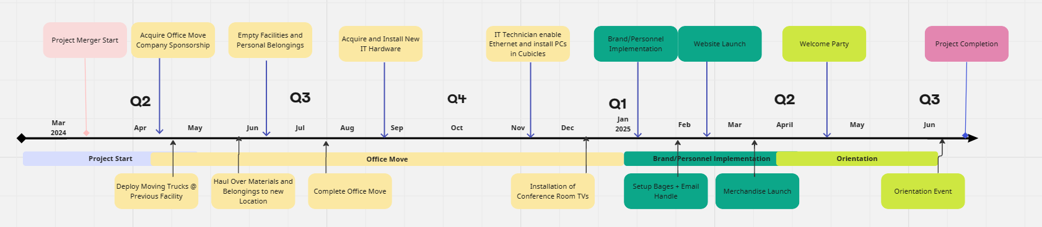**Work Breakdown structure**

Below is the work breakdown structure for the big merger project. The team used the project management platform miro to create the below diagram:

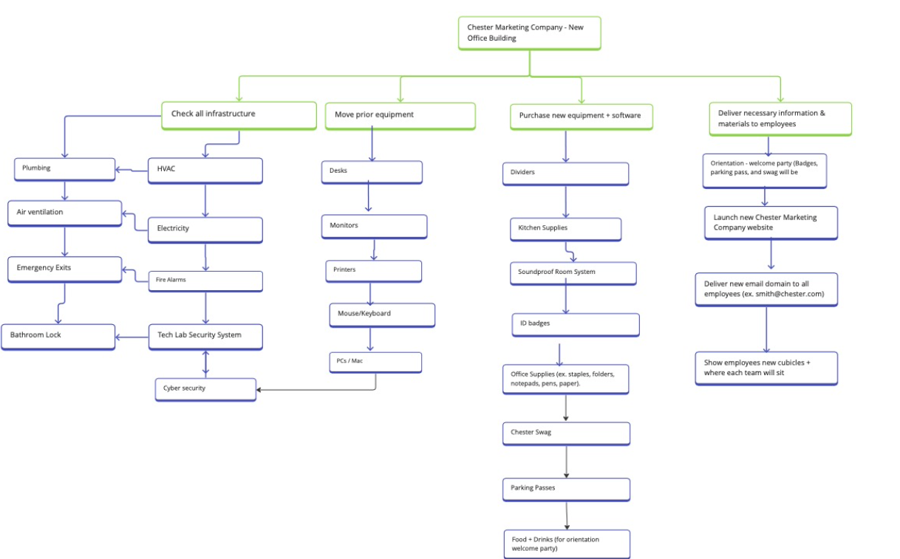

**Project Cost Estimate**

Below is the project cost estimate for the big merger project. The project cost estimate displays all wbs items and their project costs. This estimate includes level 1, level 2 and level 3 equipment. Level 1 estimates are considered the smallest costs of the total estimated cost.

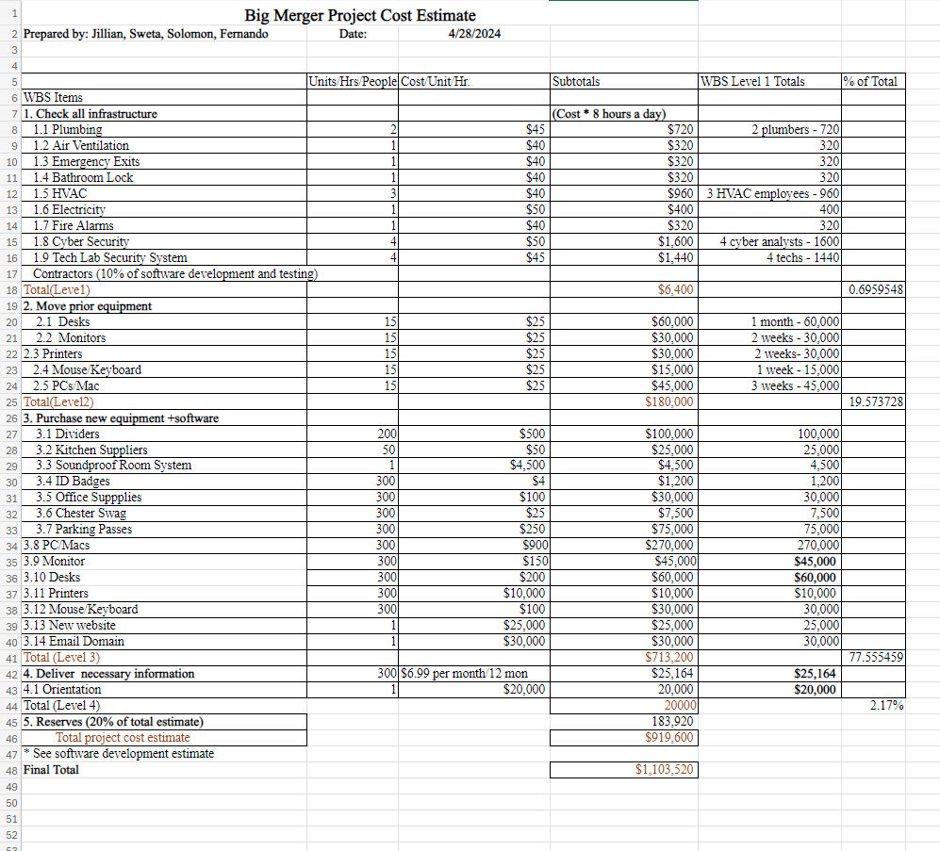

**Quality Management Plan**

# Introduction

The Quality Management Plan for the Big Merger project will establish the activities, processes, and procedures for ensuring quality deliverables with the project's completion. The purpose of this plan is to:

* Ensure quality is planned.
* Define how quality will be managed.
* Define quality assurance activities.
* Define quality control activities.
* Define acceptable quality standards.

# Quality Management Approach

The Big Merget project's quality management strategy will guarantee that both product and processes are strategically planned to ensure excellence. To achieve success, the project will accomplish its quality goals through employing an integrated quality approach. Quality management will be a key focus throughout its entire life cycle.

Our approach to quality will be proactive, aiming to prevent rework, waste, and unnecessary costs and delays. Quality will be considered both in terms of the final product and the processes used to achieve it. This involves establishing quality benchmarks, assessing quality levels, and consistently enhancing quality practices through detailed planning, prevention over inspection and continuous improvement of project.

Product quality in the Big Merger Project will be determined by how well the merged company's offerings align with established standards, specifications, and expectations, creating new standards and criteria for the merger.

The Big Merger project's process quality will concentrate on the methods used to manufacture the project's deliverable. Setting standards for process quality will guarantee that all tasks adhere to an organizational benchmark, ultimately leading to the effective delivery of the product.

The project team will collaborate with the Quality Group to establish and record all quality standards relevant to both organizational and project-specific requirements for products and processes. All quality-related documentation will be integrated into the Big Merger Project Plan and will be handed over to operations once the project is successfully concluded.

Throughout the project's duration, metrics will be set up and applied to gauge the quality of both the product and processes at various stages. The Quality Group Manager will collaborate with the project team to outline these metrics, conduct assessments, and evaluate outcomes. These measurements of product and process performance will serve as one of the criteria for assessing the project's success and must be reviewed by the project sponsor. Metrics will include:

* Timeline
* Resources
* Budget
* Process performance.
  + Operational efficiency
  + Project timeline
* Product performance
  + Move into the new building.
  + Office space
  + Websites and email addresses
  + Security and software infrastructures
  + Orientation
  + Label, cards and keys.
  + Sale Figures
* Project Satisfaction from employees and stakeholders

Any member of either the project team or quality group can propose quality enhancements. Each suggestion will be assessed to evaluate the cost-effectiveness and potential benefits of implementation, and its impact on products or processes. Should an improvement be approved, the project manager will ensure that all project documentation reflects the change, while the quality manager will update relevant organizational documentation affected by the improvement.

# Quality Requirements / Standards

***Product Quality:***

The project team and quality group will jointly establish the product quality standards and requirements, primarily drawing from the project's documented standards for the merger. If there are specific quality standards for the product that are not currently documented, the quality group will evaluate them for approval and integration into organizational documentation. Any newly identified quality standards will be documented in the Big Merger project plan by the project team, ensuring communication with all stakeholders.

During the trial phase, product compliance with quality standards will be assessed at predetermined intervals.

***Process Quality:***

The project team and quality group will collaborate to define the process quality standards and requirements. These standards will be created to ensure delivery of quality products. The Big Merger project team will partner with the quality group to establish these new standards and document them for inclusion in both organizational process documents and the Bog Merger Project plan. These standards will be effectively communicated to all project stakeholders.

# Quality Assurance

The quality assurance of the Big Merger Project focuses on the processes and materials used in ensuring the new office building is adequate, and all employees are situated in working for the new company. To ensure quality, an iterative quality process will be used throughout the project life cycle. This iterative process includes collecting and analyzing all project data, making approved changes to any building metrics lacking quality, and continuously improving the processes.

The Big Merger Project Manager and the project team will perform assessments at planned intervals throughout the project to ensure all processes are being correctly implemented and executed. The key performance metrics for ensuring a quality building and employee onboarding include new carpet flooring, new light fixtures, and cubicle dividers. The established project tolerances for these metrics are office standards for the building which the office is located in. The table below provides the key quality assurance metrics for the Big Merger Project.

|  |  |  |  |
| --- | --- | --- | --- |
| **Process Action** | **Acceptable Process Standards** | **Process Phase** | **Assessment Interval** |
| Installing New Carpet | * Base surface must be clean, all nails and debris must be cleared prior. * Proper tools for cutting carpet squares must be used. * The carpet must be power stretched, and steam cleaned. ￼ * The seam edges together securely to avoid any visible seams and seam rips. * Inspection post-installation for defects and debris. | Installing/Laying | Daily |
| Testing Light Fixtures | * Light fixtures are installed securely. * Lights do not flicker due to correct electrical engineering. * Lights are 500-1000 lux. | Testing | Daily |
| Measuring Cubicle Divider Height + Width | * Cubicles are 10ft wide, 7 ft high. * Cubicles are sturdy with vinyl paneling. | Measuring | Daily |

The quality assurance manager will provide daily updates on any changes in product or process quality. The quality assurance manager will also conduct process audits weekly. If any discrepancies are found, the quality assurance manager will review the discrepancies, notify the quality assurance team of the discrepancies, review the discrepancies with the project manager, and receive approval from the project manager about fixing the discrepancies.

The Project Manager will schedule weekly occurring project, management, and document review meetings with the quality assurance team. In these reviews, the team will project manager will review the quality assurance project processes, any discrepancies that have been found from the quality assurance manager and decide if any changes are necessary for the process improvement initiatives.

Process improvement will be assessed by the quality assurance team. Quality assurance reviews, findings, and assessments should be a known procedure by the quality assurance team and is vital for the improvement of the product. All process improvement changes must be documented, assessed, and made aware to all stakeholders as changes are made.

# Quality Control

The quality performance standards for the Big Merger – Chester Foundation are under public safety standards and employee satisfaction. However, there are several project-specific quality standards set for the Big Merger. We will prioritize how we assess the project's product to include the integration of merging employees, building, and any future websites. An established standard for acceptable quality has been processed by the project manager. The key points reviewed in this quality control form will be building functionality, website usability, and employee safety.

|  |  |  |  |
| --- | --- | --- | --- |
| **Product** | **Physical/Performance Standards** | **Quality Assessment Activities** | **Assessment Intervals** |
| Training Materials | Accessibility Check/ Multiple Languages | Feedback Survey | 2/yrs. |
| IT Infrastructure | NIST Framework | Software Audit | 1/yrs. |
| Website Content | Accessibility Check/ Multiple Languages | Analytical Tools/Audit | 1/yrs. |
| Office Equipment | Functional/Non-functional | Inspection | 4/yrs. |
| Building Safety/Infrastructure | Environmental, Safety, Accessibility Ratings within the State of Washington. | Compliance Inspections | 1/yrs. |
| ID Cards | RFID Security 2.1 | Field Testing | 6 months |

The project team will perform all physical measurements on the building and its emergency exits. The measurements will be conducted through systematic evaluation and testing. The project manager will see that the building manager extends prior history to compare with the current standards set. This should include past work done on the building to update aspects of security, health, and cleanliness.

The project manager will be responsible for the documentation of the outcomes from the quality assessment. Throughout the merger process, records of quality outcomes and any deviations from the established standards will be noted. The records will stand as valuable insights for continuous improvement as employee integration begins. This includes assessing employee satisfaction through surveys for feedback on the facility. It will also be done when the walkthrough for the building is done after it has been approved.

The big merger project will be committed to this quality control process. Aiming to ensure there is a seamless merger experience for all stakeholders involved, from employees to potential partners looking to become a sponsor of this high-quality project.

# Quality Control Measurements

For the big merger with Chester Company, we’ll be using the log to track the amount of traffic we receive for our new website, as well as tracking the number of employees who attend the orientation and welcome party. Furthermore, the log will also contain information from the pre-orientation survey and post orientation survey, as well as checking if the employee badges work and other equipment work. The log will be used as documentation to hold a record of the data we collect for the merger.

***Quality Control Log***

|  |  |  |  |  |  |  |
| --- | --- | --- | --- | --- | --- | --- |
| Operation/task | Date | Required value | Actual value | Acceptable (Yes/No) | Recommended change | Date resolution |
| # of employees at orientation |  |  |  |  |  |  |
| Website traffic/number of visits |  |  |  |  |  |  |
| Pre-orientation survey |  |  |  |  |  |  |
| Post-orientation survey |  |  |  |  |  |  |
| Badges operating |  |  |  |  |  |  |
| Other equipment operating |  |  |  |  |  |  |

**Communications Management Plan**

# Introduction

This Communications Management Plan establishes the communication structure for the project. It acts as a reference for communication throughout the project's duration and will be adjusted as communication requirements evolve. The plan outlines the roles of individuals involved in the project including Project team, Project Manager and stakeholders. It includes a communication matrix to outline communication needs. It also provides detailed guidelines for conducting meetings, covering communication protocols and meeting procedures to ensure their effectiveness. Additionally, a project team directory is included to provide contact details for all stakeholders directly engaged in the project.

# Communications Management Approach

The Project Manager Bill Smith will play an active role in ensuring efficient communication throughout this project. The communication needs are outlined in the Communications Matrix provided in this document. This matrix will serve as the roadmap for determining what information to communicate, who will be responsible for communication, when to communicate it, and who the recipients will be.

Updates and changes may become necessary as the project advances or as changes are approved. These changes could stem from shifts in personnel, scope, budget, or other factors. Furthermore, updates may be necessary as the project evolves and additional requirements emerge. Project manager will oversee all proposed and approved changes to the communications management plan. Once a change is approved, the project manager will revise the plan and associated documents and share the updates with the project team and stakeholders. This approach aligns with the project's Change Management Plan, ensuring that all project stakeholders remain informed of any modifications to communication management.

# Communications Management Constraints

All communication activities will operate within the project's approved budget, schedule, and resource allocations. It is the project manager's duty to ensure that communication tasks are undertaken by the project team without requiring external resources, which could lead to exceeding the authorized budget. Communication activities will follow the frequencies outlined in the Communication Matrix to maintain adherence to schedule constraints. Any deviation from these timelines, potentially resulting in increased costs or schedule delays, must be approved by the project sponsor.

The organizational policy of Chester Marketing Company mandates the use of standardized formats and templates for formal project communications whenever applicable. Further information regarding these policy stipulations can be found in the section labeled "Standardization of Communication" within this document.

The organizational policy of Chester Marketing Company additionally specifies that only a Vice President or an employee of a higher level may authorize the send out confidential information. The project manager must ensure approval is sought and secured before any confidential information pertaining to this project is distributed.

# Stakeholder Communication Requirements

As part of identifying all project stakeholders, the project manager will interact with each stakeholder to establish their preferred frequency and method of communication. This feedback will be documented by the project manager in the project’s Stakeholder meeting. While standard project communications will follow the Communication Matrix, customized communication to meet identified stakeholder needs is acceptable within the project's defined parameters.

In addition to determining how stakeholders prefer to communicate, it's important to outline the project's communication channels and ensure that stakeholders can access them. If project information is shared securely or through internal company resources, all stakeholders, both internal and external, must have the necessary access to receive project updates.

After identifying all stakeholders and establishing their communication needs, the project team will record this information in the project’s Stakeholder Register. This, along with the project communication matrix, will serve as the foundation for all project communications.

# Roles

**Project Sponsor**

A project sponsor in terms of the project communications plan is the focal point for authorization. It is intended to be the sponsor's responsibility to fund the project's overall success. Reaching the project sponsors should be timely and concise. Leave detailed reports to the project manager. Report to the project manager when the project sponsors have a new requirement to add to the merger plans.

**Program Manager**

The program manager differs from the project manager when it comes to overseeing the project. The program manager will be managing resources and ensuring everything is utilized. They will oversee the budget to ensure profitability is available at all stages of the project.

**Key Stakeholders**

The key stakeholders hold a unique partnership with the project. Set apart from the general stakeholders, the key stakeholders will be those who enable the communication pathways. The interest is higher within these individuals that will be closely linked to project progress. Addressing concerns or changes would need to include these individuals in emails/phone calls.

**Change Control Board**

The change control board is the group chosen to provide insights on changes to aspects of the project like scope, budget, and schedule. The board will approve changes according to their insights. Reporting in detail to the board is vital to sustain transparent management decisions from the top-down.

**Customer**

The customers for this project are Chester & Bob. Chester & Bob will be accepting the final deliverable shown by the project manager at the end of the proposed schedule. Chester & Bob will be notified of major status updates that concern them.

**Project Manager**

The project manager will coordinate all project activities and meetings, centered around meeting objectives throughout the project. Detailed updates will be provided by the project manager for effective monitoring. Communication channels will remain open outside of team meetings. The channels will include progress reports, changes, and additional tasks.

**Project Team**

The project team will be responsible for the completion of tasks contributing to the final product. The team will be comprised of experienced leaders in their sectors of project work. Constant communication will keep the team accountable. Feeding information to the project team will ensure that collaborative efforts are made with the project scope in mind. Day-to-day interactions will be encouraged to help accomplish the project goals.

**Steering Committee**

The communication strategy with the Steering Committee will be to guide all teams with project objective alignment. Regular updates will be scheduled to keep the steering committee informed about key milestones. Allowing them to create an accurate timeline to provide summarized information for any strategic decision-making on the fly.

**Technical Lead**

The IT Technical Lead will be responsible for all project team troubleshooting. The individual must be experienced in all aspects of cyber security and system implementation. The Technical lead will ensure that all teams receive detailed communication for effective solutions. Regular technical reviews will be conducted to ensure that risks are mitigated before they delay the Big Merger project. Close communication will be encouraged with the project manager and all team members.

# Project Team Directory

The following table presents contact information for all persons identified in this communications management plan. The email addresses and phone numbers in this table will be used to communicate with these people.

|  |  |  |  |  |  |
| --- | --- | --- | --- | --- | --- |
| **Role** | **Name** | **Title** | **Organization/ Department** | **Email** | **Phone** |
| **Project Sponsor** | Bob Chester | CEO | Chester Marketing Company | [bob@chester.com](mailto:bob@chester.com) | (253) 555-1212 |
| **Program Manager** | Lester Lee | PMO Manager | Programs | [lester@chester.com](mailto:lester@chester.com) | (253) 555-1313 |
| **Project Manager** | Bill Smith | Project Manager | PMO | [bill@chester.com](mailto:bill@chester.com) | (253) 555-1414 |
| **Project Stakeholders** | See  Stakeholder  Register | See Stakeholder Register | See Stakeholder Register | See Stakeholder Register | See Stakeholder Register |
| **Customer** | See Employee List | See Employee List | Chester Marketing Company | [chester_hr@chester.com](mailto:chester_hr@chester.com) | (509) 555-8121 |
| **Project Team** | See Project Team List | N/A | Project Chester Marketing | [CM_project@chester.com](mailto:CM_project@chester.com) | 699-987-9090 |
| **Technical Lead** | Gonzalez Gonzalez | IT Systems Engineer | IT Department | [GonzalezIT@chester.com](mailto:GonzalezIT@chester.com) | (509) 555-2923 |
| **Steering Committee** | See Committee List | Project Objectives | Project Scope | [St_Committee@chester.com](mailto:St_Committee@chester.com) | 509-555-8122 |

# Communication Methods and Technologies

Effective communication methods will be what the whole project team will rely on. The right strategies for technology will also be utilized to ensure that communication is smooth throughout the project. Leveraging the convenience of the merger will lead to a higher yield of success. Understanding the diverse technological capabilities will be essential for opening up communication channels.

The project team will determine, in accordance with Chester, the communication methods and technologies based on several factors including stakeholder communication requirements, internal/external technologies, and organizational policies. The Big Merger will maintain software licenses for MS Project and Adobe Creative Cloud. All project teams are responsible for assigning their members with said resources to guide their daily work. A technician will be assigned to each project team to issue troubleshooting with their given administrator accounts.

The project schedule and WBS will be housed within the programs listed above. Additionally, licensing for collaborative work will be issued within the planning phase of the Big Merger. An enterprise license for Zoom will be issued to all project leaders in each team. Upgrading meeting times from 30 minutes to 1 hour and longer. A technician will be on standby to keep logs, generate a transcript, and ensure meetings don’t lose connections. A Microsoft 365 license will be issued over software like Google Workspace. The Microsoft license will ensure compatibility with Adobe Acrobat Profiles. Enabling the use of collaborative workspace further within different teams.

All project communication, recordings, and documentation will be maintained on the cloud network built by the on-site IT Engineer. The use of the cloud network will allow for the safe transference of data across job sites. Allowing for remote workers to join on any given day. An internal password will be generated uniquely to meet the security policies set by the IT project team.

All project communications will adhere to HIPPA regulations. The Big Merger project must prioritize the safeguarding of all digital assets. Compliance with national standards of security will be upheld through this communication plan. Licenses for antivirus firewalls, intrusion detection systems, and encryption will be applied to all software internally. A license for Bitdefender Plus will be issued to help prevent cyber threats that could delay the project schedule.

# Communications Matrix

The following table identifies the communications requirements for this project.

|  |  |  |  |  |  |  |  |
| --- | --- | --- | --- | --- | --- | --- | --- |
| **Communication Type** | **Objective of Communication** | **Medium** | **Frequency** | **Audience** | **Owner** | **Deliverable** | **Format** |
| Chester Marketing Company: Kickoff Meeting | Introduce the project team and the project – The Big Merger. Review project objectives and management approach. | * Face to Face | Once | * Project Sponsor * Project Team * Stakeholders | Project Manager | * Agenda * Meeting Minutes | * Soft copy archived on project SharePoint site and project web site |
| (Recurring) Project Team Meetings | Review project status with the team and discuss any new findings. | * Face to Face * Conference Call | Weekly | * Project Team | Project Manager | * Agenda * Meeting Minutes * Project schedule | * Soft copy archived on project SharePoint site and project web site |
| Technical Design Meetings for Office Building and Website. | Discuss and develop technical design solutions of the office space. | * Face to Face * Conference Call | As Needed | * Project Technical Staff | Technical Lead | * Agenda * Meeting Minutes | * Soft copy archived on project SharePoint site and project web site |
| Monthly Project Status Meetings | Report on the status of the project (Both the office space and orientation). | * Face to Face * Conference Call | Monthly | * PMO | Project Manager | * PowerPoint updates * Project schedule | * Soft copy archived on project SharePoint site and project web site |
| Project Status Reports | Report the status of the project including budgeting, progress, opportunities, and issues. | * Email (Report) | Monthly | * Project Sponsor * Project Team * Stakeholders * PMO | Project Manager | * Project Status Report * Project schedule | * Soft copy archived on project SharePoint site and project web site |

# Communication Flowchart

The communication flowchart below was created to aid in project communication for The Big Merger project. The flowchart below provides a framework for the project team to follow when the communication process is not clear.

It is important to note additional clarification may be necessary when a specific situation occurs that is not easily identifiable through the communication flowchart. In these situations, the Project Manager (Bill Smith) is responsible for discussing the specific communication situation with the Project Sponsor (Bob Chester) and determining a plan on how to proceed.

# Guidelines for Meetings

**Meeting Agenda**

The meeting Agenda will be distributed 5 business days in advance of the meeting. The agenda should identify the presenter for each topic along with a time limit for that topic. The first item in the agenda should be a review of action items from the previous meeting.

**Meeting Minutes**

Meeting minutes will be distributed within 2 business days following the meeting. Meeting minutes will include the status of all items from the agenda along with new action items and the Parking Lot list.

**Action Items**

Action Items are recorded in both the meeting agenda and minutes. Action items will include both the action item along with the owner of the action item. Meetings will start with a review of the status of all action items from previous meetings and end with a review of all new action items resulting from the meeting. The review of the new action items will include identifying the owner for each action item.

**Meeting Chair Person**

The Chair Person is responsible for distributing the meeting agenda, facilitating the meeting and distributing the meeting minutes. The Chair Person will ensure that the meeting starts and ends on time and that all presenters adhere to their allocated time frames.

**Note Taker**

The Note Taker is responsible for documenting the status of all meeting items, maintaining a Parking Lot item list and taking notes of anything else of importance during the meeting. The Note Taker will give a copy of their notes to the Chair Person at the end of the meeting as the Chair Person will use the notes to create the Meeting Minutes.

**Time Keeper**

The Time keeper is responsible for helping the facilitator adhere to the time limits set in the meeting agenda. The Time Keeper will let the presenter know when they are approaching the end of their allocated time. Typically, a quick hand signal to the presenter indicating how many minutes remain for the topic is sufficient.

**Parking Lot**

The Parking Lot is a tool used by the facilitator to record and defer items not on the meeting agenda; however, it merits more discussion later or through another forum.

A parking lot record should identify an owner for the item as that person will be responsible for ensuring follow-up. The Parking Lot list is to be included in the meeting minutes.

# Communication Standards

For this project, the Chester Company. will utilize standard organizational formats and templates for all formal project communications. Formal project communications are detailed in the project’s communication matrix and include:

Kickoff Meeting – project team will utilize the Chester Company standard templates for meeting agenda and meeting minutes. Additionally, any slides presented will be used by the Chester Company. standard slideshow template.

Project Team Meetings – project team will utilize Chester Company standard templates for meeting agenda and meeting minutes. Additionally, any slides presented will use the Chester Company standard slideshow template.

Technical Design Meetings - project team will utilize Chester Company standard templates for meeting agenda and meeting minutes. Additionally, any slides presented will use the Chester Company standard slideshow template.

Monthly Project Status Meetings - project team will utilize Chester Company standard templates for meeting agenda and meeting minutes. Additionally, any slides presented will use the Chester Company standard slideshow template.

Project Status Reports – project team will utilize Chester Company standard templates for meeting agenda and meeting minutes. Additionally, the standard project status report document, available on the share drive, will be used to provide project status.

Informal project communications should be professional and effective but there is no standard template or format that must be used. Typically, iMessage or Teams chat will be used

# Communication Escalation Process

To ensure that the operations of the merger continue as efficiently and smoothly as possible, the Chester Company and project team will use the table below as a guideline towards handling project escalations and how promptly those issues should be resolved by the team. The table lays out the level of priority, the definition of those issues, who has the final say in the decision and the time frame for resolving that issue. This will ensure that delays won’t occur and that the project will continually progress overtime without any hiccups.

|  |  |  |  |
| --- | --- | --- | --- |
| **Priority** | **Definition** | **Decision Authority** | **Timeframe for Resolution** |
| Priority 1 | Major impact to project or business operations. If not resolved quickly there will be a significant adverse impact to revenue and/or schedule. | Vice President or higher | Within 4 hours |
| Priority 2 | Medium impact to project or business operations which may result in some adverse impact to revenue and/or schedule. | Project Sponsor | Within one business day |
| Priority 3 | Slight impact which may cause some minor scheduling difficulties with the project but no impact to business operations or revenue. | Project Manager | Within two business days |
| Priority 4 | Insignificant impact to project but there may be a better solution. | Project Manager | Work continues and any recommendations are submitted via the project change control process |

** NOTE: Any communication including sensitive and/or confidential information will require escalation to VP level or higher for approval prior to external distribution.

# Glossary of Communication Terminology

|  |  |
| --- | --- |
| Term | Definition |
| Communication | The effective sending and receiving of information. Ideally, the information received should match the information sent. It is the responsibility of the sender to ensure this takes place. |
| Stakeholder | Individuals or groups involved in the project or whose interests may be affected by the project’s execution or outcome. |
| Communications Management Plan | Portion of the overall Project Management Plan which details how project communications will be conducted, who will participate in communications, frequency of communications, and methods of communications. |
| Escalation | The process which details how conflicts and issues will be passed up the management chain for resolution as well as the timeframe to achieve resolution. |
| Merger | The joint union of two companies together to maximize each other's benefits and profits |

**Risk Register**

Below is the Risk Register for The Big Merger Project. The Risk Register displays all potential project risks, probability score, and status.

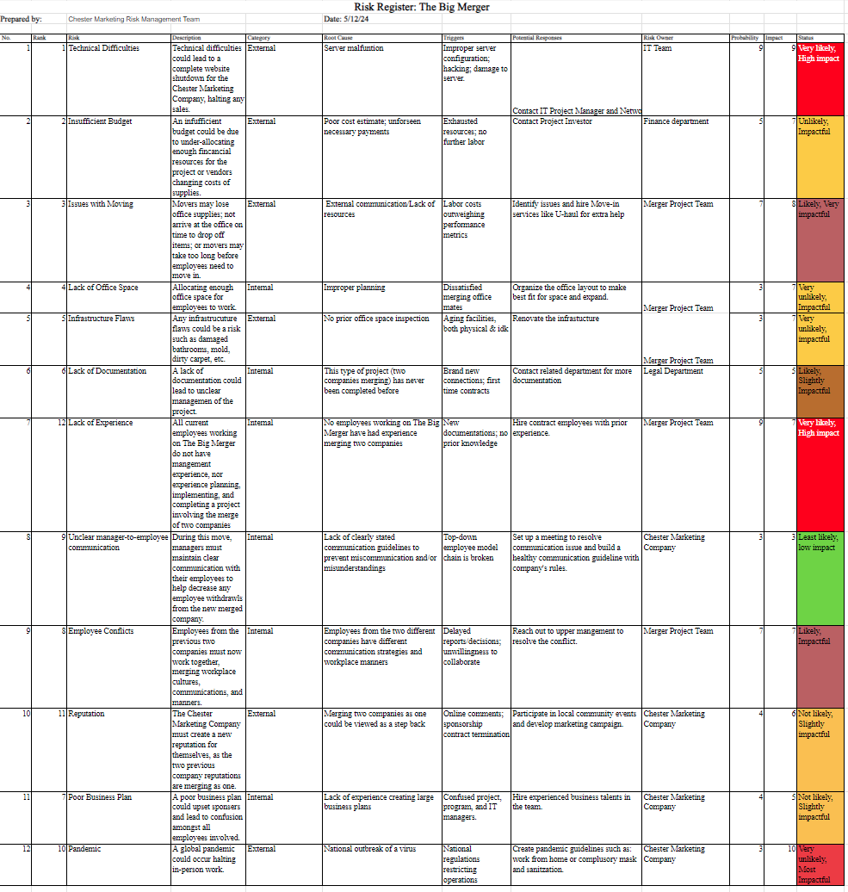

**Stakeholder Engagement Strategy for Big Merger**

**Prepared by: ￼**Jillian Lane, Fernando Trujilo Zuniga, Sweta Kharel, Solomon Kairu **Date: 5/19/24**

|  |  |  |  |
| --- | --- | --- | --- |
| **Name** | **Level of Interest** | **Level of Influence** | **Potential Management Strategies** |
| **Bob Chester (project sponsor)** | 5 | 5 | Keep Mr. Chester within loop of all the major updates and changes within the project scope and charter. This will be done by sending him weekly emails regarding the new updates. Also avidly listen to his feedback and input regarding the project. |
| **Employees** | 5 | 2 | Take recommendations and surveys from employees regarding their preferences on decision taking of office infrastructures. |
| **Customers** | 3 | 2 | Use social media and public campaigns to market the merge between the companies, as well as advertising the new changes that come from this merge. |
| **3rd party vendors/suppliers** | 2 | 3 | Invite third party vendors for demonstration of products and services to purchase as well as rebrand our services. |
| **Ellensburg community** | 2 | 2 | Similarly to the customers, aim towards marketing the new merge/company rebranding to the local Ellensburg community by advertising the new growth and ideas that will be added, as well as engaging actively with the community (such as tabling at the CWU campus) or collaborating with other local businesses. |
| **Competitors** | 2 | 2 | Use Open-Source information to be on top of the present market of competitors and collab with them. |

**Stakeholder Register**

**Prepared by:** Jillian Lane, Fernando Trujilo Zuniga, Sweta Kharel, Solomon Kairu **Date: 5/19/24**

|  |  |  |  |  |
| --- | --- | --- | --- | --- |
| **Name** | **Position** | **Internal/External** | **Project Role** | **Contact Information** |
| **Bob Chester** | CEO | Internal | The leader of the Chester Company and the main sponsor of this project. | 509-542-8989 |
| **Bill Smith** | Project Manager | Internal | Assist in all project decisions and projects. Provide ideas and hold weekly meetings with various project teams. Ensure project milestones are being completed on time. | 509-741-9633 |
| **Melissa Monroe** | Vice President of Customer Service | Internal | Collect data from customers and recent reviews of the company merge. Ensure Chester Marketing Company receives positive feedback about the merge. | 509-226-2606 |
| **Jacob Lee** | Lead Mover | External | Ensure all project office supplies is transferred to the new office on time, and in good condition. | 509-285-6278 |
| **Annie May** | Quality Assurance Manager | Internal | Ensures that the quality of the project remains consistent at each milestone. Is also responsible for creating strategies to ensure quality and to prevent quality drop. | 206-989-4478 |
| **Sarah White** | Risk Management Director | Internal | Is responsible for accessing, evaluating, and analyzing the risk within each aspect of the project and comes up with a solution based on each situation. | 253-956-9997 |

**Procurement Management Approach**

The Project Manager, Bill Smith, will oversee and manage all procurement activities for the merger project. Collaborating with the project team, the Project Manager will identify all necessary items such as budget, documentation, employee’s needs, potential locations for successful project completion. This procurement list will be reviewed by the Project Management Office (PMO) before being submitted to the contracts and purchasing department. The contracts and purchasing department will evaluate the procurement items to decide whether to make or buy them, and will initiate the vendor selection, purchasing, and contracting processes. This coordinated approach ensures that procurement activities are efficient and aligned with project objectives.

# Procurement Definition

The following items and services are deemed essential for the project's successful completion. The list, along with justifications and timelines, is currently awaiting PMO review before being submitted to the contracts and purchasing department:

|  |  |  |
| --- | --- | --- |
| Item/Service | Justification | Needed By |
| Soundproofing drywall 20’*20” $30/sq ft | Needed to build soundproof room as per the requirement of project | 15 Sep 2024 |
| Email address accounts $6.99 * 300 | Needed for 300 employee’s organizational account | 15 Jan 2025 |
| ID Badges 300 employees | Needed to provide access entry to each employee in the organization. | 1 September 2024 |
| Dividers 4* 50 | Needed to organize office into personal cubicles for each employee. | 1 July 2024 |

In addition to the above list of procurement items, the following individuals are authorized to approve purchases for the project team:

**Name** **Role**

Bill Smith Project Manager

Jeff Bousson Sustainability Officer

Bob Chester Project Sponsor

Jenny Swift Legal department head

Julie Wright Supply Chain Management

Jim Brown Lead Engineer

Bob Jones IT department head

# Type of Contract to be Used

All items and services for this project will be procured using fixed price contracts. The project team will collaborate with the contracts and purchasing department to specify the types, quantities, services, and delivery dates required and pay for the Point of Total Assumption (PTA). The contracts and purchasing department will then request bids from various vendors to secure the items within the necessary timeframe and at a reasonable cost. The selected vendor will be awarded a contract to be completed in 12 months to 2 years.

# Procurement Risks

The procurement procedure will inevitably run into risks that will threaten the project scope. Not curating a plan toward meticulous risks will set the team back. Mitigating risks means we must evaluate the current operations conditions. Strategies will be formed to attack the procurement activities Bill Smith believes will align with the project's risk management plan. The following risks are being considered as a threat.

- Vendor Redundancies

- Compliance with the region/state

- Vendor Scalability Potential

- Cultural Differences

- Production Quality

- Cost of Goods

- Outstanding/Expiring Contracts

- IT Implementation Complications

Examples of current risks facing the procurement process are listed here. The top-ranking risk is vendor redundancies. The Big Merger will cut down on contracts deemed unnecessary (i.e. multiple lumber, cleaning, moving companies).

Committing to reviewing past business relationships to form relevant partnerships today. The risks associated with the Big Merger Project will keep the project from fulfilling its projected timeline. Actively identifying new risks and managing them will be paramount for the procurement risk management team.

# Procurement Risk Management

As stated above, project risk will offer new obstacles unforeseen if not managed in a risk mitigation plan. The same can be applied to the procurement process where we are sensitive to delays. It is not enough to simply identify and address the risks to the stakeholders. The Stakeholders will want key personnel to explain a way around them.

A procurement risk management plan will be developed by Bill Smith and the procurement team to organize all sectors of operation. Whether that be supply chain, external, internal, vendor conflicts, etc. The main vector of risk Bill Smith has prioritized is the vendor connections in the current situation.

Decisions will be determined by the cost of continuing business from one vendor to another. Calculating the sensitivity of production if we pull out of contracts unnecessarily. Or we can find ourselves saving budget expenditure by negotiating a contract with a sole vendor.

A matrix with a weighted scale will be discussed in weekly meetings. Repurposing the risk management procedure when action is needed. Stakeholders will have the final approval once cases are made in meetings.

# Cost Determination

All information regarding expediting fees and cash-in flows will be posted here. Documented proposals and quotes will be stored in secure digital spaces within the IT cloud system.

The cost determination will act as a structured approach to ensuring that the project stays within the limit of spending. The Big Merger will use all documents stored in this database to make a comprehensive cost breakdown. The breakdown will include material bought for the soundproof rooms, IT infrastructure, moving, and any other maintenance (HVAC, etc.).

The vendors who will sponsor the bulk of the goods must comply with the demand we set for each phase. Detailed communication and support will be provided by referencing the completed procurement plan. Vendors will submit WBS and work schedules to make sure collaboration is aligned with the project scope. Scalability will also need to be adjusted now that the company size has grown twice the size as before.

By adhering to the risk management and cost determinations, the Big Merger project will remain informed of any given decision.

# Standardized Procurement Documentation

The procurement management process for the big merger project is very complex since the merger would require the Chester Company to acquire many of the required goods for us to properly move our equipment into the new office, along with everything the new materials needed for combining our two companies. For this reason, the document will be simplified to make understanding everything easier on everyone’s end.

The following standard documents will be used for project procurement activities:

* Standard Request for Proposal Template to include:
  + Background
  + Proposal process and timelines
  + Proposal guidelines
  + Proposal formats and media
  + Source selection criteria.
  + Pricing forms
  + Statement of work
  + Terms and Conditions
* Internal source selection evaluation forms
* Non-disclosure agreement
* Letter of intent
* Firm fixed price contract.
* Procurement audit form
* Procurement performance evaluation form
* Lessons learned form.

# Procurement Constraints

There are several constraints that must be considered as part of the project’s procurement management plan. These constraints apply to several areas which include schedule, cost, scope, resources, and technology:

Schedule:

* Project schedule is not flexible and the procurement activities, contract administration, and contract fulfillment must be completed within the established project schedule.

Scope:

* All procurement activities and contracts must fall within the scale of our scope for the big merger project.

Resources:

* All procurement activities must be performed and managed with current personnel. No additional personnel will be hired or re-allocated to support the procurement activities on this project.

Technology:

* Parts specifications have already been determined and will be included in the statement of work as part of the RFP. While proposals may include suggested alternative material or manufacturing processes, parts specifications must match those provided in the statement of work exactly.

# Contract Approval Process

The contract approval process will vary from order to order, such as if the purchase is something significant and expensive to the project or if the order is something more trivial and not as high stakes. If the purchase passes a certain threshold in price value (<$5000) then the purchase should be approved first by a majority of the project management team. Afterwards, the approval will be passed upwards towards the CEO (Bob Chester) and other sponsors of this project. If they all approve of the purchase, then the contract will be approved. As for smaller purchases, these must be approved within the project management team.

# Decision Criteria

The criteria for the selection and award of procurement contracts under this project will be based on the following decision criteria:

* Time Management; Delivery
* Efficiency
* Reliability
* Regulatory Compliance
* Quality
* Cost
* Service
* Comparison of outsourced cost versus in-sourcing
* Past Performance
* Relationship with Chester Marketing
* Flexibility
* Geographic Location

These criteria will be measured by the contracts review board and/or the Project Manager, Bill Smith. The ultimate decision will be made based on these criteria as well as available resources.

# Vendor Management

The Project Manager, Bill Smith, is ultimately responsible for managing vendors. To ensure the timely delivery and high quality of products from vendors, Bill Smith’s designee will meet weekly with the contract and purchasing department and each vendor to discuss the progress for each procured item. The meetings will be conducted via Microsoft Teams, Zoom, or in-person. The purpose of these meetings is to review all documented requirements and descriptions for each product. The tested quality of the product will also be reviewed. All aspects of the item can be reviewed and discussed using this forum. It is imperative that Chester Marketing Company ensures it complies with the requirements established in the project specifications. Additionally, any questions, requirements, or modifications can be discussed to help ensure the product is delivered in a timely manner. Bill Smith will be responsible for scheduling this meeting on a weekly basis until all items are delivered and accepted.

# Performance Metrics for Procurement Activities

While the purchasing and contracts department has their own internal metrics for procurement, the following metrics are established for vendor performance for this project’s procurement activities. Each metric is rated on a 1-3 scale as indicated below:

|  |  |  |  |  |  |  |  |
| --- | --- | --- | --- | --- | --- | --- | --- |
| Vendor | Product Quality | On Time Delivery | Documentation Quality | Development Costs | Development Time | Cost per Unit | Transactional Efficiency |
| Vendor #1 | 2 | 3 | 2 | 1 | 2 | 2 | 2 |
| Vendor #2 | 3 | 3 | 2 | 2 | 3 | 2 | 3 |

1 – Unsatisfactory

2 – Acceptable

3 - Exceptional

In addition to rating each vendor, actual values will be noted to build a past-performance data base for selecting vendors for future procurement activities.

# Sponsor Acceptance

Bob Chester

Approved by the Project Sponsor:

*Bob Chester*

Date: May 29th, 2024

Bob Chester

CEO of Chester Marketing Company