https://api.groq.com/openai/v1/audio/speech
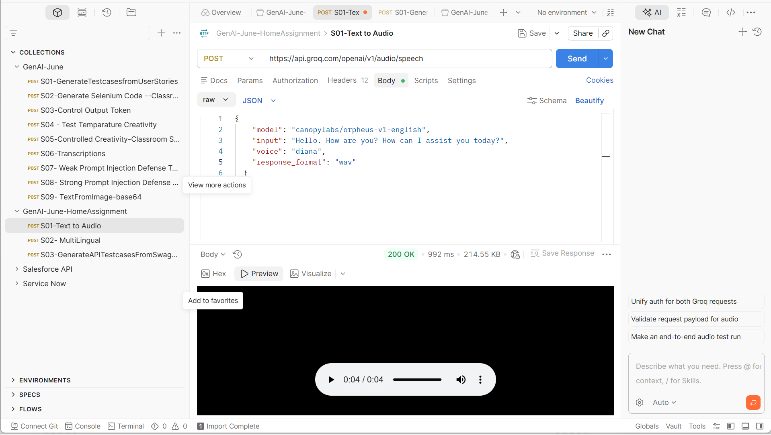

2) https://api.groq.com/openai/v1/chat/completions
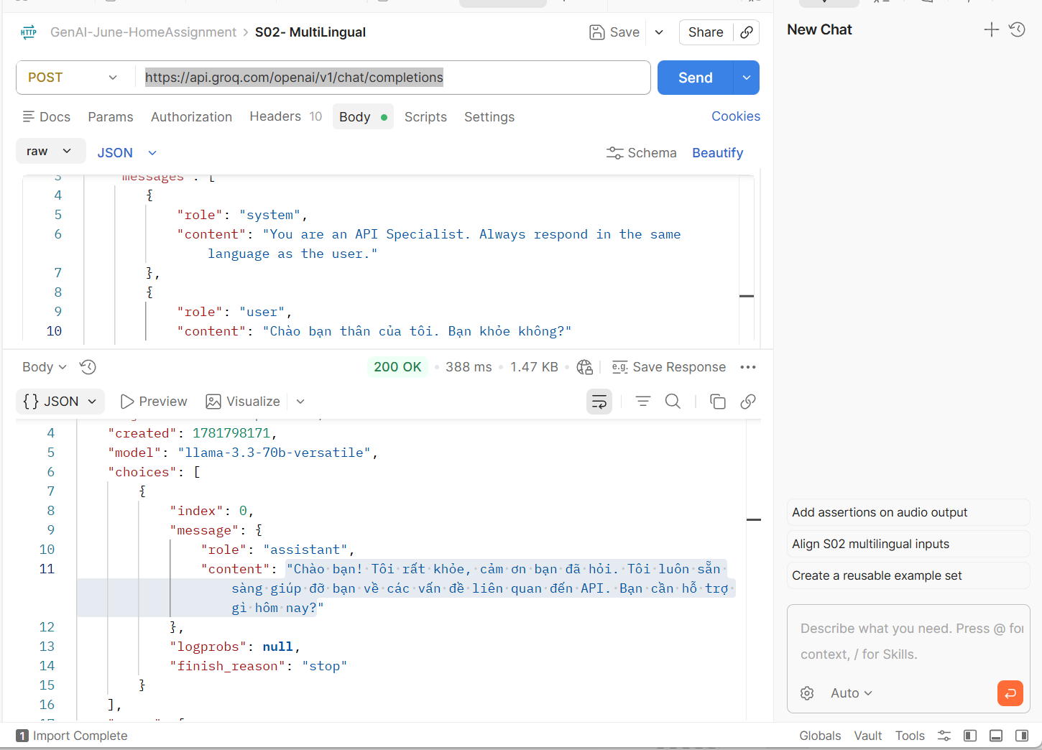
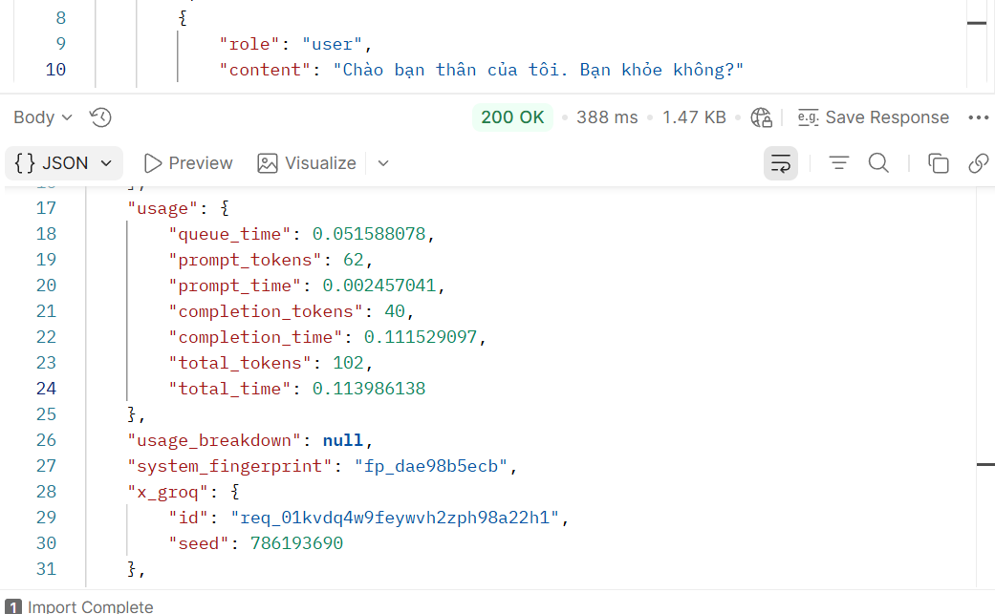

3) https://api.groq.com/openai/v1/chat/completions
