# Assignment #01 : ec2-instance-launch

1. **Start EC2 instance**
2. **Create a file on EC2 instance from CLI Ex: “EC2ToLocal.txt” And Copy file from EC2 to Local System.**
3. **Create a file on local and copy it to EC2 Instance Ex : “LocalToEC2”**

**Solution:**

1. **Ec2 Instance started over the AWS Console,**

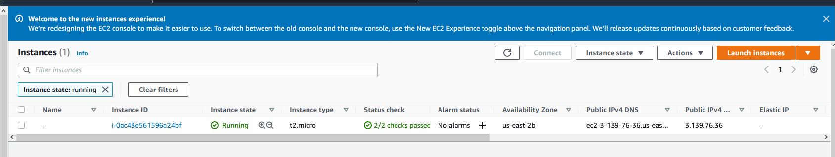

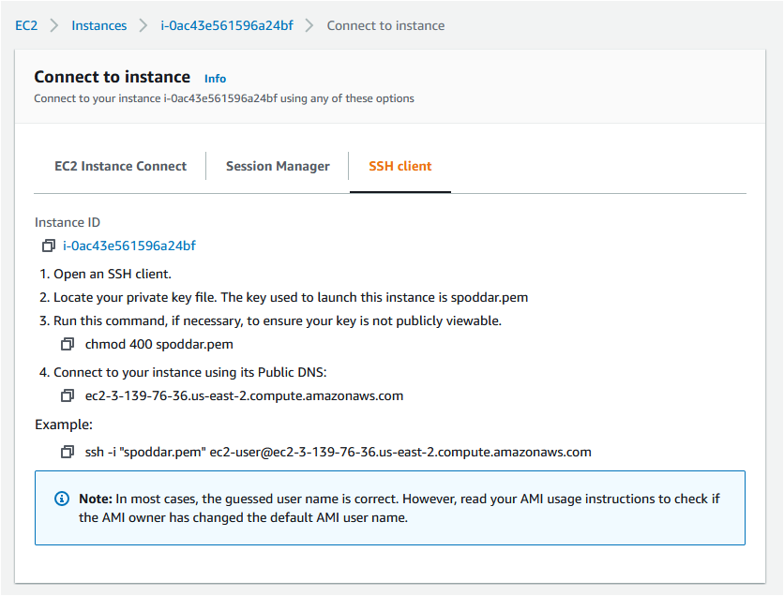

1. **File is copied from AWS EC2 Instance to Local from command line.**

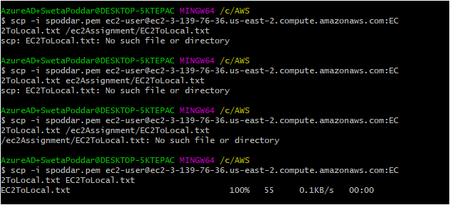

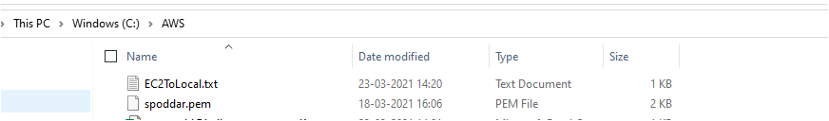

1. **Copy file from local to AWS Console**



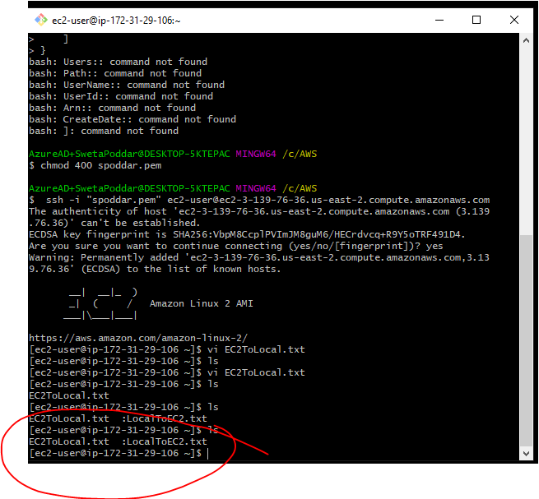

1. **Stop the EC2 Instance**

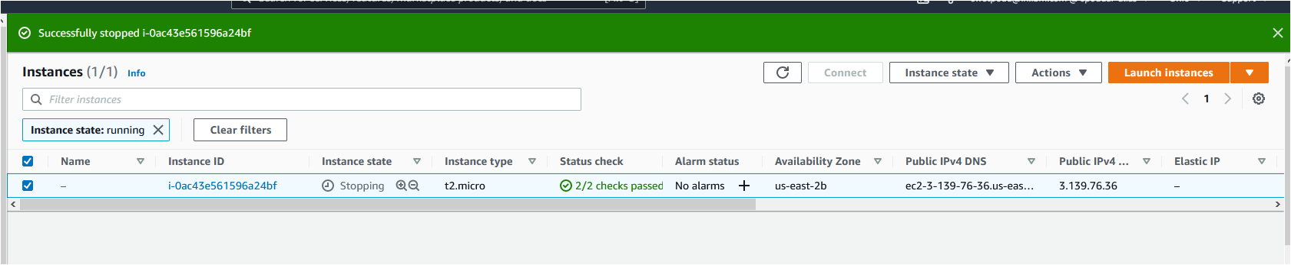

1. **Terminate the EC2 Instance.**

