ISTIO-Service Mesh

Install istio: 1

Automatically inject Envoy Sidecar proxies to default namespace 1

Deploying book-info app: 1

Verify everything working correctly or not: 1

Apply Gateway opening app from outside: 1

Finding Ingress IP and Port: 1

Setting up Environment Variables: 1

Access the App from Browser (Distributing V1/V2/V3 Apps-Round Robin Method): 1

Kiali Dashboard: 1

Install: 1

Accessing Kiali Dashboard: 1

Kiali Dashboard UI: 1

Request Routing: 1

Apply Default Destination Rules: 1

Apply Virtual Service (All Requests Routes to V1): 1

With Multiple Request Same Page Display 1

Route User Based Identity: 1

Accessing Page (User:Jason Version-2 Displays) 1

Accessing Page (Default User. V1 Displays) 1

Cleanup: 1

Fault Injection: 1

Applying Fault Injection 1

User-1 Accessing (Delaying 6 Seconds) 1

Default User Accessing (No Delay) 1

Aborting Injection of HTTP fault 1

All request no delay 1

# Download istio:

* Download Istio Installer Zip.
* Unzip the folder and copy it on C:/ Drive
* Go Inside the folder home and run the command on linux bash to add IstioCtl client to your path.

**$ export PATH=$PWD/bin:$PATH**

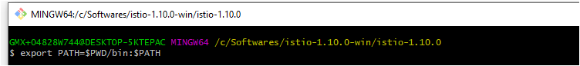

# Install istio:

**$ istioctl install --set profile=demo -y**

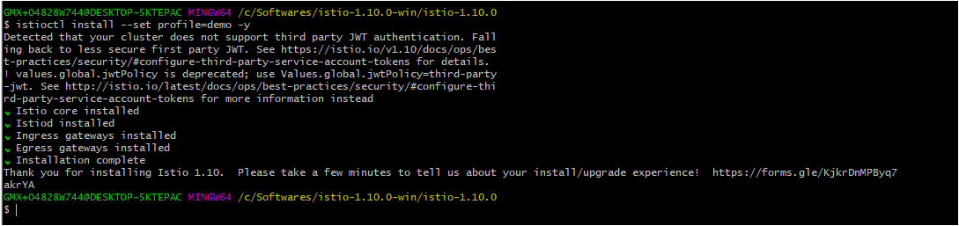

# Automatically inject Envoy Sidecar proxies to default namespace

**$ kubectl label namespace default istio-injection=enabled**

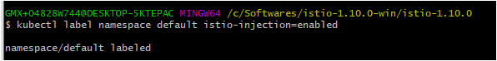

# Deploying book-info app:

**$ kubectl apply -f samples/bookinfo/platform/kube/bookinfo.yaml**

# 

# Check all services are deployed well

**$ kubectl get services**

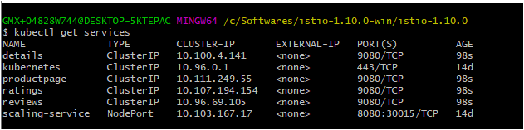

**$ kubectl get pods**

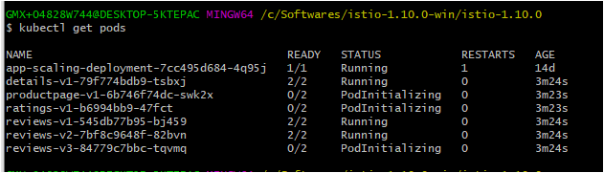

# Verify everything working correctly or not:

**$ kubectl exec "$(kubectl get pod -l app=ratings -o jsonpath='{.items[0].metadata.name}')" -c ratings -- curl -sS productpage:9080/productpage | grep -o "<title>.*</title>"**



# Apply Gateway opening app from outside:

**$ kubectl apply -f samples/bookinfo/networking/bookinfo-gateway.yaml**

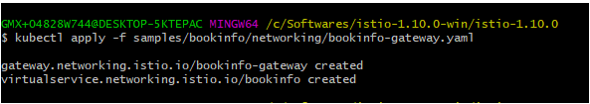

# Finding Ingress IP and Port:

kubectl get svc istio-ingressgateway -n istio-system

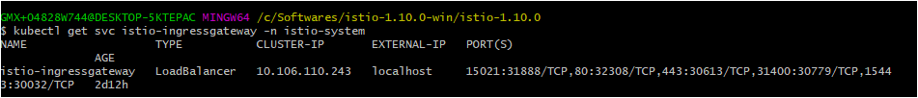

# Setting up Environment Variables:

* export INGRESS_HOST=$(kubectl -n istio-system get service istio-ingressgateway -o jsonpath='{.status.loadBalancer.ingress[0].ip}')
* export INGRESS_PORT=$(kubectl -n istio-system get service istio-ingressgateway -o jsonpath='{.spec.ports[?(@.name=="http2")].port}')
* export SECURE_INGRESS_PORT=$(kubectl -n istio-system get service istio-ingressgateway -o jsonpath='{.spec.ports[?(@.name=="https")].port}')
* echo $SECURE_INGRESS_PORT
* echo $INGRESS_HOST
* export INGRESS_PORT=$(kubectl -n istio-system get service istio-ingressgateway -o jsonpath='{.spec.ports[?(@.name=="http2")].nodePort}')
* export SECURE_INGRESS_PORT=$(kubectl -n istio-system get service istio-ingressgateway -o jsonpath='{.spec.ports[?(@.name=="https")].nodePort}')
* echo $INGRESS_HOST
* export INGRESS_HOST=$(kubectl -n istio-system get service istio-ingressgateway -o jsonpath='{.status.loadBalancer.ingress[0].hostname}')

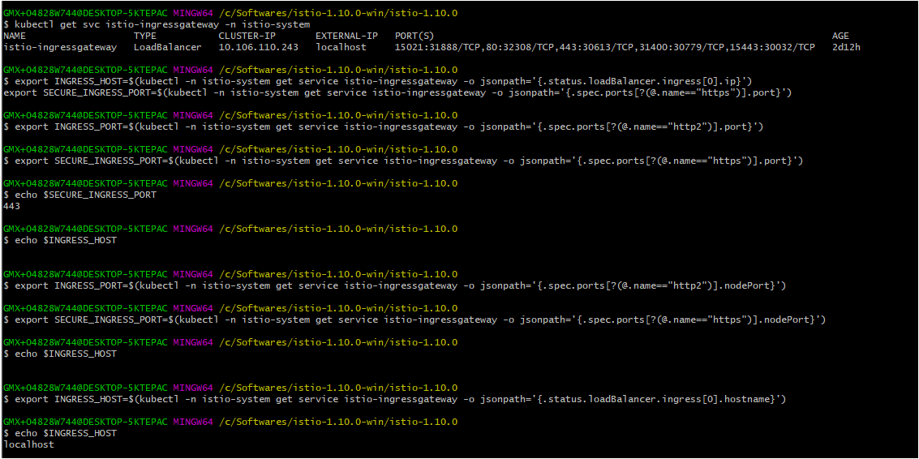

# Access the App from Browser (Distributing V1/V2/V3 Apps-Round Robin Method):

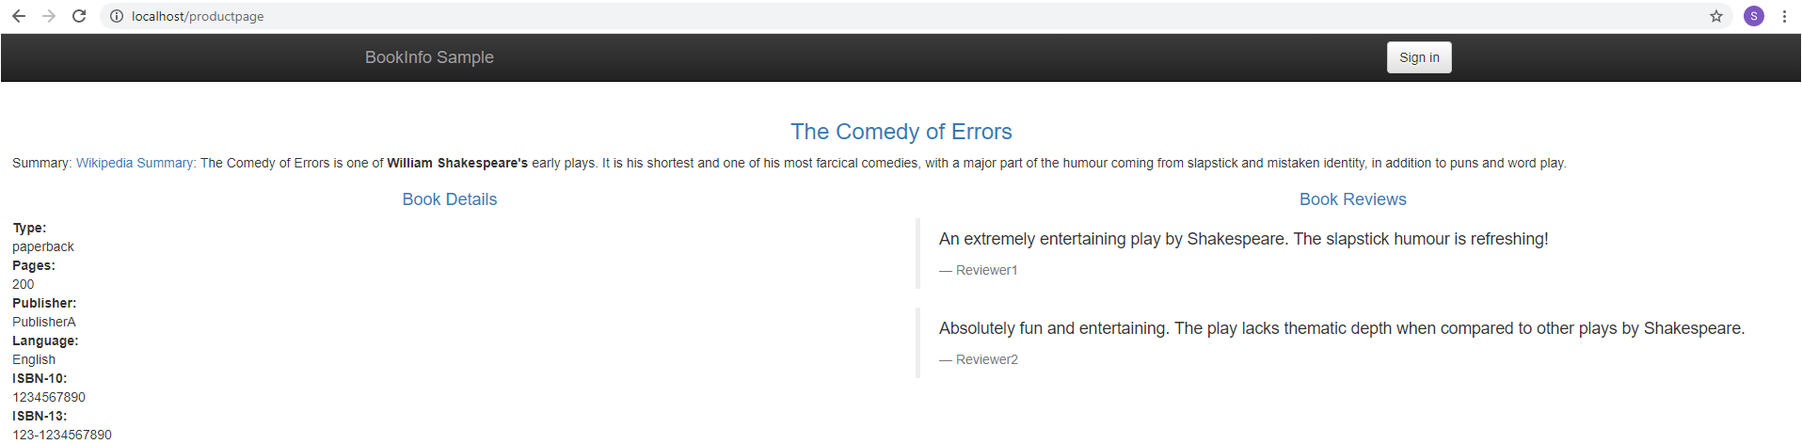

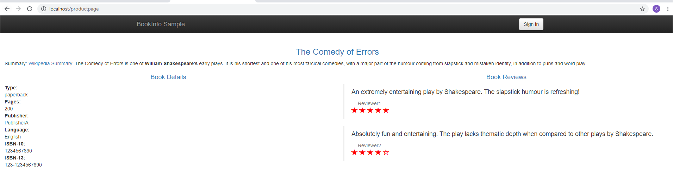

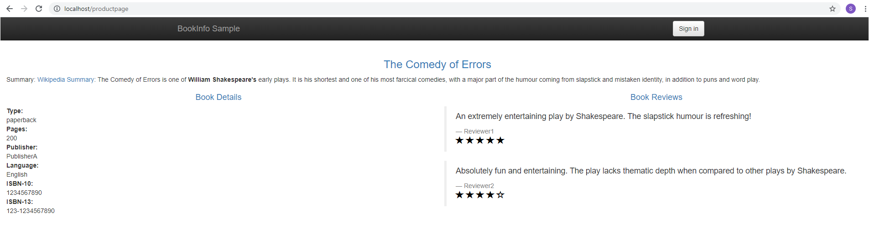

# Kiali Dashboard:

## Install:

$ kubectl apply -f samples/addons

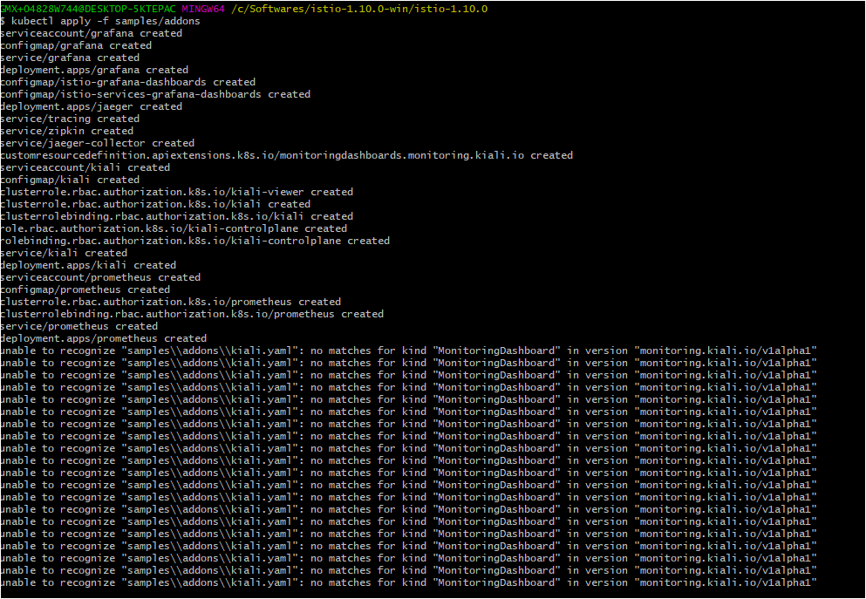

## Accessing Kiali Dashboard:

$ istioctl dashboard kiali

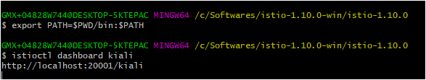

## Kiali Dashboard UI:

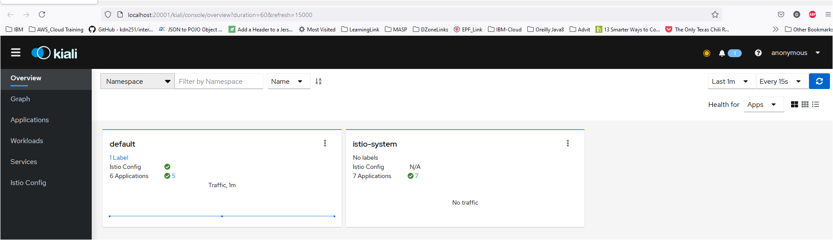

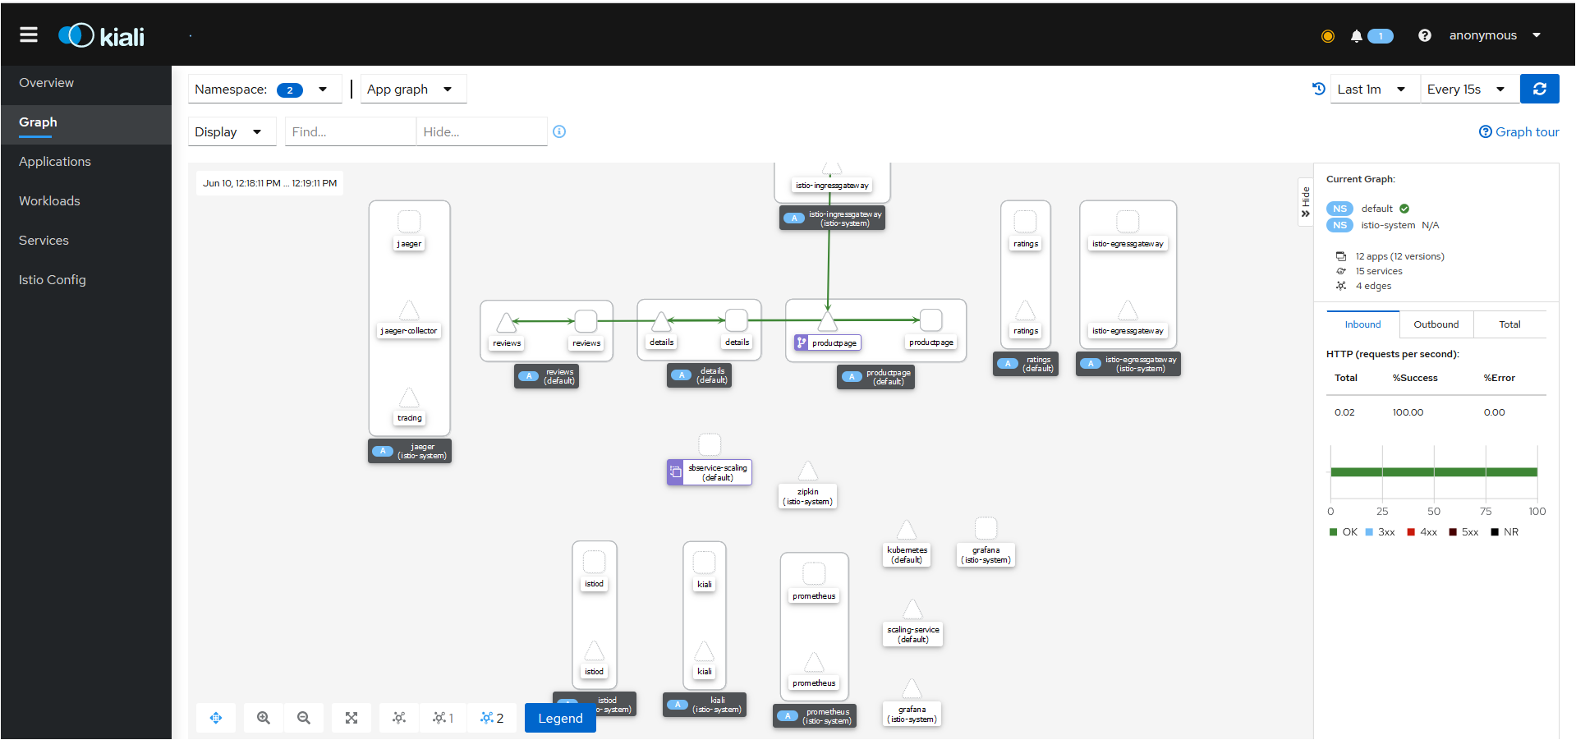

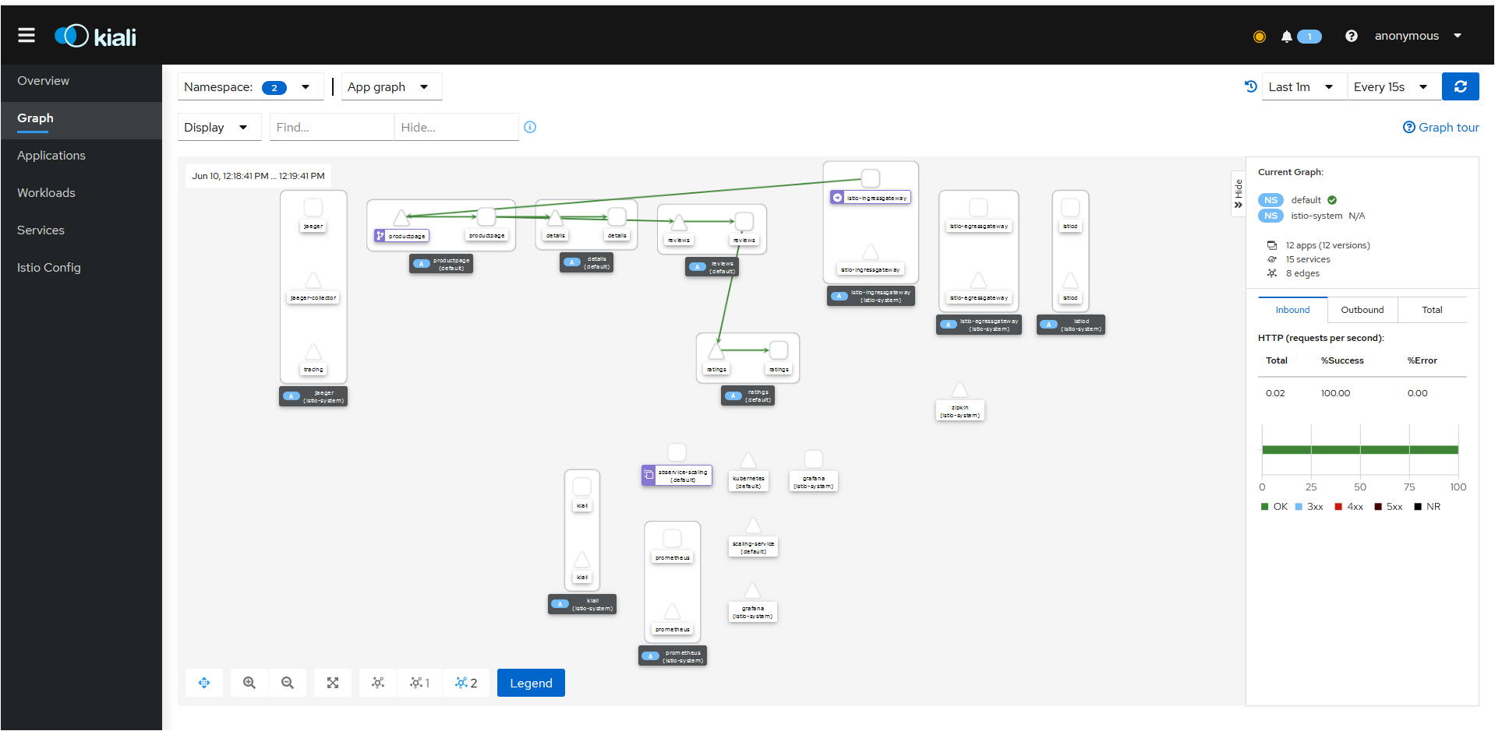

# Request Routing:

## Apply Default Destination Rules:

$ kubectl apply -f samples/bookinfo/networking/destination-rule-all.yaml

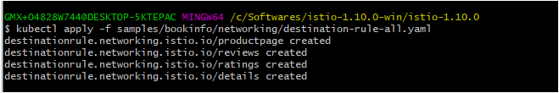

## Apply Virtual Service (All Requests Routes to V1):

$ kubectl apply -f samples/bookinfo/networking/virtual-service-all-v1.yaml

## 

## With Multiple Request Same Page Display

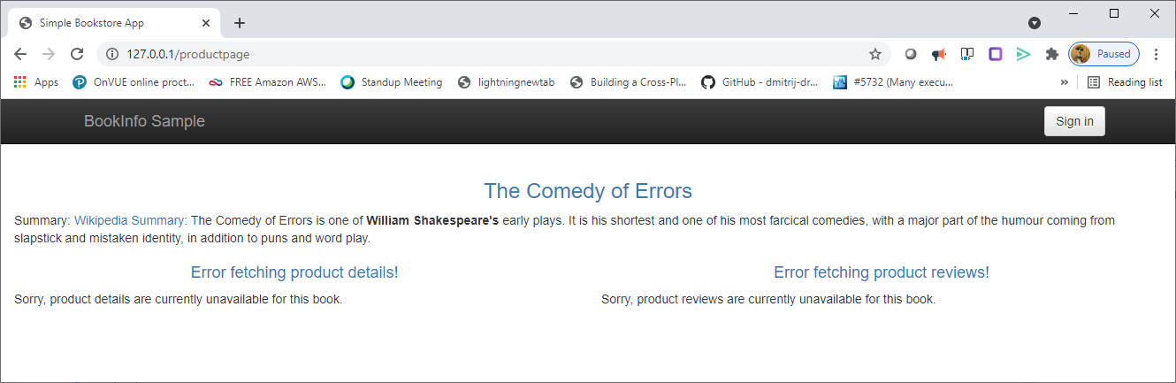

## Route User Based Identity:

$ kubectl apply -f samples/bookinfo/networking/virtual-service-reviews-test-v2.yaml

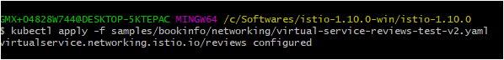

## Accessing Page (User:Jason Version-2 Displays)

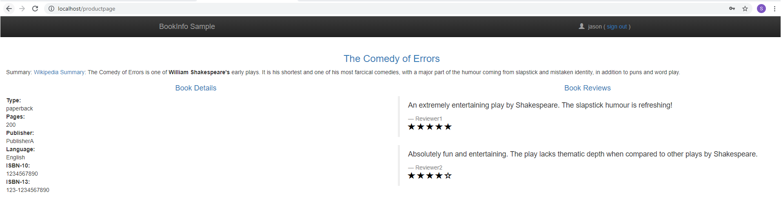

## Accessing Page (Default User. V1 Displays)



## Cleanup:

**$ kubectl delete -f samples/bookinfo/networking/virtual-service-all-v1.yaml**

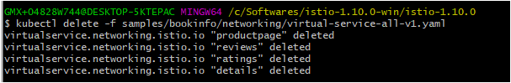

# Fault Injection:

## Applying Fault Injection

* **$ kubectl delete -f samples/bookinfo/networking/virtual-service-all-v1.yaml**
* kubectl apply -f samples/bookinfo/networking/virtual-service-all-v1.yaml
* kubectl apply -f samples/bookinfo/networking/virtual-service-reviews-test-v2.yaml
* kubectl apply -f samples/bookinfo/networking/virtual-service-ratings-test-delay.yaml

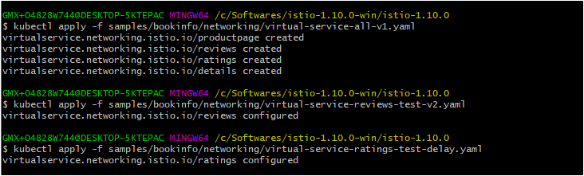

## User-1 Accessing (Delaying 6 Seconds)

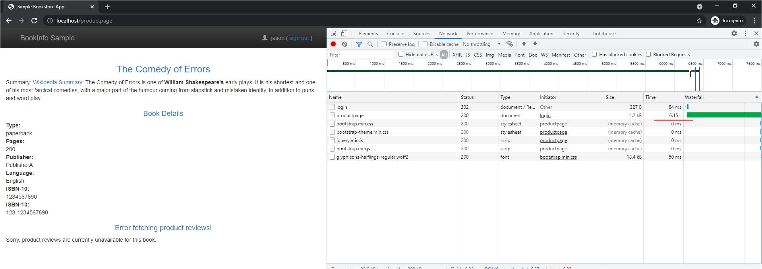

## Default User Accessing (No Delay)

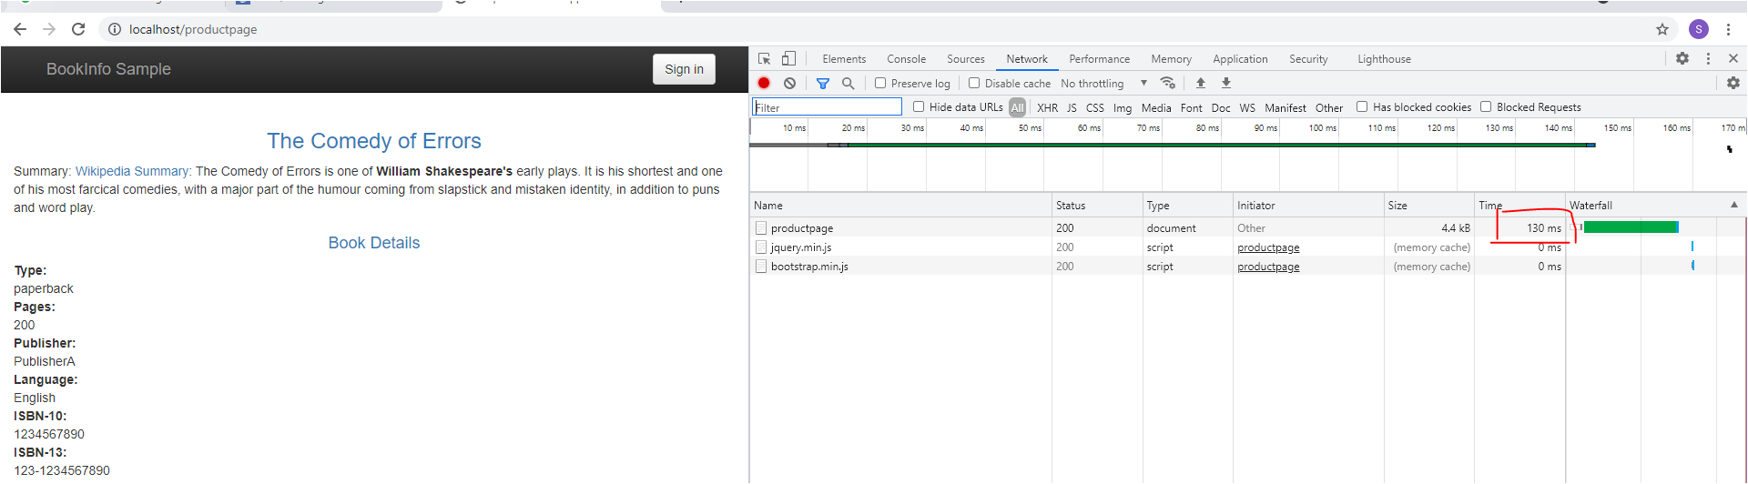

## Aborting Injection of HTTP fault

**$ kubectl apply -f samples/bookinfo/networking/virtual-service-ratings-test-abort.yaml**

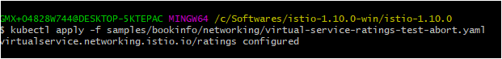

## All request no delay

