**Rolling Out – Rolling Back**

**1. Build the Spring Boot application.**

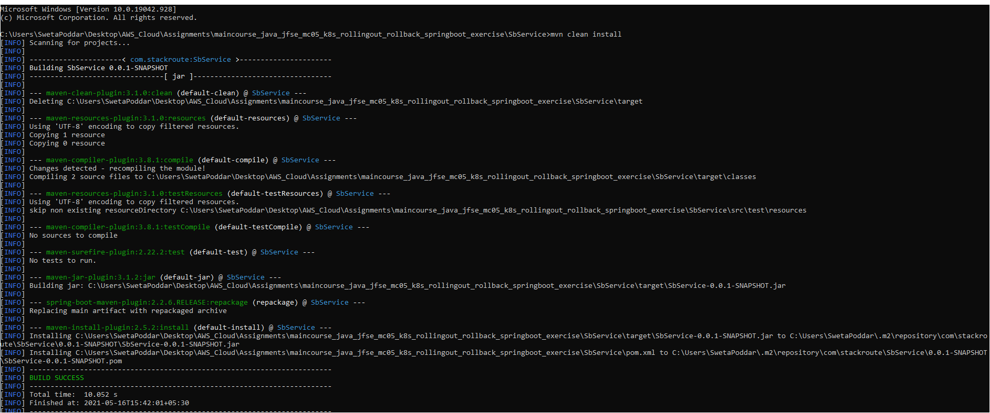

**2. Build the Docker image for the Spring Boot application.**

**3. Tag the docker image.**

**4. Push the image to Docker Hub.**

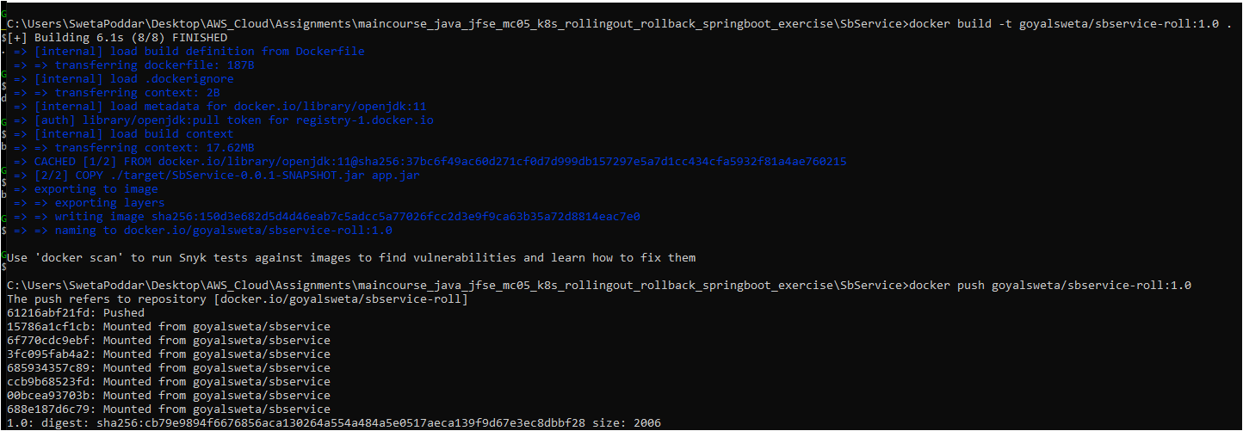

**5. Deploy the manifest files springboot-deployment.yml and springboot-svc.yml**

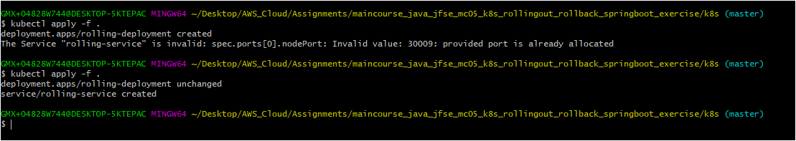





**Test the service in web browser**

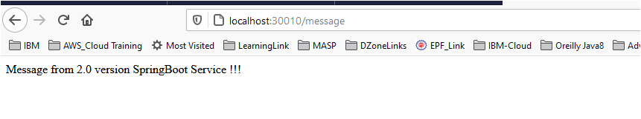

**Perform rollout, by changes in `app.message` in `application.yml`**

**Push to docker hub by tagging it as 2.0.**

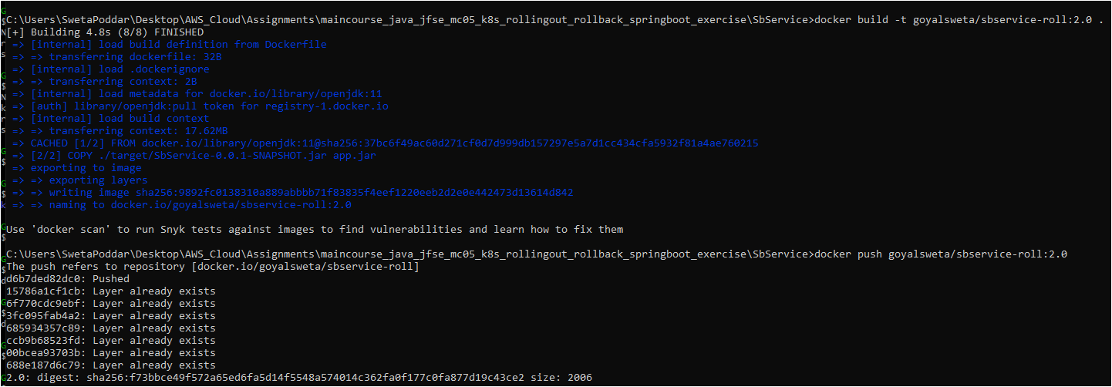

**Create the deployment again, run command `kubectl apply -f springboot-deployment.yml` in k8s folder.**

**Check the rollout status, run command `kubectl rollout status deployment.apps/<name-of-deployment>`.**

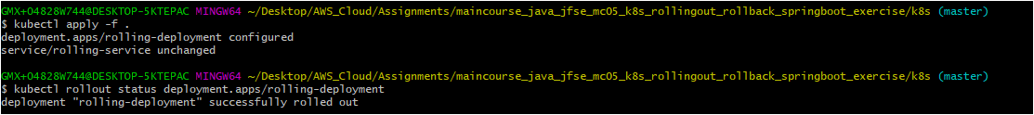

**Test the rollout service in web browser**

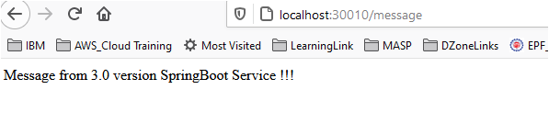

**Perform rollback, run command `kubectl rollout undo deployment.app/<name-of-deployment>`.**

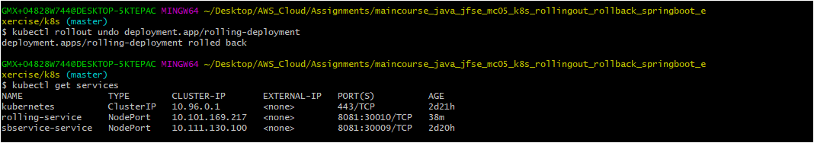

**Test the rollback service in web browser**

