1. Deploying Spring-boot Application
2. Build Application

|  |
| --- |
| GMX+04828W744@DESKTOP-5KTEPAC MINGW64 ~/Desktop/AWS_Cloud/Assignments/maincourse_java_jfse_mc05_k8s_springboot_angular_exercise/SbService (master)  $ mvn clean install  [INFO] Scanning for projects...  [INFO]  [INFO] **----------------------<** com.stackroute:SbService **>----------------------**  [INFO] **Building SbService 0.0.1-SNAPSHOT**  [INFO] **--------------------------------[ jar ]---------------------------------**  [INFO]  [INFO] **---** maven-clean-plugin:3.1.0:clean **(default-clean)** @ SbService **---**  [INFO] Deleting C:\Users\SwetaPoddar\Desktop\AWS_Cloud\Assignments\maincourse_java_jfse_mc05_k8s_springboot_angular_exercise\SbService\target  [INFO]  [INFO] **---** maven-resources-plugin:3.1.0:resources **(default-resources)** @ SbService **---**  [INFO] Using 'UTF-8' encoding to copy filtered resources.  [INFO] Copying 1 resource  [INFO] Copying 0 resource  [INFO]  [INFO] **---** maven-compiler-plugin:3.8.1:compile **(default-compile)** @ SbService **---**  [INFO] Changes detected - recompiling the module!  [INFO] Compiling 2 source files to C:\Users\SwetaPoddar\Desktop\AWS_Cloud\Assignments\maincourse_java_jfse_mc05_k8s_springboot_angular_exercise\SbService\target\classes  [INFO]  [INFO] **---** maven-resources-plugin:3.1.0:testResources **(default-testResources)** @ SbService **---**  [INFO] Using 'UTF-8' encoding to copy filtered resources.  [INFO] skip non existing resourceDirectory C:\Users\SwetaPoddar\Desktop\AWS_Cloud\Assignments\maincourse_java_jfse_mc05_k8s_springboot_angular_exercise\SbService\src\test\resources  [INFO]  [INFO] **---** maven-compiler-plugin:3.8.1:testCompile **(default-testCompile)** @ SbService **---**  [INFO] No sources to compile  [INFO]  [INFO] **---** maven-surefire-plugin:2.22.2:test **(default-test)** @ SbService **---**  [INFO] No tests to run.  [INFO]  [INFO] **---** maven-jar-plugin:3.1.2:jar **(default-jar)** @ SbService **---**  [INFO] Building jar: C:\Users\SwetaPoddar\Desktop\AWS_Cloud\Assignments\maincourse_java_jfse_mc05_k8s_springboot_angular_exercise\SbService\target\SbService-0.0.1-SNAPSHOT.jar  [INFO]  [INFO] **---** spring-boot-maven-plugin:2.2.6.RELEASE:repackage **(repackage)** @ SbService **---**  [INFO] Replacing main artifact with repackaged archive  [INFO]  [INFO] **---** maven-install-plugin:2.5.2:install **(default-install)** @ SbService **---**  [INFO] Installing C:\Users\SwetaPoddar\Desktop\AWS_Cloud\Assignments\maincourse_java_jfse_mc05_k8s_springboot_angular_exercise\SbService\target\SbService-0.0.1-SNAPSHOT.jar to C:\Users\SwetaPoddar\.m2\repository\com\stackroute\SbService\0.0.1-SNAPSHOT\SbService-0.0.1-SNAPSHOT.jar  [INFO] Installing C:\Users\SwetaPoddar\Desktop\AWS_Cloud\Assignments\maincourse_java_jfse_mc05_k8s_springboot_angular_exercise\SbService\pom.xml to C:\Users\SwetaPoddar\.m2\repository\com\stackroute\SbService\0.0.1-SNAPSHOT\SbService-0.0.1-SNAPSHOT.pom  [INFO] **------------------------------------------------------------------------**  [INFO] BUILD SUCCESS  [INFO] **------------------------------------------------------------------------**  [INFO] Total time: 12.298 s  [INFO] Finished at: 2021-05-13T20:46:32+05:30  [INFO] **------------------------------------------------------------------------**  GMX+04828W744@DESKTOP-5KTEPAC MINGW64 ~/Desktop/AWS_Cloud/Assignments/maincourse_java_jfse_mc05_k8s_springboot_angular_exercise/SbService (master)  $ ls -l |

1. Build Docker Image

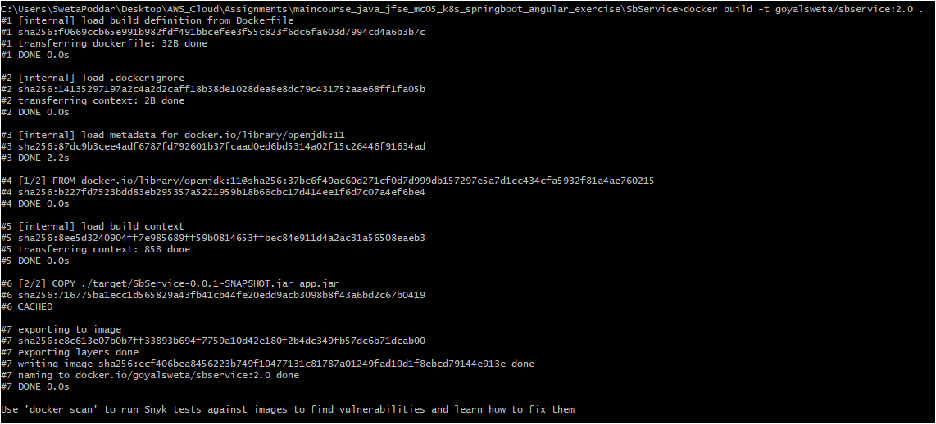

1. Push Docker Image

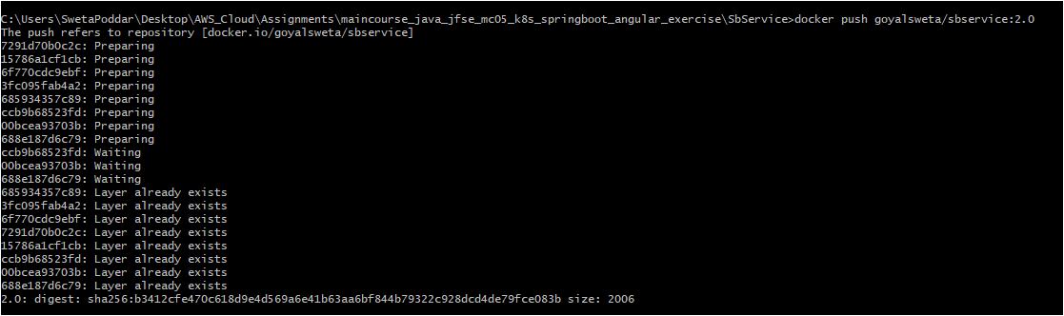

1. Deploying K8 YML



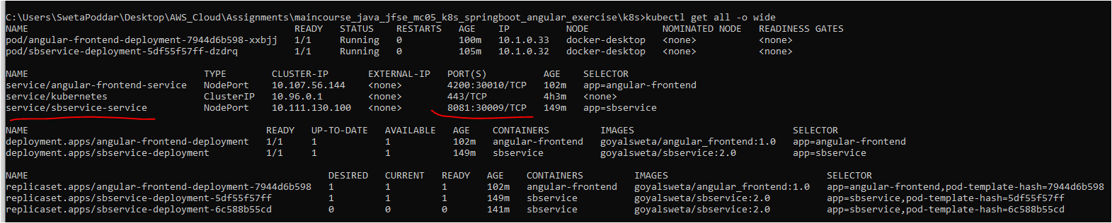

1. Screenshot of SB Application

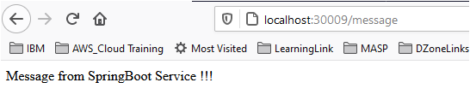

1. Deploying Angular Application
2. Build Application

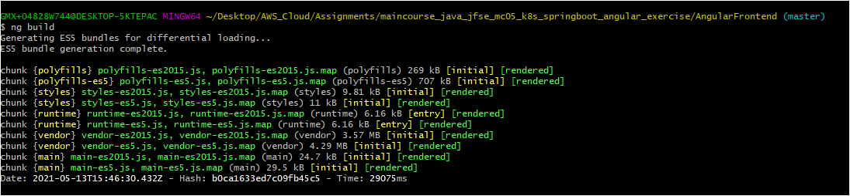

1. Build Docker Image

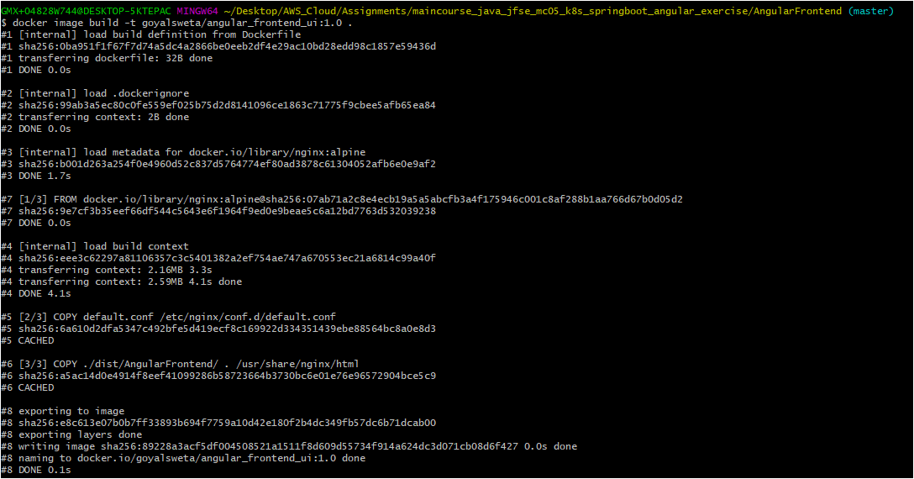

1. Push Docker Image

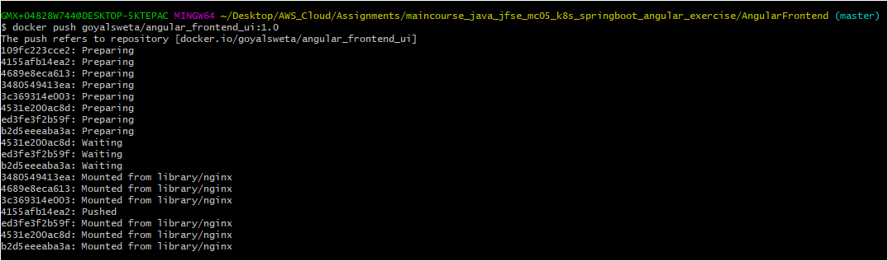

1. Deploying K8 YML



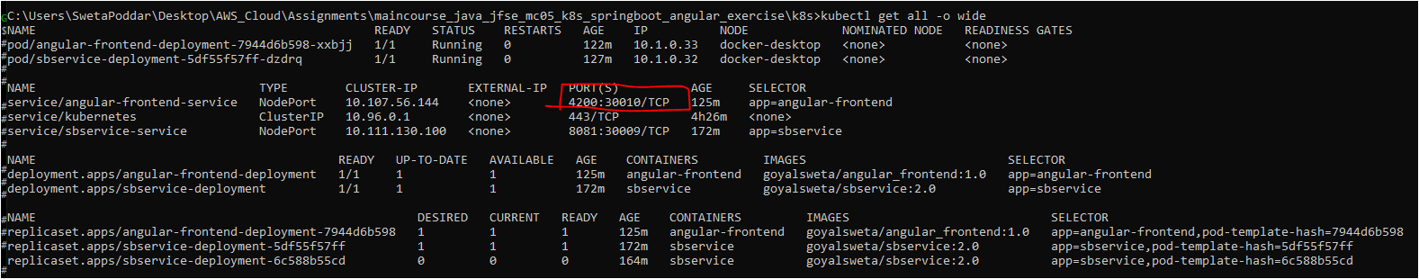

1. Screenshot of Angular Application

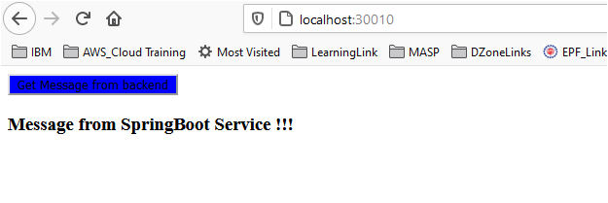

1. Status of K8 Service

|  |
| --- |
| GMX+04828W744@DESKTOP-5KTEPAC MINGW64 ~/Desktop/AWS_Cloud/Assignments/maincourse_java_jfse_mc05_k8s_springboot_angular_exercise/AngularFrontend (master)  $ kubectl.exe get all -o wide  NAME READY STATUS RESTARTS AGE IP NODE NOMINATED NODE READINESS GATES  pod/angular-frontend-deployment-7944d6b598-xxbjj 1/1 Running 0 7m54s 10.1.0.33 docker-desktop <none> <none>  pod/sbservice-deployment-5df55f57ff-dzdrq 1/1 Running 0 12m 10.1.0.32 docker-desktop <none> <none>  NAME TYPE CLUSTER-IP EXTERNAL-IP PORT(S) AGE SELECTOR  service/angular-frontend-service NodePort 10.107.56.144 <none> 4200:30010/TCP 10m app=angular-frontend  service/kubernetes ClusterIP 10.96.0.1 <none> 443/TCP 151m <none>  service/sbservice-service NodePort 10.111.130.100 <none> 8081:30009/TCP 57m app=sbservice  NAME READY UP-TO-DATE AVAILABLE AGE CONTAINERS IMAGES SELECTOR  deployment.apps/angular-frontend-deployment 1/1 1 1 10m angular-frontend goyalsweta/angular_frontend:1.0 app=angular-frontend  deployment.apps/sbservice-deployment 1/1 1 1 57m sbservice goyalsweta/sbservice:2.0 app=sbservice  NAME DESIRED CURRENT READY AGE CONTAINERS IMAGES SELECTOR  replicaset.apps/angular-frontend-deployment-7944d6b598 1 1 1 10m angular-frontend goyalsweta/angular_frontend:1.0 app=angular-frontend,pod-template-hash=7944d6b598  replicaset.apps/sbservice-deployment-5df55f57ff 1 1 1 57m sbservice goyalsweta/sbservice:2.0 app=sbservice,pod-template-hash=5df55f57ff  replicaset.apps/sbservice-deployment-6c588b55cd 0 0 0 49m sbservice goyalsweta/sbservice:2.0 app=sbservice,pod-template-hash=6c588b55cd  GMX+04828W744@DESKTOP-5KTEPAC MINGW64 ~/Desktop/AWS_Cloud/Assignments/maincourse_java_jfse_mc05_k8s_springboot_angular_exercise/AngularFrontend (master)  $ |