**1. Build the Spring Boot application.**

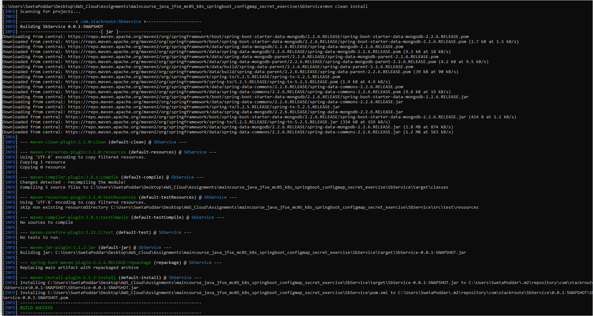

**2. Build the Docker image for the Spring Boot application.**

**3. Push the image to Docker Hub.**

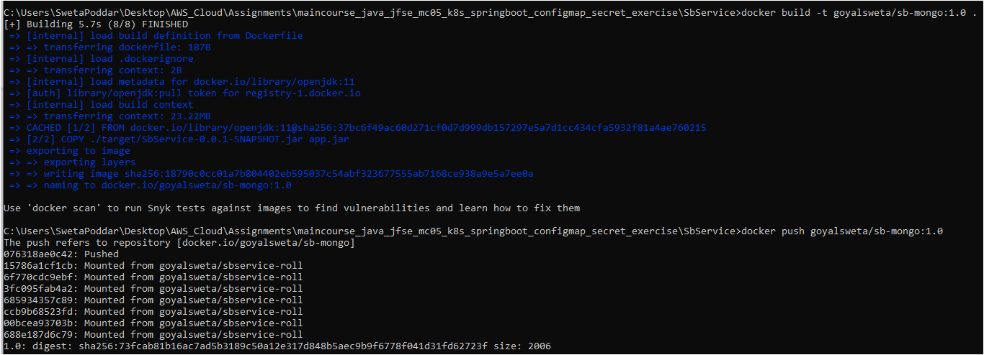

**4. Follow the instructions given in the configmap.yml file, once done, run command `kubectl apply -f configmap.yml`.**



**5. Follow the instructions given in the secret.yml file, once done, run command `kubectl apply -f secret.yml`.**



**Follow the instructions given in the mongodb.yml file, once done, run command `kubectl apply -f mongodb.yml`.**



**Follow the instructions given in the springboot.yml file, once done, run command `kubectl apply -f springboot.yml`.**



**Follow the instructions given in the ingress.yml file, once done,**

* **run command `kubectl apply -f ingress.yml`.**
* **kubectl get ingress**





**Test SpringBoot application is using ConfigMap data or not, open browser and check for `http://<minikube-ip>/message/your-name` url, you will be able to see the message.**

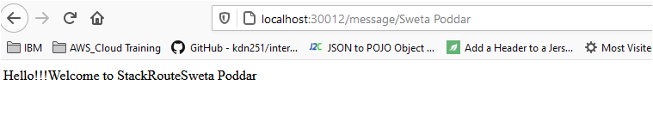

**Test SpringBoot application is using secret data or not, open browser and check for `http://<minikube-ip>/getAll` url, you will be able to see an empty array.**

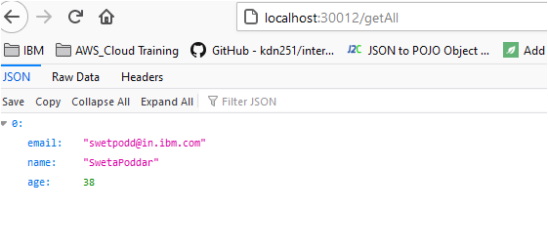

**Add a person, open browser and check for `http://<minikube-ip>/create?email=<email-id>&name=<name>&age=<age>` url,**

**You will be able to see added Person details, test `http://<minikube-ip>/getAll` url and you can view the list of persons.**

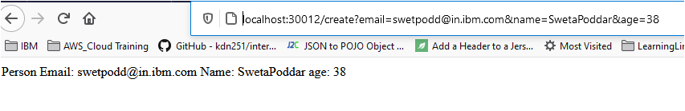

**Hosts File Entry:**

