Index | Content | Page.no
1 | Convert rows to column without using Normalizer | 2-3
2 | Convert rows to column using Normalizer
3 | Separating first half and second half of records to 2 targets
4 | Separating Duplicate and non duplicate rows to 2 targets
5 | Retrieving First and Last Record from a table
6 | Sending Alternate records to target – Even, odd records separation
7 | Separate the original records in target
8 | Get top 5 records to target without using Rank
9 | Get top 5 records to target using rank
10 | Split non-key column to separate table with key columns
11 | Remove Header and Footer
12 | Extracting every nth row
13 | Sending records to the target table in cyclic order
14 | Concatenation of duplicate value by comma separation
15 | Extracting first, middle and last name from Ename
16 | Targeting Records of Employees who joined in current month
17 | Converting Day number to corresponding Month and date of year
18 | Sending target with days difference more than 2 days
19 | Date difference in hours
20 | Check the Hire-date is Date or Not
21 | Covert Numeric Value to Date Format
22 | Remove Special characters from empno
23 | Count the no.of vowels present in emp_name column
24 | Insert , reject records using update strategy
25 | Converting ‘$’ symbol to ‘Rs’ from salary column
26 | Removing ‘$’ symbol from salary column
27 | Currency Converter
28 | Produce files as Target with dynamic names
29 | Cumulative Salary

Convert single row from source to three rows in target
We have a source table containing 3 columns : Col1, Col2 and Col3. There is only 1 row in the table as follows:
Col1 | Col2 | Col3
a | b | c
There is target table containg only 1 column Col. Design a mapping so that the target table contains 3 rows as follows:
Col
a
b
c
Without using normalizer transformation.
Solution:
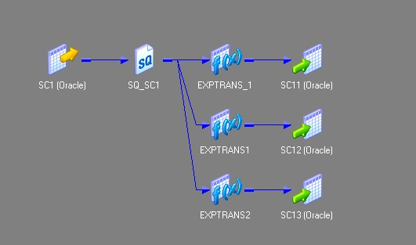

Sending first, second half records to 2 targets
Scenario 6: How to send first half record to target?
Solution:
- Drag and drop the source to mapping.
- Step:2 In source-Qualifier , go to property and write the SQL query like
?
1 | select * from emp where rownum <= ( select count(*)/2 from emp)
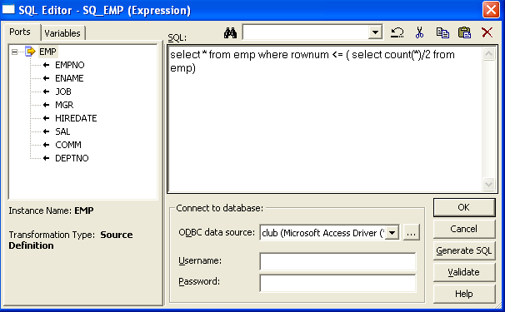
Step | select * from emp minus select * from emp where rownum <= ( select count(*)/2 from emp))
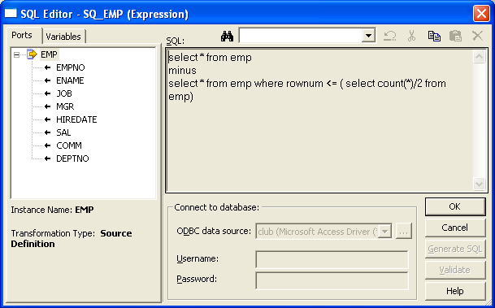

Separating duplicate and non-duplicate rows to separate tables
How to segregate the duplicate and distinct rows from source table to separate target tables?
source table:
COL1 | COL2 | COL3
a | b | c
x | y | z
a | b | c
r | f | u
a | b | c
v | f | r
v | f | r
Target Table 1: Table containing all the unique rows
COL1 | COL2 | COL3
a | b | c
x | y | z
r | f | u
v | f | r

Target Table 2: Table containing all the duplicate rows

COL1 | COL2 | COL3
a | b | c
a | b | c
v | f | r
Solution:
Step 1: Drag the source to mapping and connect it to an aggregator transformation.
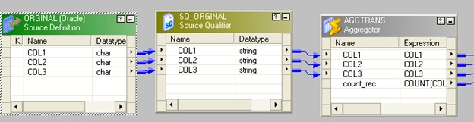
Step 2: In aggregator transformation, group by the key column and add a new port call it count_rec to count the key column.
Step 3: connect a router to the aggregator from the previous step.In router make two groups one named "original" and another as "duplicate"
In original write count_rec=1 and in duplicate write count_rec>1.
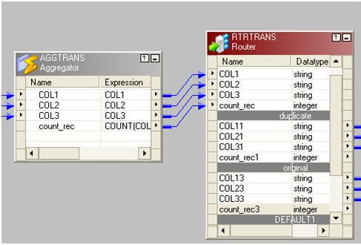
The picture below depicting group name and the filter conditions
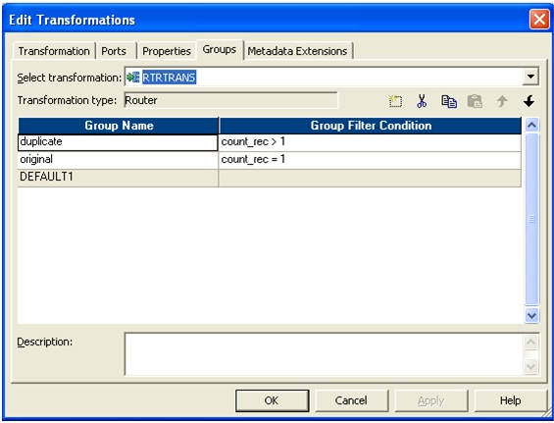
Step 4: Connect two group to corresponding target table.
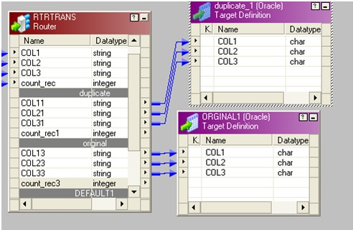
See Scenario 10 as a different approach for similar situation.

Retrieving first and last record from a table/file
Scenario 4:
How to get first and last record from a table/file?
Solution:
Step 1: Drag and drop ports from source qualifier to two rank transformations.
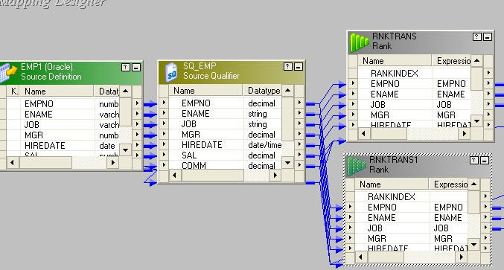
Step 2: Create a reusable sequence generator having start value 1 and connect the next value to both rank transformations.
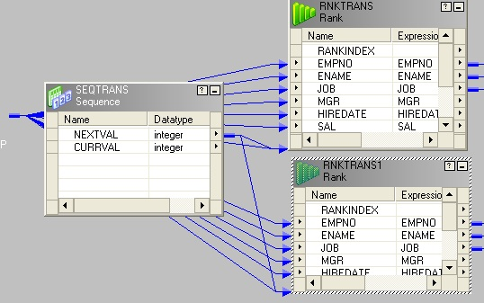
Step 3: Set rank properties as follows
In Rank1
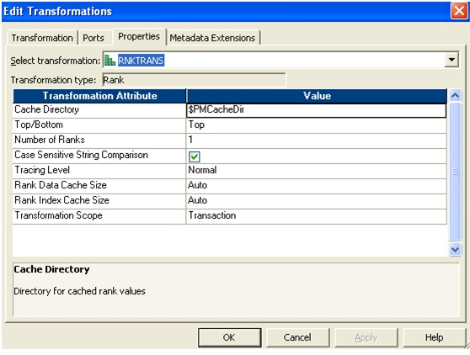
In Rank2
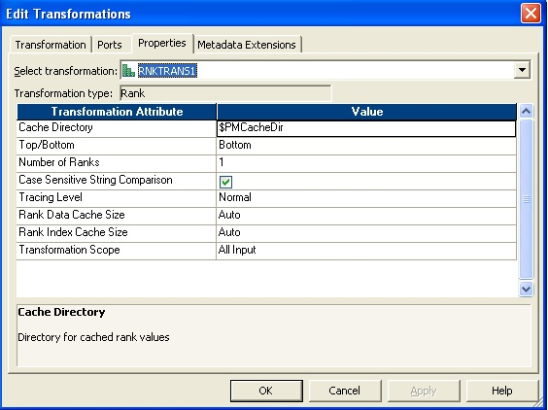
Step 4: Make two instances of the target.
Step 5: Connect the output port to target.
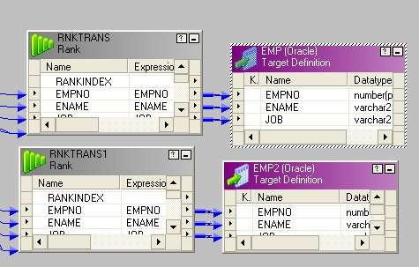

Remove Header & footer from your file
Scenario 5: How to remove footer from your file ?
For example the file content looks like as below:-
some Header here
col1 col2 col3 col4
data1 data2 data3 data4
data5 data6 data7 data8
data1 data2 data3 data4
data1 data2 data3 data4
footer
Just we have to remove footer from the file.
Solution:
Step1: Drag the source to mapping area.
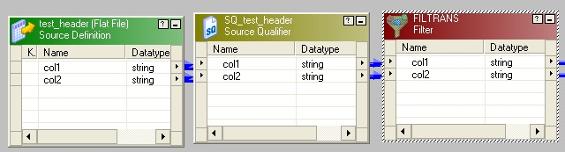
Step2: After that connect a filter or router transformation.
Step3: In filter write the condition like in the picture
Step 4:Finally pass it over to target.
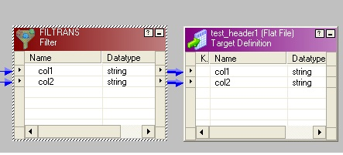
Step1: After mapping go to workflow and scheduled it.
Step2: Just double click on the session and go to mapping option.
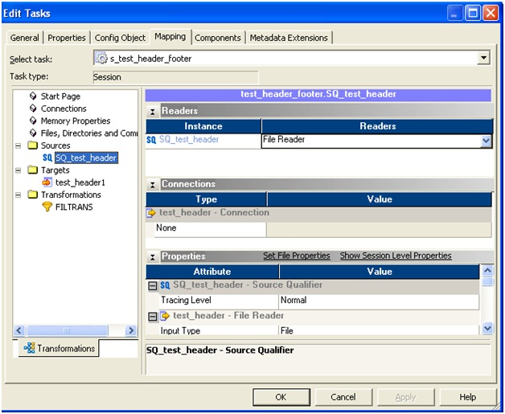
Step3: Select the source and go to the set file properties.
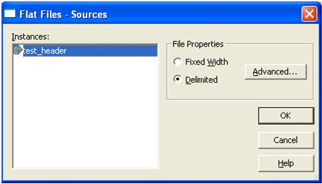
FLAT FILE PROPERTIES
Step4:Chose the advance option. Set number of initial rows skip: 1 ( it can be more as per requirement )
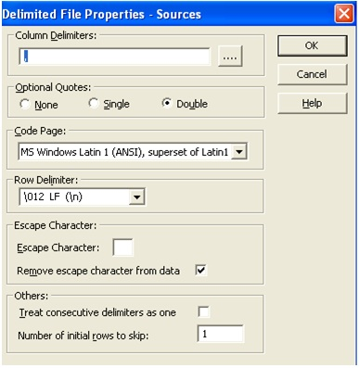

Sending alternate record to target
Scenario 9: How to send alternate record to target?
Or
Sending Odd numbered records to one target and even numbered records to another target.
Solution:
Step 1: Drag the source and connect to an expression transformation.
Step2: Add the next value of a sequence generator to expression transformation.
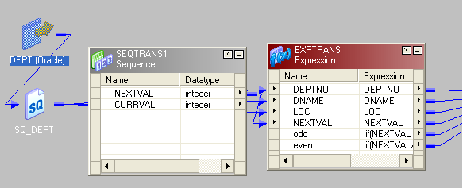
SCR TO SEQ MAPPING
Step 3: In expression transformation make two port, one is "odd" and another "even".
And Write the expression like below
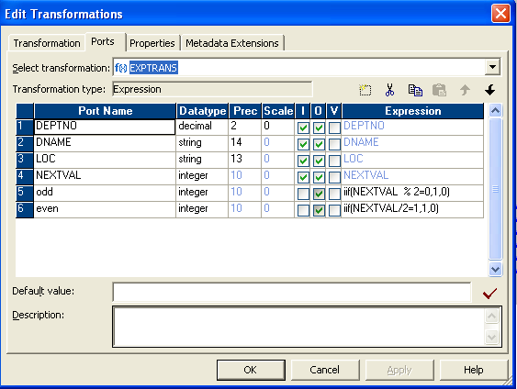
EXPRESSION PROPERTY
Step 4: Connect a router transformation to expression.
Make two group in router.
And give condition Like below
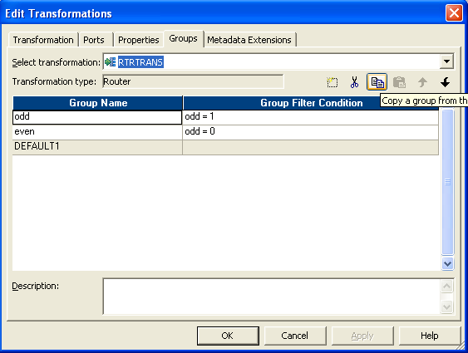
RTR PROPERTY
Step 5: Then send the two group to different targets.
The entire mapping is as below
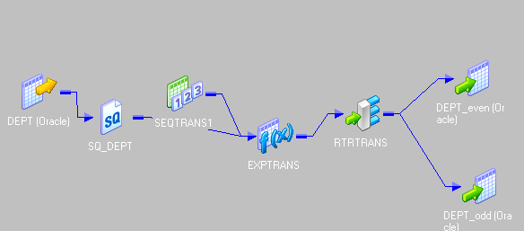
FINAL MAPPING VIEW SCENARIO 9

Separate the original records in target
Scenario 10: How to separate the original records from source table to separate target table by using rank transformation ?
Source Table
col1 | col2 | col3
a | b | c
x | y | z
a | b | c
r | f | u
a | b | c
v | f | r
v | f | r

Target Table
Col1 | Col2 | Col3
a | b | c
x | y | z
r | f | u
v | f | r

Solution:
Step 1: Bring the source to mapping.
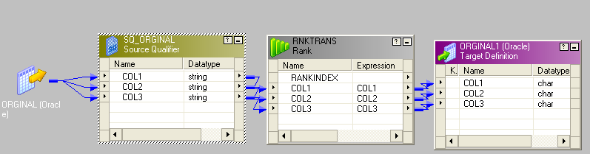
SRC TO RANK MAPPING
Step 2: Connect the rank to source.
Step 3: In rank, set the property like this.
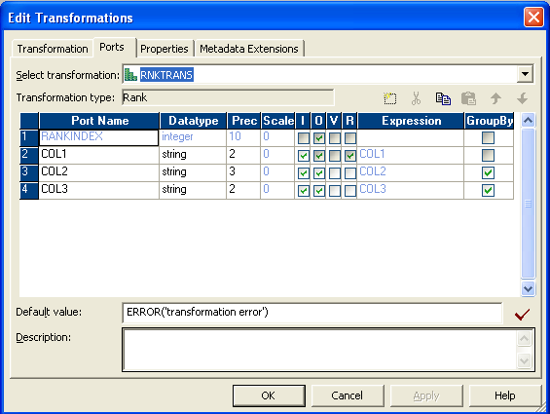
RANK PROPERTY

Get top 5 records to target without using rank
Scenario 12: How to get top 5 records to target without using rank ?
Solution:
- Drag the source to mapping and connect it to sorter transformation.
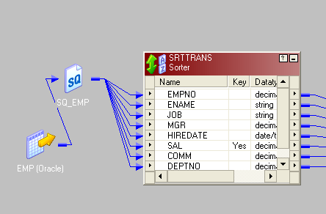
- Arrange the salary in descending order in sorter as follows and send the record to expression.
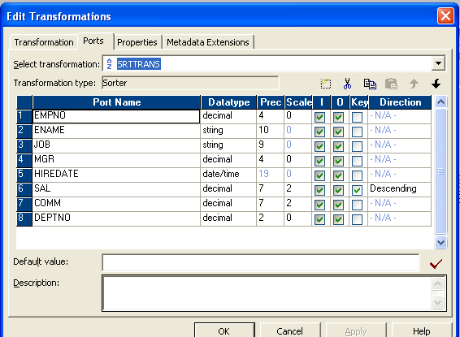
SORTER PROPERTIES
- Add the next value of sequence generator to expression.(start the value from 1 in sequence generator).
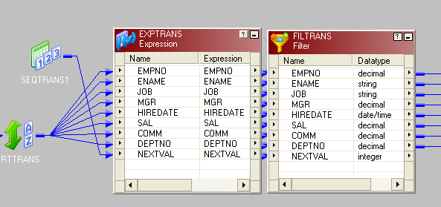
SORTER TO EXP MAPPING
- Connect the expression transformation to a filter or router. In the property set the condition as follows-
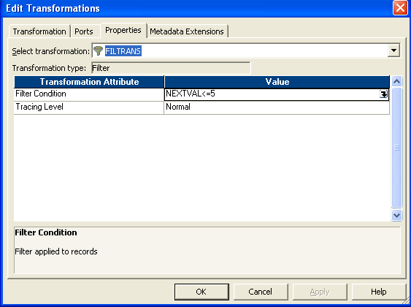
- Finally connect to the target.
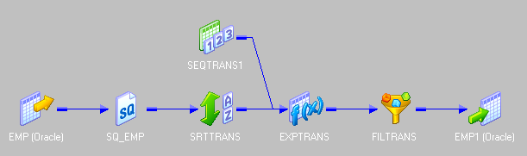
FINAL MAPPING SC12

Split the non-key columns to separate tables with key column in both
Scenario 2:
Split the non-key columns to separate tables with key column in both / How to split the data of source table column-wise with respect to primary key. See the source and target tables below.
source table: ID is the key column, Name and Phone No are non-key columns

ID | Name | Phone No
10 | AAA | 123
20 | BBB | 234
30 | CCC | 434
40 | DDD | 343
50 | EEE | 442
Target Table 1

ID | Name
10 | AAA
20 | BBB
30 | CCC
40 | DDD
50 | EEE
Target Table 2

ID | Phone No
10 | 123
20 | 234
30 | 434
40 | 343
50 | 442
Solution:
Step 1: Source qualifier: get the source table to the mapping area. See image below.
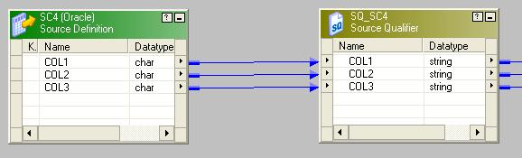
Step 2: Drag all the port from (from the previous step) to the Aggregator transformation and group by the key column. Since we have to split the columns to two different tables with the key column in each, so we are going use two expression transformation, each will take the key column and one non-key column. Connect aggregator transformation with each of the expression transformation as follows.
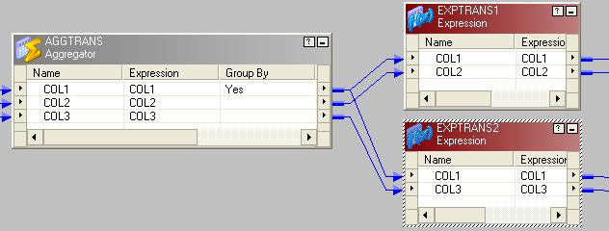
Step 3: We need another set of aggregator to be associated with each of the expression tranformation from the previous step.
Step 4: In the final step connect the aggregators with the two target tables as follows.
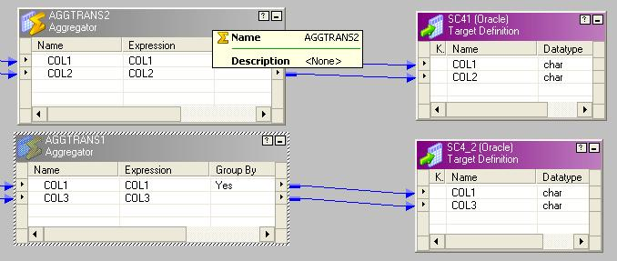
Here is the iconic view of the entire mapping.
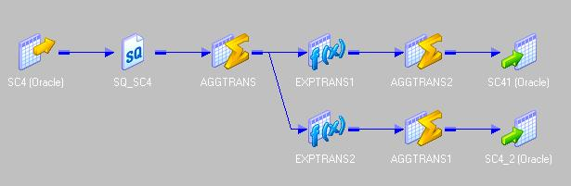

Extracting every nth row
Scenario: How to load every nth row from a Flat file/ relational DB to the target? Suppose n=3, then in above condition the row numbered 3,6,9,12,....so on, This example takes every 3 row to target table.
Solution:
- Connect an expression transformation after source qualifier.
Add the next value port of sequence generator to expression transformation.
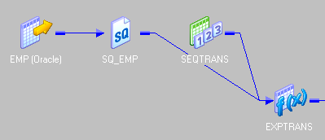
- In expression create a new port (validate) and write the expression like in the picture below.
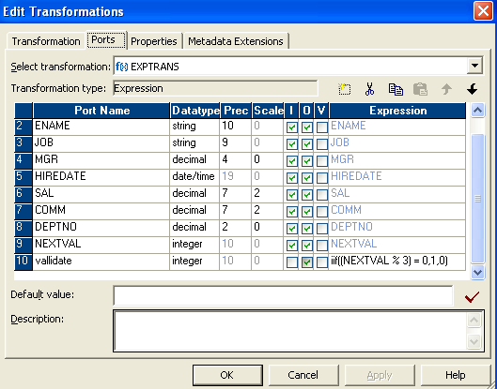
- Connect a filter transformation to expression and write the condition in property like in the picture below.
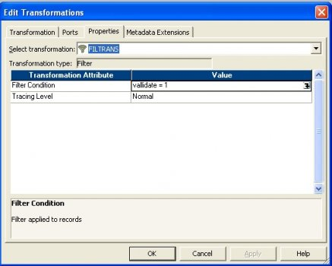
- Finally connect to target.
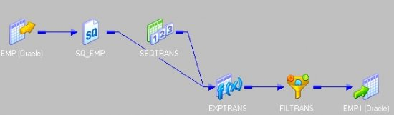

Sending records to target tables in cyclic order
Scenario: There is a source table and 3 destination table T1,T2, T3. How to insert first 1 to 10 record in T1, records from 11 to 20 in T2 and 21 to 30 in T3.Then again from 31 to 40 into T1, 41 to 50 in T2 and 51 to 60 in T3 and so on i.e in cyclic order.
Solution:
- Drag the source and connect to an expression.Connect the next value port of sequence generator to expression.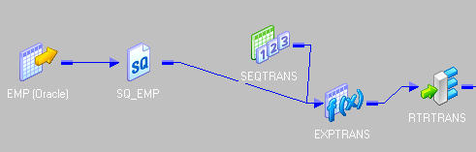
- Send the all ports to a router and make three groups as bellow
Group1
mod(NEXTVAL,30) >= 1 and mod(NEXTVAL,30) <= 10
Group2
mod(NEXTVAL,30) >= 11 and mod(NEXTVAL,30) <= 20
Group3
mod(NEXTVAL,30) >= 21and mod(NEXTVAL,30) <= 29 or mod(NEXTVAL,30) = 0
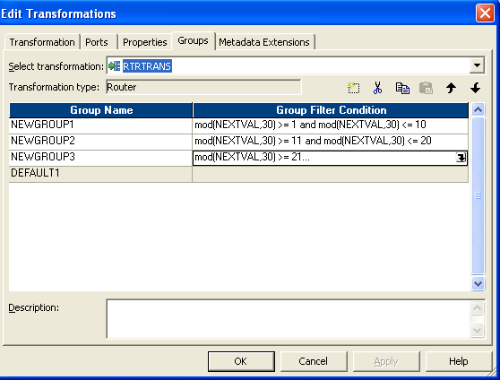
- Finally connect Group1 to T1, Group2 to T2 and Group3 to T3.
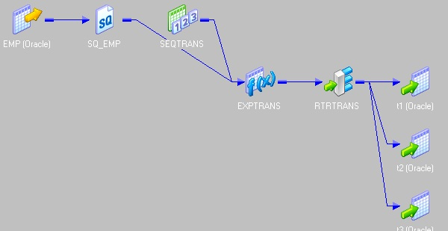

Concatenation of duplicate value by comma separation
Scenario: You have two columns in source table T1, in which the col2 may contain duplicate values.All the duplicate values in col2 of will be transformed as comma separated in the column col2 of target table T2.
Source Table: T1
Col1 | Col2
a | x
b | y
c | z
a | m
b | n

Target Table: T2
col1 | col2
a | x,m
b | y,n
c | Z
Solution:
- We have to use the following transformation as below.
First connect a sorter transformation to source and make col1 as key and its order is ascending. After that connect it to an expression transformation.
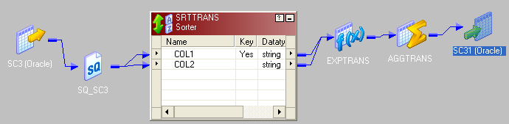
- In Expression make four new port and give them name as in picture below.
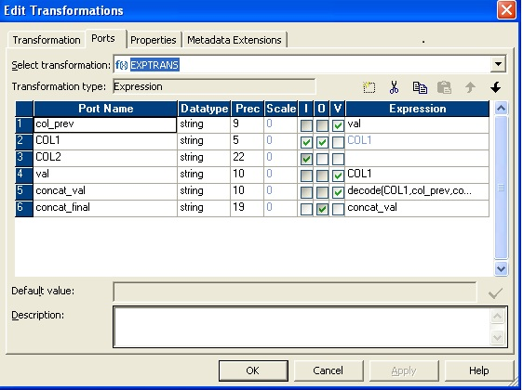
- In concat_val write expression like as describe bellow and send it to an aggregator
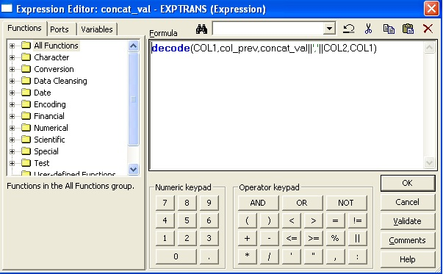
- In aggregator group it by col1 and send it to target
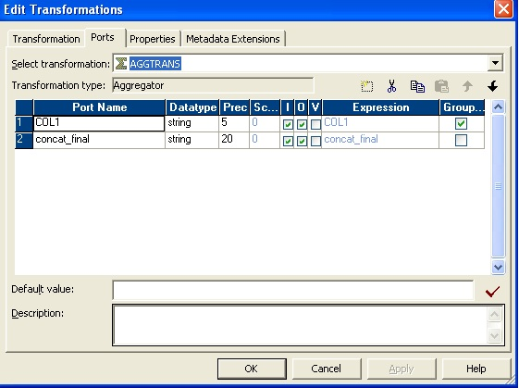
- Finally run the session.

Extracting Middle Name From Ename
Suppose in e_name column is like this
empno ename
1 Sudhansu Sekher Dash
2 Amiya Prasad Mishra
In target we have to send middle name like this
empno ename
1 Sekher
2 Prasad
These are the steps for achieving this
- Drag the source and connect to an expression transformation
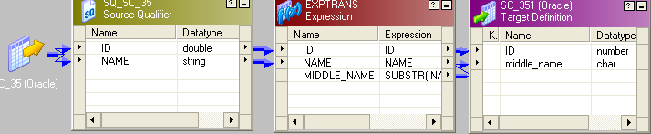
- In Expression create two ports one is name1(as variable port) and Middle_Name (o/p port)
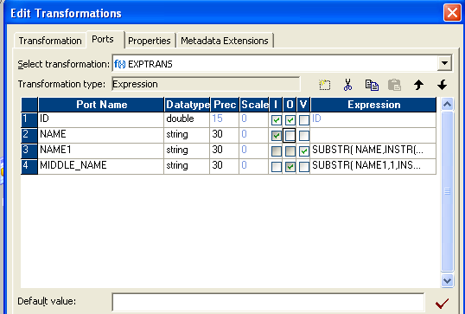
- In Name1 write the condition like this
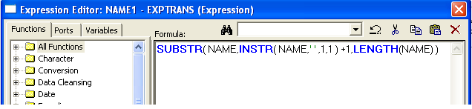
- In Middle_Name write the condition like this
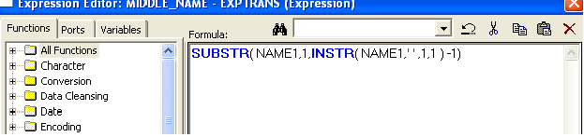
- Then send to target.

Extracting first and last name
Suppose In Ename column there is first name and last name like this
empno ename
1 Amit Rao
2 Chitra Dash
In target we have to separate ename column to firstnane and lastname like this
empno firstname Lastname
1 Amit Rao
2 Chitra Dash
Steps for solving this scenario

- Drag the source to mapping area and connect with an expression trans formation as shown bellow.
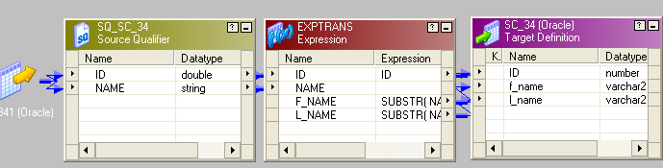
- In expression transformation create two output port one is f_name and other is l_name.
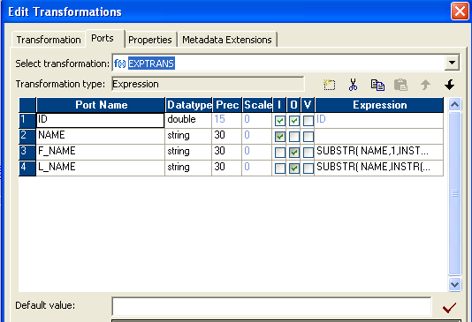
- In f_name write the condition like this
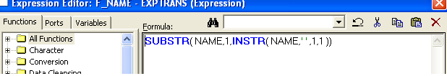
- In l_name write the condition like this
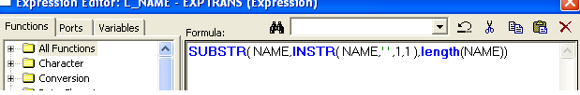
Then connect the target.
These are the basic steps for achieving this scenario

Targeting records of employees who joined in current month

scenario: Insert the records of those employees who have joined in current month and Reject other rows.
Source
E_NO JOIN_DATE
------- ---------
1 07-JUL-11
2 05-JUL-11
3 05-MAY-11
If the current month is july ,2011 then target will be like this.
Target
E_NO JOIN_DATE
------- ---------
1 07-JUL-11
2 05-JUL-11
To insert current month records we have to follow these steps

- Connect one update strategy transformation next to SQF.
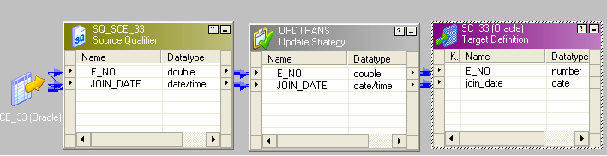
- In update strategy properties write the condition like this
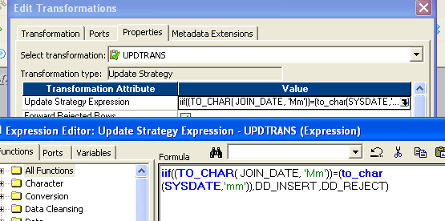
- Send required ports update strategy to targe

Convert Day No. to corresponding month and date of year
Scenario: Suppose you have a source is like this
Source
E_NO YEAR DAYNO
------ --------- - ---------
1 01-JAN-07 301
2 01-JAN-08 200
Year column is a date and dayno is numeric that represents a day ( as in 365 for 31-Dec-Year). Convert the Dayno to corresponding year's month and date and then send to targer.
Target
E_NO YEAR_MONTH_DAY
------ --------- ----------
1 29-OCT-07
2 19-JUL-08
These are the basic steps for this scenario
- Connect SQF with an expression transformation.
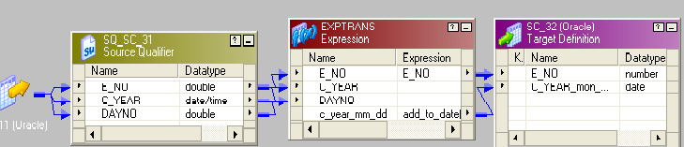
- In expression create one o/p port c_year_mm_dd, make it to date type and in that port write the condition like this.
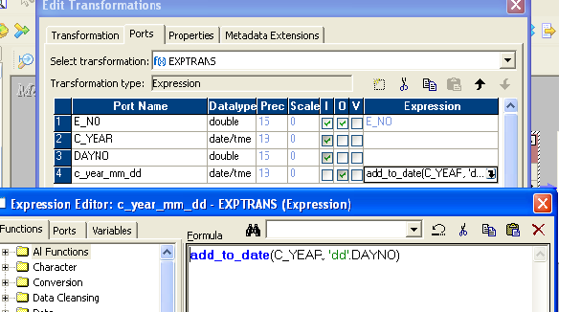
- Finally send to target

Sending to target with days difference more than 2 days
Scenario: From the order_delivery table insert the records to target where , day difference between order_date and delivery_date is greater than 2 days. ( Note: see last article , where we discussed finding the time in hour between two dates)
Source
ORDER_NO ORDER_DATE DELIVERY_DATE
--------- --------- ---------
2 11-JAN-83 13-JAN-83
3 04-FEB-83 07-FEB-83
1 08-DEC-81 09-DEC-81
Target
ORDER_NO ORDER_DATE DELIVERY_ DATE
--------- -------- ------ --- ----------
2 11-JAN-83 13-JAN-83
3 04-FEB-83 07-FEB-83
These are the steps for achieving this scenario
- Connect all the rows from SQF to update strategy transformation.
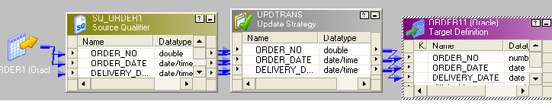
- In update strategy properties write the expression like this
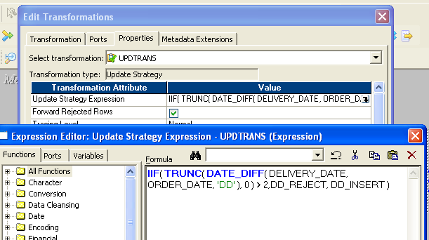
- Finally send to target.

Date Difference in Hours
Scenario:There is a order_delivery table having record like this
ORDER_NO ORDER_DATE DELIVERY_DATE
--------- --------- --------
2 11-JAN-83 13-JAN-83
3 04-FEB-83 07-FEB-83
1 08-DEC-81 09-DEC-81
We have to calculate difference between order_date and delivery date in hours and send it to target.
o/p will be
ORDER_NO ORDER_DATE DELIVERY_ DATE DIFF_IN_HH
--------- --------- --------- ---------
2 11-JAN-83 13-JAN-83 48
3 04-FEB-83 07-FEB-83 72
1 08-DEC-81 09-DEC-81 24
These are the steps for achieving this scenario

Don't forget to comment
- Connect one expression transformation next to SQF.
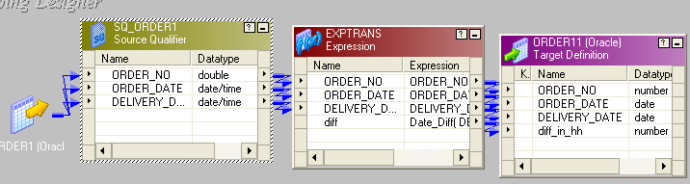

- In expression create one out/put port “diff” and make it integer type.
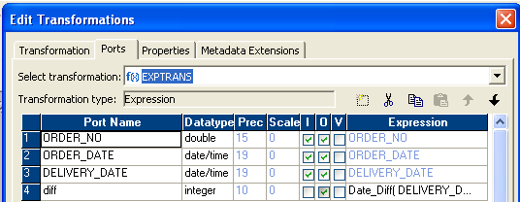
- In that port write the condition like this and sent to target.
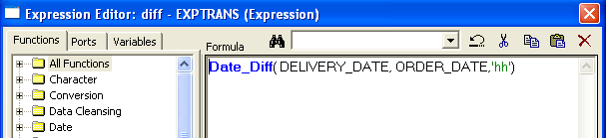

Check the Hire-Date is Date or Not
Scenario:Suppose we have a table with records like this
EMPNO HIRE_DATE
------ ---- -----------
1 12-11-87
2 02-04-88;
3 02-2323
empno is number and hire_date is in string format. We have to check the hire_date column, if it is in date format like 'dd-mm-yy', then convert it to date , in the format “mm/dd/yy” and send it to target else send null.
output
EMPNO HIRE_DATE
-------- ---------
1 11-DEC-87
2 null
3 null
These are the steps for achieving this scenaio
- Connect the ports from SQF to an expression transformation.
- In expression create another oupput port hire_date1 and make it to date data-type, shown in picture.
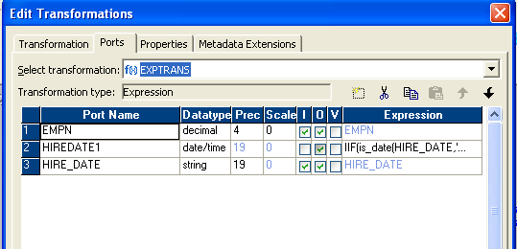
- In Hire_date1 write the condition like this.
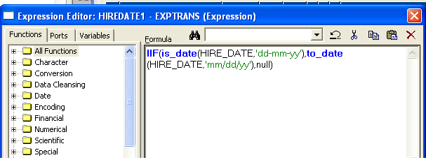
- Send ports to target.

Convert Numeric Value to Date Format
Senario:Suppose you are importing a flat file emp.csv and hire_date colummn is in numeric format, like 20101111 .Our objective is convert it to date,with a format 'YYYYMMDD'.
source
EMPNO HIRE_DATE(numeric)
------- -----------
1 20101111
2 20090909
target
EMPNO HIRE_DATE (date)
------ -----------
1 11/11/2010
2 09/09/2009
- Connect SQF to an expression.
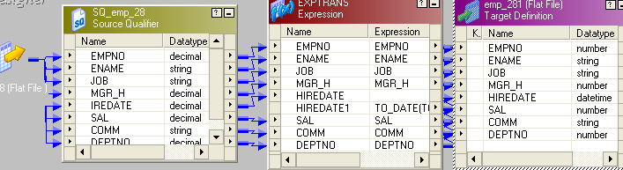
- In expression make hire_date as input only and make another port hire_date1 as o/p port with date data type.
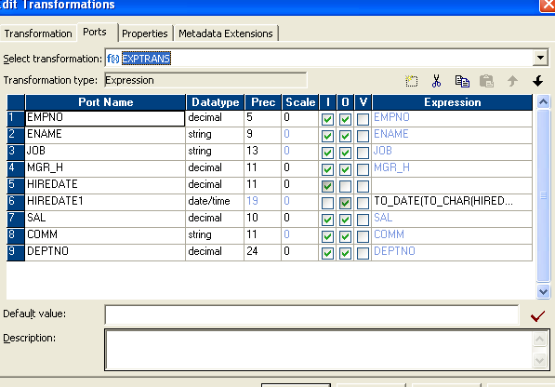
- In o/p port of hire_date write condition like as below
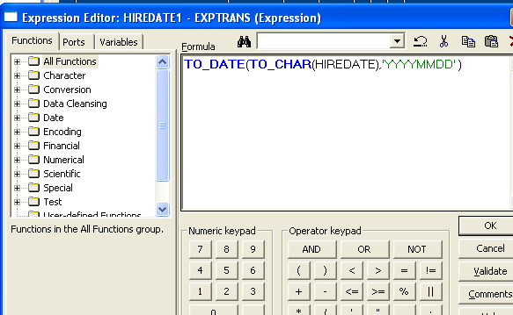
- Finally send to target

Remove special characters from empno
Senario:Suppose in flat_file some special symbols like @,%,$,#,& has added in empno column along with the actual data. How to remove those special charcters ? ( see article , on how to remove $ from salary )
example
empno in source
empno(in string format)
7@3%$,21
432#@1
324&*,$2
In target
empno
7321
4321
3242
Following are the steps for achieving this mapping
- Connect 0/p columns of SQF to an expression transformation.
- In expression make empno as input and create another port empno1 as output port with date datatype. And in empno1 write condition like this. and finally send it to target
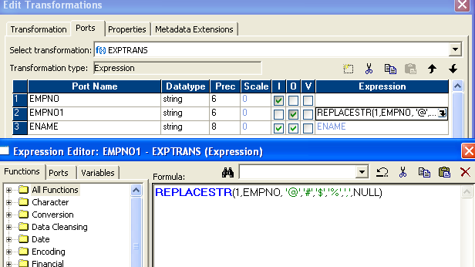

Count the no of vowel present in emp_name column
Scenario:Count the no of vowels present in emp_name column of EMP table as shown bellow.
emp_name total_vowels_count
Allen 2
Scott 1
Ward 1
These are the steps to achieve it
- Connect required columns from SQF to an expression transformation.
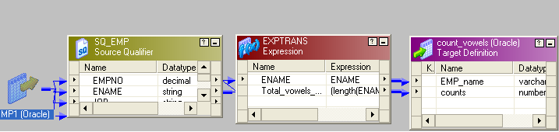
- In Expression add 6 columns like in the picture as bellow. But You can make it two columns( One for all the vowels and one for the vowel counts). For better understanding I have added 6 columns,5 for each of the vowels and one for the vowel count.
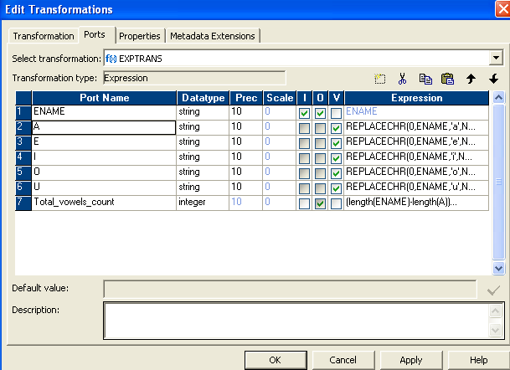
The way I achieved is for each of the vowels in ename , I replaced it with null and in port total vowel count , I substract the vowel port from the ename length which gives me the individual count of vowels, after adding up for all vowels I found all the vowels present. Here are all the variable ports.
For A write REPLACECHR(0,ENAME,'a',NULL)
For E write REPLACECHR(0,ENAME,'e',NULL)
For I write REPLACECHR(0,ENAME,'i',NULL)
For O write REPLACECHR(0,ENAME,'o',NULL)
For U write REPLACECHR(0,ENAME,'u',NULL)
And for o/p column total_vowels_count write expression like this
(length(ENAME)-length(A))
+
(length(ENAME)-length(E))
+
(length(ENAME)-length(I))
+
(length(ENAME)-length(O))
+
(length(ENAME)-length(U))
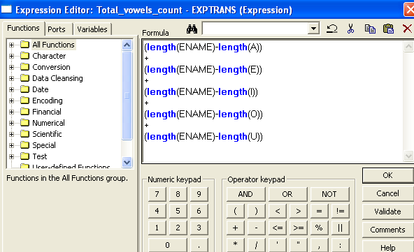
- Finally send to target.

Insert and reject records using update strategy
Scenario:There is a emp table and from that table insert the data to targt where sal<3000 and reject other rows.
Following are the steps for achieving it
- connect out-puts from SQF to Update Strategy transformation.
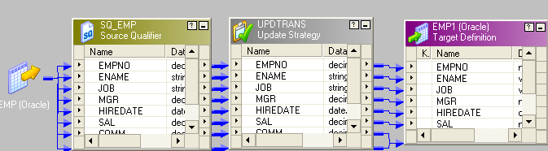
- In properties of Update Strategy write the condition like this
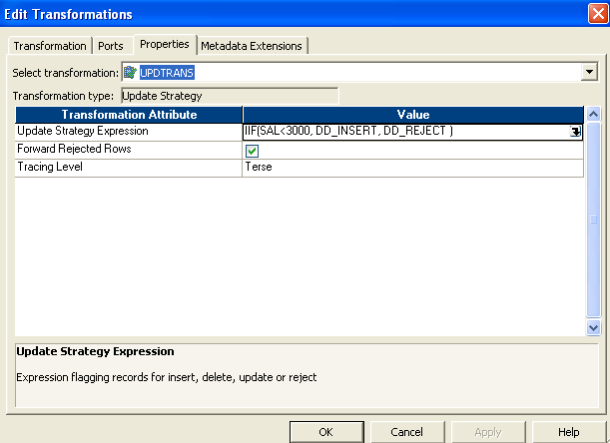
- Connectthe Update Strategy to target

Converting '$' symbol to 'RS." in sal column
Q24 The Emp table contains the salary and commission in USD, in the target the com and sal will converted to a given currency prefix ex: Rs.
Source
EMPNO ENAME JOB MGR HIREDATE SAL DEPTNO
7369 SMITH CLERK 7902 17-DEC-80 $800 20
7499 ALLEN SALESMAN 7698 20-FEB-81 $1600 30
Target
EMPNO ENAME JOB MGR HIREDATE SAL DEPTNO
7369 SMITH CLERK 7902 17-DEC-80 Rs.800 20
7499 ALLEN SALESMAN 7698 20-FEB-81 RS.1600 30
- Drag the source and connect it to expression transformation
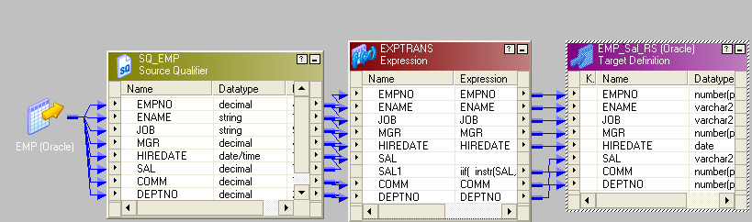
- In expression make a output port sal1 and make sal as input port only.
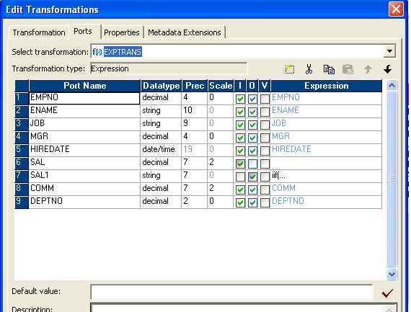
- In sal1 write the condition as like bellow
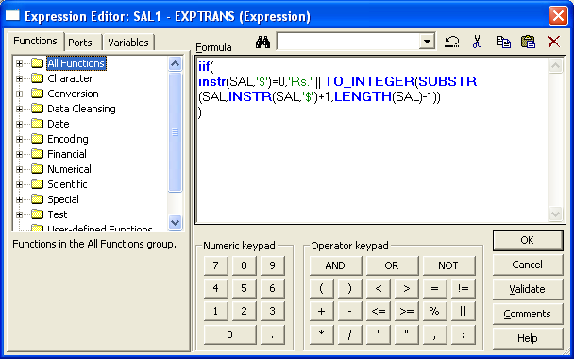
- Then send it to target.

Currency convertor
Q22 Suppose that a source contains a column which holds the salary information prefixed with the currency code , for example
EMPNO ENAME JOB MGR HIREDATE SAL DEPTNO
7369 SMITH CLERK 7902 17-DEC-80 $300 20
7499 ALLEN SALESMAN 7698 20-FEB-81 £1600 30
7521 WARD SALESMAN 7698 22-FEB-81 ¥8500 30
In the target different currency will evaluate to a single currency value, for example covert all to Rupees.
- First thing we should consider that there are different types of currency like pound, dollar, yen etc.So it’s a good idea to use mapping parameter or variable.Go to mapping=> mapping parameter and variables then create three parameters (for this example) and set its initial value as bellow
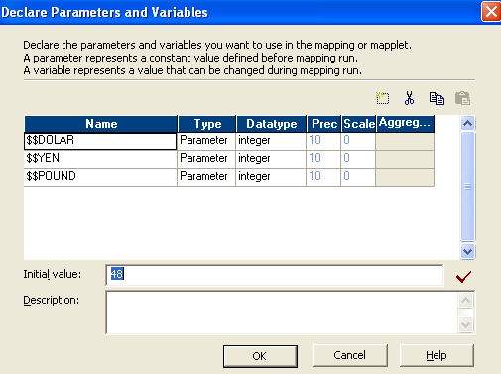
- Then drag the source to mapping area and connect to an expression transformation.
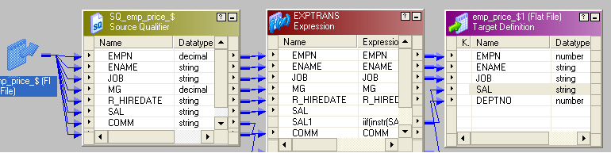
- In expression create a output port as sal1 and make sal as input only as bellow.
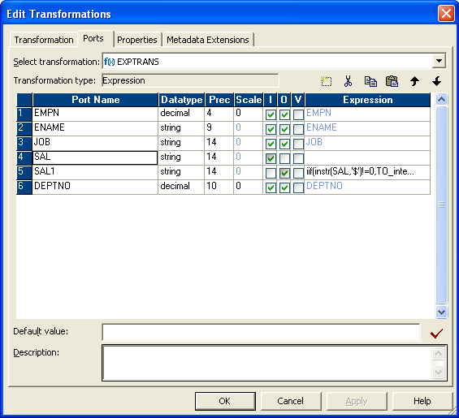
- In sal1 port write the condition as below
iif(instr(SAL,'$')!=0,TO_integer(SUBSTR(SAL,INSTR(SAL,'$')+1,LENGTH(SAL)-1))*$$DOLAR,
iif(instr(SAL,'£')!=0,TO_integer(SUBSTR(SAL,INSTR(SAL,'£')+1,LENGTH(SAL)-1))*$$POUND,
iif(instr(SAL,'¥')!=0,TO_integer(SUBSTR(SAL,INSTR(SAL,'¥')+1,LENGTH(SAL)-1))*$$YEN
)
)
)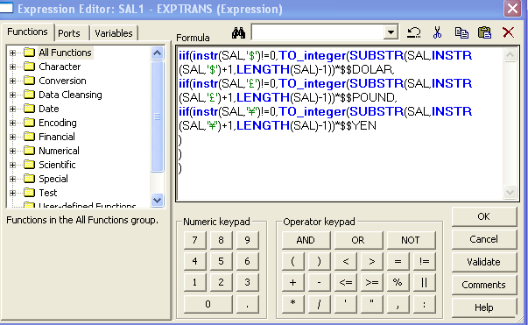
$$DOLAR,$$POUND,$$YEN these are mapping parameter . you can multiply price in rupee directly for example dollar price in rupees i.e 48 .
- Connect required output port from expression to target directly. And run the session.

Removing '$' symbol from salary column
Q21: Reading a source file with salary prefix $ , in the target the Sal column must store in number .
Source
EMPNO ENAME JOB MGR HIREDATE SAL DEPTNO
7369 SMITH CLERK 7902 17-DEC-80 $800 20
7499 ALLEN SALESMAN 7698 20-FEB-81 $1600 30
Target
EMPNO ENAME JOB MGR HIREDATE SAL DEPTNO
7369 SMITH CLERK 7902 17-DEC-80 800 20
7499 ALLEN SALESMAN 7698 20-FEB-81 1600 30
- Drag the source to mapping area and connect each port to an expression transformation.
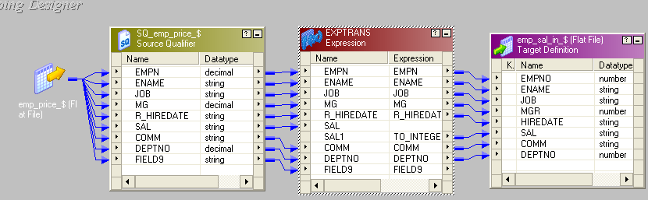
- In expression transformation add a new col sal1 and make it as out put and sal as in put only as shown in picture.
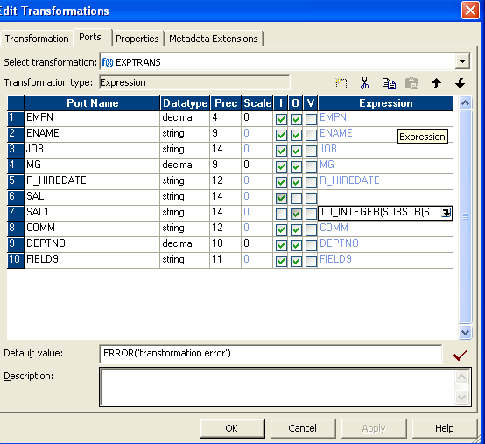
- In expression write the condition like this.
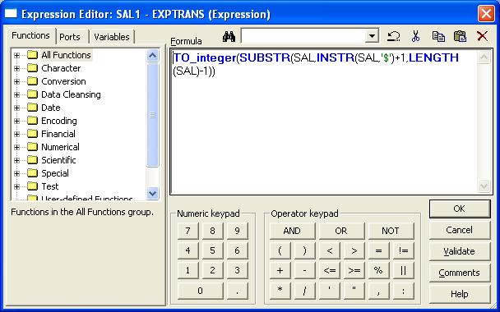
- connect the required port to target.

for replacing '$' detter to use replace funtion
ex: REPLACE('sal','$',' ')

Produce files as target with dynamic names
Scenario:How to generate file name dynamically with name of sys date ?

Solution:
- Drag your target file to target designer and add a column as show on the picture. It’s not a normal column .click on the ‘add file name to the table’ property. (I have given a red mark there)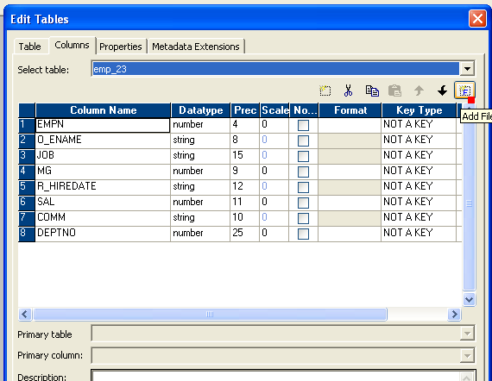
- Then drag your source to mapping area and connect it to an expression transformation.
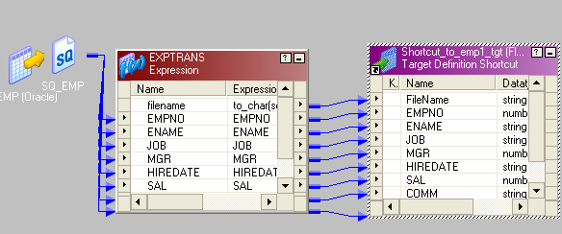
- In expression transformation add a new port as string data type and make it output port.
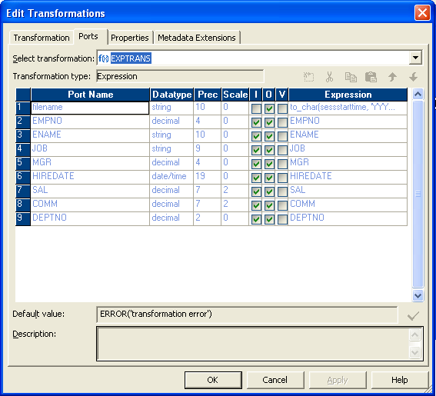
- In that output port write the condition like describe as bellow and then map it in to filename port of target. Also send other ports to target. Finally run the session. You will find two file one with sys date and other one is ‘.out’ file which one you can delete.
- 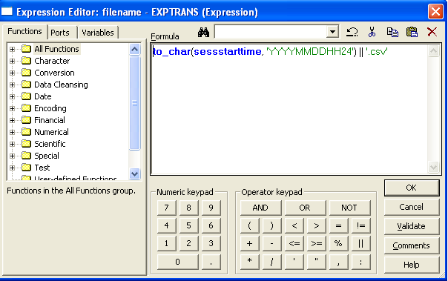

Target table rows , with each row as sum of all previous rows from source table.
Scenario: How to produce rows in target table with every row as sum of all previous rows in source table ? See the source and target table to understand the scenario.

SOURCE TABLE
Id | Sal
1 | 200
2 | 300
3 | 500
4 | 560

TARGET TABLE
Id | Sal
1 | 200
2 | 500
3 | 1000
4 | 1560
- Pull the source to mapping and then connect it to expression.
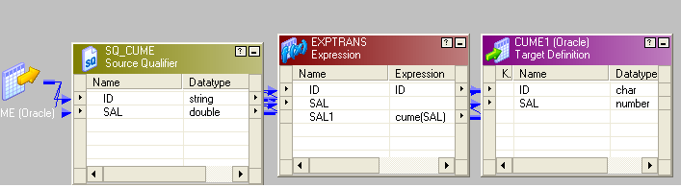
- In expression add one column and make it output(sal1) and sal port as input only.
We will make use of a function named cume() to solve our problem, rather using any complex mapping. Write the expression in sal1 as cume(sal) and send the output rows to target.