MAHARANA INSTITUTE OF PROFESSIONAL STUDIES KANPUR
Affiliated to Dr. A.P.J. Abdul Kalam Technical University, Lucknow
CERTIFICATE
DECLARATION
ABSTRACT
LIST OF FIGURES
LIST OF TABLES
LIST OF ABBREVIATIONS
INTRODUCTION
1.1 Introduction
1.2 Background of the Project
1.3 Problem Statement
1.4 Objectives
1.5 Scope of the Project
1.6 Motivation
1.7 Organization of the Report
2 LITERATURE SURVEY
2.1 Introduction
2.2 Existing Vehicle Rental Systems
2.3 Study of Existing Platforms (Zoomcar, Revv)
2.4 Existing System Limitations
2.6 Comparative Analysis
3.1 Existing System
3.2 Proposed System
3.3 Functional Requirements
3.4 Non-Functional Requirements
3.5 Hardware Requirements
3.6 Software Requirements
3.7 Feasibility Study
3.8 Use Case Description
4.1 System Architecture
4.2 Data Flow Diagram DFD
4.3 Use Case Diagram
4.4 Activity Diagram
4.5 Sequence Diagram
4.6 Database Design
4.7 ER Diagram
4.8 UI/UX Design
5 IMPLEMENTATION
5.1 Technology Stack
5.2 Frontend Implementation
5.3 Backend Implementation
5.4 Database Implementation
5.5 Authentication and Authorization
5.6 Vehicle Management
5.7 Booking Management
5.8 GPS and Map Integration
5.9 AI-Based Recommendation
5.10 Payment Integration
5.11 Admin Dashboard
5.12 Other Advanced Features
6.1 Testing Methodology
6.2 Unit Testing
6.3 Integration Testing
6.4 System Testing
6.5 Test Cases
6.6 Test Results
6.7 Screenshots of the Application
6.8 Performance and Security Testing
7 CONCLUSION AND FUTURE SCOPE
7.1 Conclusion
7.2 Project Achievements
7.3 Limitations
7.4 Future Enhancements
REFERENCES / BIBLIOGRAPHY
Appendix A – Sample Screenshots
Appendix B – Additional Technical Details
B.1 Representative Booking Algorithm
B.2 Representative API Resource Groups
B.3 Data Protection Considerations

RIDESHARE
Vehicle Rental and Sharing Management System

A B.Tech Mini Project Report submitted in partial fulfilment of the requirements for the degree of
BACHELOR OF TECHNOLOGY
Computer Science and Engineering (Artificial Intelligence and Machine Learning)

Submitted by
Sweta Singh
Roll Number: [INSERT ROLL NUMBER]

Under the guidance of
[INSERT GUIDE NAME AND DESIGNATION]

Academic Session 2026 to 2027

MAHARANA INSTITUTE OF PROFESSIONAL STUDIES KANPUR
Affiliated to Dr. A.P.J. Abdul Kalam Technical University, Lucknow

RIDESHARE
Vehicle Rental and Sharing Management System

A B.Tech Mini Project Report
Submitted in partial fulfilment of the requirements for the degree of Bachelor of Technology in Computer Science and Engineering (Artificial Intelligence and Machine Learning)

Submitted by: Sweta Singh
Roll Number: [INSERT ROLL NUMBER]
Project Guide: [INSERT GUIDE NAME AND DESIGNATION]
Department of Computer Science and Engineering (Artificial Intelligence and Machine Learning)
Academic Session 2026 to 2027

CERTIFICATE

This is to certify that the mini project report entitled “RideShare – Vehicle Rental and Sharing Management System ” is a bona fide work carried out and submitted by Sweta Singh (Roll No. 2303491530116), Tanya Khatter (Roll No. 2303491530118), Shreya Tripathi (Roll No. 2303491530106), Srashti Rathore (Roll No. 2303491530110), and Ujala Saroj (Roll No. 2303491530120) in partial fulfilment of the requirements for the award of the degree of Bachelor of Technology in Computer Science and Engineering (Artificial Intelligence and Machine Learning) during the academic session 2026–2027.
The work has been carried out by the above-mentioned students under the guidance of the undersigned.
The mini project report is approved for submission to the Department of Computer Science and Engineering, Maharana Institute of Professional Studies, Kanpur, affiliated to Dr. A.P.J. Abdul Kalam Technical University (AKTU), Uttar Pradesh.

Mr . Milind Bhatt
Head of Department
Department of CSE
MIPS , Kanpur
Approved By :

Mr . Ansh Shukla
Project Guide
Department of CSE
MIPS, Kanpur

DECLARATION

We hereby declare that the work presented in this report entitled "RideShare – Vehicle Rental and Sharing Management System " was carried out by us. We have not submitted the matter embodied in this report for the award of any other degree or diploma of any other University or Institute. We have given due credit to the original authors / sources for all the words, ideas, diagrams, graphics, computer programs, experiments, results, that are not my original contribution. We have used quotation marks to identify verbatim sentences and given credit to the original authors / sources.
We affirm that no portion of our work is plagiarized, and the experiments and results reported in the report are not manipulated. In the event of a complaint of plagiarism and the manipulation of the experiments and results, We shall be fully responsible and answerable.

ACKNOWLEDGEMENT
Date :
Place : Kanpur

Sweta Singh (2303491530116)

Tanya Khatter (2303491530118)

Shreya Tripathi (2303491530106)

Srashti Rathore (2303491530110)

Ujala Saroj (2303491530120)
We express our sincere gratitude to our project guide, the faculty members of the Department of Computer Science and Engineering, and the management of Maharana Institute of Professional Studies, Kanpur, for their valuable academic guidance, encouragement, and support throughout the development of this project.
We also acknowledge the contributions of the open-source and service-provider communities. The documentation and technical resources provided for React, Express, MongoDB, Mongoose, Leaflet, Clerk, ImageKit, Razorpay, and mapping services helped us understand and implement concepts related to component-based interface design, REST API development, document databases, authentication, location services, and payment workflows.
Finally, we extend our heartfelt thanks to our classmates, friends, and family members for their valuable suggestions, cooperation, and continuous support during the analysis, design, implementation, testing, and documentation of the RideShare – Find Your Everyday Ride on Rent project.

ABSTRACT

RideShare is a web-based vehicle rental and sharing management system that connects vehicle owners and renters through a centralized digital platform. The system aims to simplify vehicle discovery, listing management, availability verification, booking coordination, location handling, payment processing, and post-rental record management. It is designed as a role-aware application in which authenticated organization members can act as vehicle owners, renters, or both, depending on the workflow, while administrators handle verification and moderation activities.
The system is developed using a React and Vite-based client, an Express REST API, and MongoDB with Mongoose for database operations. The inspected source code includes features such as a vehicle catalogue, nearby vehicle search, owner-managed listings, date-range availability checks, quotations, booking lifecycle management, notifications, reviews, invoices, route previews, protected tracking endpoints, pricing suggestions, and a natural-language recommendation interface. Clerk is used for authentication and organization membership, ImageKit for media uploads, and Razorpay for payment operations when payment configuration is enabled. Location services use Google Maps, with Nominatim and OSRM as alternative services where appropriate.
This report presents the theoretical background, literature survey, system requirements, feasibility study, system architecture, data model, algorithms, implementation approach, testing strategy, results, limitations, and future scope of the RideShare system. It distinguishes between modules implemented in the source code and features that require valid credentials, external service availability, browser permissions, or production deployment. The future scope includes automated testing, security enhancement, privacy-aware tracking, payment reconciliation, improved recommendation capabilities, mobile application support, analytics, and operational support.

TABLE OF CONTENTS
Section Page no | Page
Certificate | iii
Declaration | iv
Acknowledgement | v
Abstract | vi
List of Figures | viii
List of Tables | ix
List of Abbreviations | x
Chapter 1 Introduction | 1
Chapter 2 Literature Survey | 5
Chapter 3 System Analysis and Requirements | 9
Chapter 4 System Design | 15
Chapter 5 Implementation | 26
Chapter 6 Testing and Results | 35
Chapter 7 Conclusion and Future Scope | 42
References / Bibliography | 46
Appendix A Sample Screenshots | 49
Appendix B Additional Technical Details | 52
Appendix C Sample Outputs | 56

LIST OF FIGURES

Figure | Title
Figure 4.1 | System architecture
Figure 4.2 | Level 1 data flow diagram
Figure 4.3 | Use case diagram
Figure 4.4 | Activity diagram for booking
Figure 4.5 | Level 2 data flow diagram for booking
Figure 4.6 | Sequence diagram for booking and payment
Figure 4.7 | Entity relationship diagram
Figure A.1 | Screenshot capture checklist

LIST OF TABLES

Table | Title
Table 1.1 | Project profile
Table 2.1 | Comparative analysis
Table 3.1 | Functional requirements
Table 3.2 | Non-functional requirements
Table 3.3 | Hardware requirements
Table 3.4 | Software requirements
Table 3.5 | Feasibility summary
Table 4.1 | Core data dictionary
Table 5.1 | Technology stack
Table 6.1 | Representative test cases
Table 6.2 | Test result summary
Table C.1 | Sample outputs

LIST OF ABBREVIATIONS

Abbreviation | Meaning
API | Application Programming Interface
AI | Artificial Intelligence
DB | Database
DFD | Data Flow Diagram
ER | Entity Relationship
GPS | Global Positioning System
HTTP | Hypertext Transfer Protocol
JWT | JSON Web Token
REST | Representational State Transfer
SSE | Server-Sent Events
UI | User Interface
UX | User Experience
UML | Unified Modeling Language
CRUD | Create, Read, Update, Delete
PDF | Portable Document Format
INR | Indian Rupee

INTRODUCTION

1.1 Introduction
Vehicle rental and sharing is a service domain in which a digital platform must coordinate people, assets, availability, location, price, and trust. Unlike a static catalogue, a rental platform must preserve the state of a vehicle and a booking over time. A vehicle can be available for one period, reserved for another period, under an active trip, or temporarily unavailable for maintenance. The system therefore combines information management with transaction processing.
RideShare is proposed as an integrated web application for this domain. It gives users a common interface to search for vehicles, inspect specifications and rental conditions, select a date range, estimate the rental amount, submit a booking request, coordinate pickup and return, and review the completed experience. The same platform also gives vehicle owners tools to publish listings, manage availability, respond to requests, and maintain operational records.

1.2 Background of the Project
Traditional rental coordination often depends on telephone calls, messaging applications, spreadsheets, and manual confirmation. These methods make it difficult to maintain one reliable view of availability, calculate a consistent quotation, or verify which participant is allowed to change a booking. A software platform addresses this coordination problem by maintaining a shared state and applying business rules at the point where a request is made.
The theoretical foundation of RideShare includes web information systems, client-server architecture, database management, RESTful service design, authentication and authorization, geospatial computation, transaction consistency, and human-computer interaction. The project also illustrates how an academic prototype can combine deterministic business rules with optional intelligent recommendations while keeping the recommendation feature advisory.

1.3 Problem Statement
The problem addressed by RideShare is the lack of a unified, transparent, and extensible workflow for vehicle discovery and rental management. Users need accurate information about vehicle specifications, location, price, rental rules, and availability. Owners need controlled listing and booking management. Administrators need tools to verify listings, manage access, and moderate user-generated content. Without a central system, duplicated records, delayed confirmation, overlapping reservations, inconsistent charges, and weak accountability may occur.
The project therefore seeks to design and implement a system that centralizes vehicle data, validates booking conditions, protects role-specific operations, provides location-aware workflows, and preserves operational records for later review.

1.4 Objectives

1.5 Scope of the Project
The current scope covers public vehicle browsing, nearby search, protected listing management, date-range availability, quote calculation, booking lifecycle management, pickup and return coordination, route preview, optional live location updates, notifications, reviews, invoices, administrator workflows, pricing suggestions, and natural-language vehicle recommendations. The data model also represents payments, additional charges, access requests, tracking sessions, pricing snapshots, and conversation history.
The scope does not claim a verified production deployment, a native mobile application, guaranteed live tracking without browser permission, fleet telemetry hardware, automatic SMS or email delivery, a completed dispute-resolution process, or production payment operation without valid provider credentials. These boundaries are important because academic prototypes should distinguish design capability from operational evidence.

1.6 Motivation
The motivation for the project is both practical and educational. Practically, a vehicle sharing platform can improve asset utilization and reduce communication overhead. Educationally, the problem requires the integration of multiple areas of software engineering: requirements analysis, interface design, database modeling, API development, security, geospatial services, testing, and project documentation. The project also provides a useful context for studying how reliability and privacy requirements affect a seemingly simple booking interface.

1.7 Organization of the Report
Chapter 1 introduces the problem and objectives. Chapter 2 surveys existing vehicle rental approaches and explains the proposed contribution. Chapter 3 presents requirements, system analysis, resources, and feasibility. Chapter 4 describes the architecture, data flow, diagrams, database design, and interface principles. Chapter 5 explains implementation modules and integrations. Chapter 6 documents testing, representative results, and evidence boundaries. Chapter 7 concludes the report and presents limitations and future scope. References and appendices provide technical sources, supplementary details, and sample outputs.

Item | Project profile
Project title | RideShare Vehicle Rental and Sharing Management System
Project type | B.Tech mini project in web-based software engineering
Programme | Computer Science and Engineering (Artificial Intelligence and Machine Learning)
Institution | Maharana Institute of Professional Studies Kanpur
University affiliation | Dr. A.P.J. Abdul Kalam Technical University, Lucknow
Students | Sweta Singh  Tanya Khatter  Ujala Saroj  Shreya Tripathi  Srashti Rathore
Academic session | 2026 - 2027
Primary users | Guests, authenticated members, vehicle owners, renters, and administrators

Table 1.1 Project profile

2 LITERATURE SURVEY

2.1 Introduction
A literature survey identifies the concepts and existing solutions that influence the proposed system. In a rental platform, the relevant literature is not limited to vehicle booking. It includes online marketplace design, resource allocation, location-based services, access control, transaction consistency, recommendation systems, and service quality. Reviewing these areas helps separate essential platform behavior from optional enhancements.

2.2 Existing Vehicle Rental Systems
Existing vehicle rental systems generally follow one of three models. In a fleet-owned model, a company owns the vehicles and controls inventory, pricing, and maintenance. In a peer-to-peer model, individual owners publish vehicles and the platform coordinates trust, verification, and payment. In a hybrid model, a platform may manage its own fleet while also onboarding external owners. Each model changes the platform’s data and authorization requirements.

2.3 Study of Existing Platforms (Zoomcar, Revv)
Zoomcar and Revv are useful reference platforms because they demonstrate consumer-facing vehicle rental workflows in the Indian market. Their public-facing experiences emphasize searchable vehicle listings, location-aware discovery, booking dates, rental plans, pickup or delivery coordination, and digital support. These platforms also illustrate the importance of clear pricing, vehicle descriptions, customer trust, and operational communication.
For an academic project, these platforms should be studied as conceptual references rather than copied as complete specifications. Their internal pricing, fraud controls, fleet operations, insurance arrangements, support procedures, and production infrastructure are not available in the project repository. RideShare therefore focuses on a smaller, demonstrable set of workflows while leaving mature operational services as future scope.

2.4 Existing System Limitations
Common limitations in small or manually coordinated rental systems include duplicated vehicle records, stale availability information, unclear authority to confirm a booking, inconsistent quotation logic, and limited auditability. A platform may also become dependent on third-party identity, map, media, or payment services. If these dependencies are not abstracted, a provider outage can make the entire workflow unusable.
Another limitation is that advanced features are often described more strongly than the available evidence permits.
2.5 Proposed System
RideShare proposes a modular client-server architecture. The React client manages the browser interface and user interaction. The Express API centralizes validation, authorization, quoting, availability checks, booking transitions, location services, and provider integrations. MongoDB stores flexible documents for users, vehicles, bookings, payments, reviews, notifications, invoices, tracking sessions, pricing snapshots, and recommendation conversations.
The proposed system uses a shared booking workflow. A user selects a vehicle and date range, the server validates the request, calculates a quote, checks overlapping bookings, and creates a pending or pending-payment record. Owner confirmation, payment verification, and status changes are handled through protected operations. The design also retains a route preview when live location updates are unavailable.

2.6 Comparative Analysis

Criteria | Manual or basic system | Large commercial platform | Proposed RideShare system
Vehicle catalogue | Static or fragmented lists | Searchable catalogue with commercial inventory | Searchable catalogue with owner-managed listings
Availability | Manual confirmation | Centralized inventory and booking rules | Server-side date validation and conflict checks
Pricing | Negotiated or inconsistent | Dynamic commercial pricing and policies | Rule-based quote, discounts, deposit, and delivery charges
Location | Telephone or text coordination | Integrated maps and operational support | Geocoding, route preview, nearby search, optional tracking
Identity and access | Implicit trust | Provider-managed verification and support | Clerk authentication, organization membership, role and ownership checks
Payment | Offline or separate transfer | Integrated payment and reconciliation | Razorpay workflow when configured; otherwise configuration-gated
Recommendations | Not available | Personalized search and promotions | Heuristic or AI-assisted vehicle recommendation interface
Evidence scope | Records may be informal | Production metrics and support processes | Academic prototype with implementation and configuration boundaries

Table 2.1 Comparative analysis of existing and proposed systems
3 SYSTEM ANALYSIS AND REQUIREMENTS

3.1 Existing System
The existing approach considered in this project is a fragmented rental process in which vehicle information, owner communication, availability, payments, and handover details are maintained through separate channels. Such a process may work at a small scale but becomes difficult to audit as the number of vehicles and users increases. It also makes it hard to apply the same validation rules to every booking request.
From a software engineering perspective, the existing system lacks a single source of truth. The proposed analysis therefore identifies the actors, data objects, operations, constraints, and external dependencies that must be represented in a unified platform.

3.2 Proposed System
The proposed system is an authenticated web application with public and protected areas. Guests can view approved vehicle listings and nearby results. Authenticated members can create and manage their own listings, submit and coordinate bookings, receive notifications, view invoices, and review completed rentals. Administrators can manage members, access requests, vehicle verification, and review moderation. Owner and renter are workflow relationships rather than separate application roles in the current design.

3.3 Functional Requirements

ID | Functional requirement | Description
FR-01 | Vehicle discovery | Browse available vehicles, inspect details, and filter by location or attributes.
FR-02 | Nearby search | Find vehicles within a capped radius using valid coordinates.
FR-03 | Access request | Submit an access request and obtain organization-backed authenticated access.
FR-04 | Vehicle management | Create, update, enable, disable, and delete an owned vehicle listing.
FR-05 | Availability and quote | Validate dates, rental duration, delivery option, discounts, deposit, and conflict status.
FR-06 | Booking management | Create, approve, reject, cancel, complete, and view booking records subject to authorization.
FR-07 | Location services | Geocode, reverse-geocode, calculate routes, and display maps where providers are available.
FR-08 | Payment operations | Create and verify payment orders, refunds, and additional charges when enabled.
FR-09 | Trip tracking | Provide a protected route preview and optional owner-device GPS updates with consent.
FR-10 | Administration | Manage members, access requests, vehicle verification, notifications, and review moderation.
FR-11 | Records | Generate notifications, invoices, reviews, pricing snapshots, and recommendation history

Table 3.1 Functional requirements

3.4 Non-Functional Requirements

ID | Quality attribute | Requirement
NFR-01 | Security | Verify identity tokens, enforce membership and roles, check ownership, protect secrets, and avoid exposing private documents.
NFR-02 | Data integrity | Validate schema values, prevent overlapping bookings, use consistent status transitions, and preserve financial records.
NFR-03 | Availability | Return controlled errors and use location fallbacks when external services are unavailable.
NFR-04 | Usability | Provide responsive pages, understandable status feedback, clear quotes, and accessible navigation.
NFR-05 | Performance | Use indexes, bounded queries, limited route payloads, caching where appropriate, and efficient UI rendering.
NFR-06 | Privacy | Minimize exposure of contact, location, identity, document, payment, and recommendation data.
NFR-07 | Maintainability | Separate routes, controllers, services, models, and client components with clear data contracts.
NFR-08 | Scalability | Support increased listings and bookings through stateless APIs, managed persistence, and monitored deployments

Table 3.2 Non-functional requirements

3.5 Hardware Requirements

Resource | Minimum development recommendation | Purpose
Processor | 64-bit dual-core processor | Run browser, editor, Node.js services, and local tooling.
Memory | 8 GB RAM; 16 GB recommended | Support client, server, database tools, and browser tabs.
Storage | 10 GB free space; SSD recommended | Store source, dependencies, uploaded test assets, and logs.
Network | Stable broadband connection | Install packages and access configured external services.
Optional device | GPS-capable smartphone or browser device | Test consented owner-device location updates.

Table 3.3 Hardware requirements

3.6 Software Requirements

Software | Requirement or option | Use
Operating system | Windows, Linux, or macOS | Cross-platform development environment.
Runtime | Node.js with package manager | Run client and server applications.
Client | React and Vite | Component-based interface and development server.
Server | Express REST API | Routing, validation, authorization, and provider integration.
Database | MongoDB with Mongoose | Document storage, schema rules, indexes, and timestamps.
Authentication | Clerk | Session token verification and organization membership.
Media | ImageKit and upload middleware | Vehicle and profile media handling when configured.
Maps | Leaflet with Google, Nominatim, or OSRM | Map display, search, geocoding, routing, and fallback behavior.
Payment | Razorpay SDK and webhooks | Payment orders, verification, refunds, and extra charges when enabled.

Table 3.4 Software requirements

3.7 Feasibility Study

Technical feasibility is high for an academic prototype because the solution uses mature web frameworks and a modular JavaScript architecture. Integration feasibility is conditional because identity, media, maps, AI, and payment services require credentials, quotas, network access, and provider-specific configuration. Economic feasibility is plausible for educational use but cannot be assumed to be zero-cost in production because hosting, storage, map requests, payment charges, monitoring, and backups may incur expenses.
Operational feasibility depends on procedures as well as software. Administrators need policies for vehicle verification, member access, refunds, disputes, security deposits, support, and incident reporting. Legal and privacy feasibility requires institutional review and deployment-specific notices, especially for location tracking, identity data, documents, and payment information.

Feasibility area | Assessment | Reason
Technical | Feasible for prototype | React, Express, MongoDB, and provider SDKs support the required modules.
Economic | Conditionally feasible | Educational or free tiers may support testing; production cost depends on traffic and providers.
Operational | Feasible with procedures | Role dashboards support operations, but verification, disputes, support, and reconciliation require human policy.
Schedule | Feasible with prioritization | Secure access, listings, availability, bookings, and testing should precede advanced features.
Legal and privacy | Requires review | Location, identity, documents, payments, and user-generated content need notices and controls.

Table 3.5 Feasibility summary

3.8 Use Case Description
The principal actors are Guest, Authenticated Member, Vehicle Owner, Renter, Administrator, Payment Provider, Map and Route Provider, and Identity Provider. A regular authenticated member can participate in both owner and renter use cases. The system checks the relationship between the current member and the target vehicle or booking before permitting mutation.
- Guest browses approved vehicle listings and nearby results.
- Member creates or updates a vehicle listing and submits media or verification information.
- Renter selects dates and locations, obtains a quote, and submits a booking request.
- Owner reviews the request and accepts, rejects, or coordinates it according to the booking state.
- Payment provider verifies a payment order when payment configuration is enabled.
- Administrator manages access requests, member status, vehicle verification, and review moderation.
- Tracking and notification services provide protected operational updates during an active booking.
4 SYSTEM DESIGN

4.1 System Architecture
RideShare follows a layered client-server architecture. The presentation layer is a React single-page application that provides catalogue, detail, dashboard, booking, map, notification, and administrative screens. The application layer is an Express REST API that implements authentication middleware, request validation, ownership checks, business rules, quote calculation, booking transitions, provider adapters, and response formatting. The data layer uses MongoDB collections accessed through Mongoose models. External services provide identity, media, maps, routes, payments, and optional AI assistance.
Layering reduces coupling. The client does not calculate authoritative prices or decide whether a booking is available; these decisions belong to the server. Provider adapters also allow the system to use fallback services or show a controlled limitation when an integration is not configured.
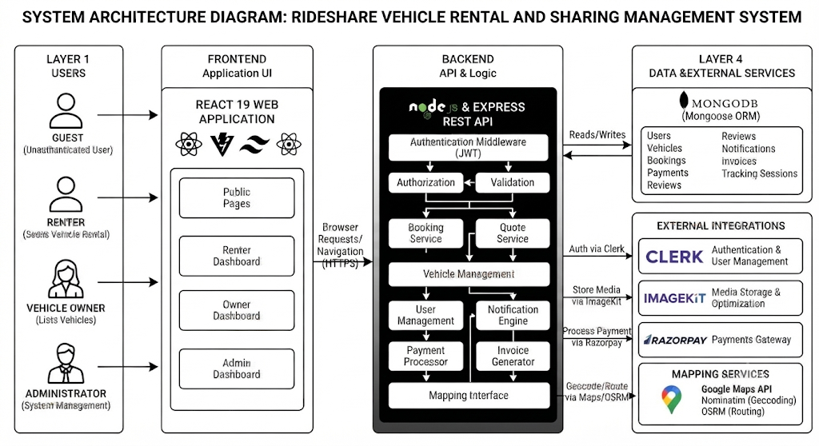
Figure 4.1 System architecture

4.2 Data Flow Diagram DFD
The Level 1 data flow partitions the system into access management, vehicle and availability management, booking and payment, location and tracking, notifications and records, and recommendation services. External actors provide inputs such as identity tokens, vehicle details, booking requests, coordinates, and payment responses. Data stores preserve users, vehicles, bookings, payments, reviews, notifications, invoices, tracking sessions, pricing snapshots, and conversations.
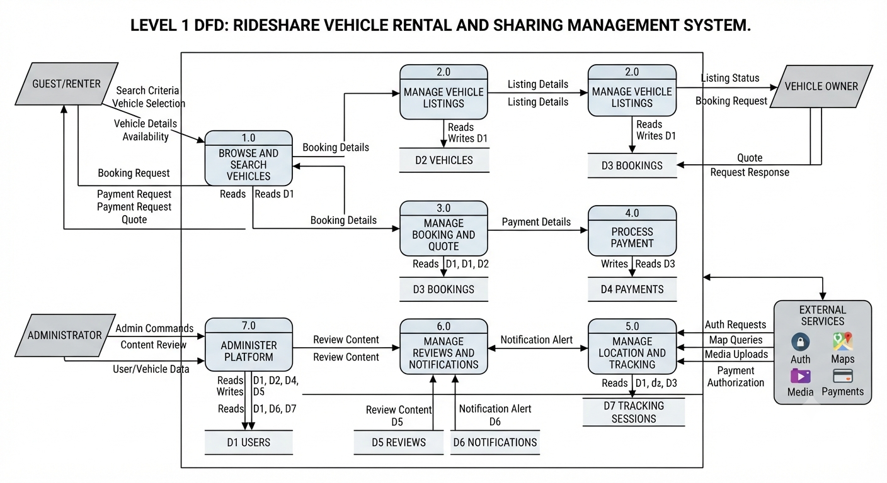
Figure 4.2 Level 1 data flow diagram
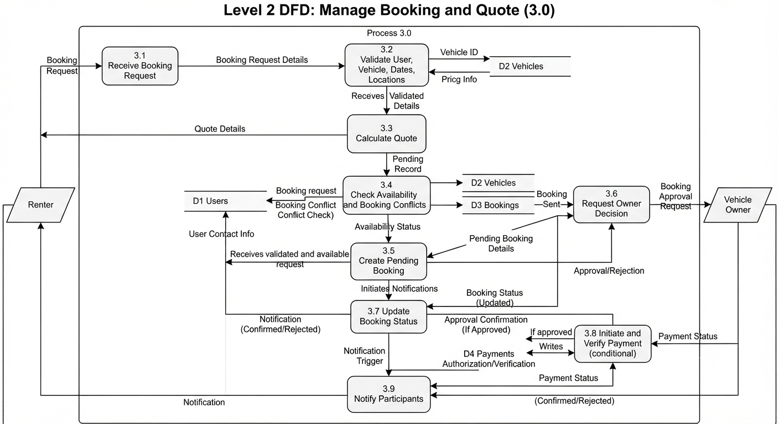
Figure 4.5 Level 2 data flow diagram for booking

4.3 Use Case Diagram
The use case model represents the services visible to each actor. The Guest is limited to public discovery and access request submission. Authenticated members can manage listings and bookings related to them. The Administrator has separate moderation and member-management capabilities. Provider actors are external dependencies and are not treated as application users.
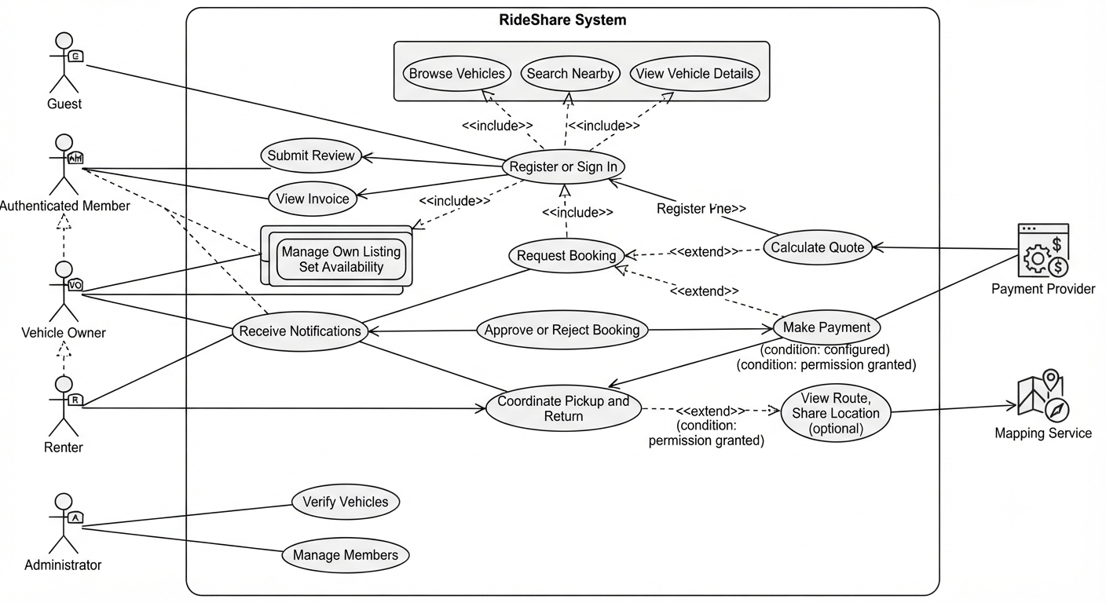
Figure 4.3 Use case diagram

4.4 Activity Diagram
The booking activity flow is designed around validation before persistence. The request is first checked for valid dates and locations, then the server calculates a quote and checks overlapping bookings. If the vehicle is available, a pending booking is created. A payment branch is followed only when payment configuration is enabled; otherwise, the workflow remains governed by owner confirmation and the configured booking policy.
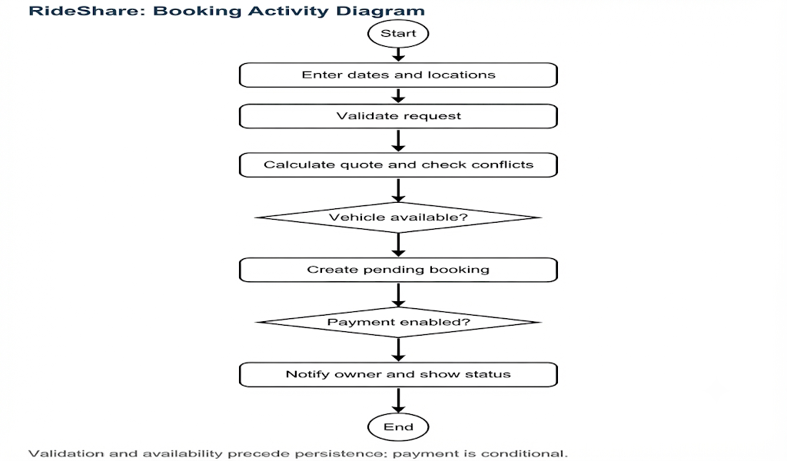
Figure 4.4 Activity diagram for booking

4.5 Sequence Diagram
The sequence design clarifies the order of interactions among the renter, browser, API, database, owner, and payment provider. The browser submits a request, the API authenticates the member, validates dates and location, calculates the quote, checks conflicts, writes a booking, and notifies the owner. When enabled, the API creates an order and later verifies the payment signature and provider state before confirmation.
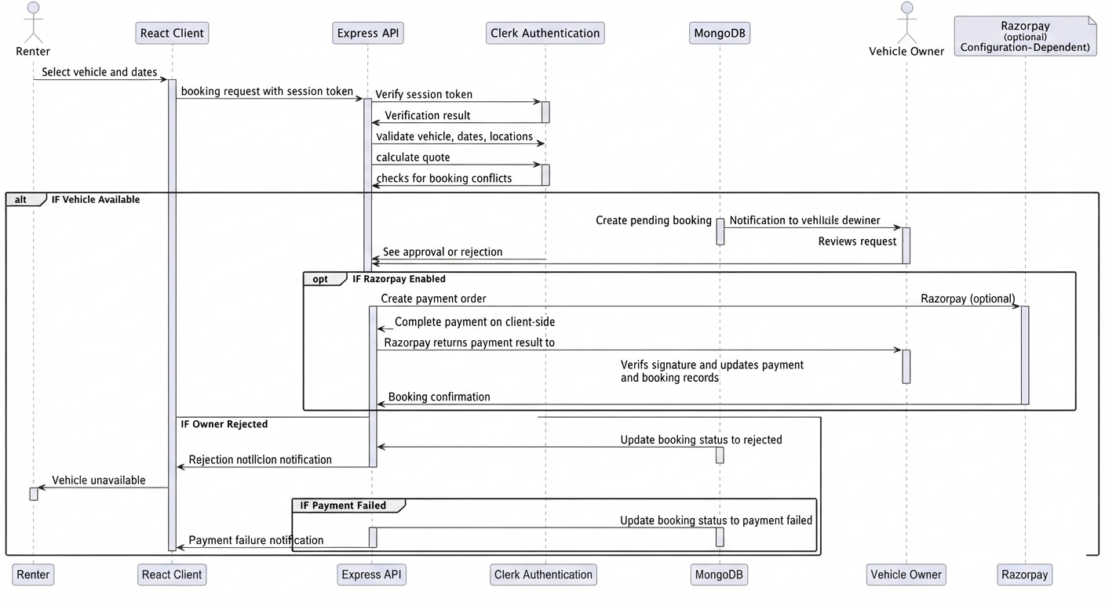
Figure 4.6 Sequence diagram for booking and payment

4.6 Database Design
MongoDB is used as a document database because the project includes both stable entities and nested, evolving data such as addresses, coordinates, rental rules, quote details, tracking snapshots, payment identifiers, and recommendation messages. Mongoose schemas provide validation, defaults, enumerations, indexes, references, and timestamps. The design uses references for entities that participate in booking and authorization relationships while keeping presentation-oriented fields close to the owning document.
Collection | Important fields | Purpose
User | clerkId, name, email, phone, location, role, ratings | Local identity mirror and authorization context.
Vehicle | owner, specifications, media, price, location, availability, rules | Public listing and owner-managed asset record.
Booking | vehicle, renter, owner, dates, quote, locations, status | Rental request and lifecycle record.
Payment | booking, provider IDs, amount, status, timestamps | Payment and refund trace when enabled.
Review | booking, reviewer, reviewee, rating, comment, moderation | Post-rental feedback with moderation.
Notification | recipient, type, title, message, booking, read state | In-application operational communication.
Invoice | booking, invoice number, amounts, issue date | Financial summary for a completed or settled booking.
TrackingSession | booking, route, current coordinates, ETA, progress, simulated flag | Protected trip route and optional location updates.
PricingSnapshot | vehicle, date, prices, utilization, recommendation | Advisory pricing analysis.
AIConversation | user, session, messages, preferences | Recommendation interaction history.

Table 4.1 Core data dictionary

4.7 ER Diagram
The ER-style view shows the principal relationships. One member may own many vehicles and participate in many bookings. Each booking links a vehicle, renter, and owner and may have a payment, review, invoice, tracking session, and additional charges. Notifications and recommendation conversations are user-centric. Because the database is document-oriented, these relationships are application-level references rather than relational foreign keys enforced by a relational database engine.
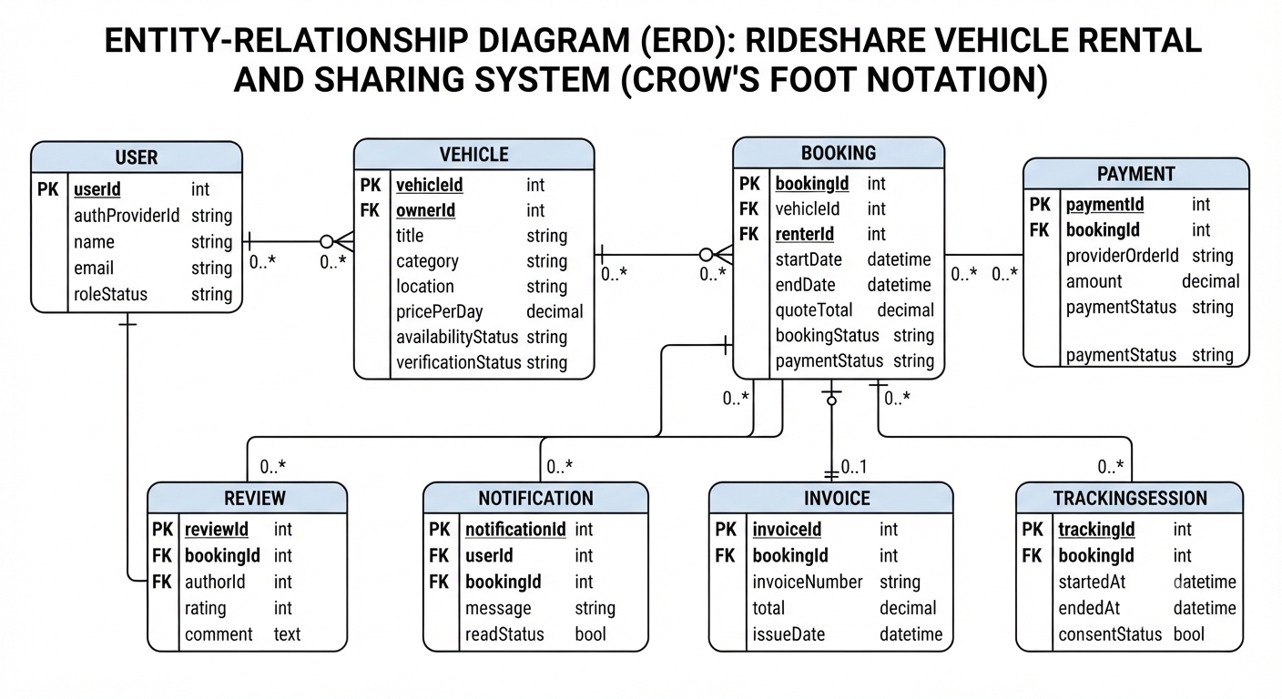Figure 4.7 Entity relationship diagram

4.8 UI/UX Design
The interface is organized around task completion rather than database structure. Public users begin with vehicle discovery and detail views. Authenticated users access dashboards for listing, booking, notification, and profile activities. Forms should expose only relevant fields, show server-validated errors near the source of the problem, and provide clear status labels for pending, confirmed, active, completed, cancelled, rejected, refunded, and payment-related states.
The map interface is designed to show markers, selected locations, route previews, and a visible indication when location data is simulated or unavailable. Visual hierarchy, responsive layouts, readable contrast, keyboard navigation, and consistent action placement are important because booking decisions involve dates, money, and location. The application assets provide the visual starting point; final accessibility and usability testing should be completed on the deployed interface.

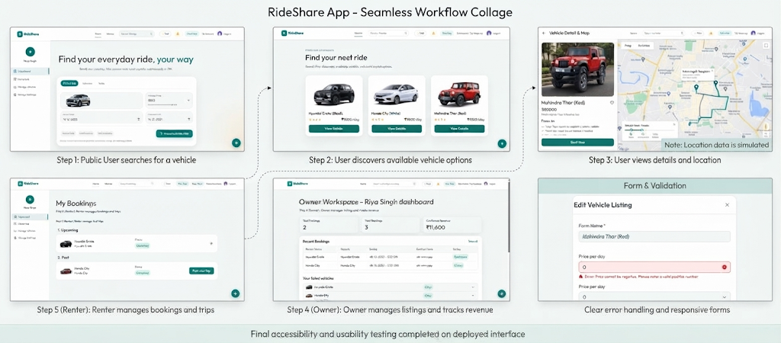

5 IMPLEMENTATION

5.1 Technology Stack
Layer | Technology | Implementation role
Frontend | React 19, Vite 6, React Router, Axios, Tailwind CSS, Motion | Component pages, routing, API calls, responsive styling, and feedback.
Backend | Node.js, Express 5, CORS, dotenv | REST routes, middleware, validation, authorization, and provider integration.
Database | MongoDB and Mongoose 8 | Document persistence, schemas, validation, indexes, references, and timestamps.
Authentication | Clerk React and Clerk backend | Session token validation, organization membership, and user mapping.
Media | Multer and ImageKit | Upload handling and hosted listing/profile media when configured.
Maps | Leaflet, React Leaflet, Google Maps, Nominatim, OSRM | Map display, geocoding, reverse geocoding, routing, and fallback behavior.
Payments | Razorpay SDK and webhooks | Orders, signature verification, captures, refunds, and extra charges when enabled.
Documents | PDF invoice generation | Downloadable invoice output for booking records.
AI assistance | Heuristic or Gemini-assisted recommendation interface | Natural-language discovery and advisory suggestions where configured.

Table 5.1 Technology stack

5.2 Frontend Implementation
The frontend is implemented as a React single-page application. Reusable components represent navigation, cards, forms, map views, status labels, notifications, dashboards, and detail sections. Client-side routing separates public browsing from protected member and administrator pages. Axios or equivalent request helpers communicate with the Express API and provide a consistent place for authorization headers, error handling, and response parsing.
The interface uses controlled form inputs for dates, locations, vehicle attributes, pricing, documents, and profile information. The client presents calculated quotations and booking states returned by the server, but it does not treat client-side calculations as authoritative. This separation is important because a malicious or outdated client must not be able to change the final price or bypass availability rules.

5.3 Backend Implementation
The backend is organized into routes, controllers, services, models, middleware, and provider utilities. Authentication middleware verifies the request token and resolves organization membership. Authorization middleware checks the application role and the relationship between the member and the target resource. Service modules centralize quote calculation, location operations, payment verification, recommendations, invoice generation, notifications, and tracking updates.
REST endpoints follow resource-oriented patterns for vehicles, bookings, payments, reviews, notifications, locations, access requests, invoices, tracking sessions, pricing, and recommendations. Input validation occurs before persistence, and errors are returned in a controlled format so that the client can display an actionable message.

5.4 Database Implementation
Mongoose schemas define required fields, enumerations, minimum and maximum values, nested objects, references, unique indexes, and timestamps. Booking queries consider blocking statuses and date overlap rather than merely checking whether a vehicle record exists. Sensitive vehicle documents are excluded from public responses. Payment identifiers, personal data, precise coordinates, and recommendation content require restricted access and a deployment-specific retention policy.

5.5 Authentication and Authorization
Clerk provides the external identity context. The server verifies token signature, expiry, authorized-party claims, and organization membership before attaching a trusted user to the request. The local User document mirrors relevant profile and role information for application operations. Route-level authorization then checks whether the member is an administrator or is related to the target vehicle or booking.
Authentication answers who the requester is; authorization answers what the requester may do. This distinction is applied to listing updates, booking coordination, tracking updates, invoices, reviews, member administration, and vehicle verification. Future hardening should add systematic regression tests for every object-ID route because broken object-level authorization is a common API risk.

5.6 Vehicle Management
The vehicle module supports creation, editing, enabling, disabling, and deletion of owner-managed listings. A listing may include category, brand, model, variant, year, capacity, fuel type, transmission, images, description, features, rental rules, price, deposit, distance and late charges, delivery options, address, locality, landmark, coordinates, availability window, and verification status. Public responses are shaped to avoid exposing private documents or unnecessary owner information.

5.7 Booking Management
Booking management is the central business workflow. The server validates pickup and return dates, rental duration, availability windows, delivery options, discount rules, deposits, and conflicting bookings. A short lock or equivalent coordination mechanism reduces the chance that simultaneous requests create overlapping records. The system then persists a pending or pending-payment booking and notifies the owner. Status transitions are used to represent approval, rejection, cancellation, payment, active rental, completion, refund, and additional charges.

5.8 GPS and Map Integration
The location service normalizes latitude and longitude and can obtain coordinates from address text. Configured Google services may be used first, followed by Nominatim for search and OSRM for routing. Leaflet renders maps and markers in the client. When a route provider is unavailable, the system may retain a route preview or return a straight-line estimate where appropriate; the interface must not present this fallback as verified live navigation.
Tracking sessions are protected by booking ownership checks. An owner device may submit browser geolocation updates only after permission is granted and while the active workflow permits tracking. The current design records whether a position is simulated so that route previews and live updates are not confused.

5.9 AI-Based Recommendation
The recommendation feature combines structured preferences with natural-language interaction. A recommendation request can consider category, capacity, fuel type, transmission, budget, distance, location, and other attributes. The output is advisory and should be explainable in terms of the filters or preferences that influenced it. If an AI provider is configured, the system should validate the response, constrain it to available vehicle data, and avoid presenting unsupported claims.

5.10 Payment Integration
Payment processing is configuration-dependent. When enabled, the server creates an order, returns the required checkout information, verifies the client signature, checks provider order and payment state, matches the expected amount, and persists provider identifiers. Webhooks and refunds require idempotent handling so that repeated provider events do not duplicate state changes. If payment configuration is disabled, the report treats payment as an integration boundary rather than as a verified production capability.

5.11 Admin Dashboard
The administrator dashboard provides governance functions such as access request review, member management, vehicle verification, review moderation, and visibility into operational records. Administrative actions should be logged and should expose only the data needed for the task. A future production version should add audit history, review queues, operational metrics, and controlled support workflows.

5.12 Other Advanced Features
Additional features include in-application notifications, reviews, invoice generation, pricing suggestions, additional booking charges, and recommendation conversations. These features broaden the platform beyond a basic catalogue and reservation screen, but they also introduce additional privacy, consistency, and support requirements. Each should be released with monitoring, clear user explanations, and a fallback behavior when an external provider or configuration is unavailable.
6 TESTING AND RESULTS

6.1 Testing Methodology
Testing is organized in layers. Unit testing checks pure functions such as date validation, quote calculation, coordinate normalization, status rules, and provider-response parsing. Integration testing checks API routes with authentication, database models, ownership checks, and provider adapters. System testing checks end-to-end workflows in a configured environment. Security testing checks access boundaries, invalid tokens, object ownership, input validation, webhook verification, and sensitive-data exposure.
The supplied source provides implementation evidence for the modules described in the earlier chapters, but it does not provide a complete automated test suite, production traffic measurements, or verified runtime screenshots. Therefore, the results below distinguish design-level expected outcomes from measurements that must be collected during an executed test run.

6.2 Unit Testing
Unit tests should be deterministic and independent of third-party providers. Recommended units include date-range comparison, rental-day calculation, discount selection, delivery and deposit rules, geographic distance, coordinate bounds, booking status transitions, quote serialization, safe error mapping, and response parsing. Unit tests should cover boundary values such as minimum rental days, maximum rental days, zero or missing coordinates, reverse dates, and empty recommendation preferences.

6.3 Integration Testing
Integration tests should run against a test database and provider mocks or sandbox credentials. They should verify authentication middleware, organization membership, authorization, listing creation, booking conflicts, notifications, invoices, payment signature handling, refund transitions, route fallbacks, and tracking access. A booking created by one member must not be editable by an unrelated member, even when the unrelated member knows the booking identifier.

6.4 System Testing
System testing should follow realistic user journeys: a guest searches the catalogue, a member requests access, an owner creates a listing, a renter searches and obtains a quote, the owner responds, the renter completes payment when enabled, the trip becomes active, the route or location state is displayed, and the booking is completed with an invoice and review. The same journeys should be repeated with invalid dates, missing configuration, denied location permission, provider errors, and interrupted payment.

6.5 Test Cases
ID | Test scenario | Expected result | Result status
TC-01 | Guest searches catalogue with valid filters. | Only available, approved vehicles matching the filters are returned. | Pass by design / execute
TC-02 | Guest searches nearby vehicles with invalid coordinates. | The request is rejected or safely returns no nearby result. | Pass by design / execute
TC-03 | Renter submits reverse or invalid dates. | The API returns a validation error and no booking is created. | Pass by design / execute
TC-04 | Two users request overlapping dates for one vehicle. | Conflict detection or lock prevents a second blocking booking. | Pass by design / execute
TC-05 | Nonparticipant updates booking coordination. | Authorization failure is returned and the record is unchanged. | Pass by design / execute
TC-06 | Payment signature is invalid. | Verification fails and the booking is not confirmed. | Pass by design / execute
TC-07 | Map provider is unavailable. | Fallback or controlled limitation is returned; UI does not claim live route. | Pass by design / execute
TC-08 | Owner denies GPS permission. | Route preview remains and the limitation is visible. | Pass by design / execute
TC-09 | Administrator moderates a review. | Only administrator authorization can change moderation state. | Pass by design / execute
TC-10 | Private document is requested publicly. | The public response excludes the private document. | Pass by design / execute

Table 6.1 Representative test cases

6.6 Test Results
Area | Evidence available from project package | Interpretation
Architecture and modules | Source modules, models, routes, and client components are present. | Implementation structure is documented.
Functional workflows | Requirements and algorithm descriptions map to the source design. | Workflow behavior should be executed in a configured environment.
External integrations | Provider adapters and configuration flags are represented. | Operation depends on credentials, quotas, provider status, and network.
Automated testing | No complete automated test suite was identified. | Test cases are specified for implementation and evaluation.
Performance | No formal benchmark or load-test result was supplied. | Performance values must be collected with representative data and traffic.
Security | Token, membership, role, ownership, and sensitive-response controls are described. | Security regression testing is required before deployment.
Table 6.2 Test result summary

6.7 Screenshots of the Application
The following screenshots document the main RideShare workflows described in this report. They correspond to the evidence checklist in Appendix A and show the public catalogue, vehicle quote, owner management, booking, map, administrator, invoice, and review interfaces.
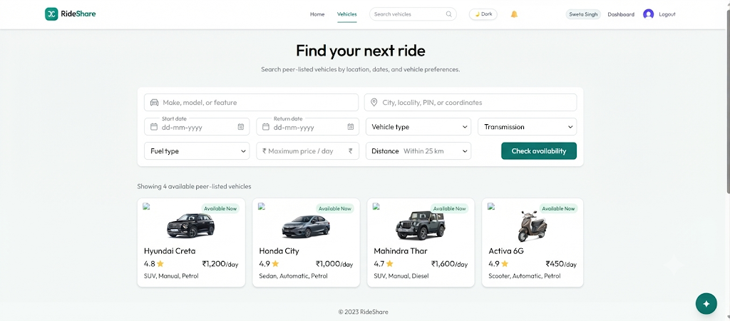
Figure A.1 Public vehicle catalogue
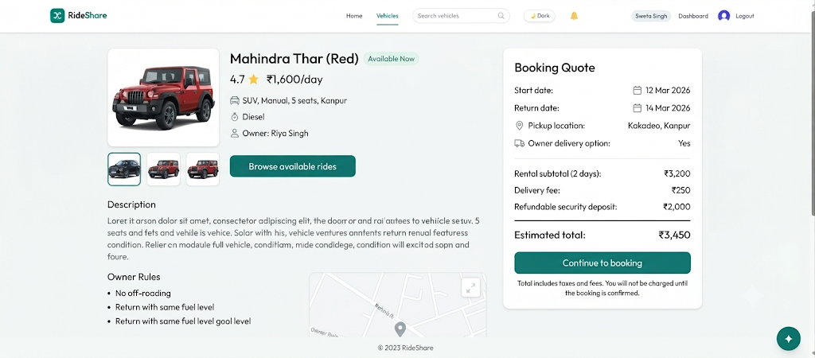
Figure A.2 Vehicle details and quote
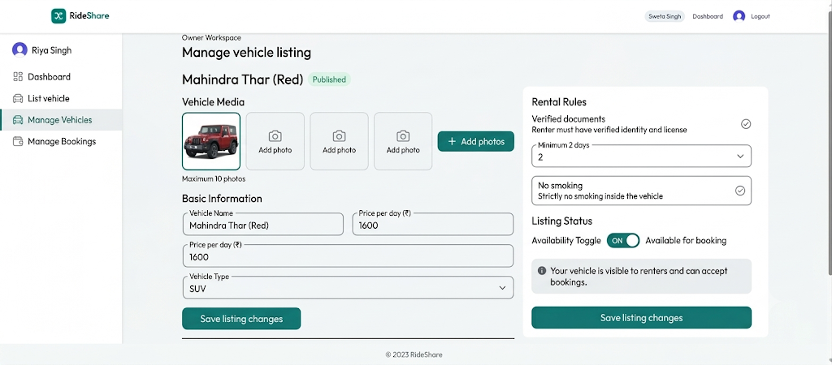
Figure A.3 Owner vehicle management
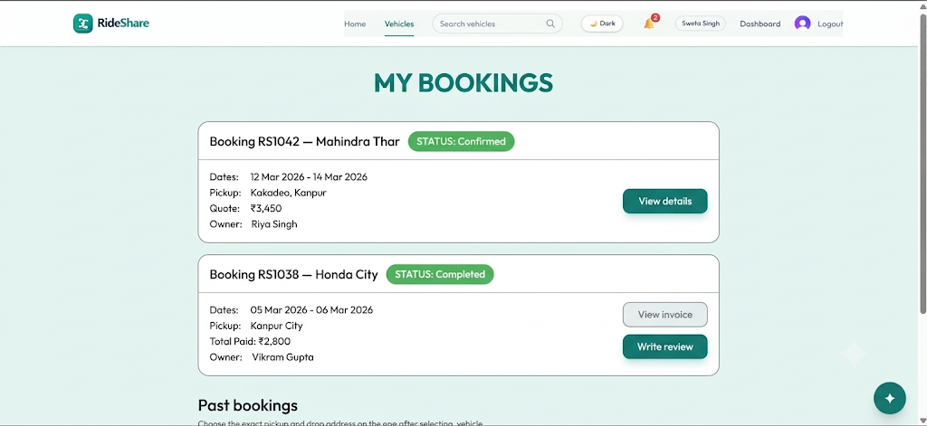
Figure A.4 Booking dashboard
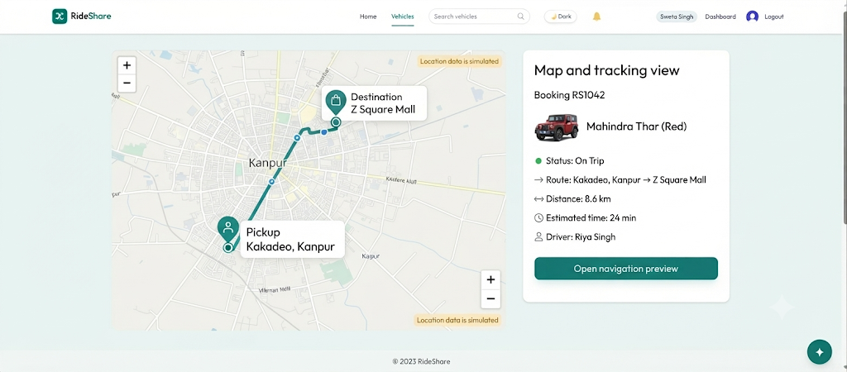
Figure A.5 Map and tracking view
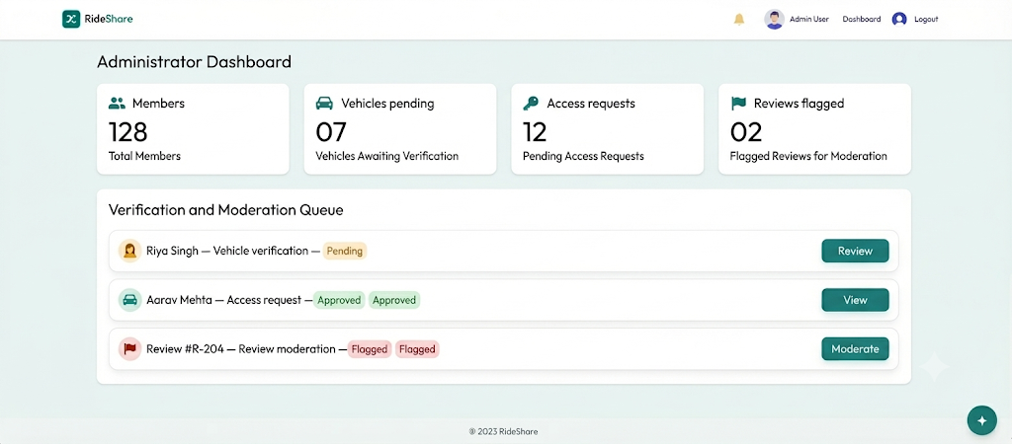
Figure A.6 Administrator dashboard
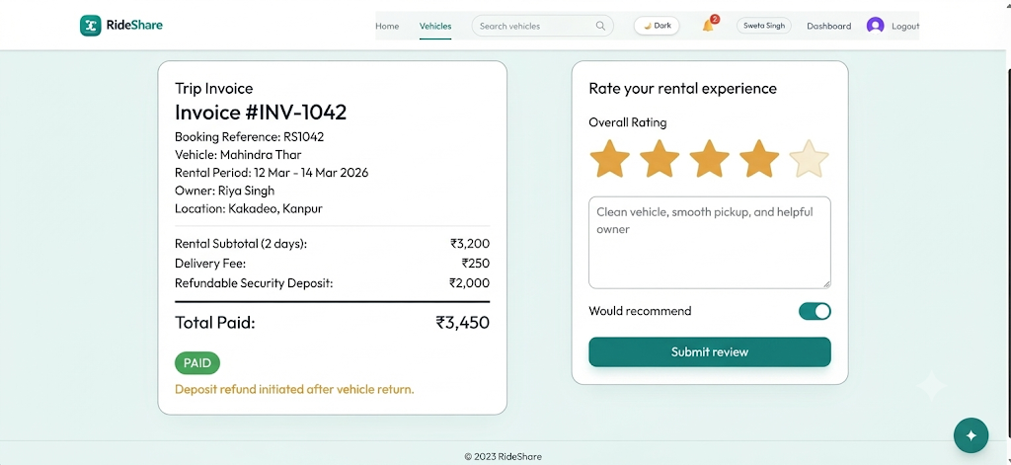
Figure A.7 Invoice and review

6.8 Performance and Security Testing
Performance testing should measure response time, throughput, database query behavior, route-provider latency, client rendering, and concurrent booking attempts. Tests should be repeated with small and larger vehicle and booking datasets. Important metrics include p50 and p95 API response time, conflict response rate, upload duration, map lookup duration, and error rate under provider failure.
Security testing should include invalid and expired tokens, missing organization membership, role escalation, object-ID substitution, mass assignment, unvalidated upload types, sensitive response fields, replayed payment callbacks, webhook signature failures, excessive location updates, and injection attempts. Production deployment should use HTTPS, secret management, least privilege, rate limiting, logging, backups, dependency updates, and incident procedures.

7 CONCLUSION AND FUTURE SCOPE

7.1 Conclusion
RideShare demonstrates the design of an integrated vehicle rental and sharing management system using a modern web stack. The project brings together vehicle discovery, owner listing management, availability validation, booking lifecycle control, location services, payment boundaries, notification, review, invoice, recommendation, and administrative workflows. The architecture separates client presentation, server business rules, document persistence, and external providers so that the system can be developed and tested incrementally.
The report also establishes an important evidence boundary. The code structure supports the described modules, but external providers, browser permissions, runtime configuration, automated tests, performance measurements, and deployment operations must be verified separately. This distinction improves the reliability of the academic documentation and gives a practical path for future work.

7.2 Project Achievements

7.3 Limitations

7.4 Future Enhancements
The future scope is organized into technical hardening, product capability, analytics, and operational governance. The first priority is reliability: add unit, integration, system, security, and load tests; introduce continuous integration; scan dependencies; centralize error monitoring; log auditable state changes; and perform backup and restore drills. Booking and payment state machines should be tested under concurrency and provider retries.
The second priority is privacy-aware location and communication. Add explicit consent screens, retention limits, visibility controls, and safe deletion for tracking data. Introduce opt-in email, SMS, or push notifications after selecting providers and documenting delivery failure behavior. Improve the location module through indexed geospatial search, route quality metrics, offline-friendly route previews, and clear status labels for simulated versus live location.
The third priority is operational maturity. Add workflows for vehicle document review, maintenance status, damage reporting, security-deposit settlement, cancellations, disputes, refund exceptions, payment reconciliation, owner onboarding, and support tickets. Add audit logs and role separation for administrators, support staff, and finance operators.
The fourth priority is intelligent assistance and scale. Evaluate recommendation quality with offline datasets and user feedback, expose explanations, monitor bias, and keep AI suggestions bounded by verified vehicle data. Pricing suggestions should be evaluated for fairness and should remain advisory until business controls are introduced. A responsive mobile experience or native mobile client can be considered after the web workflow is stable. Future versions may also add fleet analytics, demand forecasting, accessibility audits, multilingual support, and environmentally informed travel options.

REFERENCES / BIBLIOGRAPHY
1. I. Sommerville, Software Engineering, 10th ed., Pearson, 2015.
2. R. S. Pressman and B. R. Maxim, Software Engineering: A Practitioner’s Approach, 9th ed., McGraw-Hill, 2019.
3. React Team, React Documentation. https://react.dev/learn. Accessed: 27-Oct-2026.
4. Express.js, Express 5.x API Reference. https://expressjs.com/en/api/. Accessed: 27-Oct-2026.
5. Mongoose, Schemas and Models. https://mongoosejs.com/docs/guide.html. Accessed: 27-Oct-2026.
6. MongoDB, MongoDB Documentation. https://www.mongodb.com/docs/. Accessed: 27-Oct-2026.
7. Clerk, Manual JWT Verification. https://clerk.com/docs/guides/sessions/manual-jwt-verification. Accessed: 27-Oct-2026.
8. OWASP Foundation, OWASP API Security Top 10 2023. https://api-security.owasp.org/editions/2023/en/0x11-t10/. Accessed: 27-Oct-2026.
9. Leaflet, Leaflet Reference. https://leafletjs.com/reference.html. Accessed: 27-Oct-2026.
10. OpenStreetMap Foundation, Nominatim Usage Policy. https://operations.osmfoundation.org/policies/nominatim/. Accessed: 27-Oct-2026.
11. Project OSRM, OSRM API Documentation. https://project-osrm.org/docs/v5.24.0/api/. Accessed: 27-Oct-2026.
12. Google, Geocoding API and Routes API Documentation. https://developers.google.com/maps/documentation/geocoding. Accessed: 27-Oct-2026.
13. Razorpay, Payment Gateway Documentation. https://razorpay.com/docs/payments/. Accessed: 27-Oct-2026.
14. ImageKit, ImageKit Documentation. https://imagekit.io/docs/. Accessed: 27-Oct-2026.
15. Zoomcar, public vehicle rental platform information. https://www.zoomcar.com/. Accessed: 27-Oct-2026.
16. Revv, public vehicle rental platform information. https://www.revv.co.in/. Accessed: 27-Oct-2026.

Appendix A – Sample Screenshots
This appendix defines the recommended screenshot set for the final submission. Screenshots should be captured from the configured application, anonymized where necessary, and labeled with figure numbers, screen names, and the test data state. The current report records the required evidence without inventing runtime images that were not supplied.
Figure | Screen to capture | Minimum evidence
Figure A.1 | Public vehicle catalogue | Search, filter, vehicle cards, and availability indication.
Figure A.2 | Vehicle details and quote | Dates, locations, vehicle information, quote, deposit, and delivery option.
Figure A.3 | Owner vehicle management | Create or edit listing, media, rules, and availability state.
Figure A.4 | Booking dashboard | Booking status, owner or renter action, and notifications.
Figure A.5 | Map and tracking view | Pickup, destination, route preview, and live or simulated label.
Figure A.6 | Administrator dashboard | Member, vehicle verification, access request, or review moderation.
Figure A.7 | Invoice and review | Invoice details and post-rental review form or submitted review.

Figure A.1 Screenshot capture checklist

Appendix B – Additional Technical Details

B.1 Representative Booking Algorithm
- Authenticate the member and resolve the local application user.
- Validate the vehicle identifier, date range, rental duration, location values, and selected delivery option.
- Calculate the server-side quote from base price, rental duration, discounts, delivery fee, deposit, and additional rules.
- Acquire a short booking lock or equivalent coordination control.
- Query blocking bookings for the same vehicle and reject overlapping dates.
- Create a pending or pending-payment booking with the calculated values and selected locations.
- Create an owner notification and release the coordination lock in a finally-style cleanup path.
- If payment is enabled, create and verify the provider order before confirming the booking.

B.2 Representative API Resource Groups
Resource group | Representative responsibilities
Authentication and access | Token verification, membership, access requests, member administration.
Vehicles | Public browsing, nearby search, listing CRUD, uploads, availability, verification.
Bookings | Quote, conflict checks, create, lifecycle transitions, coordination, cancellation.
Payments | Orders, signature verification, provider state, refunds, extra charges, webhooks.
Locations | Geocoding, reverse geocoding, routes, coordinate normalization, fallback behavior.
Tracking | Session creation, protected updates, snapshots, event stream or polling fallback.
Records | Notifications, reviews, invoices, pricing snapshots, recommendation conversations.

B.3 Data Protection Considerations

