Near Miss Safety Form – User Manual

Introduction
This manual provides step-by-step instructions for both Operators and Managers to effectively use and manage the Near Miss Safety Form.

Accessing the Website
- Open any modern web browser (Chrome, Edge, Firefox, or Safari).
- Enter the website URL: https://dtrdata.orf.od.nih.gov/sto (Production) https://orfd-cogen.ors.nih.gov/sto (test)
- Log in with your NIH credentials.
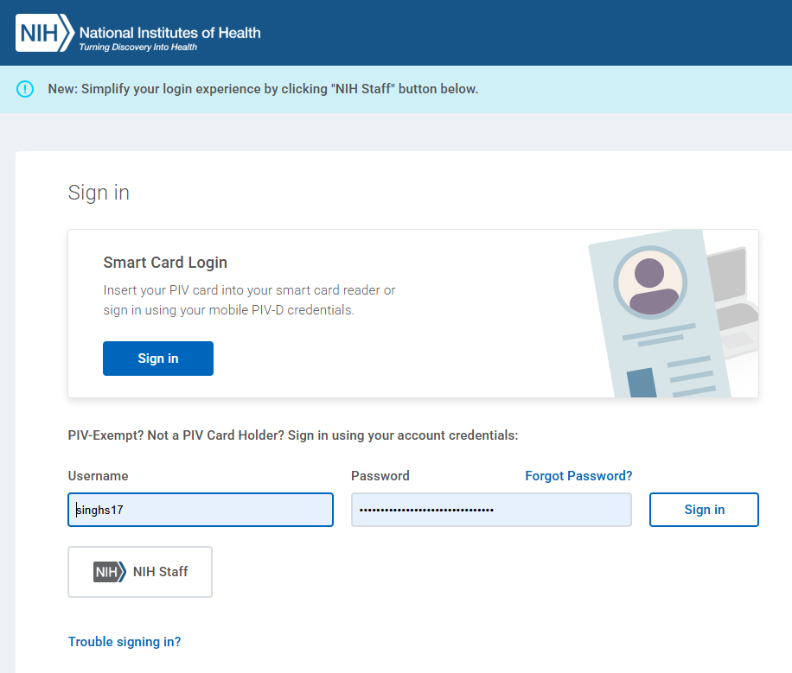
Note: Only authorized users can access the application. Unauthorized users will receive an error message. If you require access, please email ORFDTREFAMIT@mail.nih.gov.

Operator Instructions

1. Role Selection
If you have multiple roles, you will be directed to the Change Role page. Select Operator. Otherwise, you will land directly on the home page.
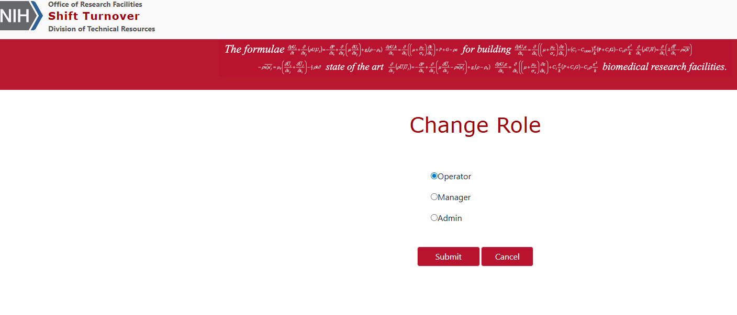

2. Creating a Report
- Navigate to: Manage Log → Safety.
- Fill in the required details.
- Attach supporting documents (if applicable).
- If the issue has already been resolved, check “Yes” under Was the incident resolved?
- Click Submit Form.
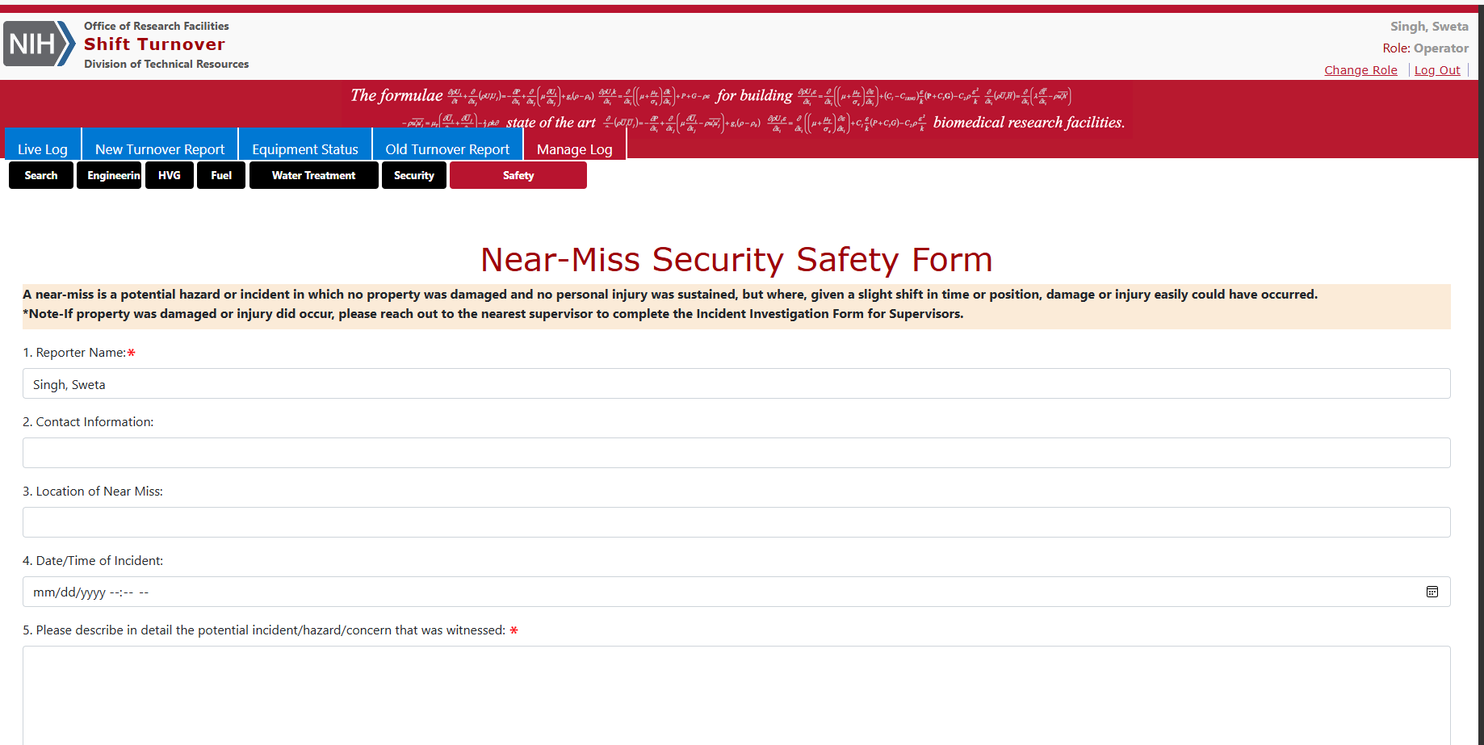

3. Confirmation
A confirmation message will appear, and an email notification will be sent to CUP-Safety@mail.nih.gov.

Manager Instructions

1. Role Selection
Change your role to Manager. Click the third navigation link to view all submitted forms.
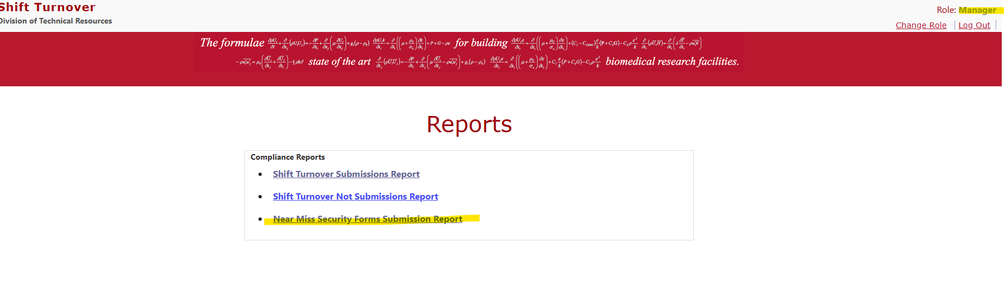

2. Viewing Reports
All submitted forms (including attachments) will be displayed. If the issue was marked as resolved by the Operator, the Resolved column will display the timestamp and Operator’s name. If not resolved, the column will show “No”.
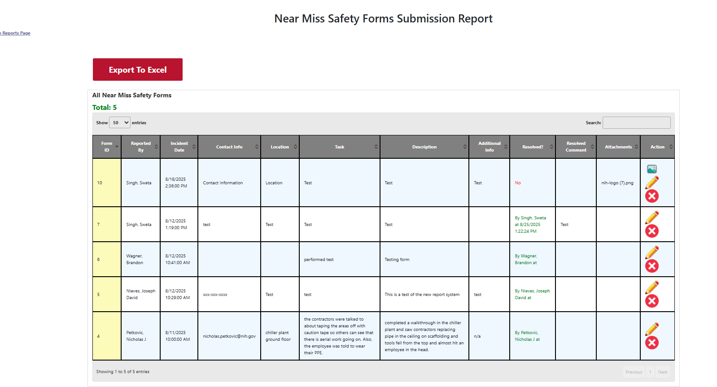

3. Actions Available
In the Action column, three icons are available:
- Download – If attachments exist, clicking this icon will download the file.
- Archive  – Archive the report after confirmation making it View Only.

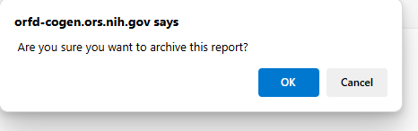
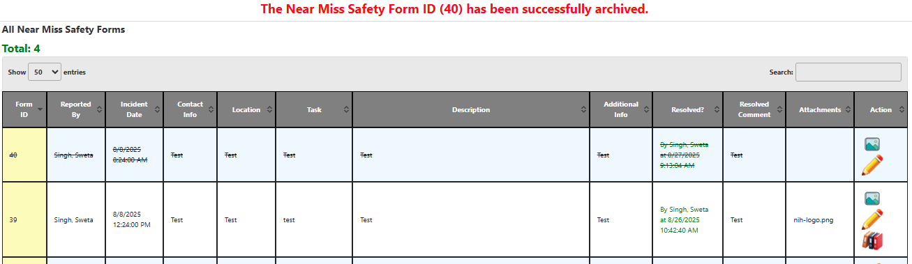
- Edit / Resolve – Opens the report in read-only mode, with the following options at the bottom:
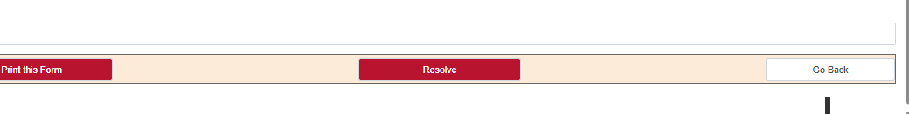
- Go Back – Returns to the listing page.
- Print / Save as PDF – Allows you to save or print the form.
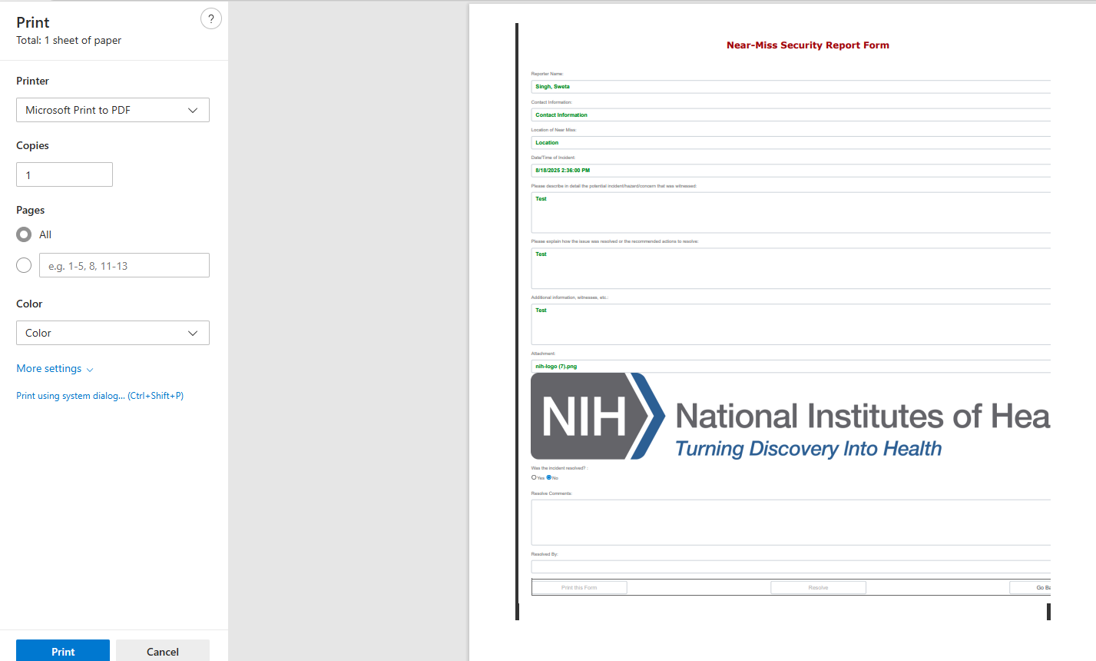
- Resolve – Adds resolution comments and updates the report. (This button is hidden if the issue is already resolved.)
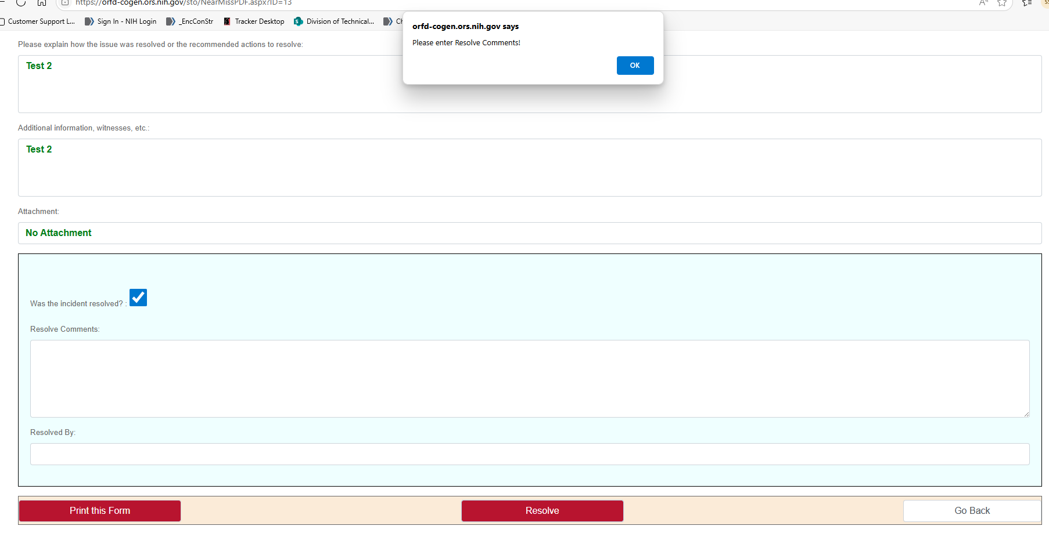

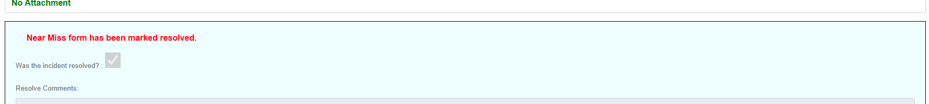

4. Confirmation of Resolution
Once resolved, the Resolved column will display the Manager’s action along with a timestamp.
