**SANA MODULES**

**Software Requirements Specification**

Prepared for

SER 515—Software Enterprise

Instructor: Dr. Kevin Gary

Fall 2015

**Team Members:**

Arpit Jaiswal

Devanshi Panu

Sweta Singhal

Parneet Kaur

Pankhi Prasher

**Table of Contents**

Revision History iii

1. Introduction 1

1.1 Overview 1

1.2 Scope 1

1.3 Purpose 1

2. General Description 1

2.1 Product Perspective 1

2.2 General Constraints 2

3. Analysis Models 2

3.1 Data Model 2

3.2 Flow Diagrams 3

4. Requirements Metadata 5

4.1 Requirement 1 5

4.2 Requirement 2 6

4.3 Requirement 3 6

4.4 Requirement 4 6

4.5 Requirement 5 6

4.6 Requirement 6 7

4.7 Requirement 7 7

4.8 Requirement 8 7

4.9 Requirement 9 8

4.10 Requirement 10 8

4.11 Requirement 11 8

4.12 Requirement 12 8

4.13 Requirement 13 9

4.14 Requirement 14 9

4.15 Requirement 15 9

4.16 Requirement 16 10

4.17 Requirement 17 10

4.18 Requirement 18 10

4.19 Requirement 19 10

4.20 Requirement 20 11

5. Test Plans 11

5. Assumptions and Dependencies 13

6. References 14

7. Glossary 14

# 

# 

# Revision History

|  |  |  |  |
| --- | --- | --- | --- |
| **Date** | **Description** | **Author** | **Comments** |
| 20-11-15 | Version 1 | Sweta Singhal | Initial Draft |
| 22-11-15 | Version 2 | Arpit Jaiswal | Updated document |
| 22-11-15 | Version 3 | Pankhi Prasher | Additions in Document |
| 22-11-15 | Version 4 | Parneet Kaur | Additions in Document |
| 23-11-15 | Version 5 | Sweta Singhal | Updated Traceability for requirements |
| 23-11-15 | Version 6 | Devanshi Panu | Additions |
| 23-11-15 | Version 7 | Pankhi Prasher | Final Version |

# 1. Introduction

## 1.1 Overview

SANA is a cross-disciplinary organization, including clinicians, engineers, policy, public health, and business experts along the entire healthcare value chain. Our approach is to democratize access to quality healthcare through open source technologies, democratize knowledge through the exchange of learning across partners, and to democratize access to global networks of multidisciplinary experts. We believe that geniuses abound in our partner countries, and these geniuses are more likely to develop sustainable and scalable solutions, as they better understand the local problems and environment.

## 1.2 Scope

We aim to modify current SANA mobile client so that patients can utilize the SANA infrastructure on their personal devices. Earlier patients were dependent on nurses to register them and upload their data to OpenMRS. Using the new version of this application, a patient could directly register himself, view notifications from the doctor. SANA app is also integrated with PROMIS pain management app for patients suffering from Sickle Cell disease which allows the patient to take SCD survey and upload it or the doctor to view. To start with we have integrated PROMIS Pain management android application with SANA application. With the OpenMRS which is a medical record system, doctor would be directly able to send notifications to user on its android application.

## 1.3 Purpose

The purpose of this document is to briefly describe the requirements of Sana Modules Integration with PROMIS application. It contains the categorization of requirements into functional and non-functional requirements and identifies attributes of each requirement.

## 2. General Description

The requirements stated below were finalized after having several rounds of group meetings and brainstorming sessions. The ideas were then discussed with Dr. Gary and a final idea was selected to be implemented.

## 2.1 Product Perspective

The product has been designed with the intention to make the SANA app usable for patients so that they don’t have to be dependent on the nurse to use SANA. Also it is integrated with PROMIS app.

## 2.2 General Constraints

*(*1) Design Constraints: This project is made on SANA infrastructure which is an open source application. This project is built from a feasibility study perspective so it might or might not be integrated with the actual SANA application.

(2) Implementation Constraints: The current implementation of the system requires the SCD survey data to be explicitly pushed to OpenMRS. Also the current system demos for the whole functionality for 5 patients.

*(*3) Operating Environment Constraints: This system does not have any operating environment constraints as such and has been tested to work fine on windows, OSX systems, and all major web browsers (Google Chrome, Firefox, Safari, IE).

## 

## 3. Analysis Models

## 3.1 Data Model

**3.1.1 Data Flow Diagram (DFD)**

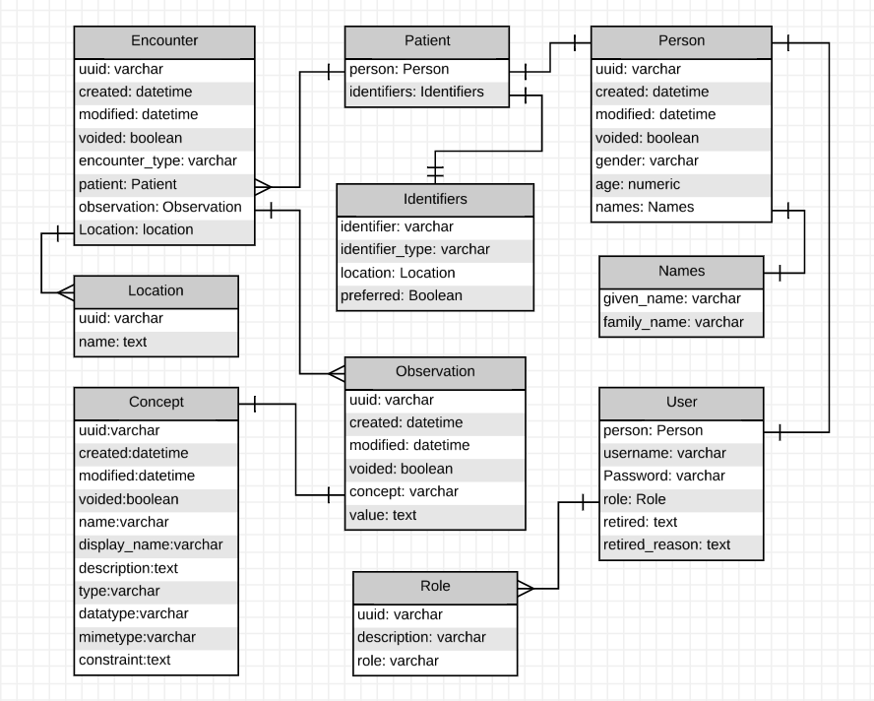

**3.2 Flow Diagrams**

* + 1. **Data Flow Diagram (DFD)**

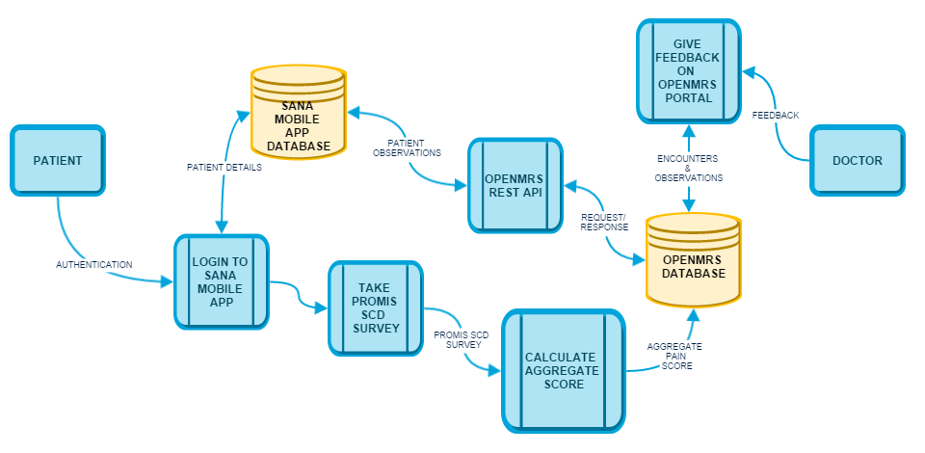

**3.3 Behavioral Diagram**

**3.3.1 USE CASE DIAGRAMS**

* + 1. Use Case Diagram for Patient

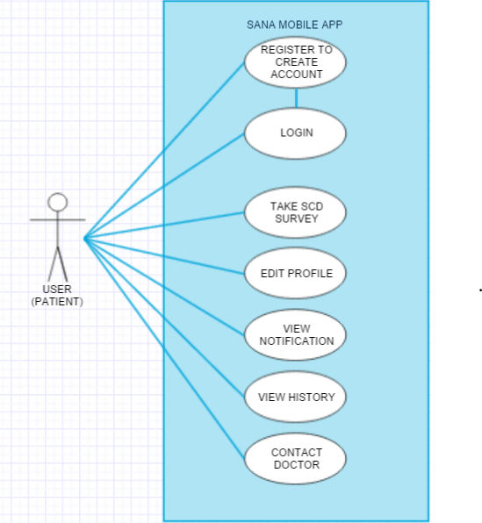

* + 1. Use Case Diagram for Doctor/Clinician

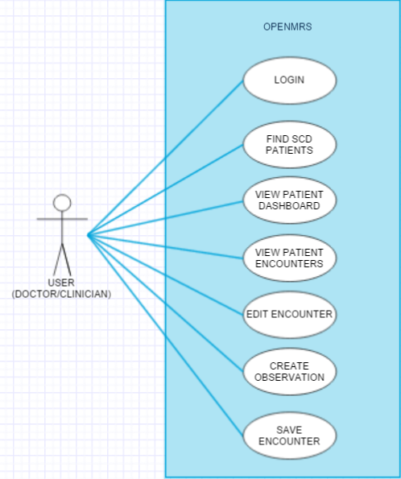

## 4. Requirements Metadata

The requirements for this project have been classified on the basis of the following attributes:

* Verifiable
* Traceable
* Volatile
* Behavior
* Perspective

## 4.1 Requirement 1

As a developer, we want to study SANA so that we can identify areas of contribution.

* Verifiable: Yes
* Traceable: User Story # 2
* Volatile: No
* Behavior: Spike
* Perspective: Developer

*Start Date:* Sep 25, 2015 *End Date: Oct 1, 2015*

## 4.2 Requirement 2

As a developer, we want to understand OpenMRS system so that we can analyze how SANA mobile application is interacting with it.

* Verifiable: Yes
* Traceable: User Story # 3
* Volatile: No
* Behavior: Spike
* Perspective: Developer

*Start Date:* Sep 25, 2015 *End Date: Oct 1, 2015*

## 4.3 Requirement 3

As a developer, we want to study PROMIS model so that we can incorporate its functionalities in SANA.

* Verifiable: Yes
* Traceable: User Story # 1
* Volatile: No
* Behavior: Spike
* Perspective: Developer

*Start Date:* Sep 25, 2015 *End Date: Oct 1, 2015*

## 4.4 Requirement 4

As a user, he will be able to login into Sana mobile app, so that he can take survey.

* Verifiable: Yes
* Traceable: User Story # 10
* Volatile: No
* Behavior: Functional
* Perspective: User

*Start Date:* Oct 2, 2015 *End Date: Oct 17, 2015*

## 4.5 Requirement 5

As a user, he can redirect to PROMIS SCD app from SANA app to take SCD survey.

* Verifiable: Yes
* Traceable: User Story # 11
* Volatile: No
* Behavior: Functional
* Perspective: User

*Start Date:* Oct 2, 2015 *End Date: Oct 17, 2015*

## 4.6 Requirement 6

As a doctor, he can see patient's details on Open MRS, so that he can evaluate patient's reports.

* Verifiable: Yes
* Traceable: User Story # 12
* Volatile: No
* Behavior: Functional
* Perspective: User

*Start Date:* Oct 2, 2015 *End Date: Oct 18, 2015*

## 4.7 Requirement 7

As a doctor, he can access procedures so that he can evaluate survey.

* Verifiable: Yes
* Traceable: User Story # 13
* Volatile: Yes
* Behavior: Functional
* Perspective: User

*Start Date:* Oct 19, 2015 *End Date: Nov 2, 2015*

## 4.8 Requirement 8

As a user, he will be able to edit his profile so that his details will be updated in the database.

* Verifiable: Yes
* Traceable: User Story # 26
* Volatile: No
* Behavior: functional
* Perspective: User

*Start Date:* Oct 22, 2015 *End Date: Oct 28, 2015*

## 4.9 Requirement 9

As a user, he should be able to send data to the doctor via SANA and receive data from the doctor.

* Verifiable: Yes
* Traceable: User Story # 32
* Volatile: No
* Behavior: Functional
* Perspective: User

*Start Date:* Oct 22, 2015 *End Date: Nov 2, 2015*

## 4.10 Requirement 10

As a user he can select the history button so that he can view all past notifications from the doctor

* Verifiable: Yes
* Traceable: User Story # 36
* Volatile: No
* Behavior: Functional
* Perspective: User

*Start Date: Oct* 29, 2015 *End Date: Nov 2, 2015*

## 4.11 Requirement 11

As a user, he will be able to send the data of his survey to the doctor.

* Verifiable: Yes
* Traceable: User Story # 29
* Volatile: No
* Behavior: Functional
* Perspective: User

*Start Date:* Nov 2, 2015 *End Date: Nov 16, 2015*

## 4.12 Requirement 12

As a developer, I can test connection between Open MRS and mobile client so that data can be transferred.

* Verifiable: Yes
* Traceable: User Story # 44
* Volatile: No
* Behavior: Spike
* Perspective: Developer

*Start Date:* Nov 3, 2015 *End Date: Nov 6, 2015*

## 4.13 Requirement 13

As a user, he can view notifications/ recommendation from the doctor so that he can act upon the doctor's advice.

* Verifiable: Yes
* Traceable: User Story # 14
* Volatile: No
* Behavior: Functional
* Perspective: User

*Start Date:* Nov 8, 2015 *End Date: Nov 16, 2015*

## 4.14 Requirement 14

As a developer I can trace the data flow so that I can identify the bug between MDS and Open MRS.

* Verifiable: Yes
* Traceable: User Story # 53
* Volatile: No
* Behavior: Spike
* Perspective: Developer

*Start Date:* Nov 6, 2015 *End Date: Nov 15, 2015*

## 4.15 Requirement 15

As a developer, I can establish to OpenMRS or MDS via mobile client so that data can be sent and retrieved.

* Verifiable: Yes
* Traceable: User Story #55
* Volatile: No
* Behavior: Spike
* Perspective: Developer

*Start Date:* Nov 7, 2015 *End Date: Nov 16, 2015*

## 4.16 Requirement 16

As user he is able to directly connect to Open MRS when he Clicks Notification tab.

* Verifiable: Yes
* Traceable: User Story # 59
* Volatile: No
* Behavior: Functional
* Perspective: User

*Start Date:* Nov 9, 2015 *End Date: Nov 16, 2015*

## 4.17 Requirement 17

As a user, I can view the most recent notifications from the doctor on the screen (outside the application) and in the History tab.

* Verifiable: Yes
* Traceable: User Story # 60
* Volatile: No
* Behavior: Functional
* Perspective: User

*Start Date:* Nov 9, 2015 *End Date: Nov 15, 2015*

## 4.18 Requirement 18

As a tester he can send survey aggregate score from SCD app to openers to test connection.

* Verifiable: Yes
* Traceable: User Story # 65
* Volatile: Yes
* Behavior: Non – functional (Robustness)
* Perspective: User

*Start Date:* Nov 17, 2015 *End Date: Nov 19, 2015*

## 4.19 Requirement 19

As a doctor he can access Open MRS web portal from anywhere so that he can give feedback to patients.

* Verifiable: Yes
* Traceable: User Story # 67
* Volatile: No
* Behavior: Non – functional (Availability)
* Perspective: User

*Start Date:* Nov 17, 2015 *End Date: Nov 18, 2015*

## 4.20 Requirement 20

As a tester check if he can get recent notification from doctor on Mobile Notification Tab.

* Verifiable: Yes
* Traceable: User Story # 66
* Volatile: No
* Behavior: Non – functional (Robustness)
* Perspective: User

*Start Date:* Nov 17, 2015 *End Date: Nov 22, 2015*

## 5. Test Plans

In the following table, the whole description of the possible test plans and expected and actual test results for the project has been made, in addition to this, both of these column here state the actual and the expected results for any test plan that we have executed till now or will are planning to apply in future. In actual results section of future work, nothing can be displayed till the whole system starts running and these tests can be shown to be executed.

|  |  |  |  |
| --- | --- | --- | --- |
| **Test ID** | **Description** | **Expected Results** | **Actual Results** |
| 1. | As a user, he will be able to login into Sana mobile app, so that he can take survey. | User can login after authenticating from the database | Login is done by the user. |
| 2. | As a user, he can redirect to PROMIS SCD app from SANA app to take SCD survey. | The user should be able to take a survey directly from SANA mobile application after logging in. | The user is able to navigate in between the two applications easily to take up the survey. |
| 3. | As a doctor, he can see patient's details on Open MRS, so that he can evaluate patient's reports. | The survey answers for the patients should be displayed on the OPEN MRS so that aggregate score for pain can be calculated. | The survey details can be seen on the Open MRS. |
| 4. | As a doctor, he can access procedures so that he can evaluate survey. | For the doctor to calculate the pain aggregate score of the patient, some procedures should be used by doctor. | This implementation is removed because of the direct linkage between Open MRS and SANA mobile client, so the middle layer of MDS to create procedures is removed. |
| 5. | As a user, he will be able to edit his profile so that his details will be updated in the database. | A separate edit profile button is displayed where the essentials for the patients are asked and after filling them he can go for further actions in the application. | This separate tab for editing a patient's profile is successfully created. |
| 6. | As a user he can select the history button so that he can view all past notifications from the doctor | Previous notifications from the doctor can be read by the patient from the history tab with the respective date and follow up. | A tab appears on the screen where three columns for date, action taken and follow up notifications are displayed. A tab appears on the screen where three columns for date, action taken and follow up notifications are displayed. |
| 7. | As a user, he should be able to send data to the doctor via SANA and receive data from the doctor. | After survey user should see doctor’s comments in sometime. | There were bugs in the MDS, so it has been removed. |
| 8. | As a developer I can trace the data flow so that I can identify the bug between MDS and Open MRS | Identification of code snippet due to which MDS and OPENMRS connection is corrupt via error logs. | The MDS code is incomplete in some parts but the actual code snippet, that is causing the connection to be faulty, could not be found. |
| 9. | As a user, he can view notifications/ recommendation from the doctor so that he can act upon the doctor's advice. | To design a separate tab for the patient to look for doctor's notification in terms of next action to be taken. | Doctors’ sent follow up, date and appropriate action is visible on the screen in SANA application. |
| 10. | As a user, he will be able to send the data of his survey to the doctor. | Data is pushed to SCD server. | Downloaded the PROMIS app and sending data to SCD server. |
| 11. | As a developer, I can establish to Open MRS or MDS via mobile client so that data can be sent and retrieved. | Connection should be established either by MDS or Open MRS and the response should be seen. | Get response through Open MRS. |
| 12. | As user he is able to connect to Open MRS when he Clicks Notification tab. | Data is retrieved from Open MRS to the mobile client. | As a user when notification tab is clicked he can see doctor's observation on mobile. |
| 13. | As a tester he can send survey aggregate score from SCD app to openers to test connection. | The aggregate score should be available on the screen for the patient. | The pain aggregate score is visible on the screen. |
| 14. | As a tester he can get notification of doctors comment on Mobile Notification Tab. | Final unseen notification attained after giving SCD survey by the patient can be viewed on the application. | Actual :The whole integration and compatibility test was done after building the APK. |

## 6. Assumptions and Dependencies

The system depends on OpenMRS and SANA which are open source applications and development is still going on and so there is no source of authentication as per the code on which this system is built upon for the users to rely upon.

## 7. References

(1) <http://sana.mit.edu/>

(2) <http://openmrs.org/>

(3) <https://talk.openmrs.org/>

(4) <https://groups.google.com/forum/#!forum/sana-users>

(5) <https://wiki.openmrs.org/display/docs/Home>

(6) <https://aws.amazon.com/education/>

## 8. Glossary

|  |  |  |
| --- | --- | --- |
| **S.No.** | **Term (word or phrase)** | **Full form or Explanation** |
| 1. | MDS | Mobile Dispatcher Server |
| 2. | SCD | Sickle Cell Disease |
| 3. | PROMIS | Patient Reported Outcomes Measurement Information System |