Playwright typescript Implementation:
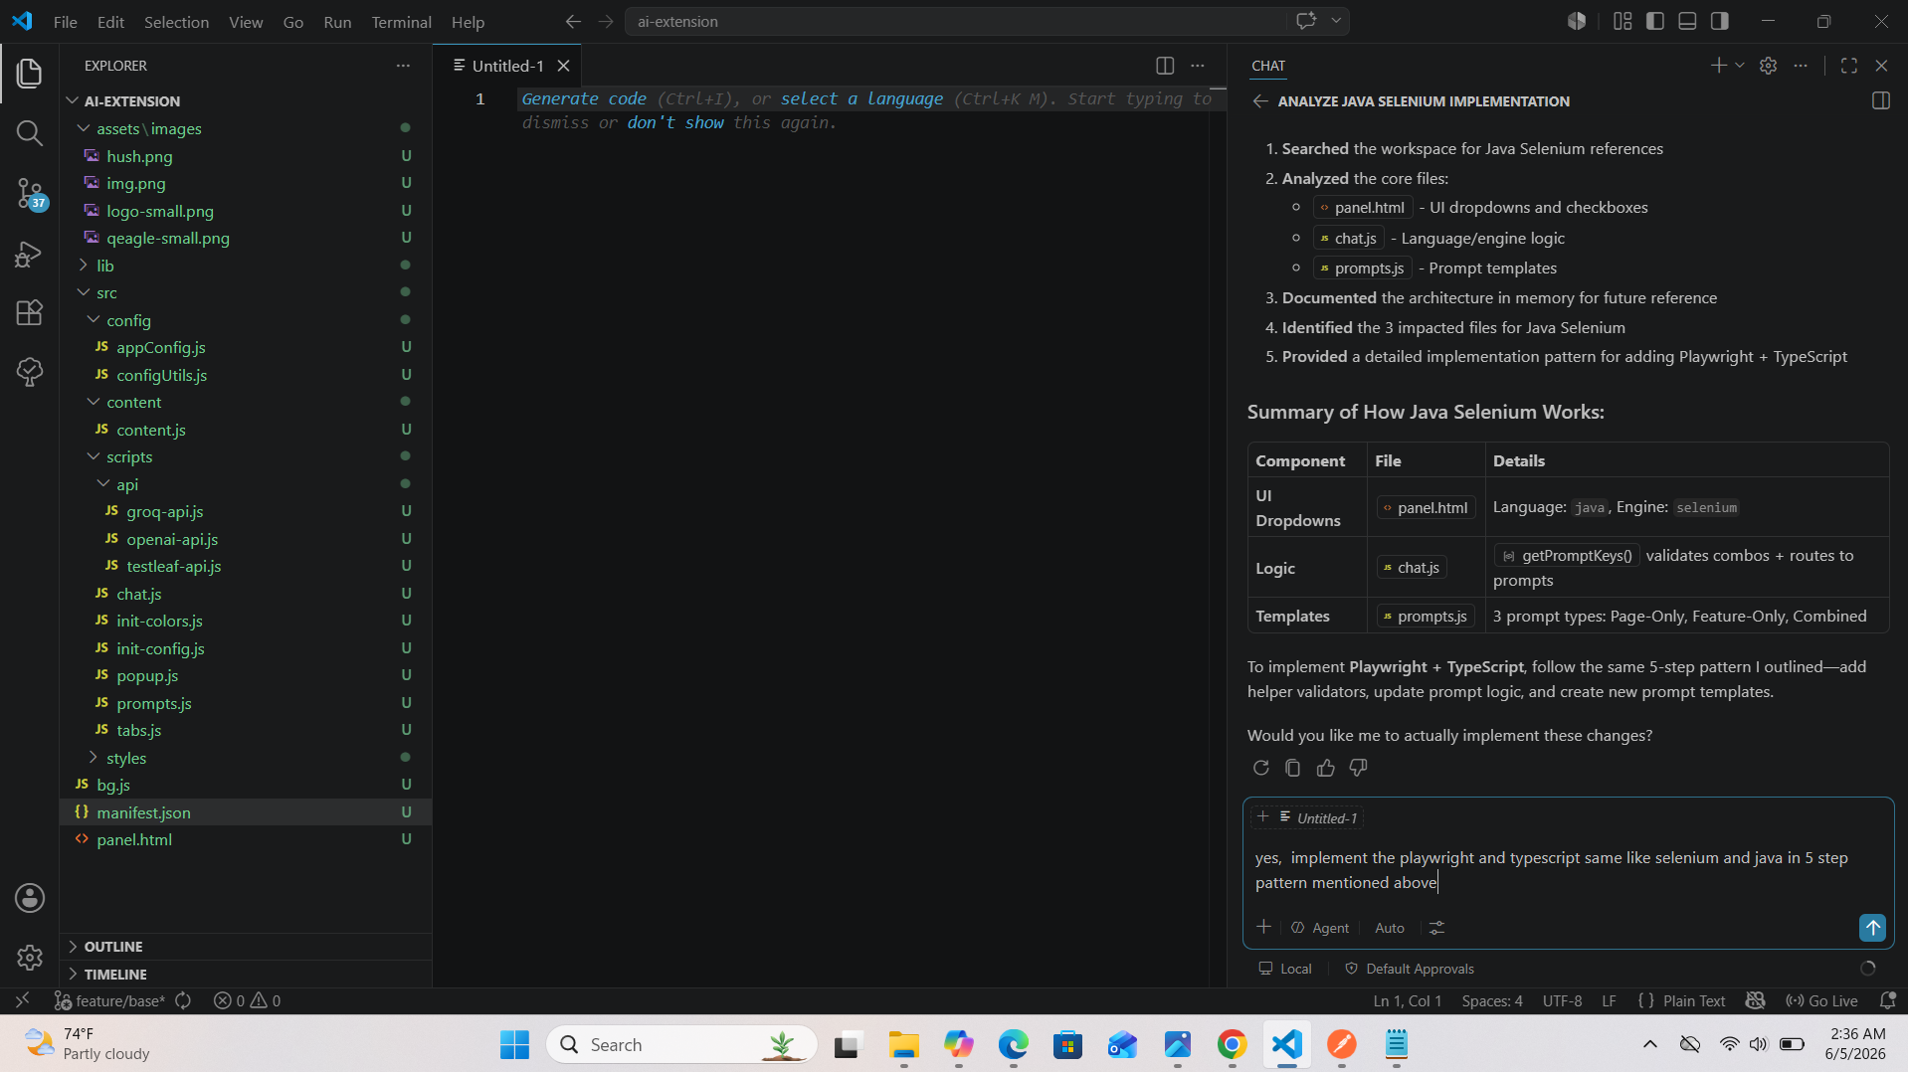
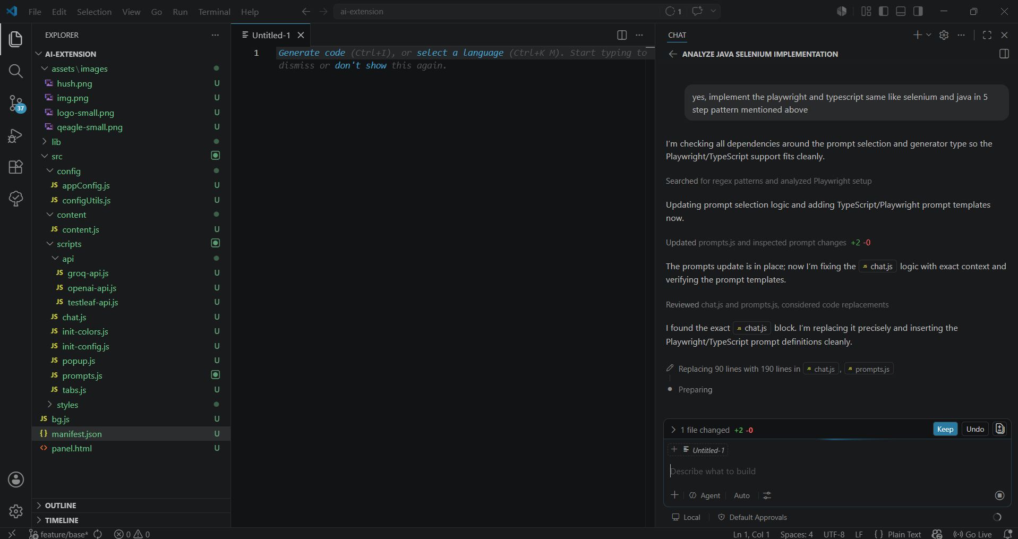
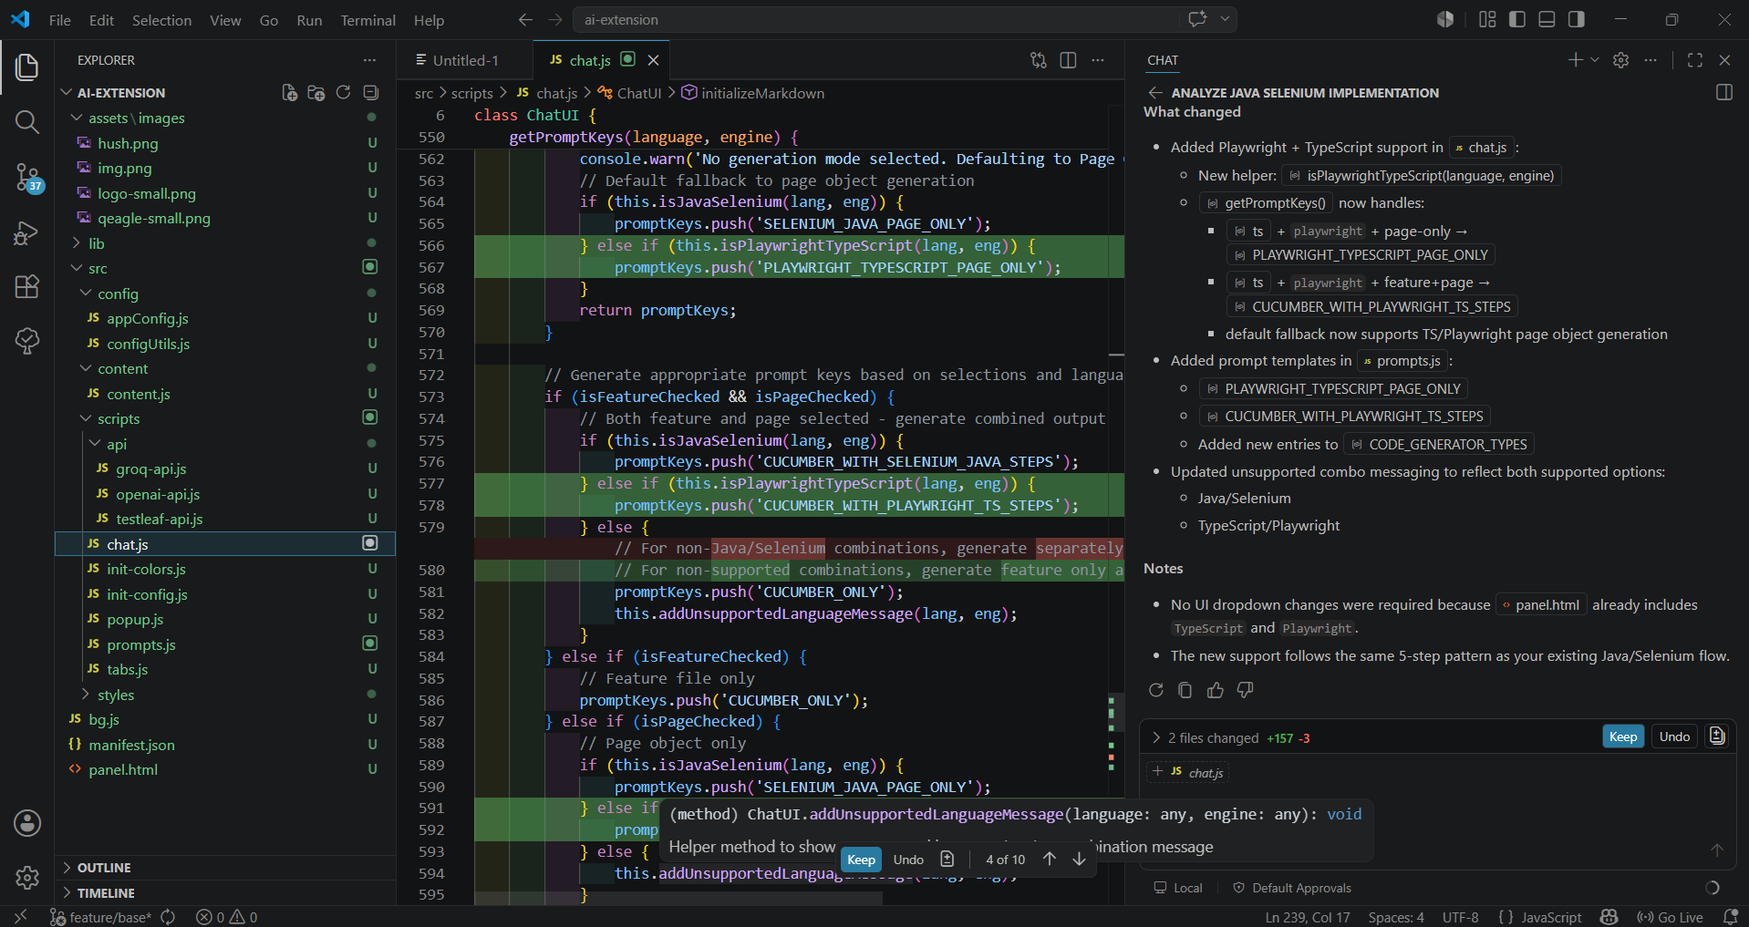
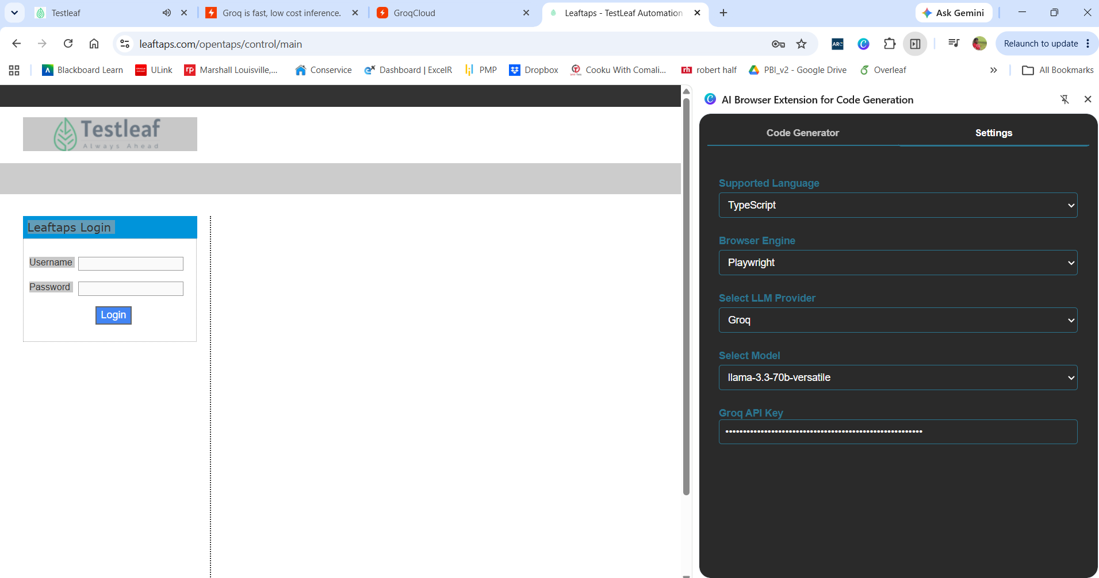
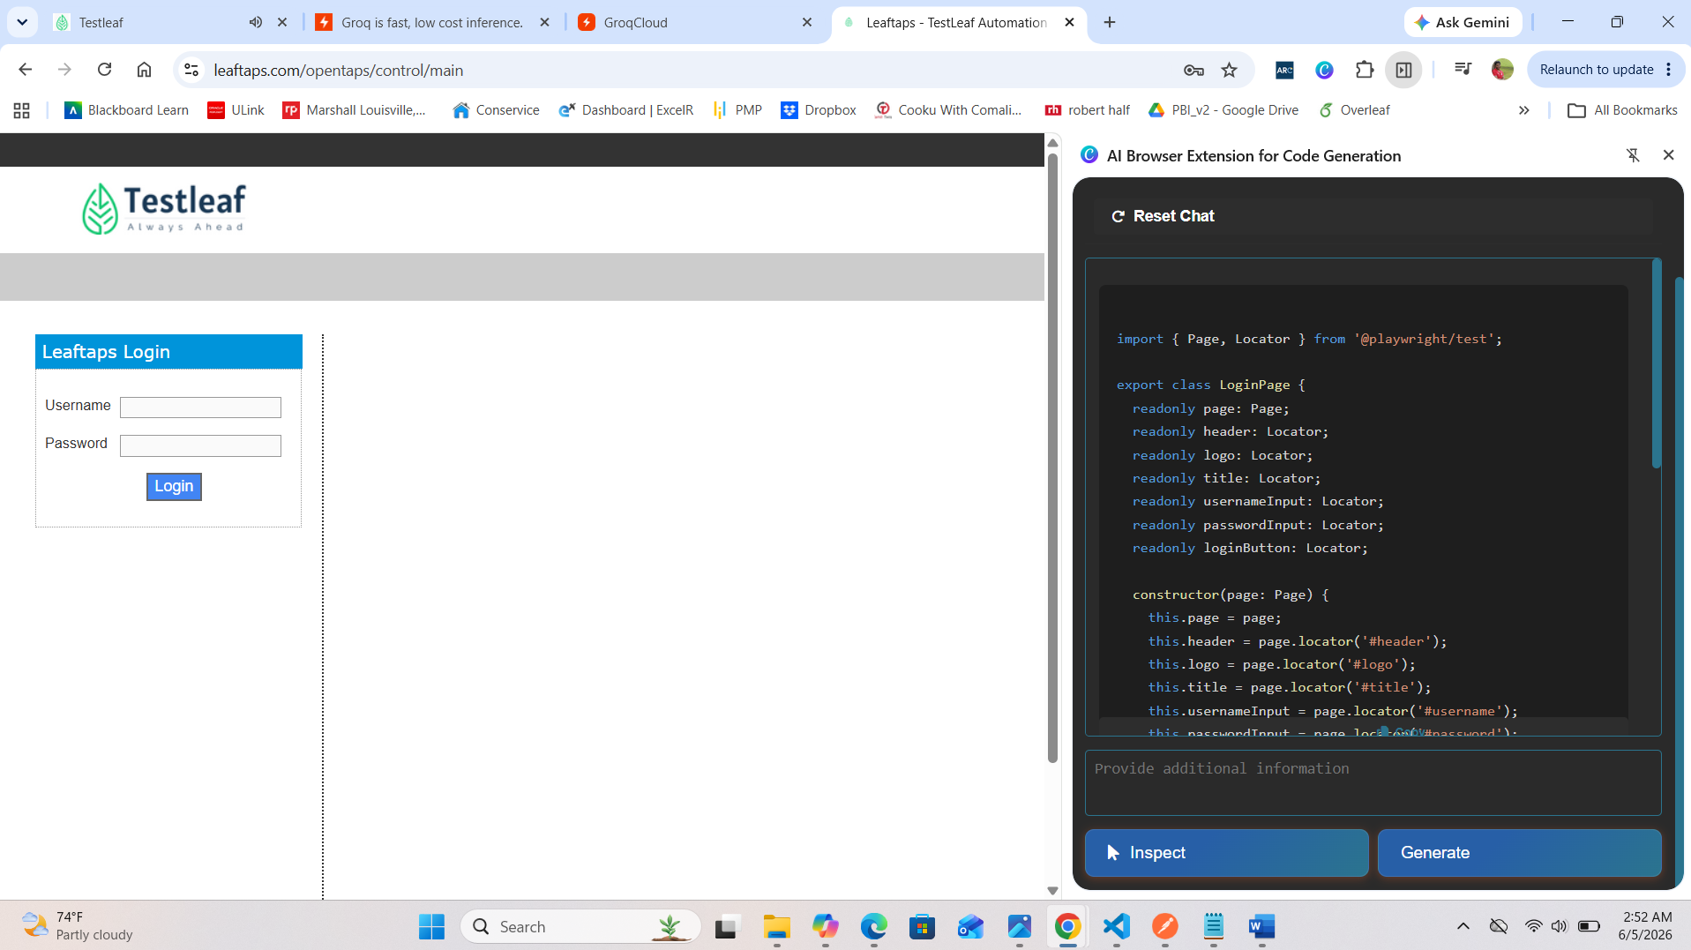

import { Page, Locator } from '@playwright/test';

export class LoginPage {
readonly page: Page;
readonly header: Locator;
readonly logo: Locator;
readonly title: Locator;
readonly usernameInput: Locator;
readonly passwordInput: Locator;
readonly loginButton: Locator;

constructor(page: Page) {
this.page = page;
this.header = page.locator('#header');
this.logo = page.locator('#logo');
this.title = page.locator('#title');
this.usernameInput = page.locator('#username');
this.passwordInput = page.locator('#password');
this.loginButton = page.locator('input[type="submit"]');
}

async navigate() {
await this.page.goto('/opentaps/control/main');
}

async enterUsername(username: string) {
await this.usernameInput.fill(username);
}

async enterPassword(password: string) {
await this.passwordInput.fill(password);
}

async clickLogin() {
await this.loginButton.click();
}

async login(username: string, password: string) {
await this.enterUsername(username);
await this.enterPassword(password);
await this.clickLogin();
}
}

