HW: AI BrowserExtension - With vibe coding generate the testscripts in the language selected
I have a browser extension installed for generating code in that i have selected typescript and playwright using those language help me generate testcase for the story fetched in dropdown as buttons

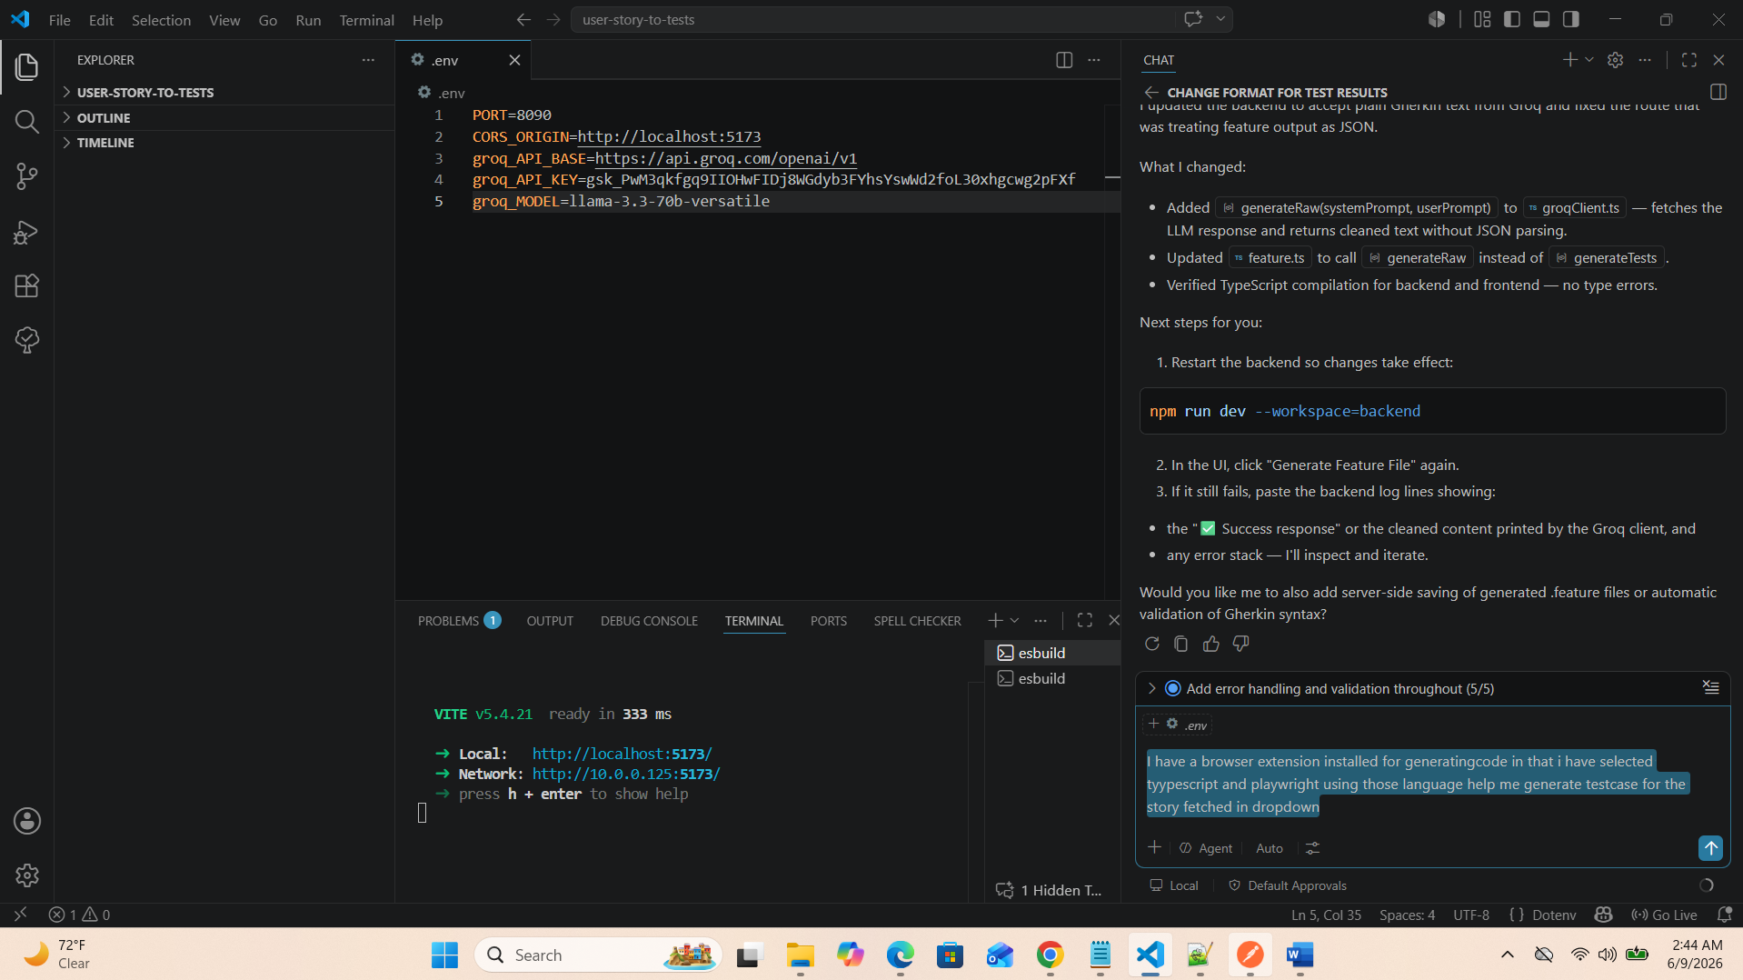
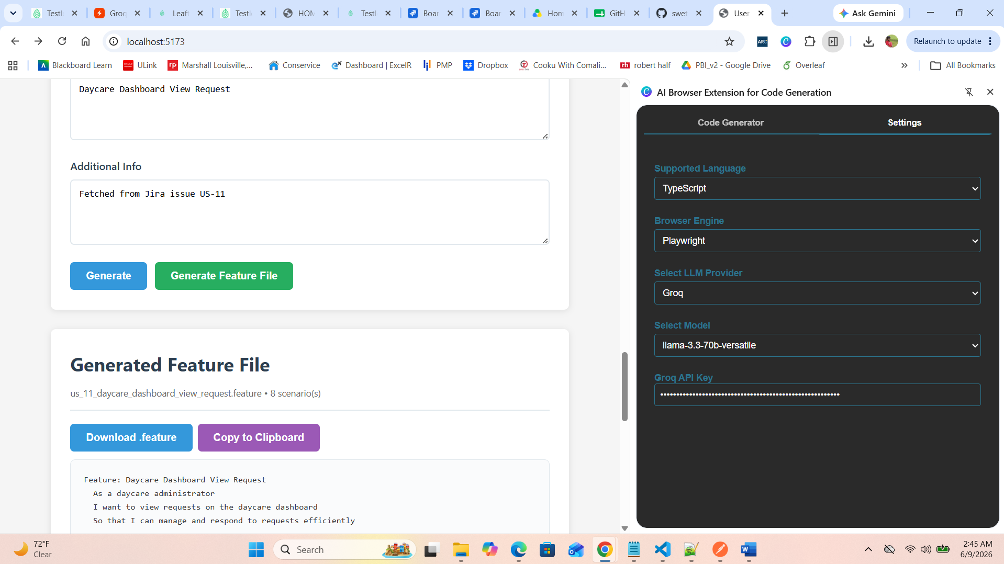
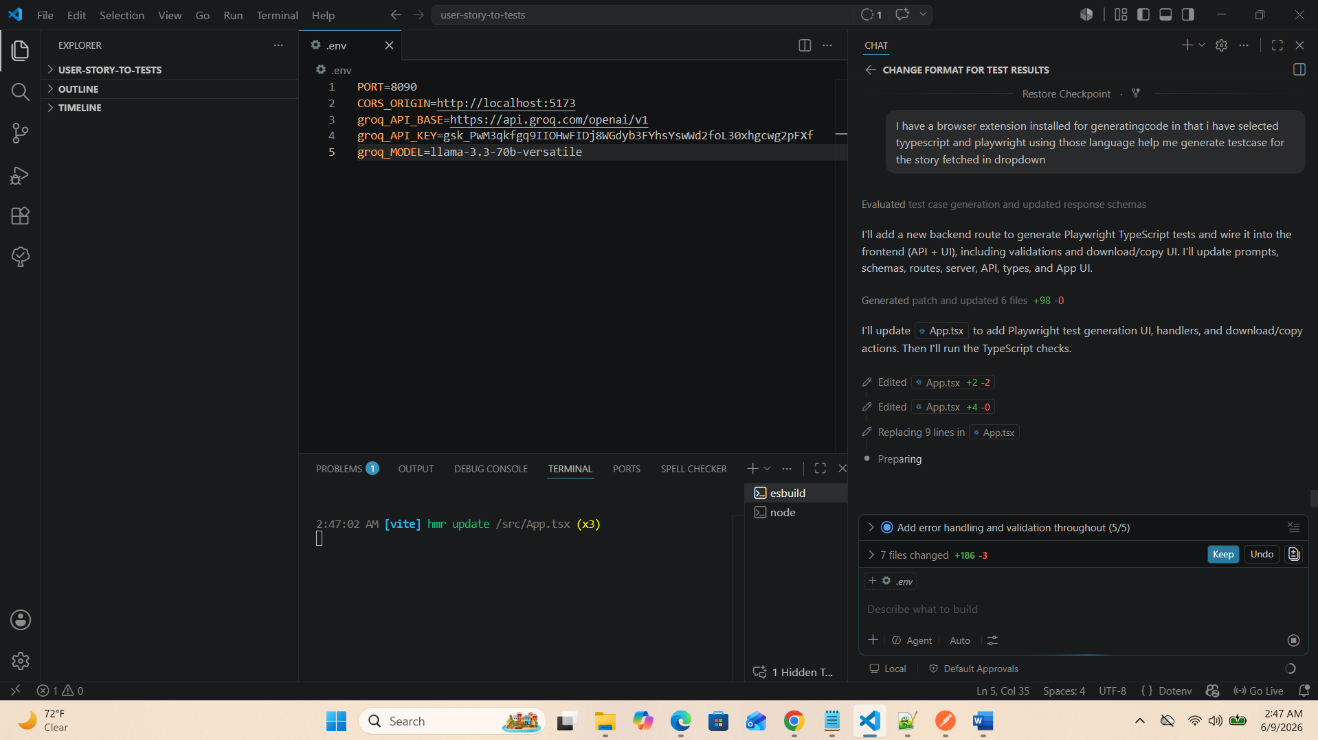
Fix all the open errors, [strict]my flow is connect to jira and list user story as drop-down and then generate testcases and then generate feature file, all these should work fine without breaking. [context] now using browser extension with language selected i need testscripts to be generated based on that language.
[strict] check all backend and frontend errors and fix it
