**EX: 05(1) REG.NO:210701276**

**Design and test various schema models to optimize data storage and retrieval Using Hive Aim:**

To Design and test various schema models to optimize data storage and retrieval Using Hbase.

**Procedure:**

**Step 1: Start Hive**

Open a terminal and start Hive by running:

**$hive**

**Step 2: Create a Database** Create a new database in Hive: **hive>CREATE DATABASE financials;**

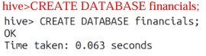

**Step 3: Use the Database:**

Switch to the newly created database: **hive>use financials;**

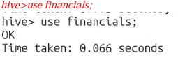

**Step 4: Create a Table:**

Create a simple table in your database: **hive>CREATE TABLE finance_table( id INT, name STRING );**

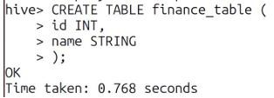

**Step 5: Load Sample Data:**

You can insert sample data into the table: **hive>INSERT INTO finance_tableVALUES (1, 'Alice'), (2, 'Bob'), (3, 'Charlie');**

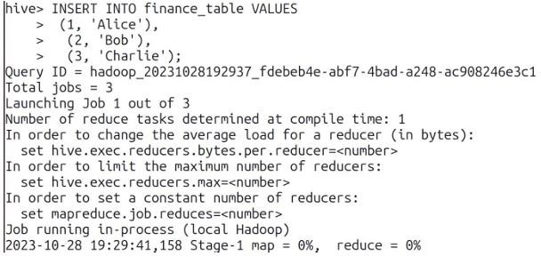

**Step 6: Query Your Data**

Use SQL-like queries to retrieve data from your table:

**hive>CREATE VIEW myview AS SELECT name, id FROM finance_table;**

**Step 7: View the data:**

To see the data in the view, you would need to query the view **hive>SELECT*FROM myview;**

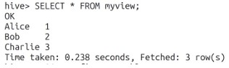

**Step 8: Describe a Table:**

You can describe the structure of a table using the DESCRIBE command: **hive>DESCRIBE finance_table;**

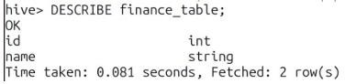

**Step 9: Alter a Table:**

You can alter the table structure by adding a new column: **hive>ALTER TABLE finance_table ADD COLUMNS (age INT);**



**Step 10: Quit Hive:**

To exit the Hive CLI, simply type: **hive>quit;**

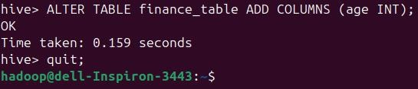

**Result:**

Thus, the usage of various commands in Hive has been successfully completed.