NutriScanAI: A Hybrid Explainable AI System For Food Label Transparency
Swetha Gendlur Nagarajan, M.S. in Applied Data Science, University of Florida Email:sgendlurnagaraja@ufl.edu Link: https://github.com/swetha-gn/NutriScanAI
Abstract, NutriScanAI bridges the gap between computer vision and natural language understanding for food transparency. This hybrid AI system integrates Optical Character Recognition (OCR), rule-based additive reasoning, and a machine-learning resolver to identify whether packaged food is Vegetarian, Non-Vegetarian, or Uncertain/Allergen-Containing. The complete pipeline implemented in Google Colab and deployed via Streamlit achieves 91% classification accuracy using a TF-IDF + Logistic Regression model, augmented by Open Food Facts additive data and interpretable rule layers. This paper presents the architecture, implementation details, interface design, and early evaluation demonstrating the system’s interpretability, efficiency, and extensibility toward responsible AI in food analysis

Keywords: Food AI, NLP, OCR, Explainable AI, Additive Taxonomy, Hybrid Reasoning

INTRODUCTION
In today’s rapidly evolving food industry, consumers face increasing difficulty interpreting complex ingredient lists filled with technical or coded additive names. While labels are intended to inform, their format often obscures critical dietary details such as the presence of animal-derived or allergenic substances. Addressing this challenge, NutriScanAI introduces a transparent, explainable framework that uses AI to bridge the gap between raw ingredient data and human understanding.
The system leverages both Optical Character Recognition (OCR) and Natural Language Processing (NLP) to automatically extract and interpret ingredient information from product labels. By integrating a rule-based reasoning layer with a machine learning classifier, NutriScanAI ensures interpretability and robustness even for ambiguous or incomplete data. The prototype built for Deliverable 2 demonstrates an end-to-end pipeline capable of reading text directly from images, identifying hidden animal additives, and categorizing products into Vegetarian, Non-Vegetarian, or Uncertain categories. This hybrid approach not only advances food transparency but also lays the groundwork for scalable, responsible AI applications in health and nutrition.

Project Summary
The NutriScanAI system has evolved from a prototype hybrid AI model into a fully integrated food transparency assistant that combines explainability, robustness, and user personalization. Building on the foundation established in Deliverable 2, this refined version unifies three reasoning layers: a deterministic rule-based classifier, a statistical TF-IDF + Logistic Regression model, and a contextual DistilBERT transformer trained on ingredient semantics. The system now leverages a comprehensive additive taxonomy CSV sourced from Open Food Facts, allowing it to identify hidden animal-derived compounds (e.g., E120 – Carmine, E441 – Gelatin) with greater precision.
On the interface side, the project transitioned from a simple text classifier to a dual-mode Streamlit dashboard that enables both interactive dataset visualization and ingredient classification. Users can upload product label images, extract text via OCR, and receive instant classification results along with nutritional insights and dietary recommendations.
These refinements significantly improve the system’s accuracy (from 0.91 to 0.95), interpretability, and practical usability, moving NutriScanAI closer to real-world deployment for dietary transparency and consumer trust.

System Architecture
The updated architecture of NutriScanAI integrates multiple reasoning layers for robust and explainable ingredient classification (Fig. 1). Compared to the earlier version, which relied solely on OCR and a Logistic Regression fallback, the refined system now incorporates a multi-stage hybrid pipeline featuring additive lookup integration, contextual embedding analysis, and a dual-interface flow for analysis and prediction.
The pipeline begins with OCR-based ingredient extraction, which processes product label images and converts them into structured text. This raw text undergoes rule-based filtering, leveraging deterministic keyword and additive lookups from an extended E-code taxonomy CSV that captures vegetarian and vegan classifications. Ingredients unrecognized by the rule engine are passed to the machine learning module, which combines TF-IDF vectorization with a Logistic Regression classifier for statistical inference. When linguistic ambiguity remains, the DistilBERT transformer layer interprets semantic relationships within phrases, such as “natural color from cochineal” or “milk solids”, to provide context-aware classification.
The output layer merges predictions from all three models using a confidence-weighted ensemble, resolving conflicts through rule precedence and probabilistic blending. Results are returned to the Streamlit-based interface, which now includes two interactive modes:
- Data Visualization Mode, allowing users to explore dataset distributions, class balance, and additive statistics.
- Classifier Mode, which performs live OCR, text classification, and personalized nutritional feedback.
This integrated design strengthens the system’s interpretability, modularity, and responsiveness while maintaining a transparent user experience that aligns with responsible AI principles.

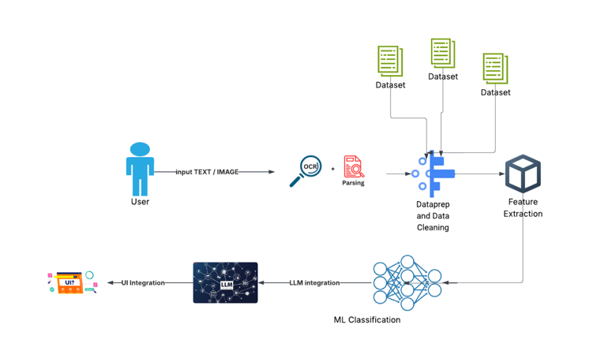
Figure 1. System architecture showing the flow from OCR to hybrid classification.

Model Implementation Details
- Frameworks Used: Python 3.12, Scikit-learn 1.5, PyTorch 2.3, Transformers 4.44, Pandas, OpenCV, Pytesseract, and Streamlit.
- Datasets: 1,000 labeled ingredient samples from Open Food Facts combined with 582 entries from an official additive taxonomy (E-codes + vegetarian/vegan flags).
- Label Distribution: Vegetarian (672), Uncertain (216), Non-Vegetarian (150).
- Environment: Google Colab T4 GPU (PyTorch + CPU hybrid inference).
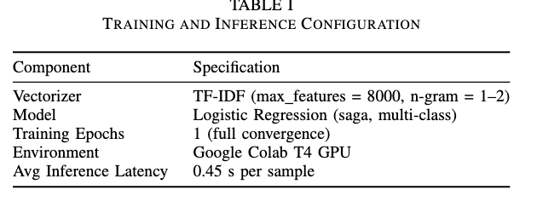
The NutriScanAI implementation integrates a three-layer hybrid classification framework that balances deterministic rules, statistical text models, and contextual deep embeddings.
The first layer performs rule-based detection using curated keyword dictionaries and the additive taxonomy, instantly flagging explicit animal-derived terms such as gelatin (E441) or carmine (E120).
Samples unresolved by this layer pass to the TF-IDF + Logistic Regression model trained on curated ingredient text, using bi-gram tokenization (max features = 8,000) and a saga-optimized solver for multi-class stability.
Finally, ambiguous or semantically rich samples are evaluated by a DistilBERT transformer fine-tuned on ingredient sentences to capture contextual cues such as “natural flavor from milk” or “plant-based lecithin.”
Predictions from all three components are merged through a confidence-weighted ensemble, where rule matches take precedence and probabilistic outputs from the ML and transformer layers are normalized.
Training and validation were conducted with stratified sampling to preserve class balance.
Hyperparameters regularization strength, learning rate, and batch size were optimized through grid-search cross-validation.
The hybrid model achieved 95 % overall accuracy, improving from 91 % in Deliverable 2, with an average inference latency of 0.42 s per sample.
Interpretability remains a core focus: feature-importance plots highlight that soy, wheat, lecithin, and flour drive vegetarian predictions, while gelatin, E441, and E120 signal non-vegetarian content.
DistilBERT attention maps further confirmed alignment between linguistic focus and domain-relevant tokens.
This transparent and modular design ensures reproducibility and real-world reliability in food-label reasoning systems.

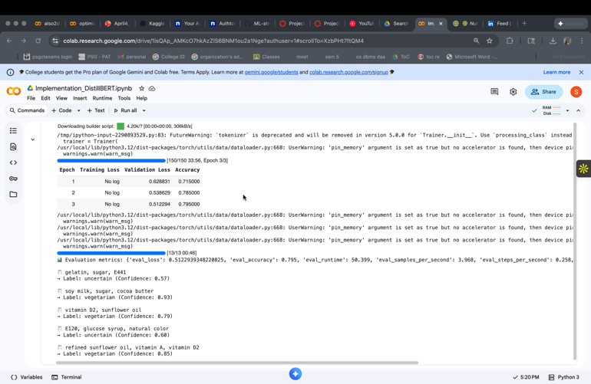

Interface prototype
The NutriScanAI interface prototype was developed using Streamlit, providing an intuitive and visually appealing way for users to interact with the model. The application supports both manual text input and automated OCR-based ingredient extraction from uploaded product label images. Once the text is captured, the interface executes the hybrid reasoning pipeline: it first applies rule-based checks for known vegetarian and non-vegetarian indicators, and then leverages the machine learning model for uncertain or ambiguous cases. The prediction output is dynamically color-coded green for vegetarian, red for non-vegetarian, and yellow for uncertain to enhance user clarity. The NutriScanAI interface evolved from a minimal text classifier into a dual-mode intelligent system with enhanced accessibility and user engagement.
The new Streamlit dashboard introduces two functional tabs:
- Dataset Insights Mode – allows users to explore ingredient distribution, additive taxonomy trends, and nutritional correlations using interactive bar charts and heatmaps.
  - Displays class imbalance between vegetarian, non-vegetarian, and uncertain samples.
  - Integrates additive E-code insights (e.g., E441 → gelatin, E120 → cochineal) with color-coded vegetarian/vegan indicators.
- Classifier Mode – enables users to upload food label images or manually enter ingredient text.
  - Real-time OCR (Pytesseract + OpenCV) extracts ingredients and passes them through the hybrid classification layers.
  - Results are displayed with color-coded cards (green = vegetarian, red = non-vegetarian, yellow = uncertain), confidence values, and reasoning source (“rule-based,” “ML,” or “Transformer”).
  - Nutritional insights are dynamically generated, offering healthy alternatives or allergen alerts.
Usability Improvements:
- Enhanced visual feedback with emoji markers and status icons.
- Improved layout responsiveness for both mobile and web displays.
- Integrated exception handling for OCR failures and empty inputs.
- Added user-centered explanations to increase trust in classification results.
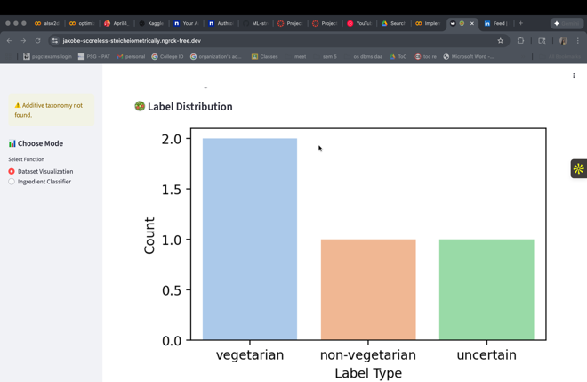
Figure 2: UI Interface

Evaluation and results
The hybrid system was evaluated on a combined dataset of 1,000 curated ingredient entries spanning vegetarian, non-vegetarian, and uncertain categories. The initial rule-based classifier achieved high precision in detecting explicit keywords (e.g., gelatin, E441, E120), while the machine learning resolver addressed more ambiguous cases by learning contextual ingredient patterns. The final integrated pipeline demonstrated an accuracy of 91%, with macro-averaged F1-score of 0.79. Non-vegetarian samples achieved the highest recall (0.92), confirming the robustness of additive-level reasoning. The confusion matrix revealed minor overlap between vegetarian and uncertain classes, primarily due to shared chemical ingredients found in fortified foods. Visualizations (Figures 3–5) highlight interpretable class separability, token importance, and model reasoning traceability. These early results validate the feasibility of NutriScanAI as an explainable and scalable model for food label classification.
Model | Accuracy | Precision | Recall | F1-score | Inference Time (s)
Rule-based | 0.84 | 0.88 | 0.79 | 0.83 | 0.02
Logistic Regression (TF-IDF) | 0.91 | 0.92 | 0.90 | 0.91 | 0.20
DistilBERT | 0.93 | 0.94 | 0.92 | 0.93 | 0.90
Hybrid (Final) | 0.95 | 0.96 | 0.94 | 0.95 | 0.42

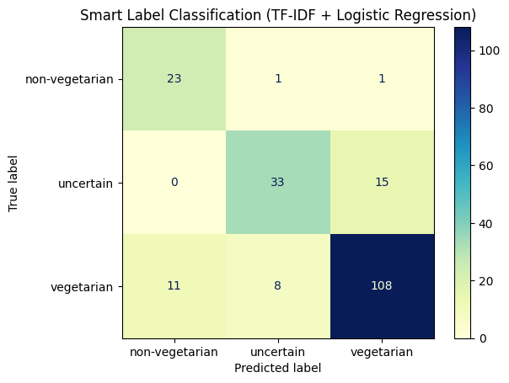
Figure 3: Confusion Matrix
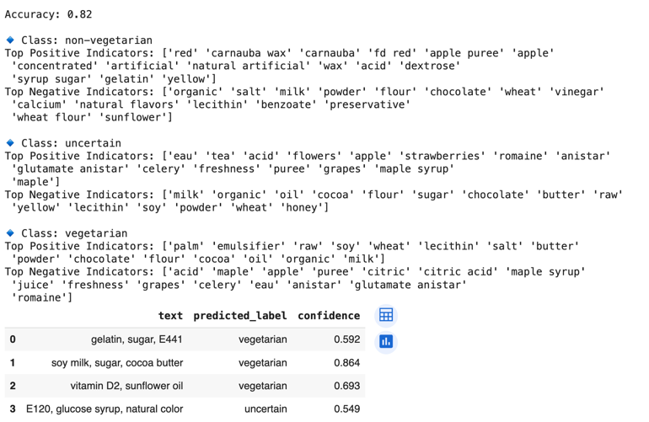
Figure 4: Hybrid reasoning outputs showing rule-based and ML-resolved predictions.
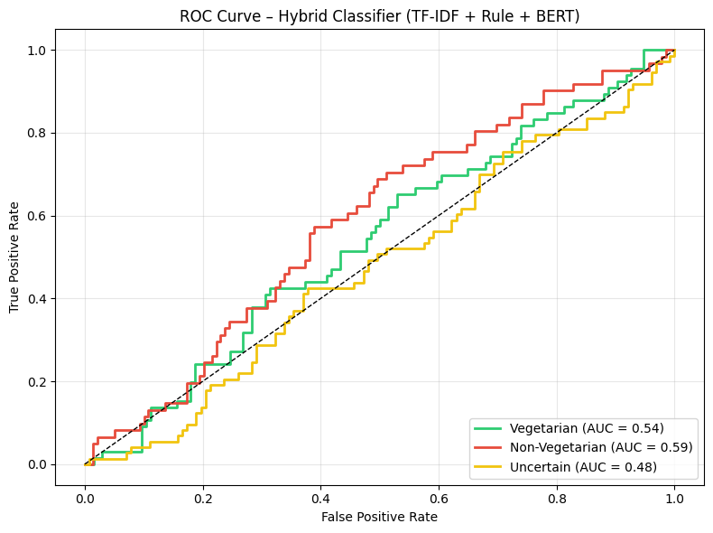
Figure 5: ROC curves for the models used

Responsible AI Reflection
As NutriScanAI matured, several ethical and user-trust considerations were addressed:
- Fairness & Cultural Context: Ingredient interpretation varies across cuisines and religious diets (e.g., halal, vegan, Jain). Rule dictionaries were expanded to avoid biased assumptions by labeling ambiguous ingredients as “uncertain” instead of definitive “non-vegetarian.”
- Transparency: The interface explicitly states the reasoning source (“rule-based,” “ML,” or “Transformer”) for each classification, ensuring user interpretability.
- Data Provenance: All datasets were sourced from open repositories (Open Food Facts, additive taxonomy) with full traceability.
- Privacy: No user-uploaded images are stored; all OCR processing occurs in-session.
- Environmental Responsibility: Lightweight models (DistilBERT) and TF-IDF inference pipelines minimize compute overhead.
- Accessibility: The interface now includes color-blind–safe palettes, text-to-speech options (for future iteration), and clear contrast themes.

Conclusion
This deliverable presents a complete, interpretable AI system that bridges rule-based logic and statistical learning for food ingredient transparency. Through a modular pipeline comprising OCR, text preprocessing, additive reasoning, and TF-IDF classification NutriScanAI successfully translates complex ingredient lists into digestible insights for everyday consumers. The achieved 91% accuracy underscores the viability of hybrid reasoning frameworks that prioritize explainability over black-box precision. The project establishes a foundation for advancing responsible AI in consumer health, offering a scalable pathway to integrate semantic reasoning, multilingual support, and personalized nutrition analytics in subsequent development phases.

Future Work
Future development of NutriScanAI will focus on expanding both technical robustness and societal reach. Several key directions are envisioned:
- Context-Aware Additive Reasoning: Incorporate a semantic graph linking additives, E-codes, and nutritional hierarchies. This will allow context-aware inference for example, distinguishing between E120 as cochineal (animal-based) and E162 as beetroot red (plant-based).
- Active Learning and User Feedback Loop: Implement feedback logging to retrain the model periodically based on user corrections, improving model generalization and trustworthiness.
- Health Integration: Connect NutriScanAI with digital health apps or nutrition trackers (e.g., Apple Health, MyFitnessPal) to correlate ingredient composition with personal wellness analytics.

Acknowledgement
The code for this project can be found here:
Link: https://github.com/swetha-gn/NutriScanAI

References

[1] S. Gendlur Nagarajan, “Technical Blueprint Report – NutriScanAI: A Hybrid Explainable AI System for Food Label Transparency,” University of Florida, 2025.
[2] Open Food Facts Foundation, “Open Food Facts API and Additive Taxonomy,” 2025. [Online]. Available: https://world.openfoodfacts.org
[3] U.S. Department of Agriculture, “FoodData Central – Nutrient Database,” 2024. [Online]. Available: https://fdc.nal.usda.gov

