Bank_Loan_Analysis.R

Admin

2023-10-30

# Load necessary packages

library(naniar)  
library(caTools)  
library(pROC)  
library(ROCR)  
library(ROSE)  
library(corrplot)  
library(gridExtra)  
library(naniar)  
library(forcats)  
library(dplyr)  
library(ggplot2)  
library(ggpubr)  
library(ggthemes)  
  
# Load the dataset  
BankDF <- read.csv("C:/Bank Loan Data/application_data.csv")  
  
# Find and drop columns with too many missing values  
  
miss <- c() # Initialize vector to store columns with too many missing values  
for (i in 1:ncol(BankDF)) {  
 if (sum(is.na(BankDF[, i])) > 140000) {  
 miss <- append(miss, i)   
 }  
}  
  
 BankDF<- BankDF[,-miss]  
 miss2 <- c() # Initialize vector to store rows with too many missing values  
 for (i in 1:nrow(BankDF)) {  
 if (sum(is.na(BankDF[i, ])) > 0.5 * ncol(BankDF)) {  
 miss2 <- append(miss2, i)   
 }  
 }  
   
BankDF<- BankDF[-miss,]  
   
BankDF<- BankDF[,-c(52:71)]  
  
#check how many columns left  
dim(BankDF)

## [1] 307466 57

# Data cleaning: Replace missing values in specific columns  
# Replace missing values in specific columns with a specific value  
BankDF$EMERGENCYSTATE_MODE[is.na(BankDF$EMERGENCYSTATE_MODE)] <- ""  
BankDF$EMERGENCYSTATE_MODE= fct_explicit_na(BankDF$EMERGENCYSTATE_MODE, "Unknown")  
  
BankDF$OCCUPATION_TYPE[is.na(BankDF$OCCUPATION_TYPE)] <- "Unknown"  
BankDF$OCCUPATION_TYPE= fct_explicit_na(BankDF$OCCUPATION_TYPE, "Unknown")  
  
  
BankDF$FONDKAPREMONT_MODE[is.na(BankDF$FONDKAPREMONT_MODE)] <- "Unknown"  
BankDF <- replace_with_na(BankDF, replace = list(FONDKAPREMONT_MODE = "Unknown", HOUSETYPE_MODE = "Unknown", WALLSMATERIAL_MODE = "Unknown"))  
  
BankDF$HOUSETYPE_MODE[is.na(BankDF$HOUSETYPE_MODE)] <- "Unknown"  
BankDF$HOUSETYPE_MODE = fct_explicit_na(BankDF$HOUSETYPE_MODE, "Unknown")  
  
BankDF$WALLSMATERIAL_MODE[is.na(BankDF$WALLSMATERIAL_MODE)] <- "Unknown"  
BankDF$WALLSMATERIAL_MODE = fct_explicit_na(BankDF$WALLSMATERIAL_MODE, "Unknown")  
  
# Extract numeric columns for replacement with mean  
numeric_cols <- sapply(BankDF, is.numeric)  
  
# Replace missing values with mean in numeric columns  
for(i in 1:ncol(BankDF)) {   
 if(numeric_cols[i]) {  
 BankDF[, i][is.na(BankDF[, i])] <- mean(BankDF[, i], na.rm = TRUE)  
 }  
}  
  
# Transform specific columns  
BankDF$DAYS_BIRTH<-BankDF$DAYS_BIRTH*-1  
BankDF$DAYS_EMPLOYED<-BankDF$DAYS_EMPLOYED*-1  
BankDF$DAYS_REGISTRATION<-BankDF$DAYS_REGISTRATION*-1  
BankDF$DAYS_ID_PUBLISH<-BankDF$DAYS_ID_PUBLISH*-1  
BankDF$DAYS_LAST_PHONE_CHANGE<-BankDF$DAYS_LAST_PHONE_CHANGE*-1  
bins = c(0,350000,700000,1000000000)  
slots = c('Low','Medium','High')  
  
#Creating bins for Credit amount  
BankDF['AMT_CREDIT_RANGE']=cut(BankDF$AMT_CREDIT,breaks=c(0,350000,700000,1000000000),labels=slots)  
bins = c(0,200000,400000,10000000000)  
slots = c('Low','Medium','High')  
  
# Creating bins for income amount  
BankDF['AMT_INCOME_RANGE']=cut(BankDF$AMT_INCOME_TOTAL,breaks=c(0,200000,400000,10000000000),labels=slots)  
bins = c(0,7300,10950,14600,18250,21900,25500)  
slots <- c('0-20','20-30','30-40','40-50','50-60','60-70')  
BankDF$AGE_RANGE <- cut(BankDF$DAYS_BIRTH, breaks = c(0,7300,10950,14600,18250,21900,25500), labels = slots)  
BankDF <- distinct(BankDF)  
  
# Finding and counting the duplicated rows in the dataset  
sum(duplicated(BankDF))

## [1] 0

# Counting the total number of missing values in the dataset  
sum(is.na(BankDF))

## [1] 0

# Displaying the dimensions of the dataset (rows and columns)  
dim(BankDF)

## [1] 307466 60

# Creating a table of proportions for the 'TARGET' variable  
prop.table(table(BankDF$TARGET))

##   
## 0 1   
## 0.91926262 0.08073738

# Removing unnecessary columns and storing the modified dataset in 'df'  
df= select(BankDF,-1,-31,)  
  
  
#Checking for missing values

# Total number of missing values in the dataset  
cat("The total number of missing values in the dataset is" , sum(is.na(BankDF)))

## The total number of missing values in the dataset is 0

colSums(is.na(BankDF))

## SK_ID_CURR TARGET   
## 0 0   
## NAME_CONTRACT_TYPE CODE_GENDER   
## 0 0   
## FLAG_OWN_CAR FLAG_OWN_REALTY   
## 0 0   
## CNT_CHILDREN AMT_INCOME_TOTAL   
## 0 0   
## AMT_CREDIT AMT_ANNUITY   
## 0 0   
## AMT_GOODS_PRICE NAME_TYPE_SUITE   
## 0 0   
## NAME_INCOME_TYPE NAME_EDUCATION_TYPE   
## 0 0   
## NAME_FAMILY_STATUS NAME_HOUSING_TYPE   
## 0 0   
## REGION_POPULATION_RELATIVE DAYS_BIRTH   
## 0 0   
## DAYS_EMPLOYED DAYS_REGISTRATION   
## 0 0   
## DAYS_ID_PUBLISH FLAG_MOBIL   
## 0 0   
## FLAG_EMP_PHONE FLAG_WORK_PHONE   
## 0 0   
## FLAG_CONT_MOBILE FLAG_PHONE   
## 0 0   
## FLAG_EMAIL OCCUPATION_TYPE   
## 0 0   
## CNT_FAM_MEMBERS REGION_RATING_CLIENT   
## 0 0   
## REGION_RATING_CLIENT_W_CITY WEEKDAY_APPR_PROCESS_START   
## 0 0   
## HOUR_APPR_PROCESS_START REG_REGION_NOT_LIVE_REGION   
## 0 0   
## REG_REGION_NOT_WORK_REGION LIVE_REGION_NOT_WORK_REGION   
## 0 0   
## REG_CITY_NOT_LIVE_CITY REG_CITY_NOT_WORK_CITY   
## 0 0   
## LIVE_CITY_NOT_WORK_CITY ORGANIZATION_TYPE   
## 0 0   
## EXT_SOURCE_2 EXT_SOURCE_3   
## 0 0   
## FONDKAPREMONT_MODE HOUSETYPE_MODE   
## 0 0   
## WALLSMATERIAL_MODE EMERGENCYSTATE_MODE   
## 0 0   
## OBS_30_CNT_SOCIAL_CIRCLE DEF_30_CNT_SOCIAL_CIRCLE   
## 0 0   
## OBS_60_CNT_SOCIAL_CIRCLE DEF_60_CNT_SOCIAL_CIRCLE   
## 0 0   
## DAYS_LAST_PHONE_CHANGE AMT_REQ_CREDIT_BUREAU_HOUR   
## 0 0   
## AMT_REQ_CREDIT_BUREAU_DAY AMT_REQ_CREDIT_BUREAU_WEEK   
## 0 0   
## AMT_REQ_CREDIT_BUREAU_MON AMT_REQ_CREDIT_BUREAU_QRT   
## 0 0   
## AMT_REQ_CREDIT_BUREAU_YEAR AMT_CREDIT_RANGE   
## 0 0   
## AMT_INCOME_RANGE AGE_RANGE   
## 0 0

View(BankDF)  
  
#Univariate Analysis

# Creating plots for analyzing individual variables in the dataset  
   
# Creating a bar plot to visualize the distribution of genders in the 'BankDF' dataset  
genderplot<-ggplot(data=BankDF,aes(x=CODE_GENDER,fill=CODE_GENDER)) +  
geom_bar(stat="count") + ggtitle('Gender')+  
theme(plot.title = element_text (hjust = 0.5)) + theme(legend.position="none") + xlab('') + ylab ('')  
  
# Creating a bar plot to explore the distribution of credit amount ranges in 'BankDF'  
AMT_CREDITRANGEplot<-ggplot(data=BankDF,aes(x=factor(AMT_CREDIT_RANGE, level=c('Low','Medium','High')),fill=AMT_CREDIT_RANGE))+  
geom_bar(stat="count") + ggtitle('Credit Amount (Range)') +   
theme(plot.title = element_text (hjust = 0.5)) + theme(legend.position="none") + xlab('') + ylab ('')  
  
# Creating a bar plot to analyze the distribution of income amount ranges in 'BankDF'  
AMT_INCOME_RANGEplot<-ggplot(data=BankDF,aes(x=factor(AMT_INCOME_RANGE, level=c('Low','Medium','High')),fill=AMT_INCOME_RANGE))+  
geom_bar(stat="count") + ggtitle('Income Amount (Range)') +   
theme(plot.title = element_text (hjust = 0.5)) + theme(legend.position="none") + xlab('') + ylab ('')  
  
# Creating a bar plot to visualize the distribution of age ranges in 'BankDF'  
AGE_RANGEplot<-ggplot(data=BankDF,aes(x=AGE_RANGE,fill=AGE_RANGE))+   
#scale_fill_manual(values = c("#F8766D","#A3A500","#00BF7D","#00B0F6","#E76BF3"))+  
geom_bar(stat="count") + ggtitle('Age Range') +  
theme(plot.title = element_text (hjust = 0.5)) + theme(legend.position="none") + xlab('') + ylab ('')  
  
# Arranging individual plots in a grid layout for comparative analysis  
p1 <- ggarrange(genderplot, AMT_INCOME_RANGEplot,  
 ncol = 1, nrow = 2)  
p2 <- ggarrange(AGE_RANGEplot, AMT_CREDITRANGEplot,   
 ncol = 1, nrow = 2)  
ggarrange(p1, p2, ncol = 2, nrow = 1)

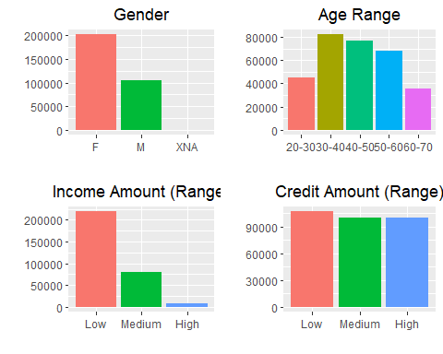

#INCOME TYPE,EDUCATION TYPE, FAMILY STATUS, HOUSING TYPE, OCCUPATION TYPE

# Analysis of Categorical Variables  
# Visualizing different categorical variables within the dataset  
   
# Creating a bar plot to analyze the distribution of income types in the 'BankDF' dataset  
incometypeplot <- ggplot(data = BankDF, aes(x = NAME_INCOME_TYPE, fill = NAME_INCOME_TYPE)) +  
 geom_bar(stat = "count") + ggtitle('Types of Income') +  
 theme(plot.title = element_text(hjust = 0.5)) +  
 theme(legend.position = "none") + xlab('') + ylab('')  
  
# Creating a bar plot to examine the distribution of education types in 'BankDF'  
edutypeplot <- ggplot(data = BankDF, aes(x = NAME_EDUCATION_TYPE, fill = NAME_EDUCATION_TYPE)) +  
 geom_bar(stat = "count") + ggtitle('Types of Education') +  
 theme(plot.title = element_text(hjust = 0.5)) +  
 theme(legend.position = "none") + xlab('') + ylab('')  
  
# Creating a bar plot to explore the distribution of marital statuses in the dataset  
marriagetypeplot <- ggplot(data = BankDF, aes(x = NAME_FAMILY_STATUS, fill = NAME_FAMILY_STATUS)) +  
 geom_bar(stat = "count") + ggtitle('Marital Status') +  
 theme(plot.title = element_text(hjust = 0.5)) +  
 theme(legend.position = "none") + xlab('') + ylab('')  
  
# Creating a bar plot to visualize the distribution of housing types  
housetypeplot <- ggplot(data = BankDF, aes(x = NAME_HOUSING_TYPE, fill = NAME_HOUSING_TYPE)) +  
 geom_bar(stat = "count") + ggtitle('Types of Housing') +  
 theme(plot.title = element_text(hjust = 0.5)) +  
 theme(legend.position = "none") + xlab('') + ylab('')  
  
# Creating a bar plot to analyze the distribution of occupation types  
worktypeplot <- ggplot(data = BankDF, aes(x = OCCUPATION_TYPE, fill = OCCUPATION_TYPE)) +  
 geom_bar(stat = "count") + ggtitle('Types of Occupation') +  
 theme(plot.title = element_text(hjust = 0.5)) +  
 theme(legend.position = "none") + xlab('') + ylab('')  
  
# Arranging the plots for income, education, marital status, housing, and occupation types  
p3 <- ggarrange(incometypeplot, edutypeplot,  
 ncol = 1, nrow = 2)  
p4 <- ggarrange(marriagetypeplot, housetypeplot,  
 ncol = 1, nrow = 2)  
ggarrange(p3, p4, ncol = 2, nrow = 1)

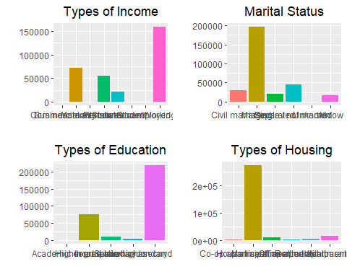

# Additional visualization: Plotting the occupation type with vertical categories for better display  
worktypeplot + coord_flip()

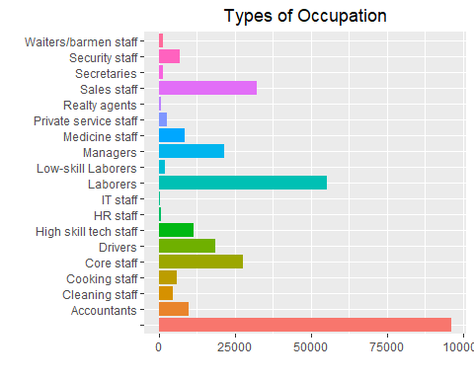

# Bivariate analysis

# Exploratory Data Analysis - Visualizing Relationships between Different Variables and the Target  
   
 # AGE and Gender vs. TARGET  
 # Plotting the distribution of 'AGE_RANGE' by 'TARGET' and 'CODE_GENDER' by 'TARGET' in two separate bar plots  
 par(mfrow = c(2, 1))  
  
# Visualization of 'AGE_RANGE' by 'TARGET'  
BankDF1 <- with(BankDF, table(TARGET, AGE_RANGE))  
barplot(BankDF1, beside = TRUE, legend = TRUE, args.legend = list(x = "topright", inset = c(-0.05, 0)),  
 col = c("Red", "Green"), xlab = "AGE_RANGE", ylab = "Values",  
 main = "Target=0: No Payment issue, Target=1: Payment issue")  
  
# Visualization of 'CODE_GENDER' by 'TARGET'  
BankDF2 <- with(BankDF, table(TARGET, CODE_GENDER))  
barplot(BankDF2, beside = TRUE, legend = TRUE, col = c("Red", "Green"), args.legend = list(x = "topright", inset = c(-0.05, 0)),  
 xlab = "CODE_GENDER", ylab = "Values",  
 main = "Target=0: No Payment issue, Target=1: Payment issue")

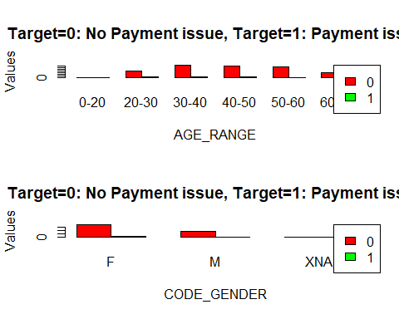

# Amount of Credit (loan), Income type, and Amount of Income vs. TARGET  
par(mfrow = c(3, 1))  
  
# Visualizing 'AMT_CREDIT_RANGE' by 'TARGET'  
BankDF3 <- with(BankDF, table(TARGET, AMT_CREDIT_RANGE))  
barplot(BankDF3, beside = TRUE, legend = TRUE, args.legend = list(x = "topright", inset = c(0, 0)),  
 col = c("Red", "Green"), xlab = "Amount of Credit(Loan)", ylab = "Values",  
 main = "Target=0: No Payment issue, Target=1: Payment issue")  
  
# Visualizing 'NAME_INCOME_TYPE' by 'TARGET'  
BankDF4 <- with(BankDF, table(TARGET, NAME_INCOME_TYPE))  
barplot(BankDF4, beside = TRUE, legend = TRUE, args.legend = list(x = "topright", inset = c(0, 0)),  
 col = c("Red", "Green"), xlab = "NAME_INCOME_TYPE", ylab = "Values",  
 main = "Target=0: No Payment issue, Target=1: Payment issue")  
  
# Visualizing 'AMT_INCOME_RANGE' by 'TARGET'  
BankDF5 <- with(BankDF, table(TARGET, AMT_INCOME_RANGE))  
barplot(BankDF5, beside = TRUE, legend = TRUE, args.legend = list(x = "topright", inset = c(0, 0)),  
 col = c("Red", "Green"), xlab = "AMT_INCOME_RANGE", ylab = "Values",  
 main = "Target=0: No Payment issue, Target=1: Payment issue")

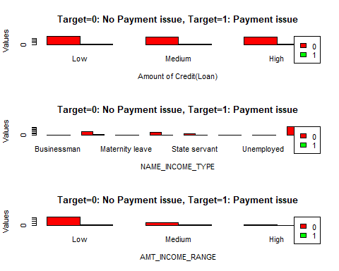

# Types of Education, Marital Status, and Types of Housing vs. TARGET  
par(mfrow = c(3, 1))  
  
# Visualizing 'NAME_EDUCATION_TYPE' by 'TARGET'  
BankDF6 <- with(BankDF, table(TARGET, NAME_EDUCATION_TYPE))  
barplot(BankDF6, beside = TRUE, legend = TRUE, args.legend = list(x = "topright", inset = c(0, 0)),  
 col = c("Red", "Green"), xlab = "Types of Education", ylab = "Values",  
 main = "Target=0: No Payment issue, Target=1: Payment issue")  
  
# Visualizing 'NAME_FAMILY_STATUS' by 'TARGET'  
BankDF7 <- with(BankDF, table(TARGET, NAME_FAMILY_STATUS))  
barplot(BankDF7, beside = TRUE, legend = TRUE, args.legend = list(x = "topright", inset = c(0, 0)),  
 col = c("Red", "Green"), xlab = "Marital Status", ylab = "Values",  
 main = "Target=0: No Payment issue, Target=1: Payment issue")  
  
# Visualizing 'NAME_HOUSING_TYPE' by 'TARGET'  
BankDF8 <- with(BankDF, table(TARGET, NAME_HOUSING_TYPE))  
barplot(BankDF8, beside = TRUE, legend = TRUE, args.legend = list(x = "topright", inset = c(0, 0)),  
 col = c("Red", "Green"), xlab = "Types of Housing", ylab = "Values",  
 main = "Target=0: No Payment issue, Target=1: Payment issue")

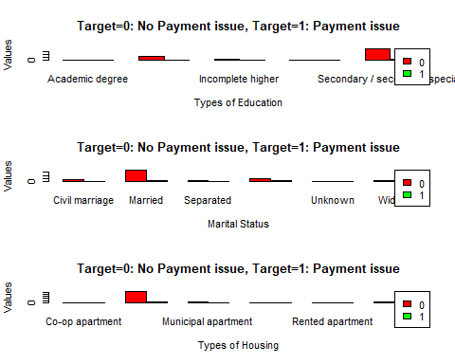

# AMT_CREDIT, AMT_ANNUITY, AMT_GOODS_PRICE vs. TARGET  
# Creating density plots for 'AMT_CREDIT', 'AMT_ANNUITY', 'AMT_GOODS_PRICE' based on the 'TARGET'  
p1 <- ggplot(data = BankDF, aes(x = AMT_CREDIT, group = TARGET, fill = TARGET)) +  
 geom_density(adjust = 1.5)  
  
p2 <- ggplot(data = BankDF, aes(x = AMT_ANNUITY, group = TARGET, fill = TARGET)) +  
 geom_density(adjust = 1.5)  
  
p3 <- ggplot(data = BankDF, aes(x = AMT_GOODS_PRICE, group = TARGET, fill = TARGET)) +  
 geom_density(adjust = 1.5)  
  
# Arrange and display the density plots in a single column  
grid.arrange(p1, p2, p3, ncol = 1)

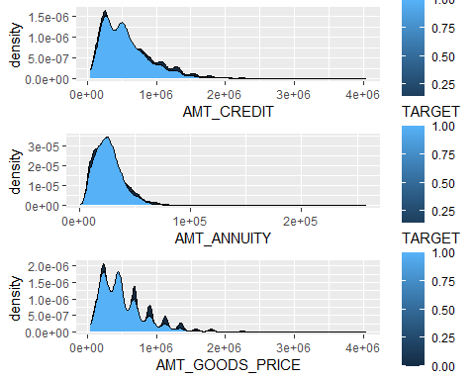

# Exploring Relationships and Data Insights  
  
# Correlation Matrix  
# Creating a correlation matrix of numeric variables in BankDF using Spearman method and visualizing the correlation matrix using corrplot.  
plot.new() # Creates a new plotting device  
dev.off() # Turns off the active plotting device

## RStudioGD   
## 2

data = select_if(BankDF, is.numeric) # Selecting only numeric columns  
data.cor = cor(data, method = c("spearman")) # Calculating the Spearman correlation matrix  
corrplot(data.cor, tl.cex = 0.5) # Visualizing the correlation matrix with adjustable text size

# Scatter Plots and Bar Plots  
  
# AMT_INCOME_TOTAL vs AMT_CREDIT, AMT_GOODS_PRICE vs AMT_CREDIT  
par(mfrow = c(1, 2)) # Divides the plotting area into a 1x2 grid  
  
# Scatter plot: Amount of Income vs Amount of Credit (Range)  
plot(data$AMT_INCOME_TOTAL, data$AMT_CREDIT,   
 main = "Amount of Income vs Amount of Credit (Range)",  
 xlab = "AMT_INCOME_TOTAL", ylab = "AMT_CREDIT", pch = 19) # Creates a scatter plot  
  
# Scatter plot: Good Price vs Amount of Credit (Range)  
plot(data$AMT_GOODS_PRICE, data$AMT_CREDIT,   
 main = "Good Price vs Amount of Credit (Range)",  
 xlab = "AMT_GOODS_PRICE", ylab = "AMT_CREDIT", pch = 19) # Creates a scatter plot

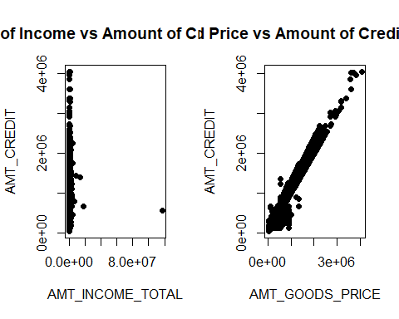

# Bar Plot: AMT_INCOME_RANGE vs CODE_GENDER  
BankDF9 <- with(BankDF, table(AMT_INCOME_RANGE, CODE_GENDER))  
barplot(BankDF9, beside = TRUE, legend = TRUE, args.legend = list(x = "topright", inset = c(0, 0)),  
 col = c("Red", "Green", "Blue"), xlab = "CODE_GENDER", ylab = "values",  
 main = "The relationship between income range and gender")  
  
# Box Plot: AMT_CREDIT vs NAME_EDUCATION_TYPE  
ggplot(BankDF, aes(x = NAME_EDUCATION_TYPE, y = AMT_CREDIT, fill = NAME_FAMILY_STATUS)) +   
 geom_boxplot() # Creates a box plot to visualize the relationship between education type and credit amount  
  
# Data Manipulation  
  
# Dropping insignificant variables (REGION_RATING_CLIENT_W_CITY, SK_ID_CURR) and assigning the modified data to 'df'  
df = select(BankDF, -1, -31) # Drops columns based on their positions (-1, -31)

#Logistic regression

# Setting a seed for reproducibility in random processes  
set.seed(123)  
  
# Splitting the dataset into training and testing sets  
split = sample.split(df$TARGET,SplitRatio = 0.70)  
training_set = subset(df, split == TRUE)  
test_set = subset(df, split == FALSE)  
  
# Standardizing continuous columns in the training and testing sets  
# List of continuous columns to standardize  
continuous_column = c('AMT_INCOME_TOTAL', 'AMT_CREDIT', 'AMT_ANNUITY', 'AMT_GOODS_PRICE', 'REGION_POPULATION_RELATIVE', 'DAYS_REGISTRATION', 'CNT_FAM_MEMBERS', 'EXT_SOURCE_2', 'EXT_SOURCE_3', 'OBS_30_CNT_SOCIAL_CIRCLE', 'DEF_30_CNT_SOCIAL_CIRCLE', 'OBS_60_CNT_SOCIAL_CIRCLE', 'DEF_60_CNT_SOCIAL_CIRCLE', 'DAYS_LAST_PHONE_CHANGE','AMT_REQ_CREDIT_BUREAU_HOUR', 'AMT_REQ_CREDIT_BUREAU_DAY', 'AMT_REQ_CREDIT_BUREAU_WEEK', 'AMT_REQ_CREDIT_BUREAU_MON', 'AMT_REQ_CREDIT_BUREAU_QRT', 'AMT_REQ_CREDIT_BUREAU_YEAR')  
training_set[continuous_column] = scale(training_set[continuous_column])  
test_set[continuous_column] = scale(test_set[continuous_column])  
table(training_set$TARGET)

##   
## 0 1   
## 197849 17377

# Balancing the training set using oversampling method to handle class imbalance  
bal_training_set=ovun.sample(TARGET~., data = training_set, method = "over", N = 197849*2)$data  
table(bal_training_set$TARGET)

##   
## 0 1   
## 197849 197849

# Defining a function to generate a confusion matrix  
get_cm <- function(test_set, y_pred){  
 cm <- as.matrix(table(Actual = test_set$TARGET, Predicted = y_pred))  
}  
  
# Defining a function to evaluate the performance of the model  
simple_eval <- function (test_set, y_pred) {  
 CM = get_cm(test_set, y_pred)  
 n = sum(CM) # number of instances  
 nc = nrow(CM) # number of classes, should be 2 in our case  
 rowsums = apply(CM, 1, sum) # number of instances per class  
 colsums = apply(CM, 2, sum) # number of predictions per class  
 p = rowsums / n # distribution of instances over the actual classes  
 q = colsums / n # distribution of instances over the predicted classes  
 diag = diag(CM) # get TP and TN using identity matrix  
   
 accuracy = sum(diag) / n # overall classification accuracy  
 precision = diag / colsums # fraction of correct predictions for a certain class  
 recall = diag / rowsums # fraction of instances of a class that were correctly predicted  
 f1 = 2 * precision * recall / (precision + recall) # harmonic mean (or a weighted average) of precision and recall  
   
 # Ensuring all vectors have the same length  
 accuracy = rep(accuracy, length.out = length(precision))  
 f1 = rep(f1, length.out = length(precision))  
   
 perf_df = data.frame(accuracy, precision, recall, f1)   
 AUC = auc(test_set$TARGET, factor(y_pred, ordered = TRUE)) # Area under ROC curve  
 expAccuracy = sum(p * q)  
 test = (accuracy - expAccuracy) / (1 - expAccuracy)  
 macroPrecision = mean(precision)  
 macroRecall = mean(recall)  
 macroF1 = mean(f1)  
   
 list(Accuracy = accuracy, ROC_area = AUC, test = test, Precision = macroPrecision,   
 Recall = macroRecall, Fscore = macroF1, performance_df = perf_df, confusion_matrix = CM)  
}  
  
  
  
# Building a logistic regression model with balanced training set  
model_glm <- glm(TARGET ~ ., data = bal_training_set, family = "binomial")  
  
# Predict test data based on model  
LR.y_pred <- predict(model_glm, newdata = test_set, type = "response")

## Warning in predict.lm(object, newdata, se.fit, scale = 1, type = if (type  
## == : prediction from rank-deficient fit; attr(*, "non-estim") has doubtful  
## cases

LR.y_pred <- ifelse(LR.y_pred >0.5, 1, 0)  
  
# Confusion matrix  
LR.eval <- simple_eval(test_set, LR.y_pred)

## Setting levels: control = 0, case = 1

## Setting direction: controls < cases

LR.eval$confusion_matrix

## Predicted  
## Actual 0 1  
## 0 58338 26455  
## 1 2434 5013

# Performance by output class  
print(round(LR.eval$performance_df,2))

## accuracy precision recall f1  
## 0 0.69 0.96 0.69 0.80  
## 1 0.69 0.16 0.67 0.26

# Displaying confusion matrix and various performance metrics  
cat('Accuracy: ', round(LR.eval$Accuracy,2),  
 '\nMacro-precision: ', round(LR.eval$Precision,2),  
 '\nMacro-recall: ', round(LR.eval$Recall,2),  
 '\nMacro-F1: ', round(LR.eval$Fscore,2),  
 '\ntest: ', round(LR.eval$test,2),  
 '\nROC area: ', round(LR.eval$ROC_area,2)  
)

## Accuracy: 0.69 0.69   
## Macro-precision: 0.56   
## Macro-recall: 0.68   
## Macro-F1: 0.53   
## test: 0.15 0.15   
## ROC area: 0.68

# Visual Inspection and Data Details  
View(BankDF)   
dim(BankDF)

## [1] 307466 60