

DEPARTMENT OF INFORMATION TECHNOLOGY 24ITT32 - PROGRAMMING IN JAVA

INDIVIDUAL PROJECT ON ACADEMIC MANAGEMENT SYSTEM

P R O J E C T R E P O R T
Submitted by
SWETHA D S
25ITR153

JAVA ASSIGNMENT

AIM:
Development of Kongu Engineering College (R2024) Student Academic &
Continuous Evaluation System using Java JDBC.

OBJECTIVE:
Design and develop a database-driven Java application using JDBC to manage student records, perform incremental marks entry (Continuous Internal Assessments and End Semester Examinations), enforce attendance eligibility rules, and generate formal academic performance reports according to Kongu Engineering College (Autonomous) - Regulation 2024. System Requirements & Specifications.

FLOW CHART:
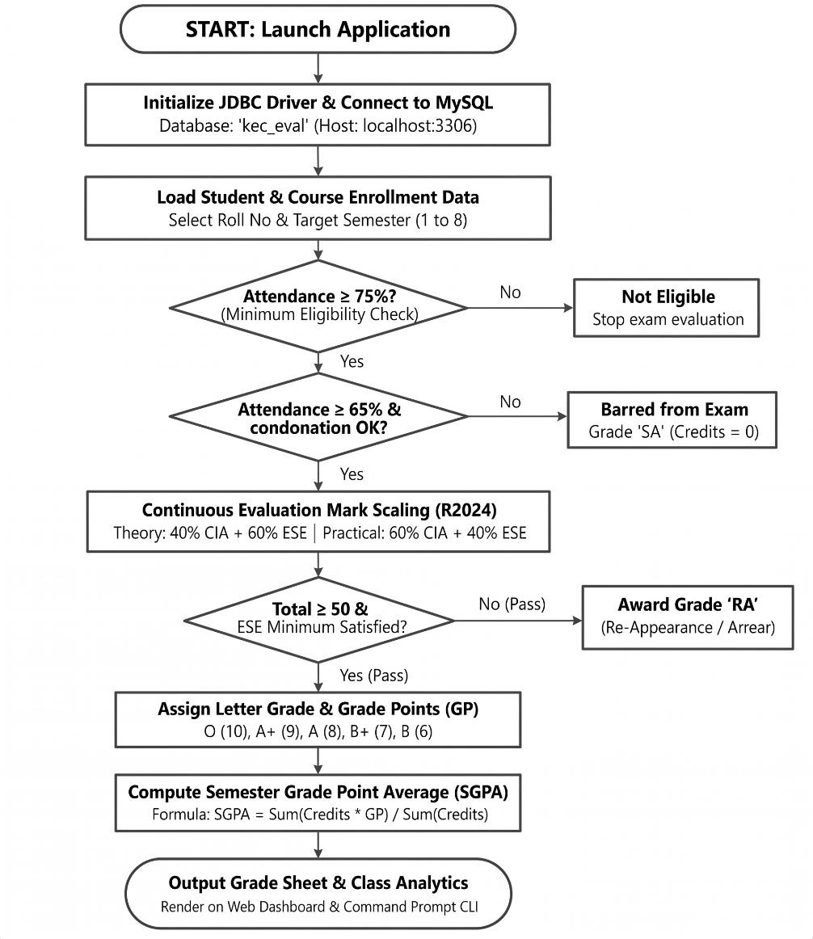

PROCEDURE :
- Load the MySQL Connector/J driver to enable communication between the Java application and the MySQL database.
- Establish a connection to the kec_eval database running on the local MySQL server using DriverManager.getConnection().

- Store and retrieve student details, including roll number, name, department, and semester, along with course information such as course code, title, credits, and course type.

- Enroll students in semester courses, record the number of classes held and attended, and calculate the attendance percentage.

- Verify examination eligibility based on attendance percentage. Students with 75% or above are eligible, those with 65%–74% require medical condonation verification, and those below 65% are marked as Shortage of Attendance (SA).

- Record CIA-1, CIA-2, and assignment marks, and calculate the scaled internal assessment marks according to the specified theory and practical course weightages.

- Record end-semester examination marks out of 100, verify the minimum passing requirements, and scale the marks according to the applicable theory and practical .

- Calculate the total marks by combining scaled CIA and ESE marks. Assign letter grades and grade points according to the specified grading scale, marking students as RA if they fail the examination or score below the required passing mark.

- Generate student grade sheets, attendance shortage reports, and department-wise pass percentage reports. Display the results through the interactive web dashboard and the command prompt console.

DATABASE SCHEMA:

- STUDENTS TABLE:

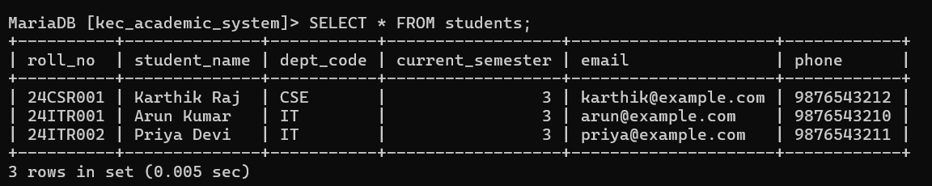

2.COURSES TABLE:
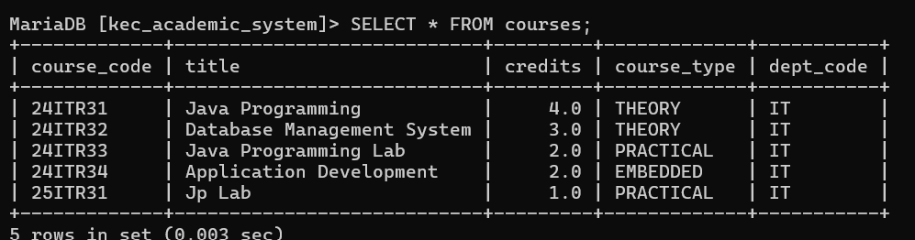

3.ENROLLMENTS TABLE:
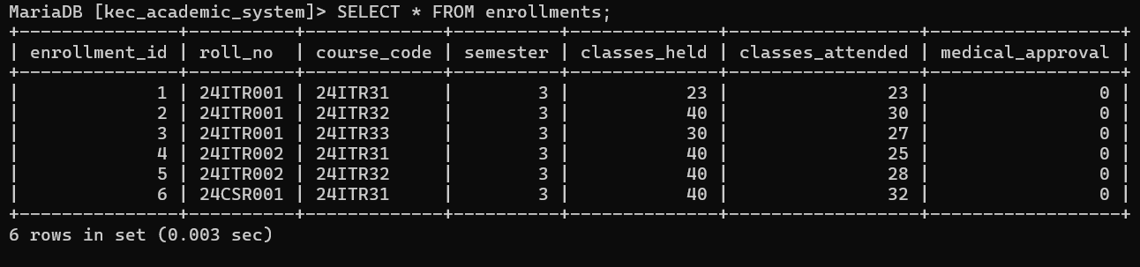
4.ASSESSMENT MARKS TABLE:
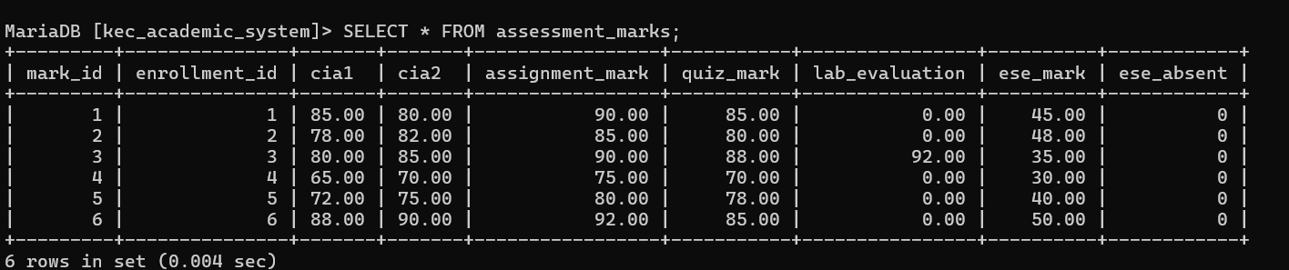

SOURCE CODE:
MAINAPP.JAVA:
import java.sql.*;
import java.util.Scanner;
import java.util.Locale;
public class MainApp {
private static final Scanner SC = new Scanner(System.in);
public static void main(String[] args) {
System.out.println("KEC STUDENT ACADEMIC & CONTINUOUS EVALUATION SYSTEM");
try (Connection ignored = DBConnection.getConnection()) {
System.out.println("Database connected successfully.");
} catch (SQLException e) {
System.out.println("Database connection failed: " + e.getMessage());
System.out.println("Check MariaDB, schema import, and DB settings in README.md.");
return;
}
int choice;
do {
menu();
choice = readInt("Enter choice: ", 0, 12);
try {
switch (choice) {
case 1 -> listStudents();
case 2 -> addStudent();
case 3 -> updateStudent();
case 4 -> deleteStudent();
case 5 -> listCourses();
case 6 -> addCourse();
case 7 -> enrollStudent();
case 8 -> updateAttendance();
case 9 -> enterMarks();
case 10 -> attendanceReport();
case 11 -> semesterMarkSheet();
case 12 -> departmentSummary();
case 0 -> System.out.println("Exiting. Thank you.");
default -> System.out.println("Invalid choice.");
}
} catch (SQLException e) {
System.out.println("Database operation failed: " + e.getMessage());
}
} while (choice != 0);
}
private static void menu() {
System.out.println("\n========== MAIN MENU ==========");
System.out.println("1. Display all students");
System.out.println("2. Register student");
System.out.println("3. Update student");
System.out.println("4. Delete student");
System.out.println("5. Display courses");
System.out.println("6. Add course");
System.out.println("7. Enroll student in course");
System.out.println("8. Update attendance / medical approval");
System.out.println("9. Enter/update CIA, assignment, ESE marks");
System.out.println("10. Attendance report / defaulters");
System.out.println("11. Student semester mark sheet / SGPA");
System.out.println("12. Department-wise performance summary");
System.out.println("0. Exit");
}
private static int readInt(String prompt, int min, int max) {
while (true) {
System.out.print(prompt);
String s = SC.nextLine().trim();
try {
int v = Integer.parseInt(s);
if (v >= min && v <= max) return v;
} catch (NumberFormatException ignored) {}
System.out.println("Enter a whole number from " + min + " to " + max + ".");
}
}
private static double readDouble(String prompt, double min, double max) {
while (true) {
System.out.print(prompt);
try {
double v = Double.parseDouble(SC.nextLine().trim());
if (Double.isFinite(v) && v >= min && v <= max) return v;
} catch (NumberFormatException ignored) {}
System.out.println("Enter a number from " + min + " to " + max + ".");
}
}
private static String readText(String prompt) {
while (true) {
System.out.print(prompt);
String s = SC.nextLine().trim();
if (!s.isEmpty()) return s;
System.out.println("This field cannot be empty.");
}
}
private static boolean readYesNo(String prompt) {
while (true) {
String s = readText(prompt + " (y/n): ").toLowerCase(Locale.ROOT);
if (s.equals("y") || s.equals("yes")) return true;
if (s.equals("n") || s.equals("no")) return false;
System.out.println("Enter y or n.");
}
}
private static void listStudents() throws SQLException {
String sql = "SELECT s.roll_no,s.student_name,d.dept_name,s.current_semester,s.email,s.phone " +
"FROM students s JOIN department d ON d.dept_code=s.dept_code ORDER BY s.roll_no";
try (Connection c=DBConnection.getConnection(); PreparedStatement p=c.prepareStatement(sql);
ResultSet r=p.executeQuery()) {
System.out.println("\\nROLL NO | NAME | DEPARTMENT | SEM | EMAIL | PHONE");
while(r.next()) System.out.printf("%s | %s | %s | %d | %s | %s%n",
r.getString(1),r.getString(2),r.getString(3),r.getInt(4),nvl(r.getString(5)),nvl(r.getString(6)));
}
}
private static void addStudent() throws SQLException {
String roll=readText("Roll number: ").toUpperCase(Locale.ROOT);
String name=readText("Student name: ");
String dept=readText("Department code (CSE/IT/ECE): ").toUpperCase(Locale.ROOT);
int sem=readInt("Current semester (1-8): ",1,8);
System.out.print("Email (optional): "); String email=SC.nextLine().trim();
System.out.print("Phone (optional): "); String phone=SC.nextLine().trim();
String sql="INSERT INTO students(roll_no,student_name,dept_code,current_semester,email,phone) VALUES(?,?,?,?,?,?)";
try(Connection c=DBConnection.getConnection(); PreparedStatement p=c.prepareStatement(sql)){
p.setString(1,roll);p.setString(2,name);p.setString(3,dept);p.setInt(4,sem);
p.setString(5,emptyNull(email));p.setString(6,emptyNull(phone));p.executeUpdate();
System.out.println("Student registered.");
}
}
private static void updateStudent() throws SQLException {
String roll=readText("Roll number to update: ").toUpperCase(Locale.ROOT);
String name=readText("New student name: ");
String dept=readText("New department code: ").toUpperCase(Locale.ROOT);
int sem=readInt("New semester (1-8): ",1,8);
System.out.print("New email (optional): ");String email=SC.nextLine().trim();
System.out.print("New phone (optional): ");String phone=SC.nextLine().trim();
try(Connection c=DBConnection.getConnection();PreparedStatement p=c.prepareStatement(
"UPDATE students SET student_name=?,dept_code=?,current_semester=?,email=?,phone=? WHERE roll_no=?")){
p.setString(1,name);p.setString(2,dept);p.setInt(3,sem);p.setString(4,emptyNull(email));p.setString(5,emptyNull(phone));p.setString(6,roll);
System.out.println(p.executeUpdate()>0?"Student updated.":"No student found.");
}
}
private static void deleteStudent() throws SQLException {
String roll=readText("Roll number to delete: ").toUpperCase(Locale.ROOT);
if(!readYesNo("Delete "+roll+"? Related enrollments will also be deleted")) return;
try(Connection c=DBConnection.getConnection();PreparedStatement p=c.prepareStatement("DELETE FROM students WHERE roll_no=?")){
p.setString(1,roll);System.out.println(p.executeUpdate()>0?"Student deleted.":"No student found.");
}
}
private static void listCourses() throws SQLException {
String sql="SELECT course_code,title,credits,course_type,dept_code FROM courses ORDER BY course_code";
try(Connection c=DBConnection.getConnection();PreparedStatement p=c.prepareStatement(sql);ResultSet r=p.executeQuery()){
System.out.println("\\nCOURSE CODE | TITLE | CREDITS | TYPE | DEPT");
while(r.next())System.out.printf("%s | %s | %.1f | %s | %s%n",r.getString(1),r.getString(2),r.getDouble(3),r.getString(4),r.getString(5));
}
}
private static void addCourse() throws SQLException {
String code=readText("Course code: ").toUpperCase(Locale.ROOT);
String title=readText("Course title: ");
double credits=readDouble("Credits (0.5-10): ",0.5,10);
String type;
while(true){type=readText("Type THEORY / PRACTICAL / EMBEDDED: ").toUpperCase(Locale.ROOT);
if(type.equals("THEORY")||type.equals("PRACTICAL")||type.equals("EMBEDDED"))break;
System.out.println("Invalid course type.");}
String dept=readText("Department code: ").toUpperCase(Locale.ROOT);
try(Connection c=DBConnection.getConnection();PreparedStatement p=c.prepareStatement(
"INSERT INTO courses(course_code,title,credits,course_type,dept_code) VALUES(?,?,?,?,?)")){
p.setString(1,code);p.setString(2,title);p.setDouble(3,credits);p.setString(4,type);p.setString(5,dept);p.executeUpdate();
System.out.println("Course added.");
}
}
private static void enrollStudent() throws SQLException {
String roll=readText("Student roll number: ").toUpperCase(Locale.ROOT);
String code=readText("Course code: ").toUpperCase(Locale.ROOT);
int sem=readInt("Semester (1-8): ",1,8);
try(Connection c=DBConnection.getConnection()){
c.setAutoCommit(false);
try(PreparedStatement p=c.prepareStatement("INSERT INTO enrollments(roll_no,course_code,semester) VALUES(?,?,?)",Statement.RETURN_GENERATED_KEYS)){
p.setString(1,roll);p.setString(2,code);p.setInt(3,sem);p.executeUpdate();
try(ResultSet keys=p.getGeneratedKeys()){if(keys.next())try(PreparedStatement m=c.prepareStatement("INSERT INTO assessment_marks(enrollment_id) VALUES(?)")){m.setInt(1,keys.getInt(1));m.executeUpdate();}}
c.commit();System.out.println("Enrollment created.");
}catch(SQLException e){c.rollback();throw e;}finally{c.setAutoCommit(true);}
}
}
private static void updateAttendance() throws SQLException {
int id=readInt("Enrollment ID (see attendance report): ",1,Integer.MAX_VALUE);
int held=readInt("Total classes held: ",0,10000);
int attended=readInt("Classes attended: ",0,held);
boolean medical=readYesNo("Medical condonation approved");
try(Connection c=DBConnection.getConnection();PreparedStatement p=c.prepareStatement(
"UPDATE enrollments SET classes_held=?,classes_attended=?,medical_approval=? WHERE enrollment_id=?")){
p.setInt(1,held);p.setInt(2,attended);p.setBoolean(3,medical);p.setInt(4,id);
System.out.println(p.executeUpdate()>0?"Attendance updated.":"Enrollment ID not found.");
}
}
private static void enterMarks() throws SQLException {
int id=readInt("Enrollment ID (see attendance report): ",1,Integer.MAX_VALUE);
double cia1=readDouble("CIA-1 (0-100): ",0,100);
double cia2=readDouble("CIA-2 (0-100): ",0,100);
double assignment=readDouble("Assignment (0-100): ",0,100);
double quiz=readDouble("Quiz (0-100): ",0,100);
double lab=readDouble("Lab evaluation (0-100): ",0,100);
double ese=readDouble("ESE (0-100; enter 0 if absent): ",0,100);
boolean absent=readYesNo("Student absent for ESE");
String sql="UPDATE assessment_marks SET cia1=?,cia2=?,assignment_mark=?,quiz_mark=?,lab_evaluation=?,ese_mark=?,ese_absent=? WHERE enrollment_id=?";
try(Connection c=DBConnection.getConnection();PreparedStatement p=c.prepareStatement(sql)){
p.setDouble(1,cia1);p.setDouble(2,cia2);p.setDouble(3,assignment);p.setDouble(4,quiz);p.setDouble(5,lab);p.setDouble(6,ese);p.setBoolean(7,absent);p.setInt(8,id);
System.out.println(p.executeUpdate()>0?"Marks saved.":"No marks record. Enroll the student first.");
}
}
private static void attendanceReport() throws SQLException {
String sql="SELECT e.enrollment_id,s.roll_no,s.student_name,c.course_code,c.title,e.classes_held,e.classes_attended,e.medical_approval " +
"FROM enrollments e JOIN students s ON s.roll_no=e.roll_no JOIN courses c ON c.course_code=e.course_code ORDER BY s.roll_no,c.course_code";
try(Connection c=DBConnection.getConnection();PreparedStatement p=c.prepareStatement(sql);ResultSet r=p.executeQuery()){
System.out.println("\\nID | ROLL NO | STUDENT | COURSE | ATTENDANCE | STATUS");
while(r.next()){
int held=r.getInt("classes_held"),att=r.getInt("classes_attended");
double pct=held==0?0:100.0*att/held;
boolean medical=r.getBoolean("medical_approval");
String status=pct>=75?"Eligible for ESE":pct>=65?(medical?"Medical condonation approved":"Medical approval required"):"SA - Not eligible";
System.out.printf("%d | %s | %s | %s | %.2f%% (%d/%d) | %s%n",r.getInt(1),r.getString(2),r.getString(3),r.getString(4),pct,att,held,status);
}
}
}
private static void semesterMarkSheet() throws SQLException {
String roll=readText("Student roll number: ").toUpperCase(Locale.ROOT);
int sem=readInt("Semester: ",1,8);
String sql="SELECT s.student_name,s.roll_no,c.course_code,c.title,c.credits,e.classes_held,e.classes_attended,e.medical_approval,"+
"m.cia1,m.cia2,m.assignment_mark,m.quiz_mark,m.lab_evaluation,m.ese_mark,m.ese_absent "+
"FROM enrollments e JOIN students s ON s.roll_no=e.roll_no JOIN courses c ON c.course_code=e.course_code "+
"LEFT JOIN assessment_marks m ON m.enrollment_id=e.enrollment_id WHERE e.roll_no=? AND e.semester=? ORDER BY c.course_code";
double weighted=0,totalCredits=0;
try(Connection c=DBConnection.getConnection();PreparedStatement p=c.prepareStatement(sql)){
p.setString(1,roll);p.setInt(2,sem);
try(ResultSet r=p.executeQuery()){
boolean any=false;
while(r.next()){
any=true;
double credits=r.getDouble("credits");
int held=r.getInt("classes_held"),att=r.getInt("classes_attended");
double pct=held==0?0:100.0*att/held;
String eligibility=pct>=75?"Eligible":pct>=65?(r.getBoolean("medical_approval")?"Condonation approved":"Medical approval required"):"SA - Not eligible";
double internal=(r.getDouble("cia1")+r.getDouble("cia2"))/2.0*0.4+r.getDouble("assignment_mark")*0.2+r.getDouble("quiz_mark")*0.1+r.getDouble("lab_evaluation")*0.3;
double total=internal*0.4+r.getDouble("ese_mark")*0.6;
boolean absent=r.getBoolean("ese_absent");
String grade=absent||pct<65?"SA":grade(total);
int gp=gradePoint(grade);
System.out.printf("%s - %s | Credits %.1f | Attendance %.1f%% (%s) | Internal %.2f | ESE %.2f | Total %.2f | Grade %s%n",
r.getString("course_code"),r.getString("title"),credits,pct,eligibility,internal,r.getDouble("ese_mark"),total,grade);
if(!grade.equals("SA")){weighted+=gp*credits;totalCredits+=credits;}
}
if(!any){System.out.println("No enrollments found for this student and semester.");return;}
}
}
System.out.printf("SGPA (excluding SA courses): %.2f%n",totalCredits==0?0:weighted/totalCredits);
System.out.println("Note: The grade thresholds and component weights are configurable academic assumptions; confirm your department's official regulation before submission.");
}
private static void departmentSummary() throws SQLException {
String sql="SELECT d.dept_code,d.dept_name,COUNT(DISTINCT s.roll_no) students,COUNT(e.enrollment_id) enrollments,"+
"AVG(CASE WHEN e.classes_held>0 THEN 100.0*e.classes_attended/e.classes_held END) avg_attendance,"+
"AVG(CASE WHEN m.ese_absent=0 THEN ( ((m.cia1+m.cia2)/2*0.4+m.assignment_mark*0.2+m.quiz_mark*0.1+m.lab_evaluation*0.3)*0.4+m.ese_mark*0.6) END) avg_total "+
"FROM department d LEFT JOIN students s ON s.dept_code=d.dept_code LEFT JOIN enrollments e ON e.roll_no=s.roll_no "+
"LEFT JOIN courses c ON c.course_code=e.course_code LEFT JOIN assessment_marks m ON m.enrollment_id=e.enrollment_id GROUP BY d.dept_code,d.dept_name ORDER BY d.dept_code";
try(Connection c=DBConnection.getConnection();PreparedStatement p=c.prepareStatement(sql);ResultSet r=p.executeQuery()){
System.out.println("\\nDEPARTMENT | STUDENTS | ENROLLMENTS | AVG ATTENDANCE | AVG MARK TOTAL");
while(r.next())System.out.printf("%s - %s | %d | %d | %s | %s%n",r.getString(1),r.getString(2),r.getInt(3),r.getInt(4),
r.getObject(5)==null?"N/A":String.format("%.2f%%",r.getDouble(5)),r.getObject(6)==null?"N/A":String.format("%.2f",r.getDouble(6)));
}
}
private static String grade(double mark) {
if(mark>=90)return "O"; if(mark>=80)return "A+"; if(mark>=70)return "A";
if(mark>=60)return "B+"; if(mark>=50)return "B"; if(mark>=40)return "C"; return "F";
}
private static int gradePoint(String g) {
return switch(g){case "O"->10;case "A+"->9;case "A"->8;case "B+"->7;case "B"->6;case "C"->5;default->0;};
}
private static String nvl(String s){return s==null?"-":s;}
private static String emptyNull(String s){return s==null||s.isBlank()?null:s;}
}

DB CONNECTION.JAVA:
import java.sql.Connection;
import java.sql.DriverManager;
import java.sql.SQLException;
/** Central MariaDB connection settings. Edit these for your local installation. */
public final class DBConnection {
private static final String URL = System.getenv().getOrDefault(
"KEC_DB_URL", "jdbc:mariadb://localhost:3306/kec_academic_system");
private static final String USER = System.getenv().getOrDefault("KEC_DB_USER", "root");
private static final String PASSWORD = System.getenv().getOrDefault("KEC_DB_PASSWORD", "");
private DBConnection() {}
public static Connection getConnection() throws SQLException {
return DriverManager.getConnection(URL, USER, PASSWORD);
}
}

STUDENTDAO.JAVA:

import java.sql.Connection;
import java.sql.PreparedStatement;
import java.sql.ResultSet;
import java.sql.SQLException;
public class StudentDAO {

public void displayStudents() {
String query = "SELECT roll_no, student_name, dept_code, current_semester FROM students";
try (Connection con = DBConnection.getConnection()) {
if (con == null) {
System.out.println("Database connection unavailable.");
return;
}
try (PreparedStatement ps = con.prepareStatement(query);
ResultSet rs = ps.executeQuery()) {
System.out.println("\n--- Student Details ---");
while (rs.next()) {
System.out.println("Roll No: " + rs.getString("roll_no"));
System.out.println("Name: " + rs.getString("student_name"));
System.out.println("Department: " + rs.getString("dept_code"));
System.out.println("Semester: " + rs.getInt("current_semester"));
System.out.println("-----------------------");
}
}
} catch (SQLException e) {
System.out.println("Error retrieving students: " + e.getMessage());
}
}
}

ACADEMICDAO.JAVA:

import java.sql.Connection;
import java.sql.PreparedStatement;
import java.sql.ResultSet;
import java.sql.SQLException;
public class AcademicDAO {
// Display attendance details and examination eligibility
public void displayAttendanceReport() throws SQLException {
String sql = """
SELECT e.enrollment_id, s.roll_no, s.student_name,
c.course_code, c.title,
e.classes_held, e.classes_attended,
e.medical_approval
FROM enrollments e
JOIN students s ON s.roll_no = e.roll_no
JOIN courses c ON c.course_code = e.course_code
ORDER BY s.roll_no, c.course_code
""";
try (Connection con = DBConnection.getConnection();
PreparedStatement ps = con.prepareStatement(sql);
ResultSet rs = ps.executeQuery()) {
System.out.println("\nID | ROLL NO | STUDENT | COURSE | ATTENDANCE | STATUS");
while (rs.next()) {
int held = rs.getInt("classes_held");
int attended = rs.getInt("classes_attended");
double percentage = held == 0
? 0 : attended * 100.0 / held;
boolean medical = rs.getBoolean("medical_approval");
String status;
if (percentage >= 75) {
status = "Eligible for ESE";
} else if (percentage >= 65) {
status = medical
? "Medical condonation approved"
: "Medical approval required";
} else {
status = "SA - Not eligible";
}
System.out.printf(
"%d | %s | %s | %s - %s | %.2f%% | %s%n",
rs.getInt("enrollment_id"),
rs.getString("roll_no"),
rs.getString("student_name"),
rs.getString("course_code"),
rs.getString("title"),
percentage,
status
);
}
}
}
// Find enrollment ID using student roll number and course code
public int findEnrollmentId(String rollNo, String courseCode)
throws SQLException {
String sql = """
SELECT enrollment_id
FROM enrollments
WHERE roll_no = ? AND course_code = ?
ORDER BY semester DESC
LIMIT 1 """;
try (Connection con = DBConnection.getConnection();
PreparedStatement ps = con.prepareStatement(sql)) {
ps.setString(1, rollNo);
ps.setString(2, courseCode);
try (ResultSet rs = ps.executeQuery()) {
if (rs.next()) {
return rs.getInt("enrollment_id");
}
}
}
return -1;
}
}

OUTPUT SCREENSHOTS:
MAIN MENU:
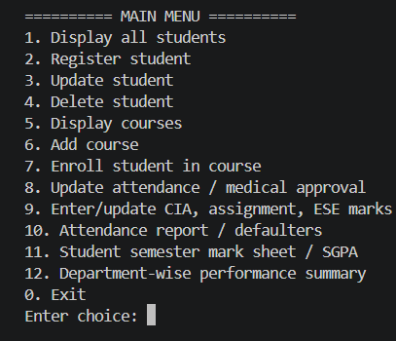
STUDENT AND COURSE MANAGEMENT:

STUDENT REGISTRATION:
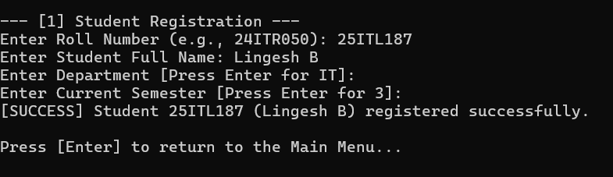

COURSE CATALOG:
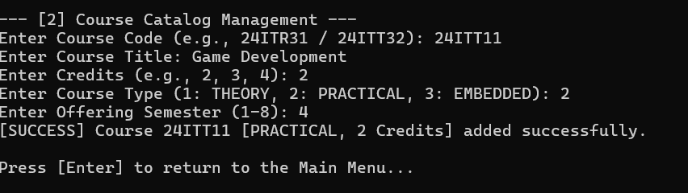

COURSE ENROLLMENT & ATTENDANCE TRACKING:
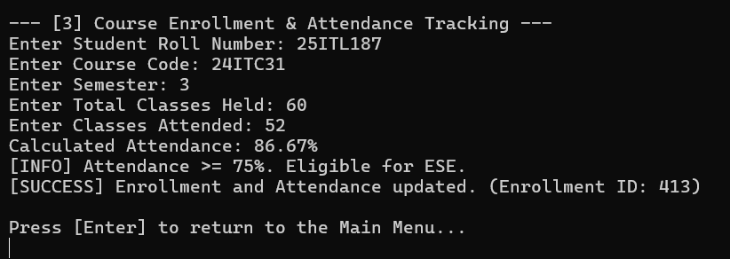

INCREMENTAL MARKS ENTRY:

PHASE 1 (MID-SEMESTER):
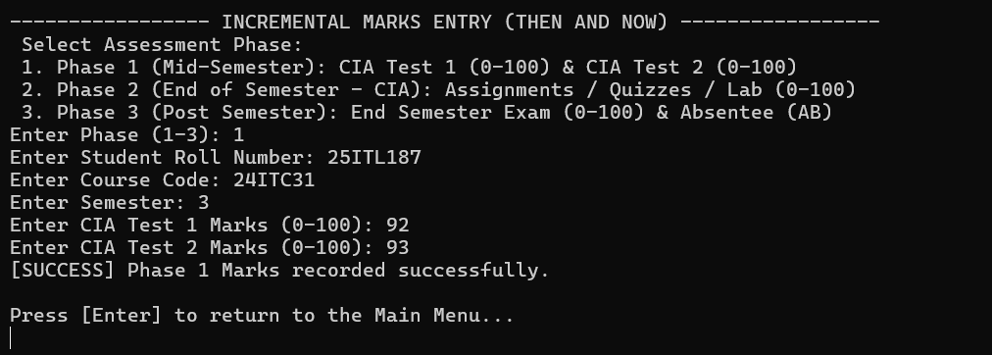

PHASE 2 (END OF SEMESTER - CIA):
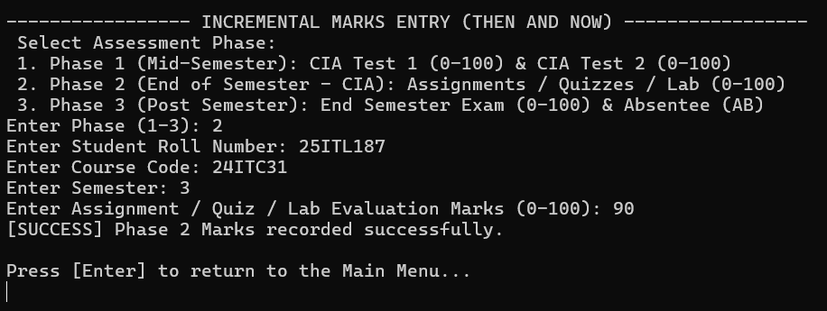

PHASE 3 (POST SEMESTER):

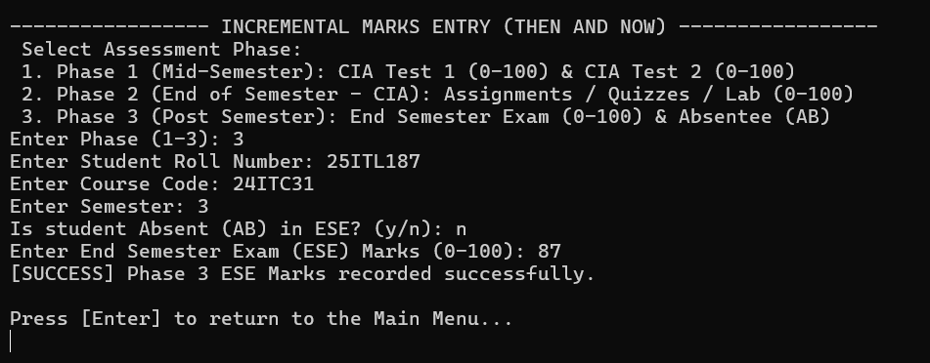

ATTENDANCE & GRADING RULES:

ATTENDANCE FILTER:
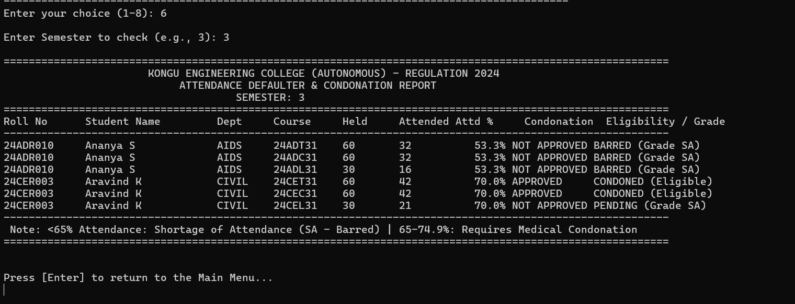

STUDENT SEMESTER MARK SHEET:
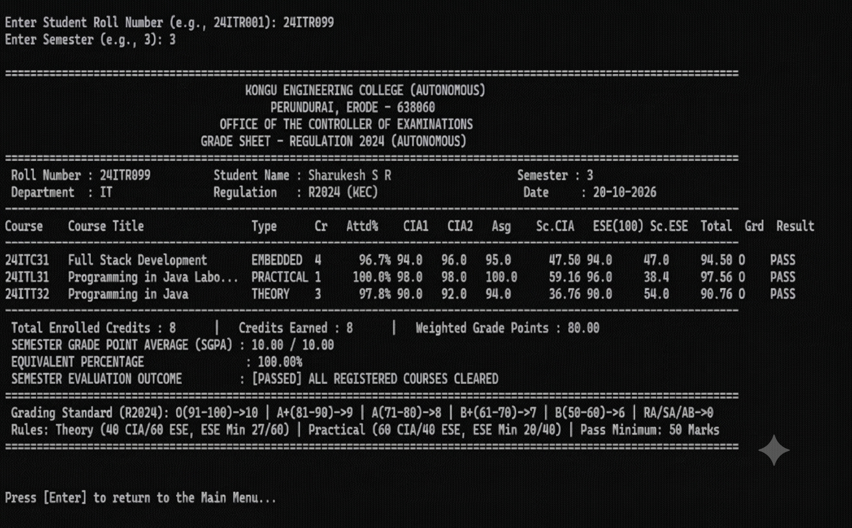

DEPARTMENT WISE CLASS PERFORMANCE & RESULT SUMMARY:

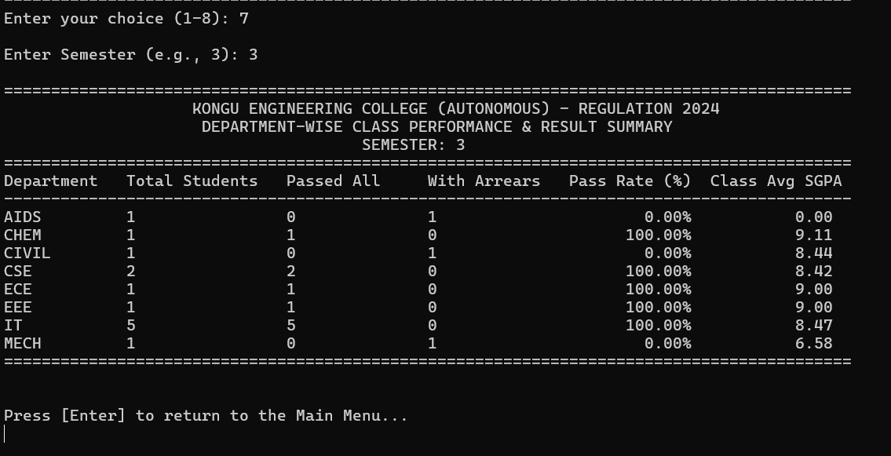

DATABASE:

STUDENTS DATABASE:

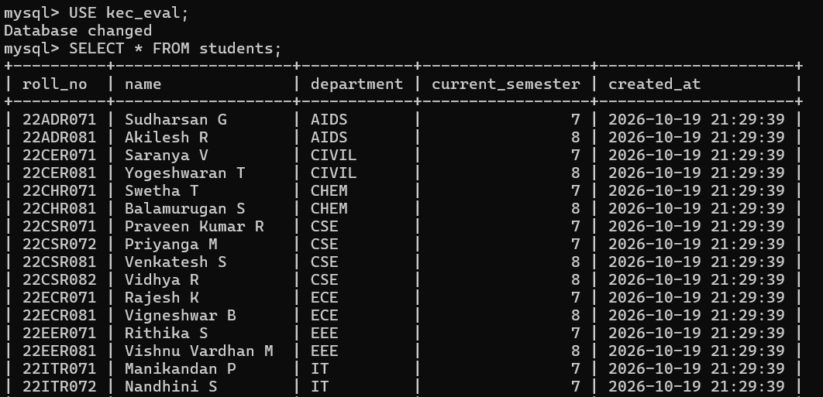

COURSES DATABASE:
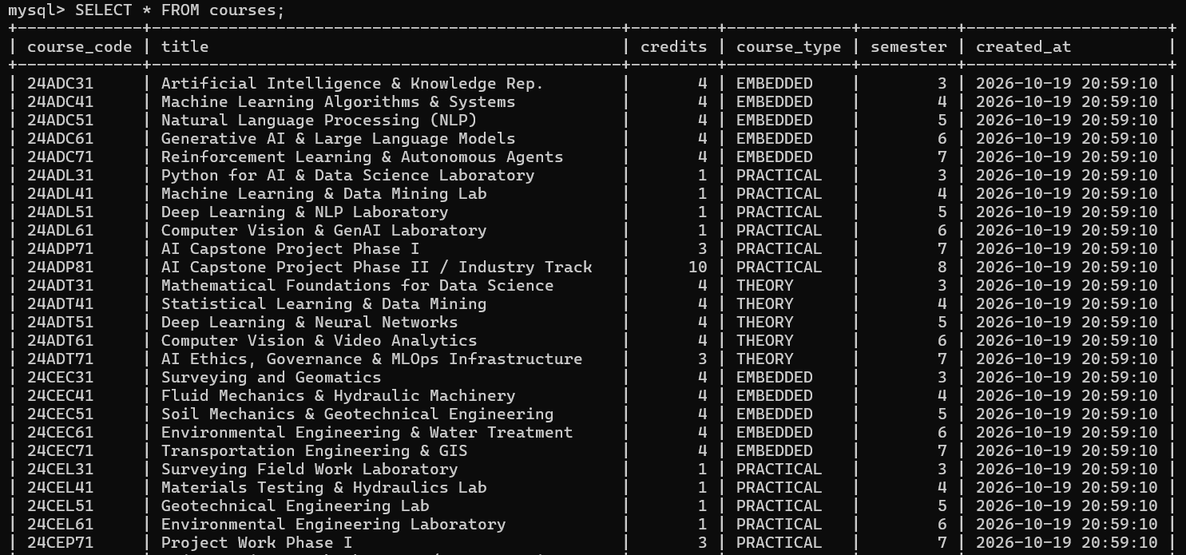

ENROLLMENTS DATABASE:
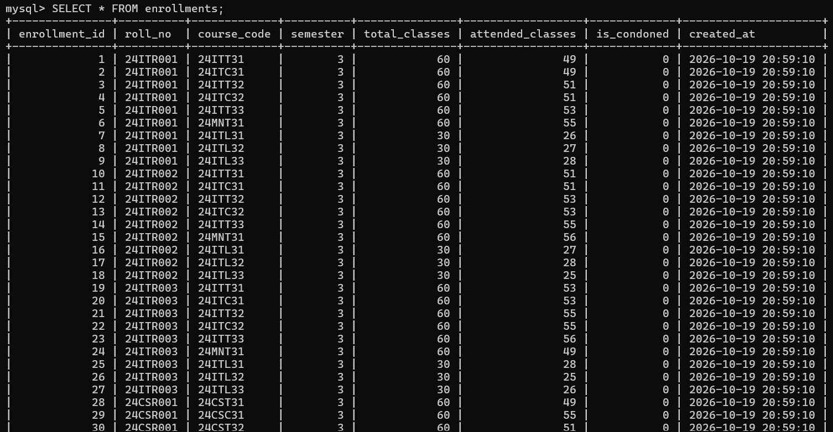

RESULT:

Thus, the Student Academic and Continuous Evaluation System for Kongu Engineering College (Autonomous) Regulation 2024 was successfully designed, developed, and tested using Java (JDBC) and MySQL. The system accurately automates the calculation of Continuous Internal Assessments (CIA), End Semester Examinations (ESE), Letter Grades, Attendance Eligibility, and Semester Grade Point Average (SGPA).

REFERENCES:
- Oracle, Java SE Documentation – JDBC Overview and Architecture. https://docs.oracle.com/javase/8/docs/technotes/guides/jdbc/ .
- Oracle, Java SE API – HttpServer. https://docs.oracle.com/en/java/javase/17/docs/api/jdk.httpserver/com/sun/net/httpserve r/HttpServer.html .
- Oracle, MySQL 8.0 Reference Manual. https://dev.mysql.com/doc/refman/8.0/en/ .

- Oracle, MySQL Connector/J Developer Guide. https://dev.mysql.com/doc/connector-j/8.0/en/ .
- University Grants Commission, Guidelines for Choice Based Credit System (CBCS). https://www.ugc.gov.in/pdfnews/8023719_Guidelines-for-CBCS.pdf .
- Chart.js, Chart.js Documentation. https://www.chartjs.org/docs/latest/ .

- Tailwind CSS, Tailwind CSS Documentation. https://tailwindcss.com/docs .

- GeeksforGeeks, Establishing JDBC Connection in Java. https://www.geeksforgeeks.org/establishing-jdbc-connection-in-java/ .
- YouTube, Java JDBC with MySQL Tutorial Videos. https://www.youtube.com/results?search_query=Java+JDBC+MySQL+tutorial .
- Anthropic, Claude AI Assistant (used for project ideas and guidance). https://claude.ai/ .

GITHUB:

LINK : https://github.com/swetha181107/Java-JDPC-Mini-Project

