**ASSIGNMENT-3**

**QUESTION:**

Power Query

Objective – Power BI Desktop, Cloud Service and End to End Workflow

Use Case – Import list of the richest people using Query Editor Source – Richest people Analytics – The raw data - your task is to transform it into something more presentable. Report/Dashboard – Richest people • Create a new Power BI report, and load in the data • Some columns have been renamed, while each person's wealth (in billions of dollars) has been extracted 1. Replace the word billion with an empty string. 2. Replace the $ symbol with an empty string. 3. Convert the resulting column to a whole number. • Create a chart just to prove that the billions really are being treated as numbers. Result - Transform data using Query Editor

**STEPS:**

**1. Create a New Power BI Report**

* Open **Power BI Desktop** → **File > New**.
* Go to **Home > Get Data > Excel (or CSV)** → Load the file called **Richest People**.

**2. Open Power Query (Query Editor)**

* In the **Home tab**, click **Transform Data**.
* This opens the **Power Query Editor** where you can clean your dataset.

**3. Clean the Wealth Column**

Assume the column is something like **Wealth** with values like:  
$120 billion, $80 billion, etc.

Do the following in **Power Query**:

1. **Replace “billion”**
   * Select the **Wealth column**.
   * Go to **Transform > Replace Values**.
   * Find: billion → Replace with: *(leave blank)*.
   * Now values look like $120, $80, etc.
2. **Remove the $ sign**
   * Again, **Transform > Replace Values**.
   * Find: $ → Replace with: *(leave blank)*.
   * Now values look like 120, 80, etc.
3. **Change Column Type**
   * Select the **Wealth column**.
   * In the toolbar → **Data Type dropdown** → Choose **Whole Number**.
   * Power Query may ask: “Replace Current Step or Add New Step” → Choose **Replace Current**.

**4. Apply Changes**

* Click **Close & Apply** (top left).
* Now the clean dataset is loaded back into Power BI.

**5. Create a Chart to Prove Numbers Work**

* In **Report View**, select a **Bar Chart** or **Column Chart**.
* Drag:
  + **Person Name** → Axis
  + **Wealth (cleaned)** → Values
* The chart should show bars with numeric lengths → proving the billions are treated as numbers.

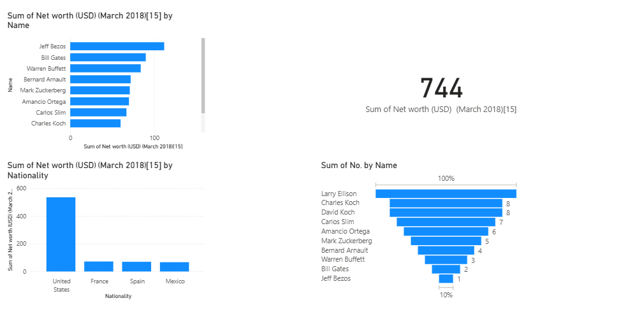**DASHBOARD:**