**ASSIGNMENT-4**

**QUESTION:**

Objective – Power BI Desktop, Cloud Service and End to End Workflow Use Case – Working with Date & Delimiter Source – GOT Analytics – The raw data - your task is to transform it into something more presentable. Report/Dashboard – GOT • Split the author column in two and replace the resulting nulls with blanks. • The dates needs to be format as I am not happy they are appearing. • You should also filter the data to show only episodes directed by Daniel. • Should show how many people watched each episode Written by the various authors o Episode Name o No. of viewers o Mostly watch Directors • Can you show me some interesting insights in terms of the release dates that will help me to have an idea about frequency of each episode coming up and help me to plan the future production.

Result - Transform data using Query Editor.

**STEPS:**

**Step 1: Load the Data**

1. Open **Power BI Desktop**.
2. Click **Home > Get Data > Excel or CSV**.
3. Choose your **GOT data file**.
4. Click **Load**.

**Step 2: Open Power Query to Clean the Data**

1. Click **Home > Transform Data**.

**Step 3: Split the Author Column**

1. Find the column called Author.
2. Right-click it > **Split Column > By Delimiter**.
3. Choose **Comma (,)** > Click **OK**.
4. You’ll now see Author.1, Author.2.
5. Select those new columns.
6. Go to **Transform > Replace Values**:
   * Find: null
   * Replace with: *(leave it blank)*

**Step 4: Fix the Date Format**

1. Select the Release Date column.
2. Go to the top menu: **Transform > Data Type > Date**.
3. Done — date will now look clean.

**Step 5: Keep Only Director = Daniel**

1. Click the filter icon on the Director column.
2. Type “Daniel” in the search box.
3. Check only the names that contain **Daniel**.
4. Click **OK**.

**Step 6: Apply Changes**

1. Click **Home > Close & Apply**.

**Step 7: Create Visuals in Report View**

**Table: Viewers per Episode by Author**

1. Click **Table** visual.
2. Add fields:
   * Episode Name
   * Viewers
   * Author.1
   * Author.2

**Bar Chart: Most Watched Episodes**

1. Click **Bar Chart**.
2. Axis: Episode Name
3. Value: Viewers

**Line Chart: Episodes Over Time**

1. Click **Line Chart**.
2. Axis: Release Date
3. Value: Episode Name (set to **count**)

**Step 8: Save and Publish**

1. Click **File > Save** to save your report.
2. To publish:
   * Click **Home > Publish**
   * Sign in to Power BI Service
   * Choose a **workspace**

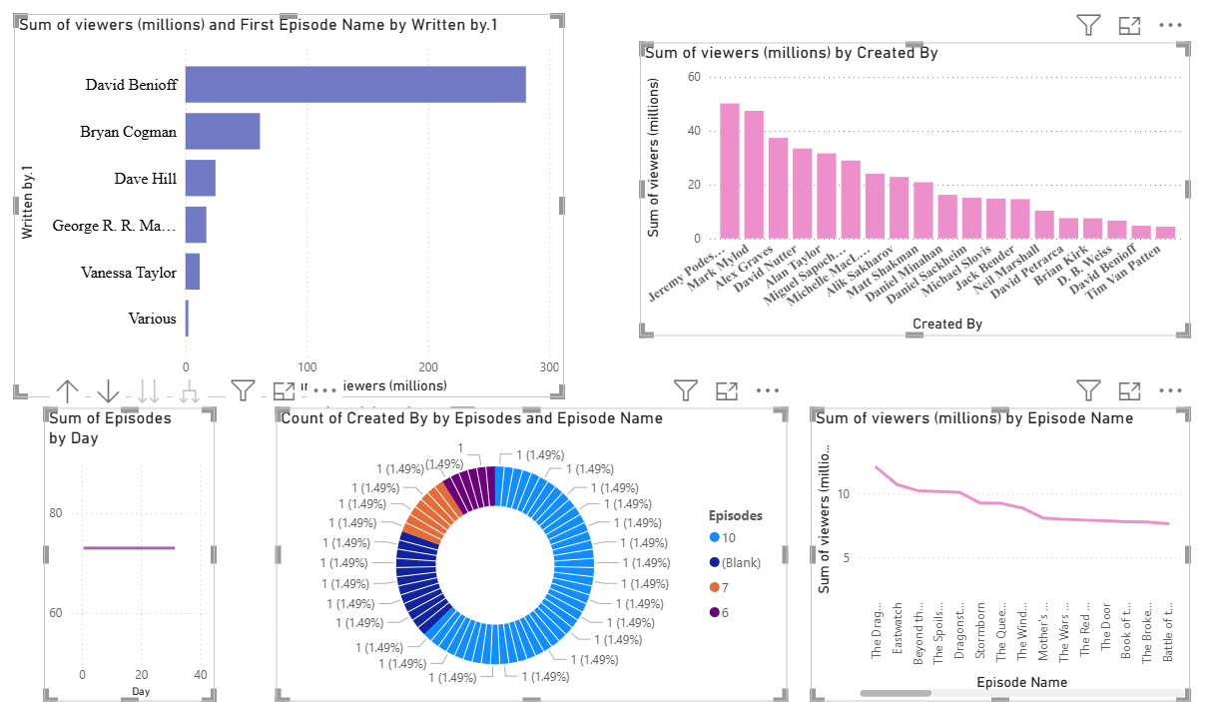**DASHBOARD:**