**ASSIGNMENT-5**

**QUESTION:**

**Query Editor**

**Objective – Power BI Desktop, Cloud Service and End to End Workflow**

**Use Case – Conditional Formatting**

**Source – LTD Sales**

**Analytics – Format as per the condition**

**Report/Dashboard – Sales Range**

**• Need to showcase the Revenue as per the State.**

**• Create a new column as per following condition as per the sales**

**1. Sales Range**

**2. Less 100**

**3. 1001 to 5000**

**4. 6000 to 10000**

**5. 11000 to 15000**

**6. 16000 to 20000**

**7. 21000 to 25000**

**8. Above 25000**

**• Create a new column as per following condition as per the Product**

**Category where for:-**

**1. Furniture it should show “Office Infra”**

**2. Others it should show “Non-Office Infra”**

**Result - Transform data using Query Editor**

**STEPS:**

**1. Load the Data**

* Open **Power BI Desktop**.
* Go to **Home > Get Data > Excel/CSV** → Import **LTD Sales** dataset.
* Click **Transform Data** to open **Power Query Editor**.

**2. Create Sales Range Column**

We need to categorize Revenue into ranges.

* In **Power Query Editor**, go to **Add Column > Conditional Column**.
* Name the new column: **Sales Range**.
* Add conditions:
* If **Revenue** ≤ 100 → Less 100
* Else if **Revenue** between 1001 and 5000 → 1001 to 5000
* Else if **Revenue** between 6000 and 10000 → 6000 to 10000
* Else if **Revenue** between 11000 and 15000 → 11000 to 15000
* Else if **Revenue** between 16000 and 20000 → 16000 to 20000
* Else if **Revenue** between 21000 and 25000 → 21000 to 25000
* Else → Above 25000

⚡ Note: You’ll need to build multiple "Else if" conditions inside the Conditional Column dialog.

**3. Create Product Category Column**

Now we’ll map Furniture → *Office Infra* and all others → *Non-Office Infra*.

* Again, go to **Add Column > Conditional Column**.
* Name it: **Product Infra**.
* Condition:
* If **Product Category = Furniture** → Office Infra
* Else → Non-Office Infra

**4. Apply & Load**

* Once both columns are created, click **Close & Apply**.
* Data loads back into Power BI with your transformations.

**5. Build Report (Optional for Dashboard)**

* Insert a **Table visual**.
* Drag in **State**, **Revenue**, **Sales Range**, **Product Infra**.
* This will now display Revenue by State, categorized into Sales Ranges and Product Infra groupings

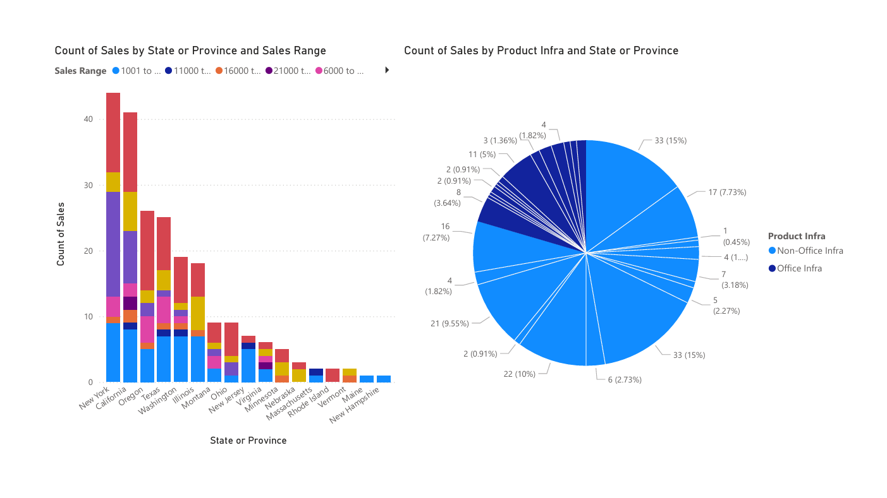**DASHBOARD:**