Car Mileage Analysis Using Fuel Type

Project Objective
Using the CarMakers dataset, the objective is to:
1. Create a Side-by-Side Bar Chart using the Fuel-Type dimension.
2. Show the average mileage for City MPG and Highway MPG.
3. List drawbacks of using Side-by-Side Bar Charts.

Screenshot: Tableau Visualization
Below is the screenshot provided for the analysis:
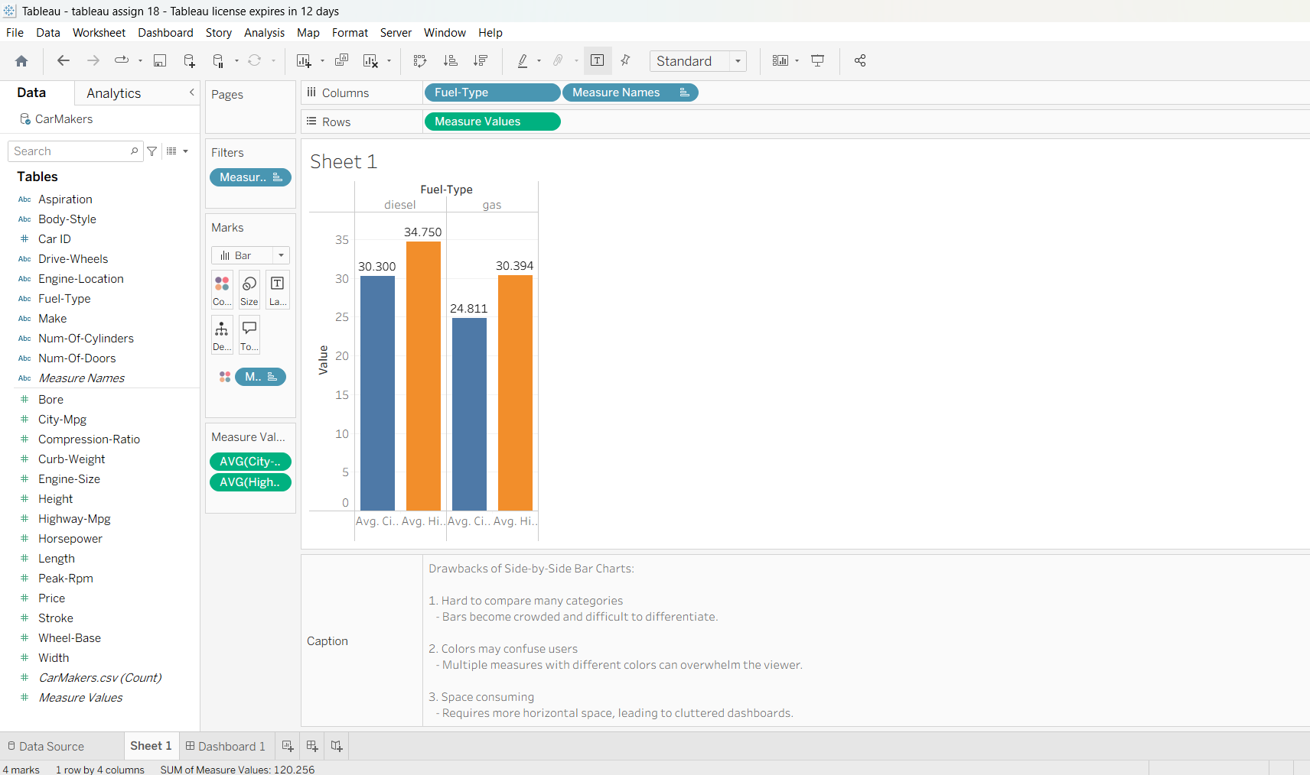

Step 1: Data Connection & Preparation
1. Open Tableau Desktop / Tableau Public.
2. Connect to CarMakers.csv.
3. Verify data types:
- Fuel-Type → Dimension
- City-mpg → Measure
- Highway-mpg → Measure

Step 2: Create Side-by-Side Bar Chart
1. Drag Fuel-Type → Columns.
2. Drag Measure Names → Columns.
3. Drag Measure Values → Rows.
4. Filter to City-mpg and Highway-mpg.
5. Set Marks type to Bar.
6. Drag Fuel-Type → Color.
7. Format chart with labels and clean axes.
Insights:
- Gas vehicles show higher highway mileage.
- Diesel vehicles maintain steady city mileage performance.

Step 3: Dashboard Creation
1. Create a new Dashboard.
2. Add the Side-by-Side Bar Chart.
3. Add title: “Fuel-Type Based Mileage Analysis”.
4. Add filters for Fuel-Type and Mileage Type.

Step 4: Story Presentation
1. Create a new Story.
2. Add dashboard and charts as story points.
3. Add captions explaining each insight.

Drawbacks of Side-by-Side Bar Charts
1. Hard to compare many categories when bars become crowded.
2. Colors may confuse users when too many measures are added.
3. Space consuming and may clutter dashboards.

Key Insights
- Gas cars have the highest average highway mileage.
- Diesel cars show consistent city mileage.
- Side-by-side bars clearly compare mileage differences.

Name: S Swetha
USN: 1VI23CD046

