SELF-EVALUATING
RAG LESSON GENERATOR
Project Documentation

An n8n workflow for generating, evaluating, and revising beginner-friendly educational content

Project topic | Introduction to Retrieval-Augmented Generation (RAG)
Target learner | 12th-grade graduate in India; limited English vocabulary; no technical background
Workflow platform | n8n with AI agents, structured output parsers, and a Data Table

1. Project Overview
This project implements a self-evaluating lesson-generation workflow in n8n. Given a topic and learner profile, it creates a lesson plan, generates a complete lesson, evaluates that lesson against six strict pass/fail checks, and either returns the accepted lesson or records the failure and attempts a revision.
The workflow is designed for the topic “Introduction to RAG.” Its learner profile is a 12th-grade graduate from India with limited English vocabulary and no technical background. The prompts instruct the agents to use simple words, short sentences, familiar examples, and explanations of technical terms.

2. Objectives
- Generate a complete, standalone lesson that is accessible to a beginner.
- Use a planning stage before lesson generation to support a logical teaching sequence.
- Evaluate generated content with explicit hard pass/fail criteria.
- Use evaluator feedback to revise lessons that do not pass.
- Store rejected attempts and reuse topic-related failure information in later runs.
- Limit repeated revisions and return a clear final status and rejection log.

3. Tools and Workflow Components
Component | Role in this workflow | Configuration / notes
n8n | Connects the steps and routes PASS/FAIL paths. | Manual trigger and IF nodes
AI agents | Plan, generate, evaluate, and revise the lesson. | Planner, Generator, Evaluator, Revision
OpenRouter Chat Model nodes | Provide the language model used by the agents. | Exported workflow specifies openai/gpt-4o-mini
Structured Output Parsers | Require predictable structured outputs. | Planner plan schema and evaluator decision/check schema
Data Table: lesson_failures | Stores rejected lessons and their failure information. | Fields include topic, lesson, failure_reason, failed_checks, run_id

4. Workflow Architecture

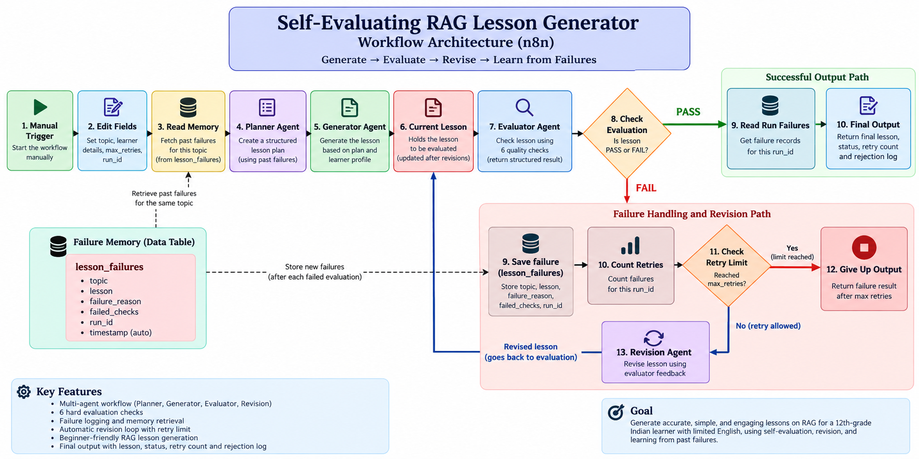
The workflow is a feedback loop. The same Current Lesson field is used to hold the latest version, so the revised lesson is evaluated again rather than starting a separate workflow.

5. Step-by-Step Operation

5.1 Start and configure input
The manual trigger starts the workflow. Edit Fields sets the topic to “Introduction to RAG,” the learner education, English level, technical background, a maximum of two retries, and a run ID based on the n8n execution ID.

5.2 Retrieve memory
Read Memory queries the lesson_failures Data Table for records matching the topic, with a limit of five records. The retrieved failed checks and reasons are supplied to the Planner and Generator as guidance to avoid repeating earlier problems.

5.3 Plan the lesson
The Planner Agent prepares a teaching plan rather than writing the lesson. The plan is intended to start with the main idea, explain why the topic matters, use a familiar example, explain the process, define important terms, and finish with a recap. A structured parser formats the plan.

5.4 Generate the lesson
The Generator Agent uses the plan, topic, learner profile, and memory guidance to produce the complete lesson. Its prompt requests simple English, short sentences, a logical sequence, explanations of technical terms, and no unsupported facts.

5.5 Evaluate the lesson
The Evaluator Agent assesses the current lesson using six hard checks. It returns an overall PASS or FAIL plus a result for each check, a reason for each failure, and a concrete correction. The structured output parser makes this evaluation available to the routing logic.

5.6 Route the result
Check Evaluation compares the evaluator’s decision with PASS. A passing lesson proceeds to Final Output. A failing lesson is stored in the failure table and proceeds to retry counting.

5.7 Revise and repeat
If the retry limit has not been exceeded, the Revision Agent receives the original/current lesson and evaluator feedback. It is instructed to correct every failed check, preserve correct material, and return the complete revised lesson. The revised lesson returns to Current Lesson and is evaluated again.

6. Evaluation Rubric
The evaluator applies these six checks with no partial credit. The lesson is not approved if any check fails.
Check | PASS requirement
1. Accuracy and grounding | Explain RAG correctly; do not claim it guarantees truth or prevents all hallucinations; do not present invented example information as fact.
2. Beginner-friendly language | Use simple English and short sentences suitable for a learner with no technical background.
3. Teaches by example | Include a familiar example showing how RAG finds information and uses it to answer.
4. No unexplained jargon | Explain technical terms in simple words before or when first used.
5. Key points covered | Explain what RAG is, why it is useful, how it works step by step, how documents are prepared and searched, and how retrieved information is used.
6. Clear teaching flow | Move logically from basic ideas to the process, example, and recap.

7. Failure Logging, Memory, and Retry Policy
When evaluation fails, the workflow writes a row to the lesson_failures Data Table. The row records the topic, rejected lesson, failed check names, failure reasons and suggested corrections, and run ID. The run ID allows the workflow to count failures belonging to the current execution and later assemble its rejection log.
The configured maximum is two retries. The first and second failed evaluations can lead to a revision. If the third evaluation also fails, the failure count is greater than the retry limit and the workflow routes to Give Up Output. This is intended to allow the initial generation plus up to two revisions.
Memory is implemented as stored failure records retrieved by topic and included in prompts. This is failure-informed generation; it is not automatic code modification or automatic rewriting of the rubric.

8. Final Outputs
The PASS path returns the following fields:
- status: passed
- topic
- retries_used
- final_lesson
- rejection_log
The Give Up path returns:
- status: failed_max_retries
- topic
- retries_used
- the most recent lesson for manual review
- rejection_log and a note that the lesson did not pass within the retry limit

9. Implementation Notes and Limitations
- The supplied workflow JSON specifies the OpenRouter model identifier openai/gpt-4o-mini for its chat-model nodes. The document therefore describes that exported configuration; it does not claim the workflow is configured to use Qwen.
- The workflow relies on an OpenRouter credential configured in the n8n instance. A person importing the JSON into another account or instance may need to configure their own credential.
- The Data Table must exist in the target n8n project with the expected fields, including run_id.
- The workflow’s memory retrieves prior records for the same topic. It does not use embeddings or semantic similarity search.
- A PASS indicates that the lesson passed the six configured checks. It is not a guarantee that every factual or instructional error has been detected.
- The workflow JSON describes configuration and routing. Successful runtime behavior should be demonstrated with actual executions; this document does not claim that test runs have passed.

10. Testing and Demonstration Plan
For the project demonstration, run and show these cases:
- PASS case: show the generated lesson, all six evaluator results, and Final Output.
- Revision case: show a failed check, its saved failure record, the Revision Agent output, and re-evaluation.
- Retry-limit case: if available, show the workflow returning failed_max_retries after the configured attempts.
- Memory case: after at least one failure has been stored, run the same topic again and show that prior failure information is included in the prompt.
Record the actual execution outcome, number of revisions, and any errors observed during testing before submitting the final demonstration. Do not report a case as successful unless it was run.

11. Conclusion
This project demonstrates a multi-step AI content-generation workflow with planning, generation, strict evaluation, failure logging, memory retrieval, and bounded revision. Its main contribution is a repeatable process for checking generated educational content and using evaluator feedback to improve a lesson, while keeping the final decision and rejection history visible.

Demo_link:

Demo_Link_1:https://www.loom.com/share/5efca7dfa8f3459c9c7135bc4c3d5968
Demo_Link_2:https://www.loom.com/share/78057914301c4c53b6fa0f225a310ec0
Demo_Link_3:https://www.loom.com/share/1a92d85bf5764727b738599f49d2c9e6

