Traveling Santa Problem
Abhinav S Godalla (01119442), Akshata R Chalke (01116014), Hima Swetha Gutti (01100555), Naga Vamsi Krishna Pabbisetty (01071855),
Subrahmanya Kalyana Yasaswy Kandukuri (01077915)

Introduction
Christmas is fast approaching, and Santa is getting ready to gift us all (unless you fall in the naughty list). Santa is taking special care so that he doesn’t miss out on anyone’s house. But he just realized that his reindeer, Rudolph, is not feeling that great and needs to get the ‘gift distribution’ done as quickly as possible. Santa needs to find two shortest-distance paths and he approached five computer scientists for that. In this paper, we attempt to solve Santa’s problem in two different methods.

Dataset
There are two datasets given for this problem. Both the datasets consist of X and Y co-ordinates of different locations. We need to find a path from these points and the cost value is the Euclidean distance between the points. The formula for Euclidean distance between points (x₁, y₁) and (x₂, y₂) is given as:
Distance = [(x₁ – x₂)² + (y₁ – y₂)²]^{1/2}

Methods
In this problem, we try to solve Santa’s problem using two methods. The first method is finding a path that yields minimum path cost. It works like an ordinary traveling salesman problem, which means that the next destination from our current point depends on choosing the path that requires minimum cost from all the options we have.
The other method is like the first method except that in here, we are supposed to provide two disjoint paths instead of
one. Both the paths are supposed to be disjoint.

Both the paths are calculated with the help of genetic algorithm. Genetic algorithm works by using operators like crossover, selection, and mutation.

Working of Genetic Algorithm: It basically has three stages – selection, crossover (also known as recombination), and mutation.

During the selection phase, a part of the existing population (the subjects or the features are called population) is chosen for breeding. Ideally, the percent of the population that satisfy the fitness function are chosen for the selection phase.

Then comes the crossover phase where we mate the strings we have chosen in the previous phase. Crossover, in general, involves swapping the strings that we have chosen during this phase. After this phase comes the next phase.

The third phase is the mutation phase. Here, we apply random mutation. We copy the bits from the crossover to the next population. For each bit we are to copy to the next population, we take in a small probability of error.

Based on these three operators majorly, we run our algorithm.

Traveling Salesman Problem

This method works by calculating the minimum path cost for the next step at every step. In our program, we used genetic algorithm to get this done.
In this case, we focus on generating the optimal path in each case. The optimal path in this case is the minimum distance between the points in our datasets.
The distance between a pair of points is measured by calculating the Euclidean distance (the formula that has been mentioned under of the previous headings).
Initially, we take the X and Y co-ordinates as a list and then proceed to create objects. We create a class in order to plot the points in the form of a scatterplot where X and Y are taken as vertices.
And we then create a class that tries to generate a random path on our given graph that we have created.
Then, we apply the genetic algorithm and try plotting the best path. We also calculate the total cost for the best path.

Disjoint Path method

This method is quite like our previous method except that the paths are supposed to be disjoint as the name suggests. None of the paths generated must be like the previous path because Santa wants a change, all the time!

Suppose if one of the paths generated contains an edge from A to B, then the next generated path must not contain an edge from A to B or B to A.

While implementing this method, we faced a challenge because we should make sure that the edge our path contained earlier should not exist in the next path.

So, we used an approach, though not ideal, that would give us the solution. After plotting the path for the traveling salesman problem, we randomly shuffled the points in the dataset and then, plotted a new path.

This way, we were able to avoid most of the edges plotted in the previous graph.

Language and Packages

We used Python programming language to solve this problem. We used Numpy and Random for operations like calculating Euclidean distance and picking random points or random shuffling. We used Pandas to read the dataset and work on them and used Matplotlib to plot the path.

FlowChart
The following are the flow charts for the genetic algorithm, task 1, and task 2.

The following is the flowchart for Genetic algorithm.
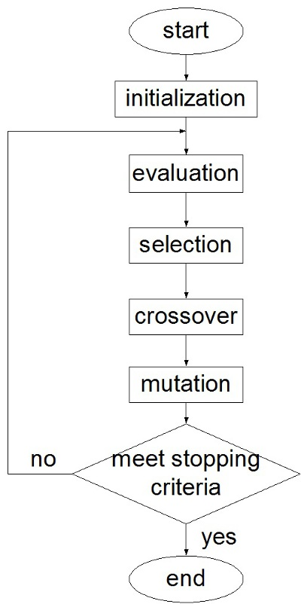

Using the genetic algorithm, the following is the flowchart for the first task.
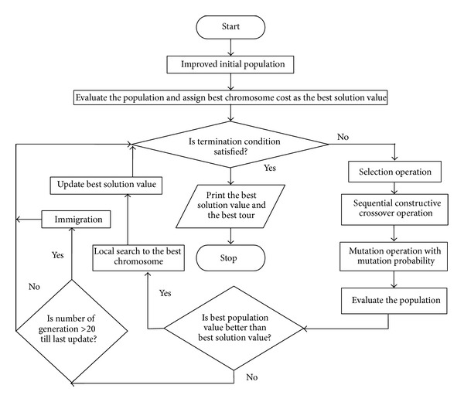

The flowchart for task 3 is as follows.
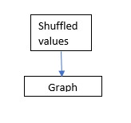

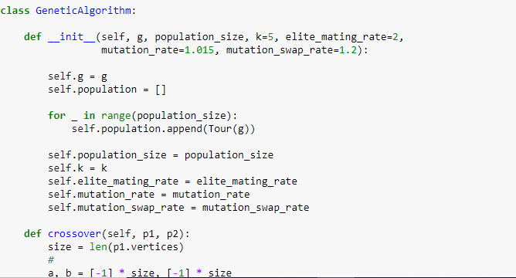

1)Code Snippet for genetic Algorithm

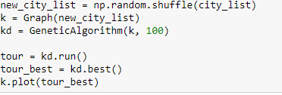2)Code Snippet for genetic Algorithm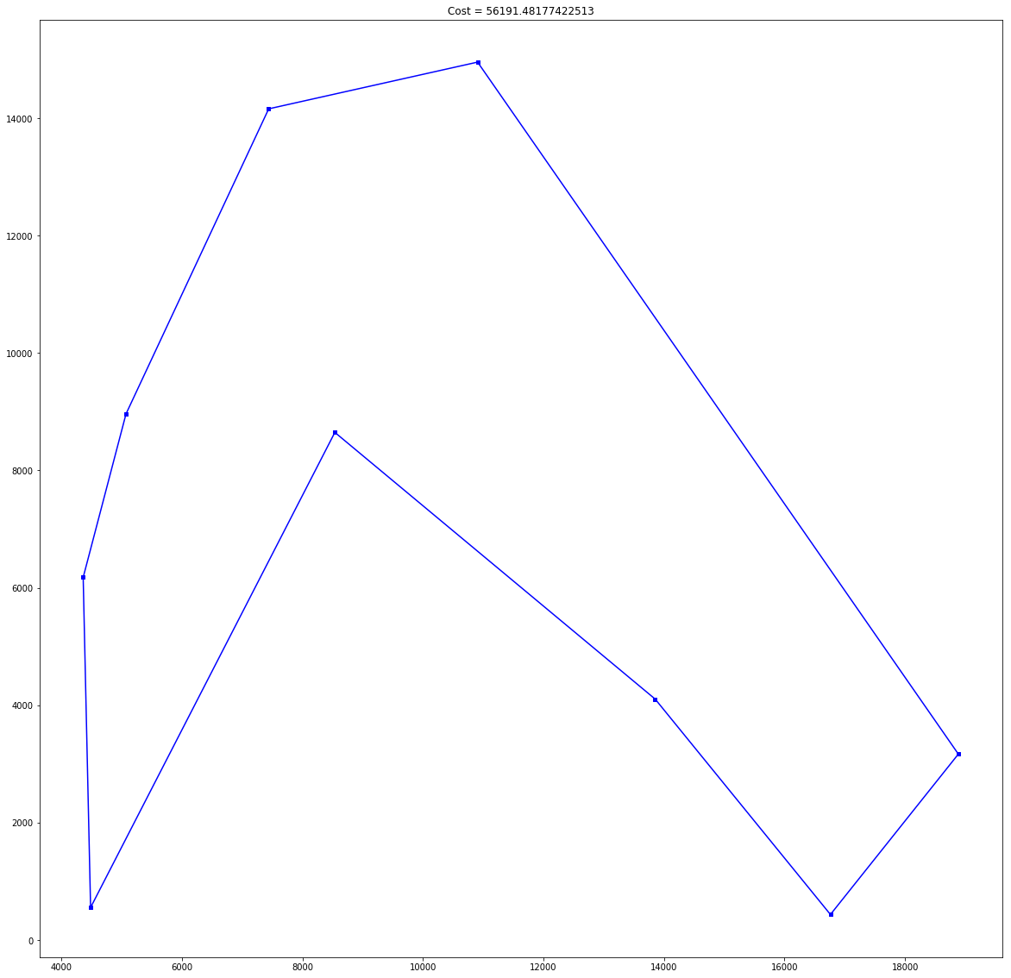
Initial path

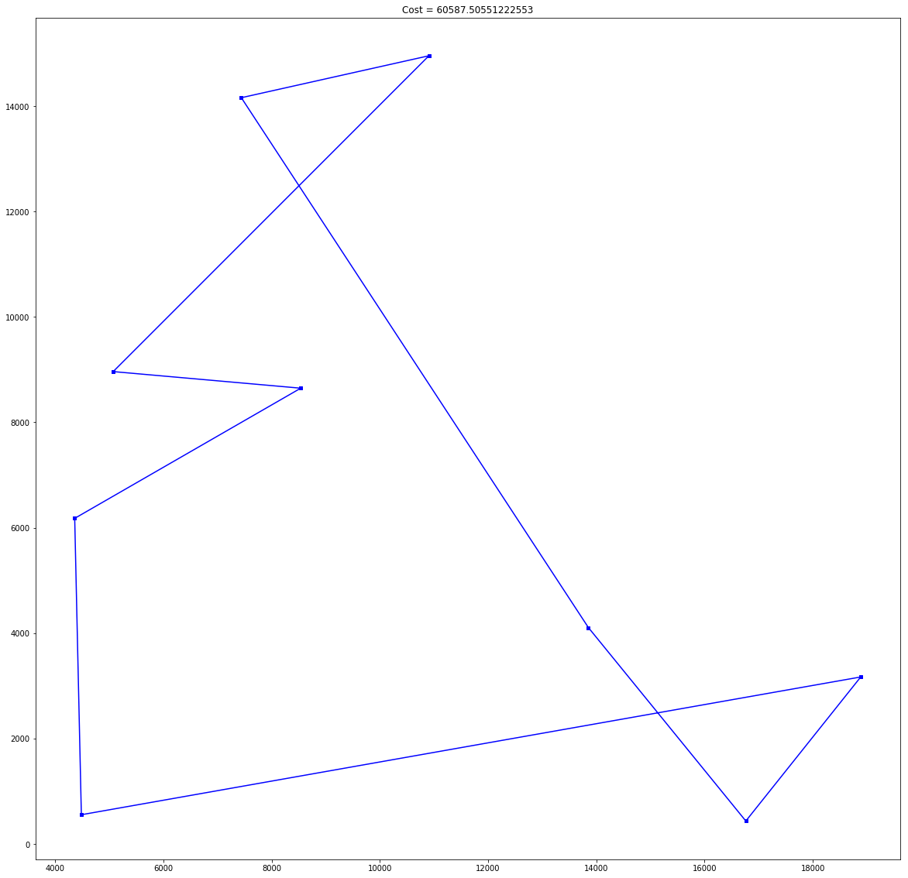
Distinct path

Results and Analysis
After trying out both the methods, we see that the total cost during the first task is 1299959.64 and the total cost during the second task is 1907338.61
We can conclude that the traveling salesman problem yields better results than the disjoint path method. One of the reasons could that we are randomly shuffling the points in the data.

References
The following are the sources that helped us with our quest in helping Santa.

- https://www.hindawi.com/journals/tswj/2014/258207/fig4/
- https://figshare.com/articles/_Flow_Chart_of_Genetic_Algorithm_with_all_steps_involved_from_beginning_until_termination_conditions_met_6_/1418786
- http://nbviewer.jupyter.org/url/norvig.com/ipython/TSP.ipynb
- https://www.kaggle.com/c/traveling-santa-problem#description
- https://stackoverflow.com/
- https://www.intechopen.com/books/convergence-and-hybrid-information-technologies/parameters-determination-for-optimum-design-by-evolutionary-algorithm

I

