**A REVIEW OF A LIVER PATIENT ANALYSIS USING MACHINE LAGUAGE**

**Introduction:**

**1.1 Overview:**

*Liver is the largest internal organ in the humanbody,it is essentialfor digesting food andreleasing thetoxic element of the body and plays a major role in metabolism and serving several vital functions. The liver is the largest glandular organ of the body. It weighs about 3 lb (1.36 kg) .The liver's main job is to strain the blood coming from the digestive tract, before passing it to therest of the body. The liver also detoxifies chemicals and metabolizes drugs. As it does so, the liver hides bile that ends upback in the intestines.*

*The liver also makes proteins importantfor blood clotting and other functions.The liver supports almost every organ in the body and is vital for our survival. Liver disease may notcause any symptoms at earlier stage or the symptoms may be vague, like weakness and loss of energy. Symptoms partly dependon the type and the extent of liver disease. Liver diseases are diagnosed based on the liver functional test[1].*

*Several diseases states can disturb the liver. Some of the diseases are Wilson's disease, hepatitis (an inflammation of the liver), liver cancer, and cirrhosis (a chronic inflammation that progresses ultimately to organ failure). Alcohol alters the metabolism of the liver, which can have on the whole detrimental effects if alcohol istaken over long periods oftime. Hemochromatosis can cause liver problems [2]*

**Common liver disorder:**

***•Fatty liveris:*** *a revocable condition where large vacuoles of triglyceride fat acquire in liver cells via the process of limit. It can occur in people with a high level of alcohol consumption as well as in people who never had alcohol.*

*•****Hepatitis:****(usually caused by a virus spread by excess contamination or direct contact with infected body fluids).*

*•****Cirrhosis:*** *of the liver is one of the most serious liver diseases. It is an action used to indicate all forms of diseases of the liver characterized by the significant loss of cells. The liver gradually contracts in size and becomes leathery and hard. The regenerative action continues under liver cirrhosis but the progressive loss of liver cells exceeds cell replacement.*

***•Liver cancer****: The risk of liver cancer is higher in those who have cirrhosis or who had valid types of viral hepatitis; but more often, the liver is the site of secondary (metastatic) cancers spread from other* organs.

**1.2 Purpose:**

*Therefore, the goal of this work is to evaluate the performance of different Machine Learning algorithms in order to reduce the high cost of liver disease diagnosis. Early prediction of liver disease using classification algorithms is an efficacious task that can help the doctors to diagnose the disease within a short duration of time.*

***2.PROBLEM DEFINITION & DESIGN THINKING:***

**2.1 Empathy Map:**

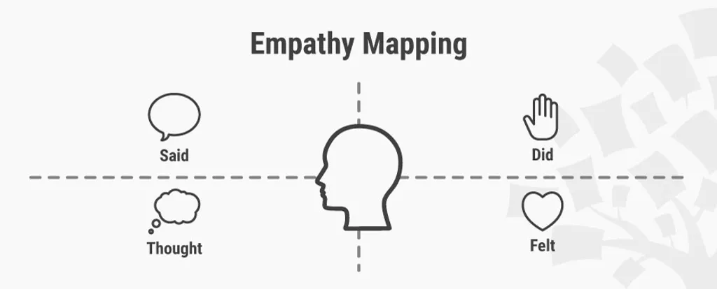

**Best practice**

***Step 1: Fill out the Empathy Map***

*Lay the four quadrants out on a table, draw them on paper or on a whiteboard.*

*Review your notes, pictures, audio, and video from your research/fieldwork and fill out each of the four quadrants while defining and synthesising:*

***Step 2: Synthesise NEEDS***

*Synthesise the user’s needs based on your Empathy Map. This will help you to define your design challenge.*

*Needs are verbs, i.e. activities and desires. Needs are not nouns, which will instead lead you to define solutions.*

*Identify needs directly from the user traits you noted. Identify needs based on contradictions between two traits, such as a disconnection between what a user says and what the user does.*

***Step 3: Synthesise INSIGHTS***

*An “Insight” is your remarkable realization that can help you to solve the current design challenge you’re facing.*

*Look to synthesise major insights, especially from contradictions between two user attributes. It can be found within one quadrant or in two different quadrants. You can also synthesise insights by asking yourself: “Why?” when you notice strange, tense, or surprising behaviour*

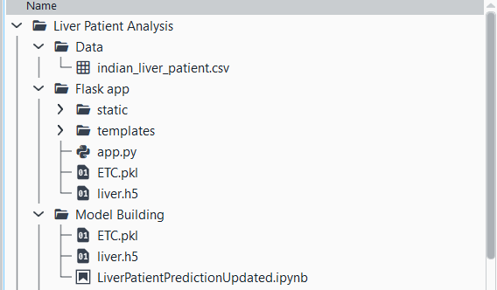

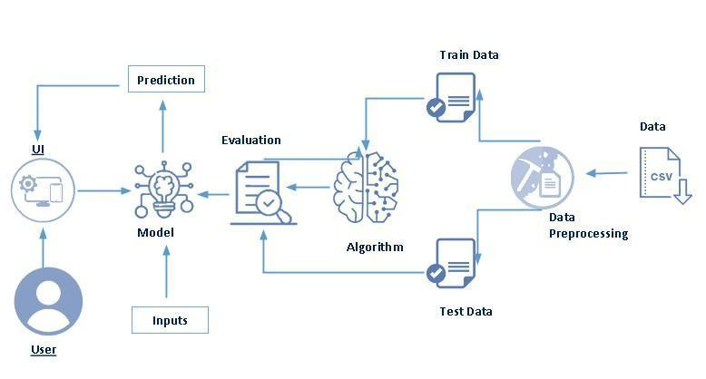

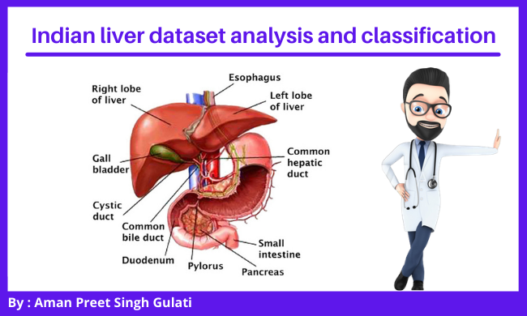

2.2 Ideation and Brainstorming:

*Brainstorming is the most frequently practiced form of ideation. We recommend that you use it along with Brainwriting, Brainwalking, and Braindumping. Here, you’ll learn the best practices from the very best experts from d-school and IDEO as well of the father of the Brainstorming technique, Alex Osborn.*

*of the Brainstorming technique, Alex Osborn.*

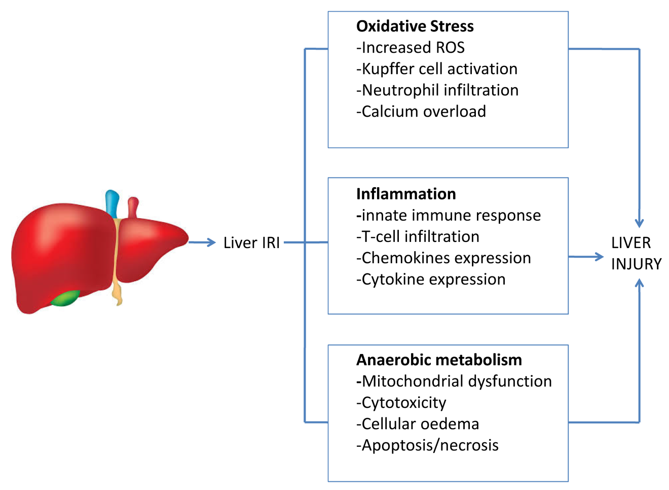

*Brainstorming is a great way to generate a lot of ideas that you would not be able to generate by just sitting down with a pen and paper. The intention of brainstorming is to leverage the collective thinking of the group, by engaging with each other, listening, and building on other ideas. Conducting a brainstorm also creates a distinct segment of time when you intentionally turn up the generative part of your brain and turn down the evaluative part. You can use brainstorming throughout any design or work process, of course, to generate ideas for design solutions, but also any time you are trying to generate ideas, such as planning where to do empathy work, or thinking about product and services related to your project.*

***Learn the Best Practices from the Experts Themselves:***

*Here, you’ll learn the best practices from the very best experts from d-school and IDEO as well of the father of the Brainstorming technique, Alex Osborn. IDEO is a hugely successful international design and consulting firm, which uses the Design Thinking methodology to advance innovative design in products, services, environments, and digital experiences.*

*The d.school celebrates Design Thinking, and it’s one of the most – if not the most – celebrated and recognised sources on Design Thinking and ideation techniques. d.school is a design school based in Stanford University in cooperation with the German Hasso Plattner Institute of the University of Potsdam.*

*Brainstorming (or just ‘brainstorm’, for short) has remained the cornerstone of the creative industry for decades and has evolved over the years as experience and learning developed from its variety of applications. Brainstorming essentially relies on a group of people coming together with their prior knowledge and research in order to gather ideas for solving the stated problem. It evokes images of exploration, experimental thinking, and wild ideas. However, all too often it takes the form of controlled sessions where dominant figures assert themselves over others and creativity ends up getting stifled. Or, in other cases, the facilitator does not succeed in helping the team steer towards the goal by keeping the user, the user’s need and the team’s insights about them in a problem statement – also called Point of View – at the front of the team’s minds.*

*In the following, we’ll let you in on some amazing brainstorm rules which will help keep you from falling into these traps, and instead facilitate innovative and effective brainstorming sessions.*

***Best Practice Rules for Effective Brainstorming:***

*Author/Copyright holder: Teo Yu Siang and Interaction Design Foundation. Copyright terms and licence: CC BY-NC-SA 3.0*

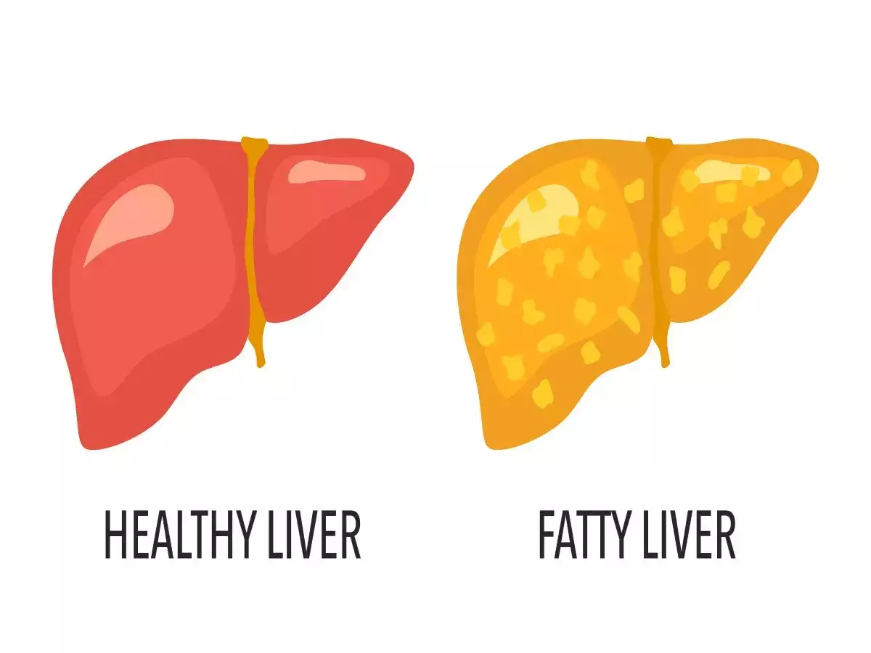

*Idea generation, or Ideation, is an art form, which is dependent on appointing an experienced facilitator and having an experienced team. However, we’re all here to learn, and here is how you can start learning to become a successful facilitator of brainstorming sessions. Brainstorming is about setting a safe, creative space for people to feel like they can say anything and be wild—and know that they will not be judged for doing so—so that new ideas can be born. The following are some rules, principles, and suggestions so you can make brainstorming sessions much more user-oriented, effective, innovative – and fun.*

***3.RESULT:***

***Experiment and Results:***

*So, let’s build the model but have some patience before analyzing the data set the pre-processing of data set should be done like remove the outliers using clustering, normalize the data and the advantage of using pre-processing to remove redundancy of the data, so initially the data set is as much as 200 tuples reduced to 157 tuples. For analyze the performance of the algorithm support vector machine (SVM) is used in classifying liver disease, Python using jupyter notebook and Weka tool software was used followed by 10 cross validation and compare both results and analyze which shows more accuracy of the model.*

*The accuracy of the model is find out by the help of the confusion matrix. The formula for measuring the accuracy of the model using confusion matrix as follows:*

*Abbreviation named are TP (True Positive) is the number of positive cases that is correctly classified as positive, TN (True Negative) is the number of negative cases that is correctly classified as negative, FP (False Positive) is the number of negative cases that is incorrectly classified as positive cases, FN (False Negative) is the number of positive cases that is incorrectly classified as negative cases. Mention below table 5 present the confusion matrix.*

*As a result, AI is able to aid physicians in making more productive and accurate imaging diagnoses, which can greatly minimize the physicians’ workload. In this respect, the two main methods of AI widely used in medical imaging are currently the traditional machine learning algorithm and deep learning algorithms.*

*Traditional machine learning algorithms mainly depend on the pre-defined concocted structures that describe in detail the inherent regular patterns in the extracted data and from the regions of interest containing explicit parameters according to expert knowledge*

**4.*ADVANTAGES & DISADVANTAGES:***

**Advantages:**

**.***Decision Trees are a type of Supervised Machine Learning where the data is continuously split according to a certain parameter.*

***.****Decision Tree calculation has a place with the supervised learning algorithms .*

***.****It is a flowchart-like structure in which each internal node represents a test on a feature (e.g. whether a coinflip comes up heads or tails) , each leaf node represents a class label (decision taken after computing all features) and branches represent conjunctions of features that lead to those class labels.*

***.****The tree can be explained by be explained by two entities, namely decision nodes and leaves.*

***.****The leaves are the decisions or the final outcomes. The paths from root to leaf represent classification rules.*

***.****Below diagram illustrate the basic flow of decision tree for decision making with labels (Rain(Yes), No Rain(No))“Support Vector Machine” (SVM) is a supervised machine learning algorithm which can be used for both classification and regression challenges.*

***.****However, it is mostly used in classification problems.*

***Disadvantage :***

***.****They are kernel based supervised classifier developed by Vapnik .*

***.****The objective of the support vector machine algorithm is to find a hyperplane in an N-dimensional space (N — the number of features) that distinctly classifies the data points.*

***.****In the SVM algorithm, we plot each data item as a point in n-dimensional space with the value of each feature being the value of a particular coordinate.*

***.****Then, we perform classification by finding the hyper-*

**5.APPLICATION:**

*Five algorithms namely Naïve Bayes, Logistic Regression, Decision Tree, Random forest and SVM were implemented for classification of the Indian Liver Patient Dataset. The models were generated for the training set and evaluated on the test set. Based on the accuracy of prediction it was observed that SVM achieved an accuracy of 74.09%.*

*The goal of this project is to reduce some of the delays caused by unnecessary detours between the hospital and the pathology laboratory. Historically, work has been done to detect the onset of heart disease, such as Parkinson’s, and machine learning algorithms have been de*

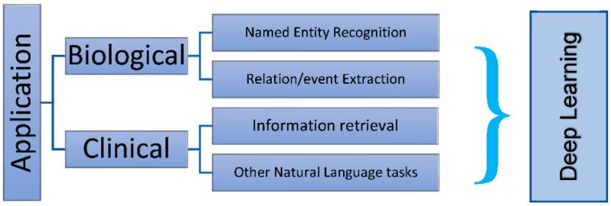

*veloped to predict liver disease in patients based on a variety of characteristics.*

*The application of AI evidently continues to appear as a valid assistant to traditional statistics as a result of its ability to process large amounts of data, while discovering concealed interconnections between variables. In other research focused on characterization of lesions, classifying, and segmenting, several approaches were utilized to test the convolutional neural network (CNN) model accuracy. Basically, the structure of a classical convolutional neural network consists of one or more convolutional layers, followed by a pooling layer. In principle, this unit can repeat itself as often as desired;*

***6.CONCLUSION:***

*In conclusion, we can state that AI provides medicine and science with enhanced predictions of identification, treatment, and survival following treatment for liver-related diseases as compared to conventional linear models. Innumerous factors determine the surgical course and the care required post-surgery. Major challenges encountered in surgeries are grafting ability, efficiency, and accuracy.*

*ML algorithms have dominantly played a crucial role in developing the prediction models for surgical accuracy* pies are developing trends to make them more user-friendly, lighter, and more ergonomically-sound, as well as safer and more accessible to clinicians

Artificial intelligence can anticipate the outcomes of output variables by identifying correlations between input factors. Artificial neural networks, decision tree classifiers, random forest, and Bayes classification models are the most extensively used classifiers for organ transplants. Artificial intelligence is currently being explored in the fields of organ transplantation (e.g., the liver), very specifically in survival analysis, and oncology

ANNs are impactful possibilities for identifying patter*need to look deeper using DL in clinical imaging, IR, genomics, and drug discovery. Using DL in analyzing massive biological data can help doctors guide patients and enhance medical wellness in an efficient manner. Issues and obstacles for applying deep learning in computational medicine could be data insufficiency, model interpretability, privacy and ethical issues, and heterogeneity. ML and DL serve as a guideline for future deep learning applications in medicine and health.*

*It is a universally accomplished fact that improving one’s wellbeing with AI research is difficult.*

*Initially, the data set was studied and prepared for inclusion in the classifiers. This was achieved by removing some rows containing zero values, modifying some columns indicating the skewness, and using appropriate conversion techniques (a hot coding) to make the labels more useful for classification purposes. The performance indicators for which the models will be evaluated have been resolved. The data set was then divided into a reading and testing package.*

*First, a simple predictive and base model (“Logistic Regression”) was developed in the data set to determine the value of the base accuracy. The biggest challenge in implementing this project was in two areas: defining learning algorithms and selecting the appropriate parameters for precise configuration. Initially, making a decision on 3 or 4 methods out of the many choices available at sklearn was very tedious.*

*Algorithms and Techniques used to develop this Liver Patient Analysis Machine Learning Project are*

*1. Random Forest Classifier:*

*2. Gaussian Naive Bayes Classifier*

*3. Logistic Regression:*

**7.FUTURE SCOPE :**

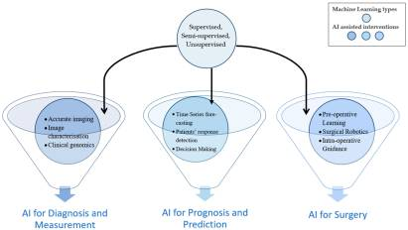

*. We might* Develop the use of AI in surgical practice by providing complete telemetry and a sophisticated viewing console. Machine learning improves surgical skill development, surgical process efficiency, surgical guiding, and postoperative outcome prediction. Tension sensors on robotic arms and augmented reality approaches can assist in improving surgical outcomes and tracking organ movement.

The application of AI in robotic surgery is predicted to improve future surgical training as well as the operative experience. Both strive to achieve precision surgery and hence improve surgical treatment. Using AI in master-slave robotic surgery may allow for a more gradual transition to autonomous robotic surgery

The rapies, rehabilitation, and hospital automation, in particular, developing robots for the least invasive procedures. The combination of imaging, sensing, and robotics might affect patient care pathways toward precision intervention and patient-specific therapy. Future robotic therans that are too complicated for a doctor to understand, and they can make very close predictions on data, reaching 95% for 3-month’s graft survival. However, it is expected that yet to be implemented neural networks have the potential to overcome some of the limitations of ANNs, particularly the lack of knowledge about the variables they give. For example, random forest algorithms may boost confidence in using marginal organs and improve transplant outcomes

**8.APPENDIX:**

**.**AKMS Rahman, FMJM Shamrat, Z Tasnim… - … Journal of Scientific & …, 2019 - researchgate.net Chronic Liver Disease is the leading cause of global death that impacts the massive quantity of humans around the world. This disease is caused by an assortment of elements that harm

**.**B Khan, PK Shukla, MK Ahirwar… - Handbook of Research on …, 2021 - igi-global.com Liver diseases avert the normal activity of the liver. Discovering the presence of liver disorder at an early stage is a complex task for the doctors. Predictive analysis of liver …

**A.SOURCE CODE:**



