SMART WATER SYSTEM

TEAM MEMBERS

BHARATHI G 412721106007

KALPANA S 412721106022

RAGHUL T 412721106036

VIGNESH M 412721106051

**PROBLEM STATEMENT:**

* This project aims to develop a smart water quality monitoring system using IoT technology to promote water conservation and improve public health.
* The system will be able to monitor the pH, water level, turbidity, conductivity, and temperature of water in real time and transmit the data to a cloud-based platform for analysis and visualization.
* The system will be used to identify and address water quality issues early on, thereby reducing the risk of water pollution and ensuring the safety of drinking water

**OBJECTIVE:**

To implement an IoT-based water consumption monitoring system in public places to promote water conservation by making real-time water consumption data publicly.This includes the following sub-objectives:

* Define the specific requirements of the system, such as the types of sensors to be used, the data to be collected, and the frequency of data collection.
* Design the IoT sensor system, including the hardware and software components, and the communication protocol to be used.
* Develop the data-sharing platform, including the web server and database to store and display the water consumption data.
* Integrate the IoT sensor system and the data-sharing platform using IoT technology and Python.

**LIMITATIONS OF EXISTING ALGORITHMS**.

IoT sensors to monitor water consumption in public places, facing some following limitations:

* Accuracy: Existing algorithms for water consumption monitoring are not always accurate, especially when used to measure water consumption from multiple sources. This is because these algorithms can be affected by a number of factors, such as the type of water meter used, the quality of the data collected, and the presence of noise in the data.
* Cost: Existing algorithms for water consumption monitoring can be expensive to develop and implement. This is because these algorithms often require complex hardware and software.
* Complexity: Existing algorithms for water consumption monitoring can be complex to develop and understand. This can make it difficult to troubleshoot problems with these algorithms or to adapt them to new applications.
* Scalability: Existing algorithms for water consumption monitoring may not be scalable to large deployments. This is because these algorithms can be computationally expensive, and they may not be able to handle the large volume of data generated by large deployments of water meters.

**Concept of proposed method:**

* The Internet of Things (IoT) are enabling new types of environmental monitoring systems. One such system, which has been developed using the Arduino software platform, uses a variety of wireless communication standards to monitor water quality. The system includes a microcontroller, mobile communications, assorted water quality monitoring sensors, and an analog-to-digital converter (ADC).
* To develop complex environmental monitoring systems that are also cost-effective and easy to deploy. The water quality monitoring using IOT consists of three levels:
* Level 1 consists of the sensor part
* Level 2 consists of the cloud part
* Level 3 consists of the user part

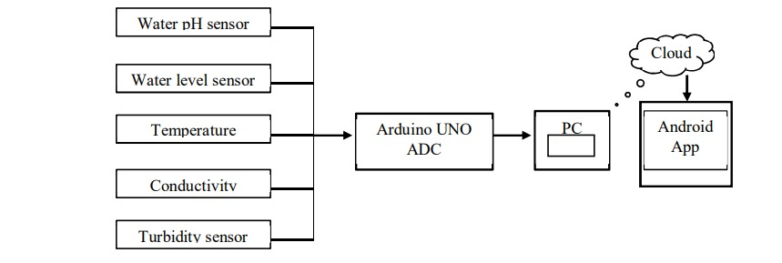

* A smart water quality monitoring system that uses a reconfigurable smart water sensor interface device to integrate data storage, data processing, and wireless transmission. The system consists of the following hardware components:
  + pH sensor
  + Temperature sensor
  + Turbidity sensor
  + Water flow sensor
  + Conductivity sensor
  + Wi-Fi module
  + Arduino board
* The Arduino board is the heart of the system and controls the sensors and data transmission. The Wi-Fi module allows the system to transmit data to a cloud-based platform. To use the system, the admin first registers himself to the cloud and logs in. He then uploads the sensor data to the cloud, where it is stored in a folder. The admin can then download the data to his Android phone using an app. Users of the system can log in to their accounts and give commands to acquire values. The system will then upload the sensor data to the cloud, where the user can download it.
* Water quality assessment provide the base line information on water safety. Since water quality in any source of water and at the point of use can change with time and other factors continuous monitoring of water is essential.
  + Microbiological parameters
  + Physical parameters
  + Harmful chemical

**DETAILS OF ALGORITHM**

* Data collection: The algorithm will collect data from the IoT sensors in real time. This data will include the pH, water level, turbidity, conductivity, and temperature of the water.
* Data preprocessing: The algorithm will preprocess the collected data to remove any noise or errors. This may involve filtering the data, smoothing the data, or filling in any missing data points.
* Data analysis: The algorithm will analyze the pre processed data to identify any water quality issues. This may involve comparing the data to historical data or to established water quality standards.
* Alert generation: If the algorithm identifies any water quality issues, it will generate an alert to notify the appropriate authorities.

**CONCLUSION:**

The proposed smart system of single chip solution to interface transducers to sensor network using Arduino is presented with wireless method by using a IOT. The results of the five parameters of water quality are verified that the system achieved the reliability and feasibility of using it for the actual monitoring purposes. The water temperature may vary from 0 to 0.4 Degree Celsius depending on the speed of the ambient air temperature cycles. The time interval of monitoring can be changed depending on the need. The proposed system inherits high execution speed and reusable Intellectual Property (IP) design. The proposed system will assist in protecting the ecological environment of water resources. The smart system minimizes the time and costs in detecting water quality of a reservoir as part of the environmental management. The WSN network will be developed in the future comprising of more number of nodes to extend the coverage range.

**REFERENCES:**

[1] B. Corona, M. Nakano, H. Pérez, “Adaptive Watermarking Algorithm for Binary Image Watermarks”, Lecture Notes in Computer Science, Springer, pp. 207-215, 2004.

[2] A. Reddy and B. N. Chatterji, "A new wavelet based logo-watermarking scheme," Pattern Recognition Letters, vol. 26, pp. 1019-1027, 2005.

[3] P. S. Huang, C. S. Chiang, C. P. Chang, and T. M. Tu, "Robust spatial watermarking technique for colour images via direct saturation adjustment," Vision, Image and Signal Processing, IEE Proceedings -, vol. 152, pp. 561-574, 2005.