**PL/SQL EXERCISES**

**Exercise 1: Control Structures**

CREATE TABLE Customers (

CustomerID NUMBER PRIMARY KEY,

Name VARCHAR2(50),

Age NUMBER,

InterestRate NUMBER

);

INSERT INTO Customers VALUES (1, 'Ravi', 65, 7.5);

INSERT INTO Customers VALUES (2, 'Priya', 45, 8.0);

INSERT INTO Customers VALUES (3, 'John', 70, 6.5);

INSERT INTO Customers VALUES (4, 'Anu', 58, 9.0);

COMMIT;

**SCENARIO 1 :**

DECLARE

    CURSOR cur_customers IS

        SELECT CustomerID, InterestRate, Age FROM Custome  WHERE Age > 60;

BEGIN

    FOR rec IN cur_customers LOOP

        UPDATE Customers

        SET InterestRate = InterestRate - (InterestRate * 0.01)

        WHERE CustomerID = rec.CustomerID;

    END LOOP;

    COMMIT;

    DBMS_OUTPUT.PUT_LINE('Discount applied to customers above 60 years.');

END;

**OUTPUT :** 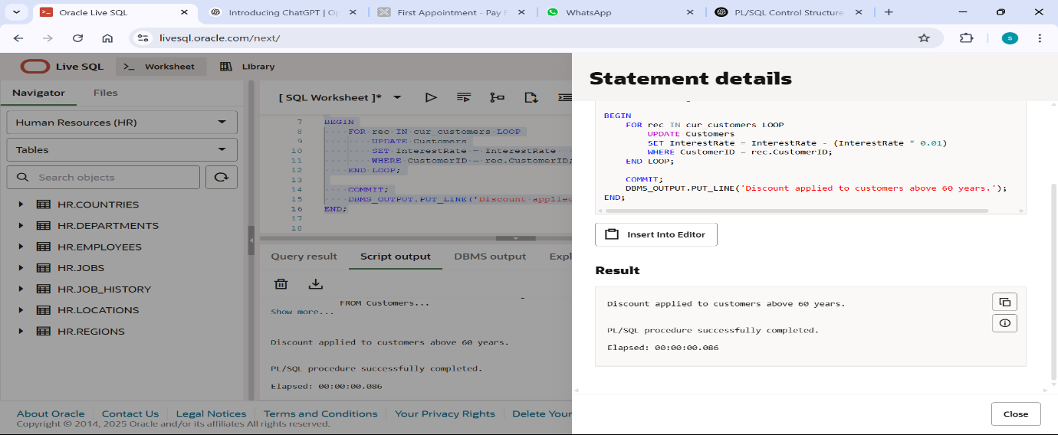

**SCENARIO 2 :**

DECLARE

    CURSOR cur_vip IS

        SELECT CustomerID

        FROM Customers

        WHERE Balance > 10000;

BEGIN

    FOR rec IN cur_vip LOOP

        UPDATE Customers

        SET IsVIP = 'TRUE'

        WHERE CustomerID = rec.CustomerID;

    END LOOP;

    COMMIT;

    DBMS_OUTPUT.PUT_LINE('VIP status updated for customers with balance over 10,000.');

END;

**OUTPUT :**

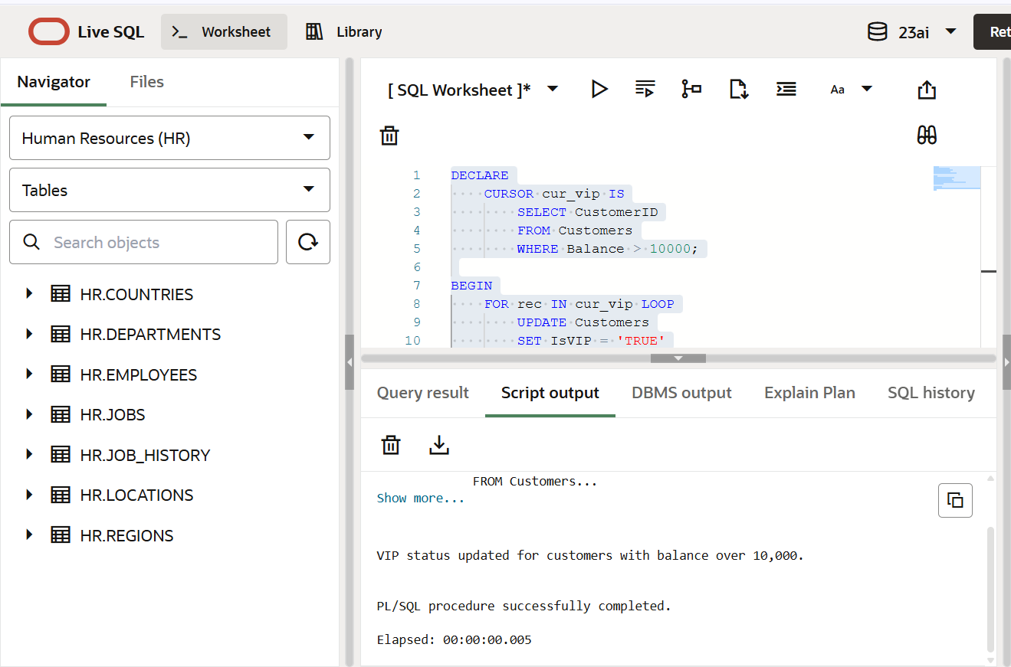

**SCENARIO 3 :**

DECLARE

    CURSOR cur_vip IS

        SELECT CustomerID

        FROM Customers

        WHERE Balance > 10000;

BEGIN

    FOR rec IN cur_vip LOOP

        UPDATE Customers

        SET IsVIP = 'TRUE'

        WHERE CustomerID = rec.CustomerID;

    END LOOP;

    COMMIT;

    DBMS_OUTPUT.PUT_LINE('VIP status updated for customers with balance over 10,000.');

END;

**OUTPUT :**

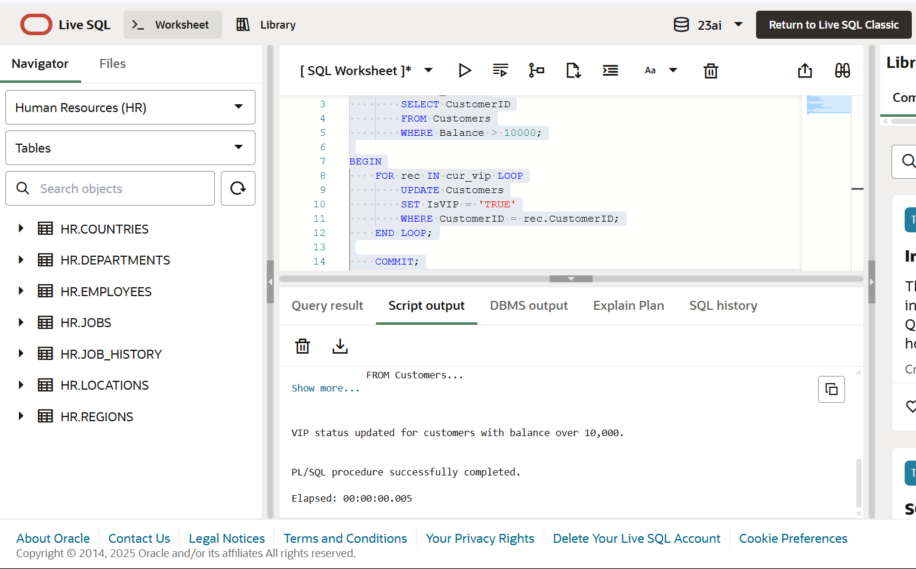

**Exercise 2: Stored Procedures**

CREATE TABLE Accounts (

AccountID NUMBER PRIMARY KEY,

AccountType VARCHAR2(20),

Balance NUMBER

);

INSERT INTO Accounts VALUES (101, 'Savings', 1000);

INSERT INTO Accounts VALUES (102, 'Current', 2000);

INSERT INTO Accounts VALUES (103, 'Savings', 3000);

COMMIT;

**SCENARIO 1 :**

CREATE OR REPLACE PROCEDURE ProcessMonthlyInterest IS

BEGIN

    UPDATE Accounts

    SET Balance = Balance + (Balance * 0.01)

    WHERE AccountType = 'Savings';

    COMMIT;

    DBMS_OUTPUT.PUT_LINE('Monthly interest applied to all savings accounts.');

END;

**OUTPUT :**

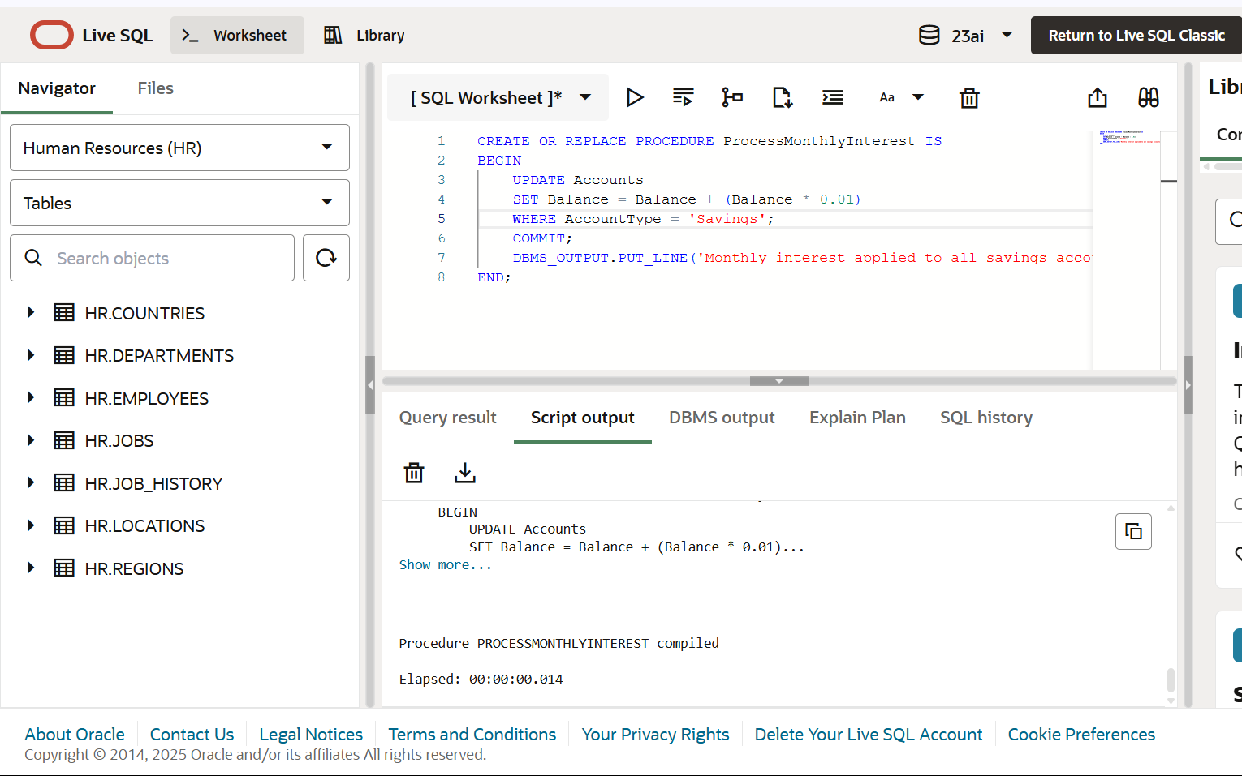

**SCENARIO 2 :**

CREATE TABLE Employees (

EmployeeID NUMBER PRIMARY KEY,

Name VARCHAR2(50),

DepartmentID NUMBER,

Salary NUMBER

);

INSERT INTO Employees VALUES (1, 'John', 10, 50000);

INSERT INTO Employees VALUES (2, 'Sara', 10, 52000);

INSERT INTO Employees VALUES (3, 'Mike', 20, 48000);

COMMIT;

CREATE OR REPLACE PROCEDURE UpdateEmployeeBonus (

    dept_id IN NUMBER,

    bonus_pct IN NUMBER  -- e.g., 0.10 = 10%

) IS

BEGIN

    UPDATE Employees

    SET Salary = Salary + (Salary * bonus_pct)

    WHERE DepartmentID = dept_id;

    COMMIT;

    DBMS_OUTPUT.PUT_LINE('Bonus applied to department ' || dept_id);

END;

**OUTPUT :**

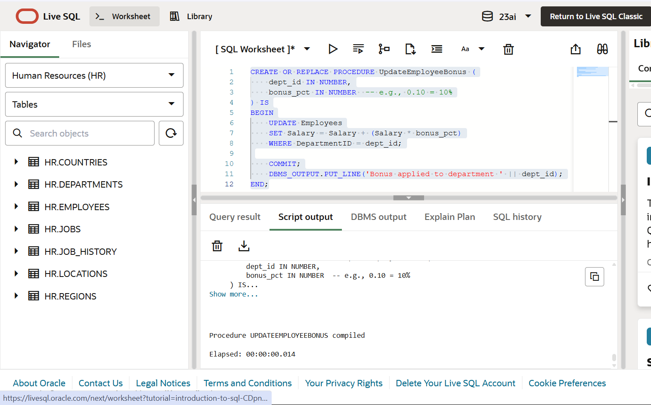

**SCENARIO 3 :**

CREATE OR REPLACE PROCEDURE TransferFunds (

    from_acc IN NUMBER,

    to_acc IN NUMBER,

    amt IN NUMBER

) IS

    insufficient_balance EXCEPTION;

    v_balance NUMBER;

BEGIN

    -- Check balance of source account

    SELECT Balance INTO v_balance FROM Accounts WHERE AccountID = from_acc FOR UPDATE;

    IF v_balance < amt THEN

        RAISE insufficient_balance;

    END IF;

    UPDATE Accounts

    SET Balance = Balance - amt

    WHERE AccountID = from_acc;

    UPDATE Accounts

    SET Balance = Balance + amt

    WHERE AccountID = to_acc;

    COMMIT;

    DBMS_OUTPUT.PUT_LINE('Transferred ' || amt || ' from Account ' || from_acc || ' to Account ' || to_acc);

EXCEPTION

    WHEN insufficient_balance THEN

        DBMS_OUTPUT.PUT_LINE('Transfer failed: insufficient balance in Account ' || from_acc);

        ROLLBACK;

    WHEN OTHERS THEN

        DBMS_OUTPUT.PUT_LINE('An error occurred: ' || SQLERRM);

        ROLLBACK;

END;

**OUTPUT :**

