**REACT HANDS-ON**

**1.**

import React from 'react';

function App() {

  return (

    <div>

      <h1 >Welcome to the first session of React</h1>

    </div>

  );

}

export default App;

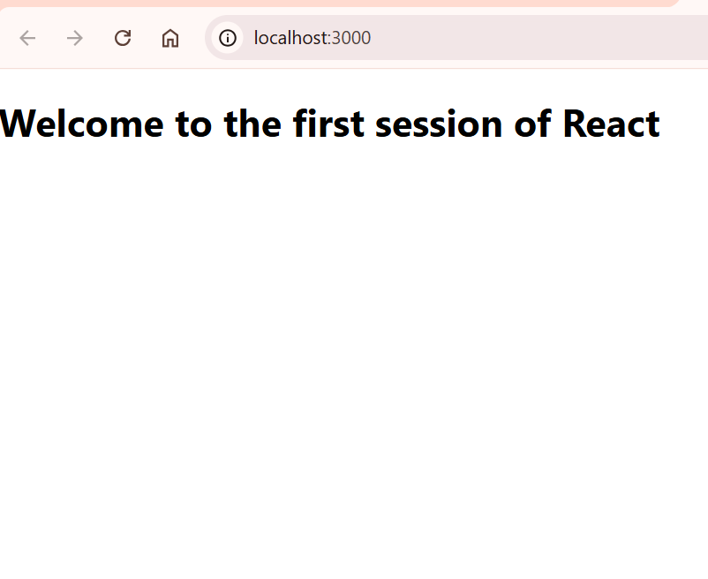

**2.**

**Home.js**

import React, { Component } from 'react';

class Home extends Component {

  render() {

    return <h2>Welcome to the Home page of Student Management Portal</h2>;

  }

}

export default Home;

**About.js**

import React, { Component } from 'react';

class About extends Component {

  render() {

    return <h2>Welcome to the About page of the Student Management Portal</h2>;

  }

}

export default About;

**Contact.js**

import React, { Component } from 'react';

class Contact extends Component {

  render() {

    return <h2>Welcome to the Contact page of the Student Management Portal</h2>;

  }

}

export default Contact;

**App.js**

import React from 'react';

import './App.css';

import Home from './Components/Home';

import About from './About';

import Contact from './Contact';

function App() {

  return (

    <div className="App">

      <Home />

      <About />

      <Contact />

    </div>

  );

}

export default App;

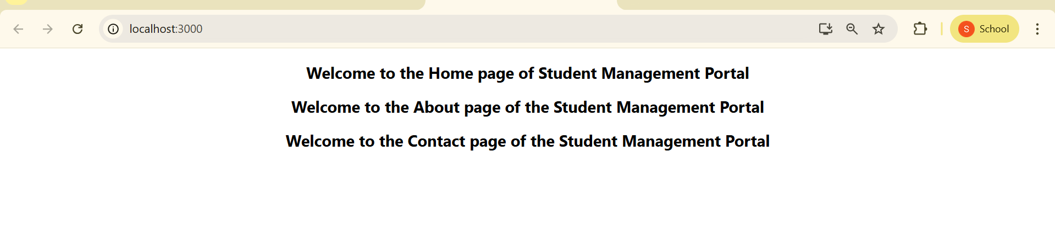

**3.**

**CalculateScore.js**

import React, { useState } from 'react';

import '../Stylesheets/myStyles.css';

function CalculateScore() {

  const [name, setName] = useState('');

  const [school, setSchool] = useState('');

  const [total, setTotal] = useState('');

  const [goal, setGoal] = useState('');

  const [average, setAverage] = useState(null);

  const handleCalculate = () => {

    if (total && goal) {

      const avg = ((parseFloat(total) / parseFloat(goal)) * 100).toFixed(2);

      setAverage(avg);

    }

  };

  return (

    <div className="container">

      <h2>Student Score Calculator</h2>

      <input type="text" placeholder="Enter Name" onChange={(e) => setName(e.target.value)} />

      <input type="text" placeholder="Enter School" onChange={(e) => setSchool(e.target.value)} />

      <input type="number" placeholder="Enter Total Score" onChange={(e) => setTotal(e.target.value)} />

      <input type="number" placeholder="Enter Goal Score" onChange={(e) => setGoal(e.target.value)} />

      <button onClick={handleCalculate}>Calculate Average</button>

      {average && (

        <div className="result">

          <p><strong>Name:</strong> {name}</p>

          <p><strong>School:</strong> {school}</p>

          <p><strong>Average Score:</strong> {average}%</p>

        </div>

      )}

    </div>

  );

}

export default CalculateScore;

**myStyles.css**

.container {

  max-width: 400px;

  margin: 50px auto;

  padding: 30px;

  background: #f0f4ff;

  border-radius: 10px;

  box-shadow: 0px 0px 10px #ccc;

  font-family: 'Segoe UI', sans-serif;

}

.container h2 {

  text-align: center;

  margin-bottom: 20px;

}

.container input {

  width: 100%;

  padding: 10px;

  margin: 8px 0;

  box-sizing: border-box;

  border: 1px solid #ccc;

  border-radius: 5px;

}

.container button {

  width: 100%;

  padding: 10px;

  background-color: #0077cc;

  color: white;

  border: none;

  border-radius: 5px;

  margin-top: 10px;

  cursor: pointer;

}

.container button:hover {

  background-color: #005fa3;

}

.result {

  margin-top: 20px;

  background-color: #e7f3ff;

  padding: 15px;

  border-radius: 5px;

}

**App.js**

import React from 'react';

import './Stylesheets/myStyles.css';

import CalculateScore from './Components/CalculateScore';

function App() {

  return (

    <div className="App">

      <CalculateScore />

    </div>

  );

}

export default App;

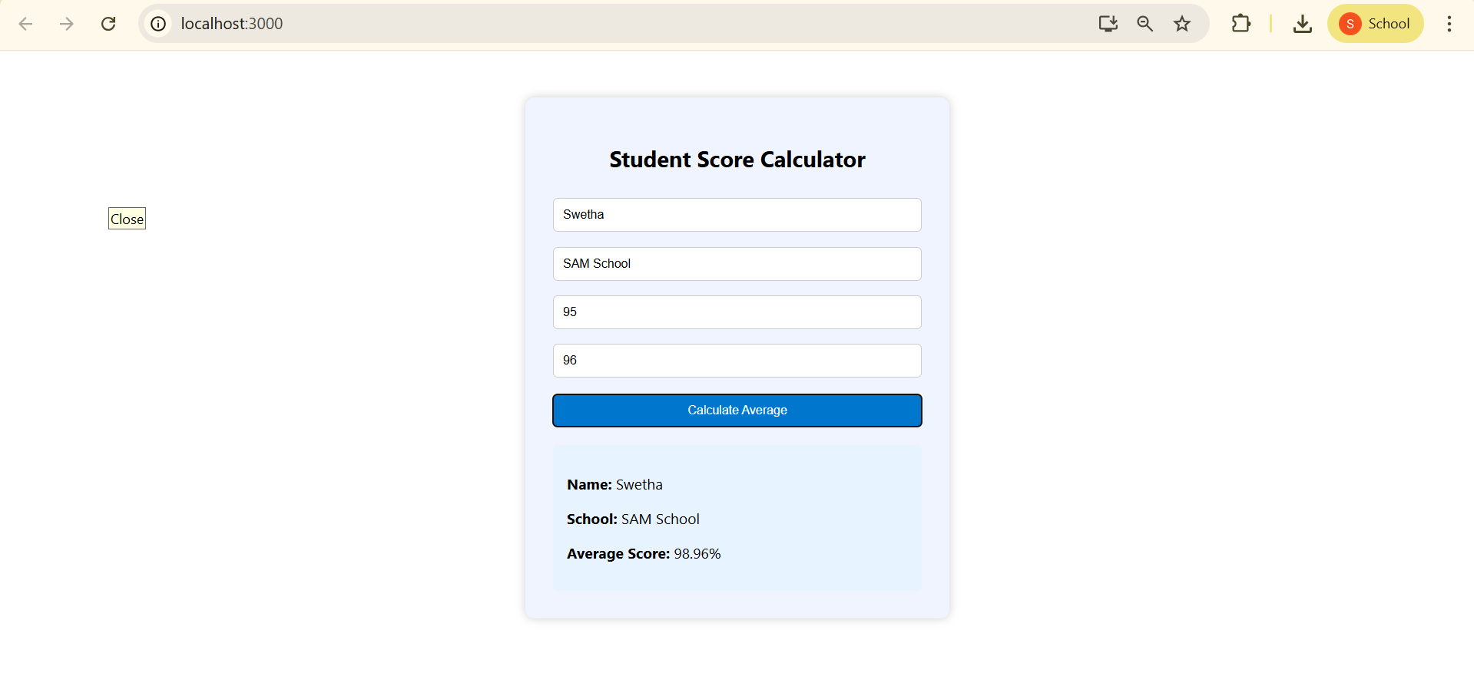

**4.**

**Post.js**

import React from 'react';

const Post = ({ title, body }) => {

  return (

    <div className="post">

      <h2>{title}</h2>

      <p>{body}</p>

    </div>

  );

};

export default Post;

**Posts.js**

import React, { Component } from 'react';

import Post from './Post';

class Posts extends Component {

  constructor(props) {

    super(props);

    this.state = {

      posts: [],

      hasError: false

    };

  }

  loadPosts = async () => {

    try {

      const response = await fetch('https://jsonplaceholder.typicode.com/posts');

      const data = await response.json();

      this.setState({ posts: data.slice(0, 5) }); // Load first 5 posts for brevity

    } catch (error) {

      throw new Error('Failed to load posts');

    }

  }

  componentDidMount() {

    this.loadPosts();

  }

  componentDidCatch(error, info) {

    alert("An error occurred in the Posts component.");

    console.error("Error:", error);

    console.error("Info:", info);

    this.setState({ hasError: true });

  }

  render() {

    if (this.state.hasError) {

      return <h1>Something went wrong.</h1>;

    }

    return (

      <div>

        <h1>Blog Posts</h1>

        {this.state.posts.map(post => (

          <Post key={post.id} title={post.title} body={post.body} />

        ))}

      </div>

    );

  }

}

export default Posts;

**App.js**

import React from 'react';

import Posts from './Posts';

function App() {

  return (

    <div className="App">

      <Posts />

    </div>

  );

}

export default App;

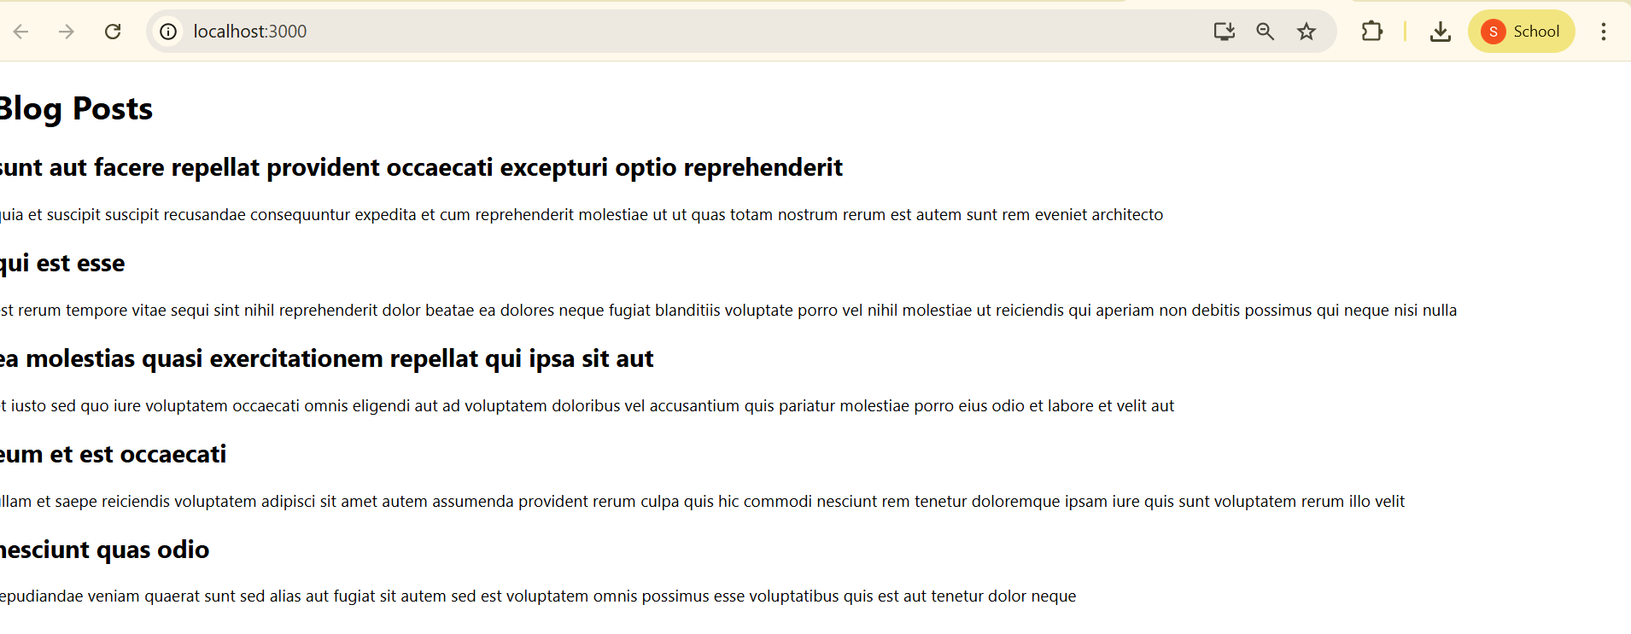

**5.**

**CohortDetails.js**

import React from 'react';

import styles from './CohortDetails.module.css'; // Import CSS Module

const CohortDetails = ({ cohort }) => {

  // Inline style based on status

  const headingStyle = {

    color: cohort.status.toLowerCase() === 'ongoing' ? 'green' : 'blue'

  };

  return (

    <div className={styles.box}>

      <h3 style={headingStyle}>{cohort.name}</h3>

      <dl>

        <dt>Status:</dt>

        <dd>{cohort.status}</dd>

        <dt>Start Date:</dt>

        <dd>{cohort.startDate}</dd>

        <dt>End Date:</dt>

        <dd>{cohort.endDate}</dd>

      </dl>

    </div>

  );

};

export default CohortDetails;

**CohortDetails.module.css**

.box {

  width: 300px;

  display: inline-block;

  margin: 10px;

  padding: 10px 20px;

  border: 1px solid black;

  border-radius: 10px;

dt {

  font-weight: 500;

}

**App.js**

import React from 'react';

import CohortDetails from './Components/CohortDetails';

function App() {

  const cohorts = [

    {

      name: 'React Bootcamp',

      status: 'Ongoing',

      startDate: '2025-07-01',

      endDate: '2025-08-01',

    },

    {

      name: 'Node.js Mastery',

      status: 'Completed',

      startDate: '2025-05-01',

      endDate: '2025-06-01',

    },

  ];

  return (

    <div>

      <h1>Cohort Dashboard</h1>

      {cohorts.map((cohort, index) => (

        <CohortDetails key={index} cohort={cohort} />

      ))}

    </div>

  );

}

export default App;

