**REACT**

**1.Cricket App**

**IndianPlayers.js**

// src/components/IndianPlayers.js

import React from 'react';

const IndianPlayers = () => {

  const allPlayers = ['Virat', 'Rohit', 'Rahul', 'Pant', 'Jadeja', 'Ashwin'];

  const oddTeam = allPlayers.filter((_, i) => i % 2 === 0);

  const evenTeam = allPlayers.filter((_, i) => i % 2 !== 0);

  const [p1, p2, p3] = oddTeam;

  const [q1, q2, q3] = evenTeam;

  const T20Players = ['Surya', 'Ishan', 'Hardik'];

  const RanjiPlayers = ['Gambhir', 'Dhawan', 'Karun'];

  const allIndianPlayers = [...T20Players, ...RanjiPlayers];

  return (

    <div>

      <h2>Odd Team Players </h2>

      <ul>

        <li>{p1}</li>

        <li>{p2}</li>

        <li>{p3}</li>

      </ul>

      <h2>Even Team Players </h2>

      <ul>

        <li>{q1}</li>

        <li>{q2}</li>

        <li>{q3}</li>

      </ul>

      <h2>All Indian Players Merged</h2>

      <ul>

        {allIndianPlayers.map((player, idx) => (

          <li key={idx}>{player}</li>

        ))}

      </ul>

    </div>

  );

};

export default IndianPlayers;

**ListofPlayers.js**

// src/components/ListofPlayers.js

import React from 'react';

const ListofPlayers = () => {

  const players = [

    { name: 'Virat', score: 85 },

    { name: 'Rohit', score: 60 },

    { name: 'Rahul', score: 75 },

    { name: 'Pant', score: 45 },

    { name: 'Jadeja', score: 95 },

    { name: 'Ashwin', score: 30 },

    { name: 'Shami', score: 80 },

    { name: 'Bumrah', score: 50 },

    { name: 'Surya', score: 99 },

    { name: 'Ishan', score: 55 },

    { name: 'Kuldeep', score: 70 },

  ];

  const lowScorers = players.filter(player => player.score < 70);

  return (

    <div>

      <h2>All Players</h2>

      <ul>

        {players.map((player, idx) => (

          <li key={idx}>{player.name} - {player.score}</li>

        ))}

      </ul>

      <h2>Players with score below 70</h2>

      <ul>

        {lowScorers.map((player, idx) => (

          <li key={idx}>{player.name} - {player.score}</li>

        ))}

      </ul>

    </div>

  );

};

export default ListofPlayers;

**App.js**

// src/App.js

import React from 'react';

import ListofPlayers from './components/ListofPlayers';

import IndianPlayers from './components/IndianPlayers';

function App() {

  const flag = false;

  return (

    <div className="App">

      <h1>🏏 Cricket App</h1>

      {flag ? <ListofPlayers /> : <IndianPlayers />}

    </div>

  );

}

export default App;

**OUTPUT :**

**When flag=true;**

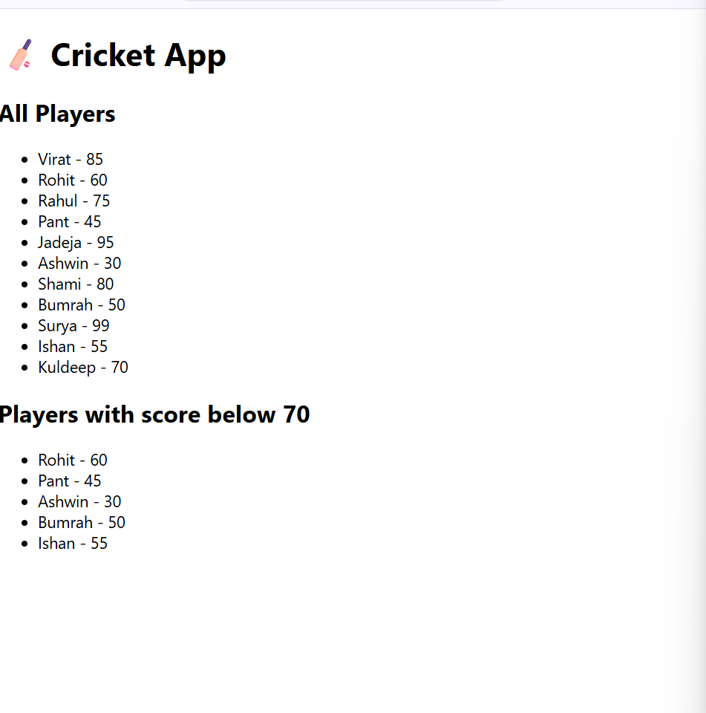

**When flag=false;**

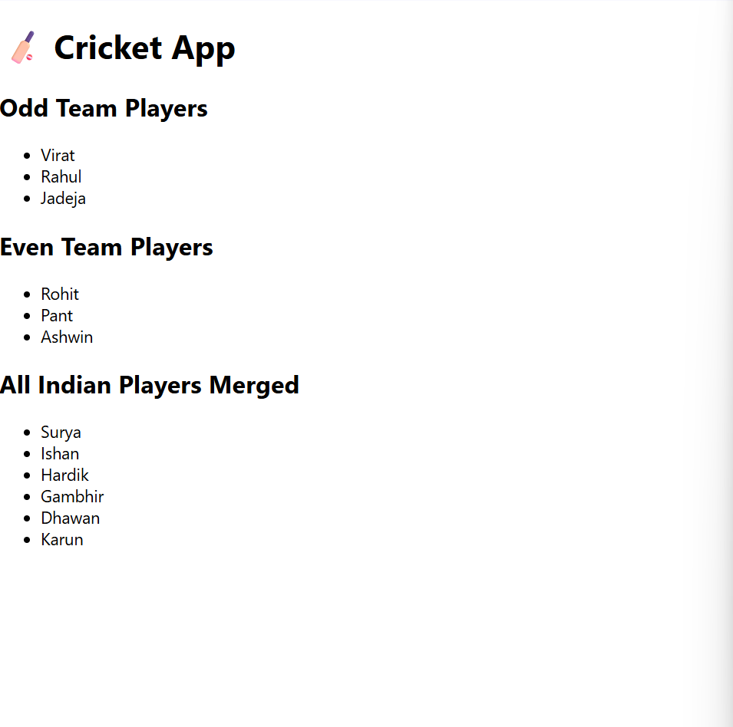

**2.OfficeSpaceRentalApp**

**App.js**

// src/App.js

import React from 'react';

import './App.css';

function App() {

  const office1 = {

    name: "CoWork Hub",

    rent: 55000,

    address: "123 MG Road, Bengaluru",

    image: "https://via.placeholder.com/300x200?text=CoWork+Hub"

  };

  const officeList = [

    {

      name: "Tech Park",

      rent: 45000,

      address: "Park Street, Chennai",

      image: "https://via.placeholder.com/300x200?text=Tech+Park"

    },

    {

      name: "Startup Space",

      rent: 75000,

      address: "Banjara Hills, Hyderabad",

      image: "https://via.placeholder.com/300x200?text=Startup+Space"

    },

    {

      name: "Business Bay",

      rent: 62000,

      address: "Cyber City, Gurugram",

      image: "https://via.placeholder.com/300x200?text=Business+Bay"

    }

  ];

  const heading = <h1 style={{ color: '#333', textAlign: 'center' }}>Office Space Rental Listings</h1>;

  return (

    <div className="App" style={{ fontFamily: 'Arial', padding: '20px' }}>

      {heading}

      <div style={styles.card}>

        <img src={office1.image} alt={office1.name} style={styles.image} />

        <h2>{office1.name}</h2>

        <p>{office1.address}</p>

        <p style={{ color: office1.rent < 60000 ? 'red' : 'green' }}>

          Rent: ₹{office1.rent}

        </p>

      </div>

      <hr />

      <div style={{ display: 'flex', flexWrap: 'wrap', gap: '20px' }}>

        {officeList.map((office, index) => (

          <div key={index} style={styles.card}>

            <img src={office.image} alt={office.name} style={styles.image} />

    <h2>{office.name}</h2>

            <p>{office.address}</p>

            <p style={{ color: office.rent < 60000 ? 'red' : 'green' }}>

              Rent: ₹{office.rent}

            </p>

          </div>

        ))}

      </div>

    </div>

  );

}

const styles = {

  card: {

    border: '1px solid #ccc',

    padding: '16px',

    borderRadius: '8px',

    width: '300px',

    boxShadow: '2px 2px 6px rgba(0,0,0,0.1)',

  },

  image: {

    width: '100%',

    height: 'auto',

    borderRadius: '4px',

  }

};

export default App;

**OUTPUT :** 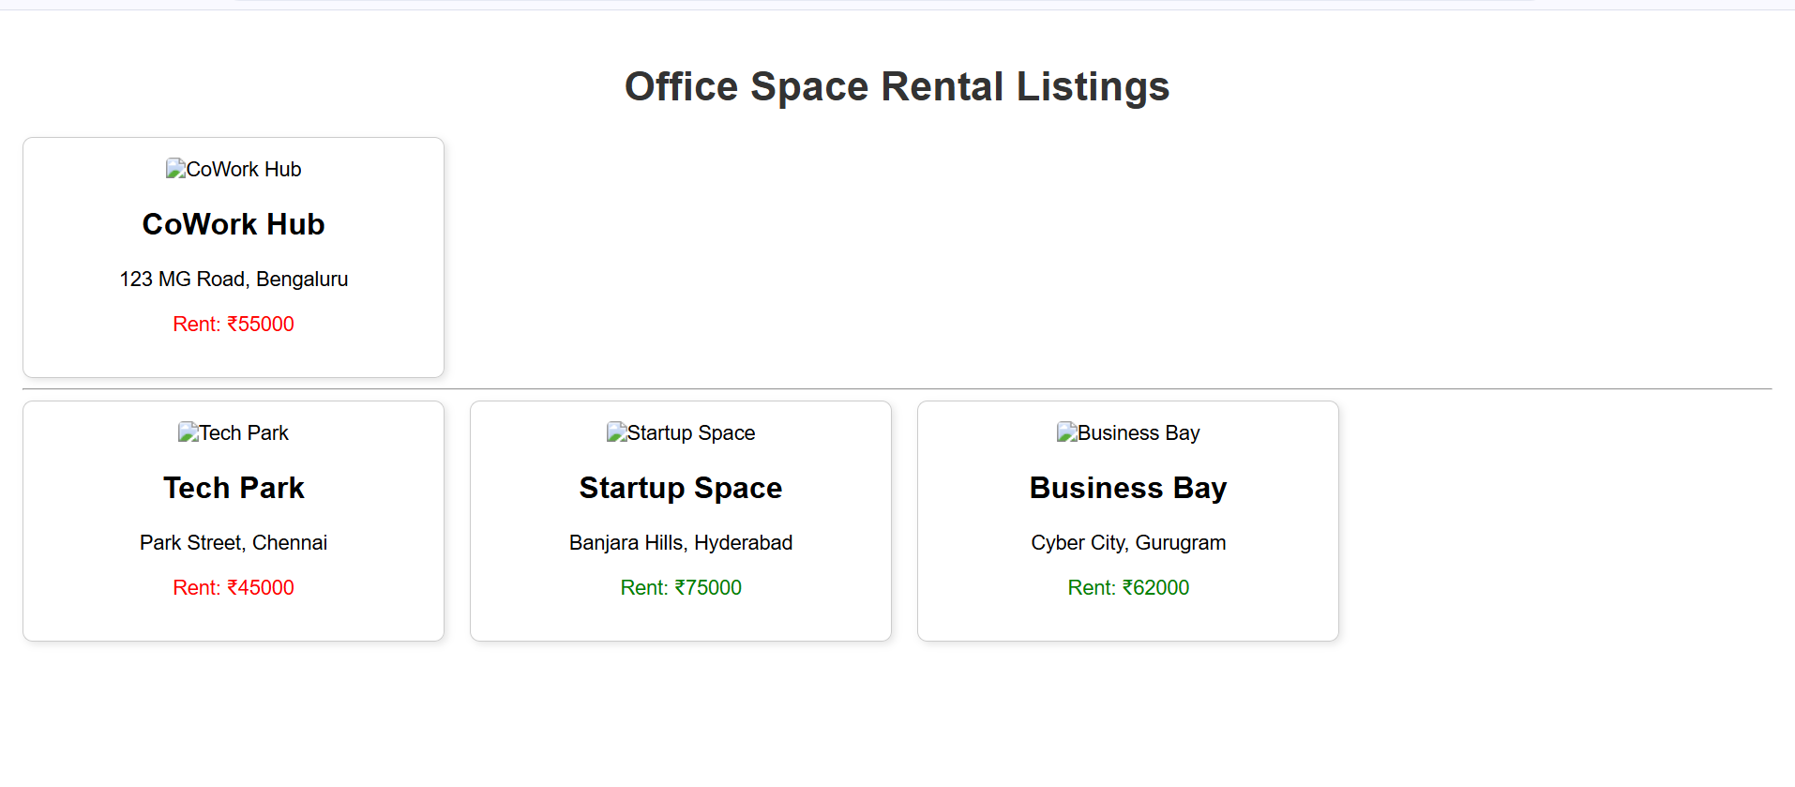

**3.EventExamples App**

**Counter.js**

// src/components/Counter.js

import React, { Component } from 'react';

class Counter extends Component {

  constructor() {

    super();

    this.state = {

      count: 0

    };

    this.handleDecrement = this.handleDecrement.bind(this);

  }

  handleIncrement = () => {

    this.setState(prevState => ({ count: prevState.count + 1 }));

    this.sayHello();

  };

  sayHello = () => {

    console.log("Hello! Counter incremented.");

  };

  handleDecrement() {

    this.setState(prevState => ({ count: prevState.count - 1 }));

  }

  render() {

    return (

      <div>

        <h2>Counter: {this.state.count}</h2>

        <button onClick={this.handleIncrement}>Increment</button>

        <button onClick={this.handleDecrement}>Decrement</button>

      </div>

    );

  }

}

export default Counter;

**CurrencyConvertor.js**

// src/components/CurrencyConvertor.js

import React, { useState } from 'react';

const CurrencyConvertor = () => {

  const [rupees, setRupees] = useState('');

  const [euros, setEuros] = useState('');

  const handleSubmit = (e) => {

    e.preventDefault(); // Prevent default form submission

    const conversionRate = 0.011; // Example: 1 INR = 0.011 EUR

    const converted = (parseFloat(rupees) * conversionRate).toFixed(2);

    setEuros(converted);

  };

  return (

    <div>

      <h2>Currency Convertor</h2>

      <form onSubmit={handleSubmit}>

        <input

          type="number"

          placeholder="Enter amount in INR"

          value={rupees}

          onChange={(e) => setRupees(e.target.value)}

        />

        <button type="submit">Convert</button>

      </form>

      {euros && <p>{rupees} INR = {euros} EUR</p>}

    </div>

  );

};

export default CurrencyConvertor;

**WelcomeButton.js**

// src/components/WelcomeButton.js

import React from 'react';

const WelcomeButton = () => {

  const sayMessage = (message) => {

    alert(message);

  };

  return (

    <div>

      <button onClick={() => sayMessage("Welcome to React Event Handling!")}>

        Say Welcome

      </button>

    </div>

  );

};

export default WelcomeButton;

**App.js**

// src/App.js

import React from 'react';

import Counter from './components/Counter';

import WelcomeButton from './components/WelcomeButton';

import CurrencyConvertor from './components/CurrencyConvertor';

function App() {

  const SyntheticEventButton = () => {

    const handleClick = (e) => {

      alert("I was clicked");

      console.log("Synthetic event triggered", e);

    };

    return <button onClick={handleClick}>Click Me (Synthetic Event)</button>;

  };

  return (

    <div className="App" style={{ padding: '20px', fontFamily: 'Arial' }}>

      <h1>React Event Handling Demo</h1>

      <Counter />

      <hr />

      <WelcomeButton />

      <hr />

      <SyntheticEventButton />

      <hr />

      <CurrencyConvertor />

    </div>

  );

}

export default App;

**OUTPUT :**

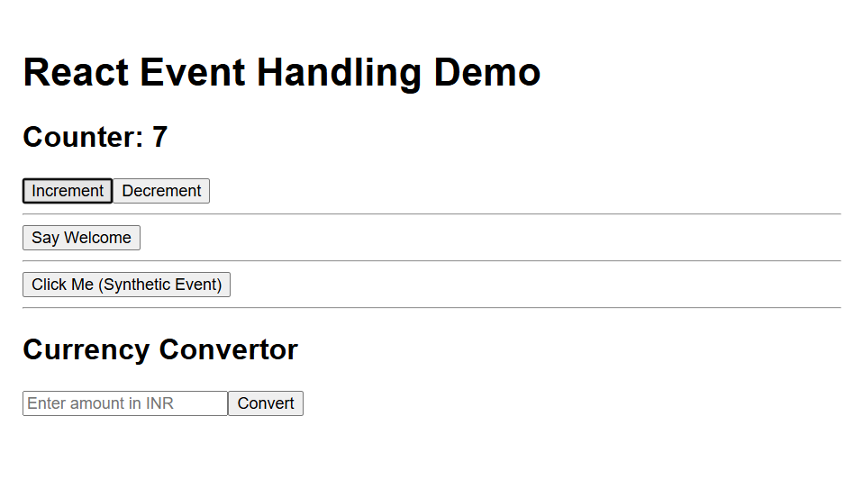

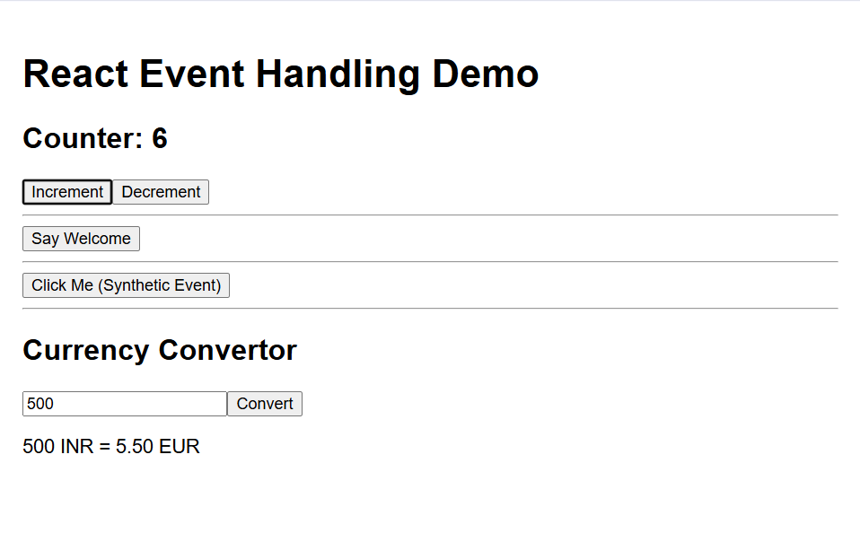

**4.TicketBooking App**

**GuestPage.js**

// src/components/GuestPage.js

import React from 'react';

const GuestPage = () => {

  return (

    <div>

      <h2>Welcome, Guest!</h2>

      <p>Browse flight details below:</p>

      <ul>

        <li>✈️ Flight 101 - Delhi to Mumbai</li>

        <li>✈️ Flight 202 - Chennai to Bengaluru</li>

        <li>✈️ Flight 303 - Hyderabad to Kolkata</li>

      </ul>

    </div>

  );

};

export default GuestPage;

**UserPage.js**

// src/components/UserPage.js

import React from 'react';

const UserPage = () => {

  return (

    <div>

      <h2>Welcome, User!</h2>

      <p>You can now book tickets:</p>

      <button>Book Flight 101</button>

      <button>Book Flight 202</button>

    </div>

  );

};

export default UserPage;

**App.js**

// src/App.js

import React, { useState } from 'react';

import GuestPage from './components/GuestPage';

import UserPage from './components/UserPage';

function App() {

  const [isLoggedIn, setIsLoggedIn] = useState(false);

  // Element variable for conditional rendering

  let pageContent;

  if (isLoggedIn) {

    pageContent = <UserPage />;

  } else {

    pageContent = <GuestPage />;

  }

  return (

    <div className="App" style={{ padding: '20px', fontFamily: 'Arial' }}>

      <h1>✈️ Ticket Booking App</h1>

      {/* Login/Logout buttons */}

      {isLoggedIn ? (

        <button onClick={() => setIsLoggedIn(false)}>Logout</button>

      ) : (

        <button onClick={() => setIsLoggedIn(true)}>Login</button>

      )}

      <hr />

      {/* Conditionally render guest or user page */}

      {pageContent}

    </div>

  );

}

export default App;

**OUTPUT :**

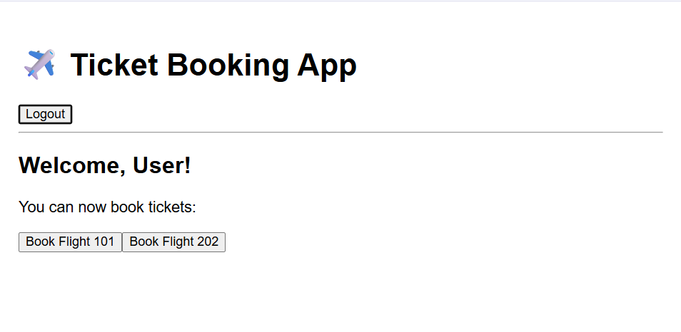

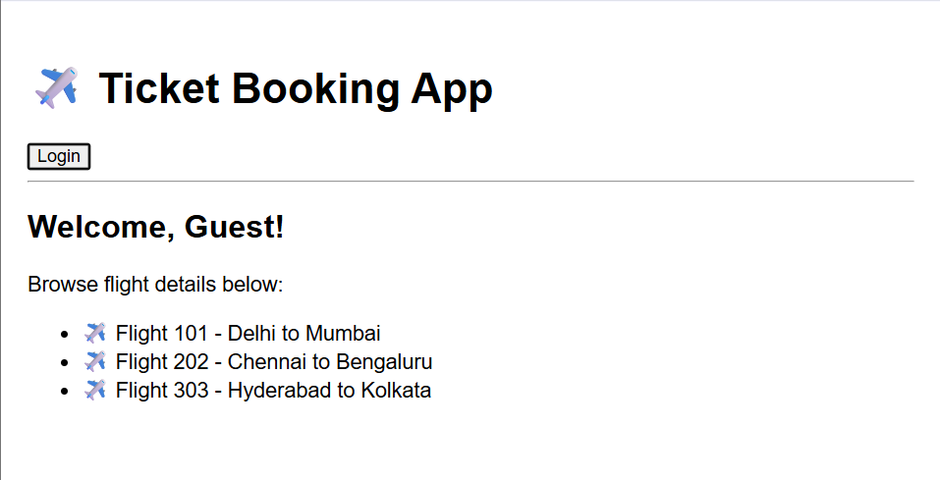

**5.Blogger App**

**BlogDetails.js**

// src/components/BlogDetails.js

import React from 'react';

import CardComponent from './CardComponent';

const blogs = [

  { id: 1, title: 'React Hooks', description: 'A deep dive into Hooks.' },

  { id: 2, title: 'Functional Programming', description: 'Clean and declarative JS.' }

];

const BlogDetails = () => {

  return (

    <div>

      <h2>📝 Blog Articles</h2>

      {blogs.map(blog => (

        <CardComponent key={blog.id} title={blog.title} description={blog.description} />

      ))}

    </div>

  );

};

export default BlogDetails;

**BookDetails.js**

// src/components/BookDetails.js

import React from 'react';

import CardComponent from './CardComponent';

const books = [

  { id: 1, title: 'React in Action', description: 'Comprehensive guide to React.' },

  { id: 2, title: 'JavaScript: The Good Parts', description: 'Best practices in JS.' },

  { id: 3, title: 'Learning Web Design', description: 'HTML, CSS, and more.' }

];

const BookDetails = () => {

  return (

    <div>

      <h2>📚 Book List</h2>

      {books.map(book => (

        <CardComponent key={book.id} title={book.title} description={book.description} />

      ))}

    </div>

  );

};

export default BookDetails;

**CardComponent.js**

// src/components/CardComponent.js

import React from 'react';

const CardComponent = ({ title, description }) => {

  return (

    <div style={styles.card}>

      <h3>{title}</h3>

      <p>{description}</p>

    </div>

  );

};

const styles = {

  card: {

    border: '1px solid #ccc',

    padding: '12px',

    margin: '10px',

    borderRadius: '8px',

    backgroundColor: '#f9f9f9'

  }

};

export default CardComponent;

**CourseDetails.js**

// src/components/CourseDetails.js

import React from 'react';

import CardComponent from './CardComponent';

const courses = [

  { id: 1, title: 'Frontend Mastery', description: 'HTML, CSS, JavaScript' },

  { id: 2, title: 'React Bootcamp', description: 'Hooks, Redux, Router' },

  { id: 3, title: 'Full Stack Web Dev', description: 'MERN Stack' }

];

const CourseDetails = () => {

  return (

    <div>

      <h2>🎓 Course Catalog</h2>

      {courses.map(course => (

        <CardComponent key={course.id} title={course.title} description={course.description} />

      ))}

    </div>

  );

};

export default CourseDetails;

**App.js**

// src/App.js

import React, { useState } from 'react';

import BookDetails from './components/BookDetails';

import BlogDetails from './components/BlogDetails';

import CourseDetails from './components/CourseDetails';

function App() {

  const [view, setView] = useState('books'); // 'books', 'blogs', 'courses'

  let content;

  if (view === 'books') {

    content = <BookDetails />;

  } else if (view === 'blogs') {

    content = <BlogDetails />;

  } else {

    content = <CourseDetails />;

  }

  return (

    <div className="App" style={{ padding: '20px', fontFamily: 'Arial' }}>

      <h1>📖 BloggerApp Dashboard</h1>

      <button onClick={() => setView('books')}>Books</button>

      <button onClick={() => setView('blogs')}>Blogs</button>

      <button onClick={() => setView('courses')}>Courses</button>

      <hr />

      {content}

      <div style={{ marginTop: '20px' }}>

        <h3>Status:</h3>

        <p>

          {view === 'books'

            ? 'You are viewing Book Details.'

            : view === 'blogs'

            ? 'You are reading Blog Articles.'

            : 'You are checking Course Catalog.'}

        </p>

      </div>

      {view === 'books' && <p>✅ Special Offer: Buy 2 books, get 1 free!</p>}

    </div>

  );

}

export default App;

**OUTPUT :**

