MACHINE LEARNING ACTIVITY SHEET-1
NAME: SWETHA M
ROLL NO: CH.SC.U4CSE24248
Activity 1: Loading a CSV Dataset
Dataset: Iris Dataset
Dataset Link:
https://archive.ics.uci.edu/dataset/53/iris
Objective
- Download a CSV dataset.
- Load it using Pandas.
Explore its contents.
Exercises
- Download the dataset.
- Load it into a Pandas DataFrame.
- Display
  - first 10 rows
  - last 5 rows
- Find
  - number of rows
  - number of columns
  - column names
- Display the data types.
- Generate summary statistics.
- Count the number of samples in each class.

CODE:
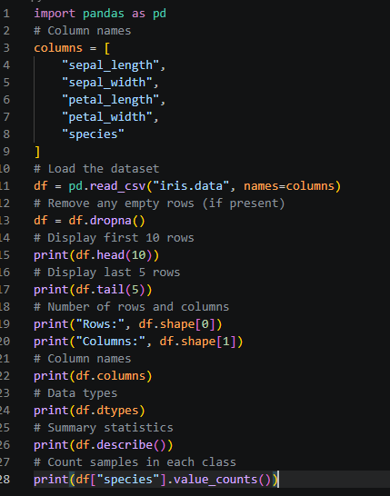

OUTPUT:
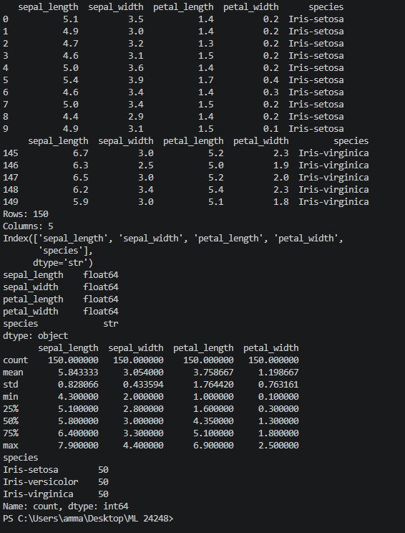

Activity 2: Handling Missing Values
Dataset: Titanic Dataset
Dataset Link:
https://www.kaggle.com/c/titanic/data
Objectives
Learn preprocessing techniques.
Exercises
- Load the dataset.
- Identify columns containing missing values.
- Calculate the percentage of missing values.
- Replace missing numerical values with the median.
- Replace missing categorical values with the mode.
- Remove duplicate rows.
- Verify that no missing values remain.

CODE:
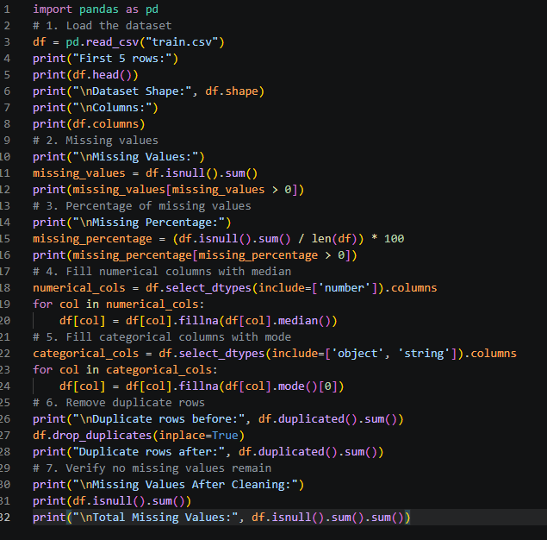

OUTPUT:
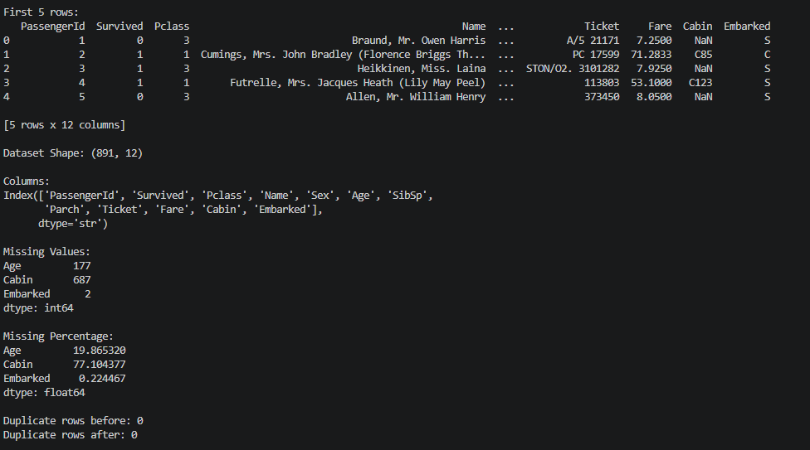
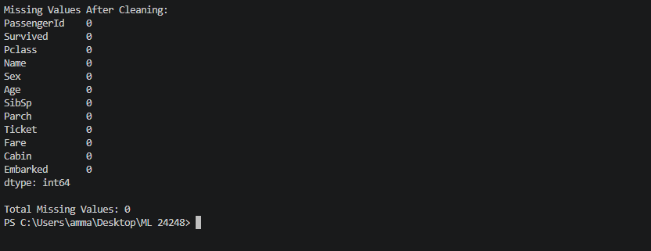

Activity 3: Feature Encoding
Dataset: Adult Income Dataset
Dataset Link:
https://archive.ics.uci.edu/dataset/2/adult
Exercises
- Load the dataset.
- Identify categorical and numerical attributes.
- Apply Label Encoding to binary features.
- Apply One-Hot Encoding to multi-class features.
- Compare the dataset dimensions before and after encoding.

CODE:
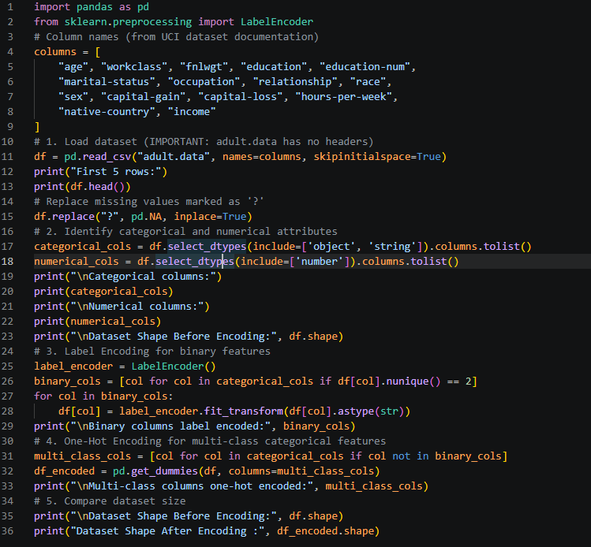
OUTPUT:
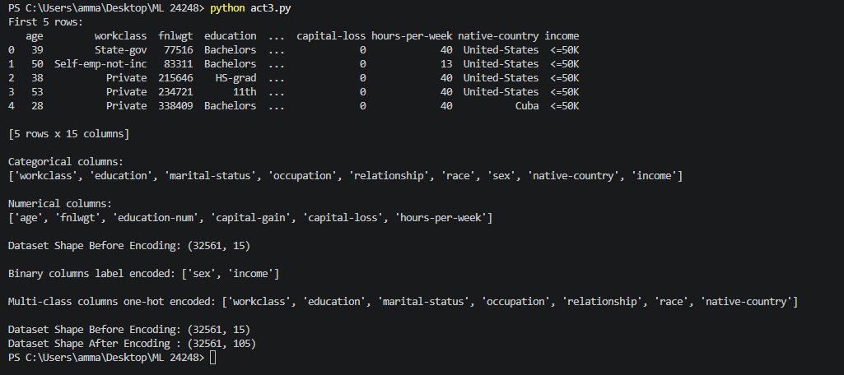

Activity 4: Data Scaling
Dataset: Wine Dataset
Dataset Link:
https://archive.ics.uci.edu/dataset/109/wine
Exercises
- Load the dataset.
- Compute the minimum and maximum value of each feature.
- Apply Min-Max Scaling.
- Apply Standardization.
- Compare the mean and variance before and after preprocessing.

CODE:
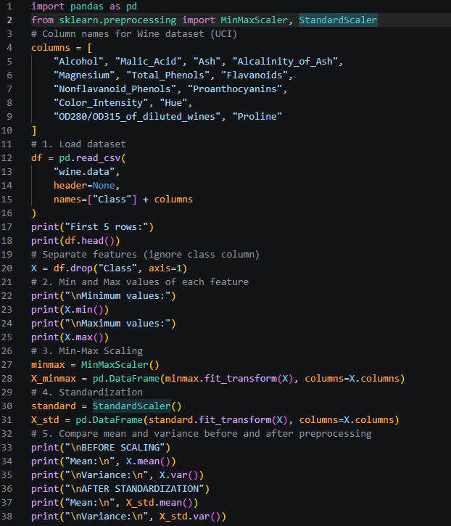

OUTPUT:
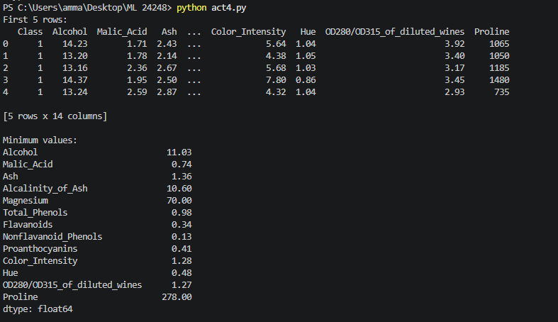
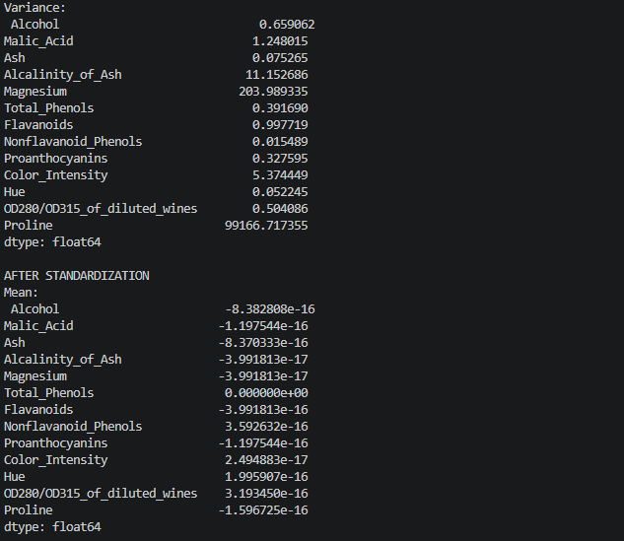
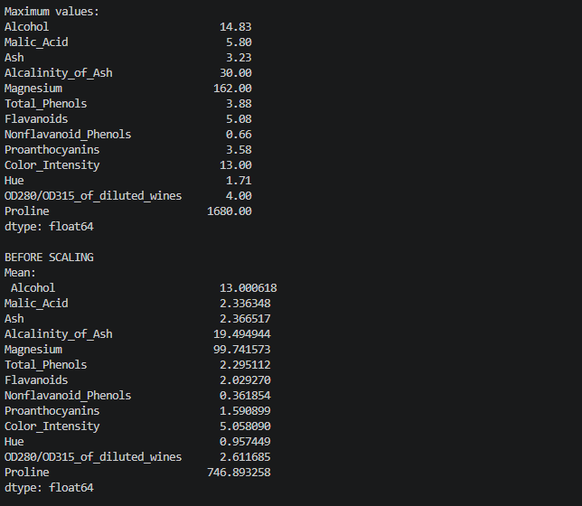
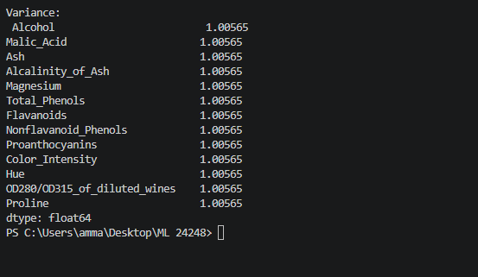

Activity 5: Data Splitting
Use any dataset from Activities 1–8.
Exercises
- Split the dataset into
  - 70% Training
  - 15% Validation
  - 15% Testing
- Verify the number of samples in each subset.
- Ensure the class distribution is maintained using stratified sampling.
CODE:
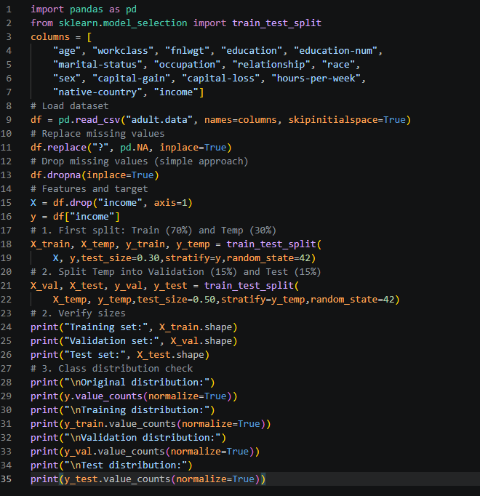

OUTPUT:

OUTPUT:
