Student Marks Dashboard Using Claude AI
Project Overview
The Student Marks Dashboard is an AI-powered project that analyzes student marks from an Excel spreadsheet. It automatically calculates totals and averages, identifies the highest and lowest scorers, and presents the results in a simple dashboard with charts and insights.

Problem Statement
Teachers and schools spend a lot of time analyzing student marks manually. This project helps automate the process by using AI to analyze the data and generate a visual dashboard.

Objectives
- Analyze student marks from an Excel file.

- Calculate total and average marks.

- Identify the highest and lowest scorers.

- Display charts for better visualization.

- Provide insights and recommendations.

Features
- Upload Excel file

- Automatic data analysis

- Total and average marks calculation

- Highest and lowest scorer identification

- Bar chart generation

- Pie chart generation

- Performance summary

- Recommendations

Tools Used
- Claude AI

- Microsoft Excel

- GitHub

Input
An Excel file containing:
- Student Name
- Tamil
- English
- Maths
- Science
- Total Marks

Output
The system generates:
- Student performance dashboard
- Total and average marks
- Highest and lowest scorer
- Bar chart
- Pie chart
- Key insights
- Recommendations
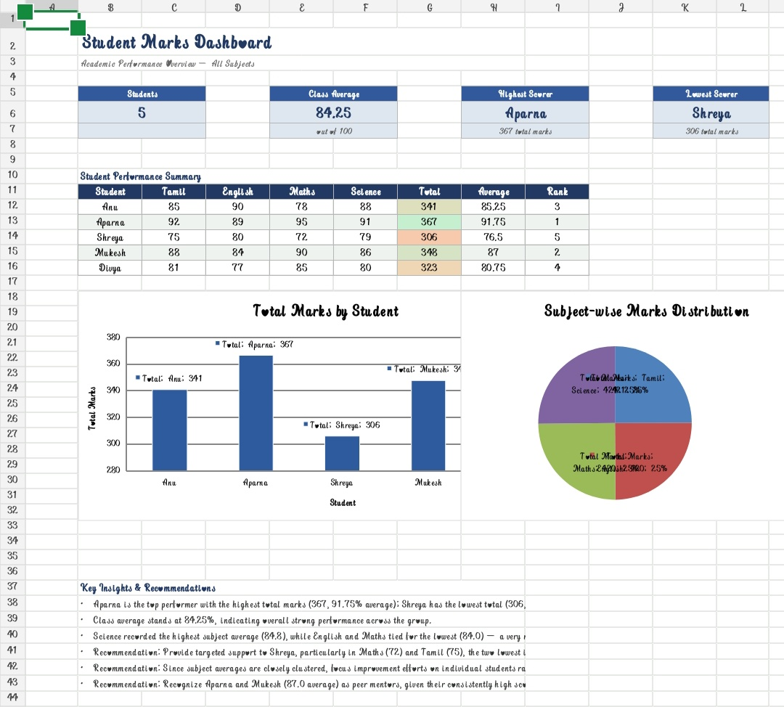
Benefits
- Saves time
- Easy to understand
- Improves data analysis
- Helps teachers evaluate student performance quickly

